# WebService服务注册流程

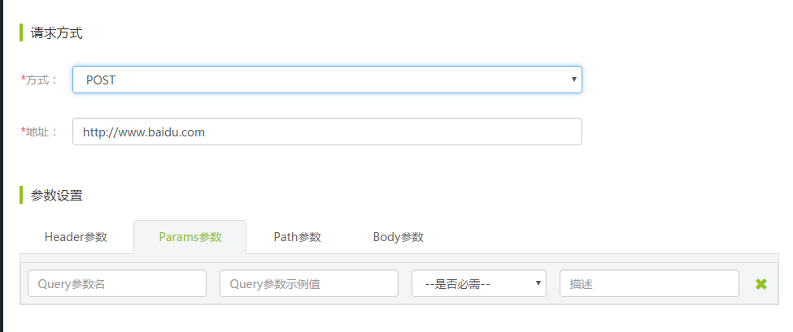

调用方式中选择post

参数设置中选择Body参数

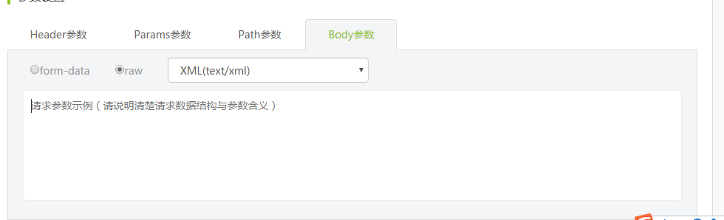

将请求中的soapui写入参数示例

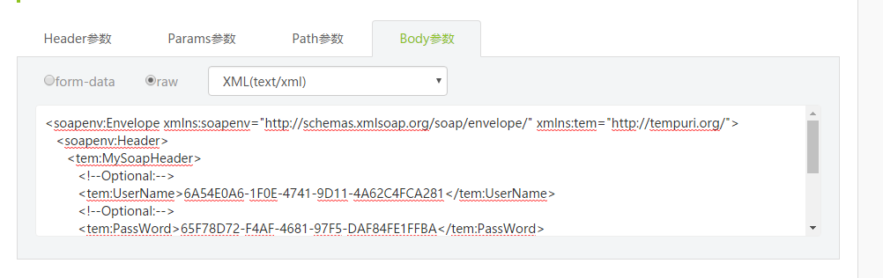

调用者使用方法

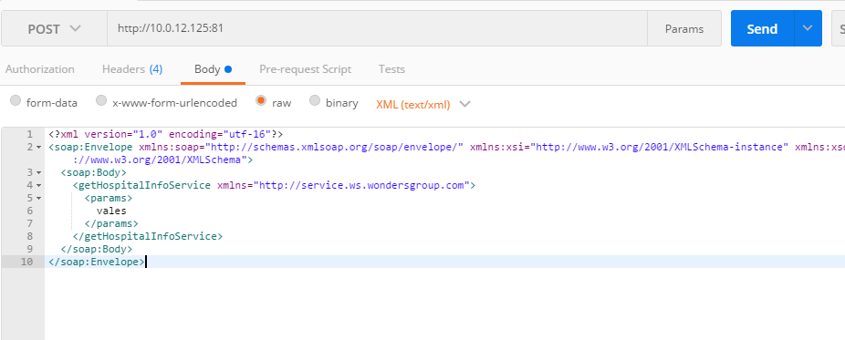

选择Post 在body中写入要请求的xml参数

# 市卫计委时间戳服务注册

## 时间戳服务接口地址

<http://10.141.1.22/services/TimeStampServices>

## generateTimestampByHashData接口请求参数

|  |
| --- |
| <soapenv:Envelope xmlns:soapenv=**"http://schemas.xmlsoap.org/soap/envelope/"** xmlns:web=**"http://webservice.tsp.openapi.sp.custle.com"**>  <soapenv:Header/>  <soapenv:Body>  <web:generateTimestampByHashData>  <web:in0><![CDATA[<?xml version=**"1.0"** encoding=**"UTF-8"** ?><Root><AppCode>ywxt</AppCode><AppPWD>12345678</AppPWD><Request><HashData>yiLkflLG6DU/PqpgkG/EqQLurCY=</HashData><HashAlg>SHA256</HashAlg><CertReq>false</CertReq></Request></Root>]]></web:in0>  </web:generateTimestampByHashData>  </soapenv:Body>  </soapenv:Envelope> |

响应参数

|  |
| --- |
| <soap:Envelope xmlns:soap=**"http://schemas.xmlsoap.org/soap/envelope/"** xmlns:xsd=**"http://www.w3.org/2001/XMLSchema"** xmlns:xsi=**"http://www.w3.org/2001/XMLSchema-instance"**>  <soap:Body>  <ns1:generateTimestampByHashDataResponse xmlns:ns1=**"http://webservice.tsp.openapi.sp.custle.com"**>  <ns1:out><![CDATA[<Root><RetCode>1</RetCode><RetMsg>成功</RetMsg><Response><TimeStamp></TimeStamp></Response></Root>]]></ns1:out>  </ns1:generateTimestampByHashDataResponse>  </soap:Body>  </soap:Envelope> |

## generateTimestampByInData接口请求参数

|  |
| --- |
| <soapenv:Envelope xmlns:soapenv=**"http://schemas.xmlsoap.org/soap/envelope/"** xmlns:web=**"http://webservice.tsp.openapi.sp.custle.com"**>  <soapenv:Header/>  <soapenv:Body>  <web:generateTimestampByInData>  <web:in0><![CDATA[<?xml version=**"1.0"** encoding=**"UTF-8"** ?><Root><AppCode>ywxt</AppCode><AppPWD>12345678</AppPWD><Request><InData>dGhpc2lzdGVzdA==</InData><HashAlg>SM3</HashAlg><CertReq>false</CertReq></Request></Root>]]></web:in0>  </web:generateTimestampByInData>  </soapenv:Body>  </soapenv:Envelope> |

响应参数

|  |
| --- |
| <soap:Envelope xmlns:soap=**"http://schemas.xmlsoap.org/soap/envelope/"** xmlns:xsd=**"http://www.w3.org/2001/XMLSchema"** xmlns:xsi=**"http://www.w3.org/2001/XMLSchema-instance"**>  <soap:Body>  <ns1:generateTimestampByInDataResponse xmlns:ns1=**"http://webservice.tsp.openapi.sp.custle.com"**>  <ns1:out><![CDATA[<Root><RetCode>1</RetCode><RetMsg>成功</RetMsg><Response><TimeStamp></TimeStamp></Response></Root>]]></ns1:out>  </ns1:generateTimestampByInDataResponse>  </soap:Body>  </soap:Envelope> |

## getTimeStampInfo接口请求参数

|  |
| --- |
| <soapenv:Envelope xmlns:soapenv=**"http://schemas.xmlsoap.org/soap/envelope/"** xmlns:web=**"http://webservice.tsp.openapi.sp.custle.com"**>  <soapenv:Header/>  <soapenv:Body>  <web:getTimeStampInfo>  <web:in0><![CDATA[<?xml version=**"1.0"** encoding=**"UTF-8"** ?><Root><AppCode>ywxt</AppCode><AppPWD>12345678</AppPWD><Request><TimeStamp></TimeStamp></Request></Root>]]></web:in0>  </web:getTimeStampInfo>  </soapenv:Body>  </soapenv:Envelope> |

响应参数

|  |
| --- |
| <soap:Envelope xmlns:soap=**"http://schemas.xmlsoap.org/soap/envelope/"** xmlns:xsd=**"http://www.w3.org/2001/XMLSchema"** xmlns:xsi=**"http://www.w3.org/2001/XMLSchema-instance"**>  <soap:Body>  <ns1:getTimeStampInfoResponse xmlns:ns1=**"http://webservice.tsp.openapi.sp.custle.com"**>  <ns1:out><![CDATA[<Root><RetCode>1</RetCode><RetMsg>成功</RetMsg><TSTInfo><Time>2014-11-12 01:02:52</Time><HashData>yiLkflLG6DU/PqpgkG/EqQLurCY=</HashData><HashAlg>SHA1</HashAlg><SerialNumber>129287d25c4c4e</SerialNumber><Signer>C=CN,CN=TSA</Signer><Cert></Cert></TSTInfo></Root>]]></ns1:out>  </ns1:getTimeStampInfoResponse>  </soap:Body>  </soap:Envelope> |

## verifyTimeStamp接口请求参数

|  |
| --- |
| <soapenv:Envelope xmlns:soapenv=**"http://schemas.xmlsoap.org/soap/envelope/"** xmlns:web=**"http://webservice.tsp.openapi.sp.custle.com"**>  <soapenv:Header/>  <soapenv:Body>  <web:verifyTimeStamp>  <web:in0><![CDATA[<?xml version=**"1.0"** encoding=**"UTF-8"** ?><Root><AppCode>ywxt</AppCode><AppPWD>12345678</AppPWD><Request><TimeStamp></TimeStamp><Cert></Cert></Request></Root>]]></web:in0>  </web:verifyTimeStamp>  </soapenv:Body>  </soapenv:Envelope> |

响应参数

|  |
| --- |
| <soap:Envelope xmlns:soap=**"http://schemas.xmlsoap.org/soap/envelope/"** xmlns:xsd=**"http://www.w3.org/2001/XMLSchema"** xmlns:xsi=**"http://www.w3.org/2001/XMLSchema-instance"**>  <soap:Body>  <ns1:verifyTimeStampResponse xmlns:ns1=**"http://webservice.tsp.openapi.sp.custle.com"**>  <ns1:out><![CDATA[<Root><RetCode>1</RetCode><RetMsg>成功</RetMsg></Root>]]></ns1:out>  </ns1:verifyTimeStampResponse>  </soap:Body>  </soap:Envelope> |