# MULTIPLE CHOICES

# What are the design principles for modern computers?

# Provide plenty of registers

1. Instructions should be easy to decode
2. Only loads, stores should reference memory
3. Minimize rate at which instructions are issued
4. **Which of following is true for the cell?**
5. Memories consist of a number of cells
6. A cell with k bits can hold one of 2k different values
7. If an address has m bits, the maximum number of cells addressable is 2m
8. **Which of following is true about byte?**
9. 1 byte is 8-bit
10. 1 byte is 4-bit
11. 64-bit Word: 8 bytes per word
12. 32-bit Word: 8 bytes per word

**4. The von Neumann model of a computer consists of three major components: the central processing unit (CPU), main memory, and input-output. In which of these components might we find the 32 registers of a MIPS processor?**

A. CPU

B. Main memory

C. Input-output

D. CPU as well as main memory

E. Main memory as well as input-output

**5.Consider the sequence of four instructions shown below.**

loop: lw $6, 0($5)

add $7, $7, $6 addi $5, $5, -4 bne $5, $8, loop

In the space provided below, show the binary representation of each of the four instructions in this sequence. Clearly mark the instruction fields and show their decimal equivalent.

**lw $6, 0($5)**

|  |  |  |  |  |  |  |  |  |  |  |  |  |  |  |  |  |  |  |  |  |  |  |  |  |  |  |  |  |  |  |  |  |
| --- | --- | --- | --- | --- | --- | --- | --- | --- | --- | --- | --- | --- | --- | --- | --- | --- | --- | --- | --- | --- | --- | --- | --- | --- | --- | --- | --- | --- | --- | --- | --- | --- |
|  |  |  |  |  |  |  |  |  |  |  |  |  |  |  |  |  |  |  |  |  |  |  |  |  |  |  |  |  |  |  |  |  |

**add $7, $7, $6**

|  |  |  |  |  |  |  |  |  |  |  |  |  |  |  |  |  |  |  |  |  |  |  |  |  |  |  |  |  |  |  |  |
| --- | --- | --- | --- | --- | --- | --- | --- | --- | --- | --- | --- | --- | --- | --- | --- | --- | --- | --- | --- | --- | --- | --- | --- | --- | --- | --- | --- | --- | --- | --- | --- |
|  |  |  |  |  |  |  |  |  |  |  |  |  |  |  |  |  |  |  |  |  |  |  |  |  |  |  |  |  |  |  |  |

# addi $5, $5, -4

|  |  |  |  |  |  |  |  |  |  |  |  |  |  |  |  |  |  |  |  |  |  |  |  |  |  |  |  |  |  |  |  |
| --- | --- | --- | --- | --- | --- | --- | --- | --- | --- | --- | --- | --- | --- | --- | --- | --- | --- | --- | --- | --- | --- | --- | --- | --- | --- | --- | --- | --- | --- | --- | --- |
|  |  |  |  |  |  |  |  |  |  |  |  |  |  |  |  |  |  |  |  |  |  |  |  |  |  |  |  |  |  |  |  |

# bne $5, $7, loop

|  |  |  |  |  |  |  |  |  |  |  |  |  |  |  |  |  |  |  |  |  |  |  |  |  |  |  |  |  |  |  |  |
| --- | --- | --- | --- | --- | --- | --- | --- | --- | --- | --- | --- | --- | --- | --- | --- | --- | --- | --- | --- | --- | --- | --- | --- | --- | --- | --- | --- | --- | --- | --- | --- |
|  |  |  |  |  |  |  |  |  |  |  |  |  |  |  |  |  |  |  |  |  |  |  |  |  |  |  |  |  |  |  |  |

举例：

**addi $8, $9, -3**

Opcode (8) rs (9) rt (8) immed (-3)

|  |  |  |  |  |  |  |  |  |  |  |  |  |  |  |  |  |  |  |  |  |  |  |  |  |  |  |  |  |  |  |  |  |
| --- | --- | --- | --- | --- | --- | --- | --- | --- | --- | --- | --- | --- | --- | --- | --- | --- | --- | --- | --- | --- | --- | --- | --- | --- | --- | --- | --- | --- | --- | --- | --- | --- |
| **0** | **0** | **1** | **0** | **0** | **0** | **0** | **1** | **0** | **0** | **1** | **0** |  | **1** | **0** | **0** | **0** | **1** | **1** | **1** | **1** | **1** | **1** | **1** | **1** | **1** | **1** | **1** | **1** | **1** | **1** | **0** | **1** |

* 1. 30 29 28 27 26 25 24 23 22 21 20 19 18 17 16 15 14 13 12 11 10 9 7 6 5 4 3 2 1 0

**6.The following diagram gives the organization of a simple computer with one CPU and two I/O devices. Is it correct? If not, please correct it in the diagram.**

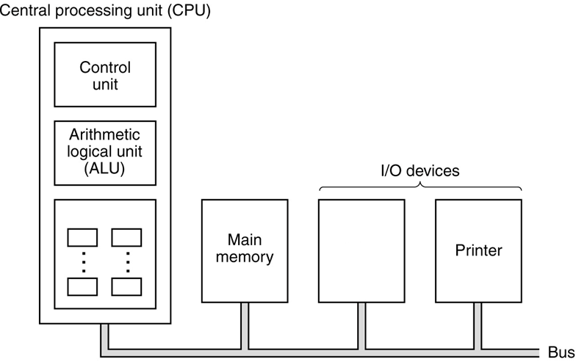

**7. How many bits are sufficient for an address to reference the memory of Figs (a), (b), (c) ?**

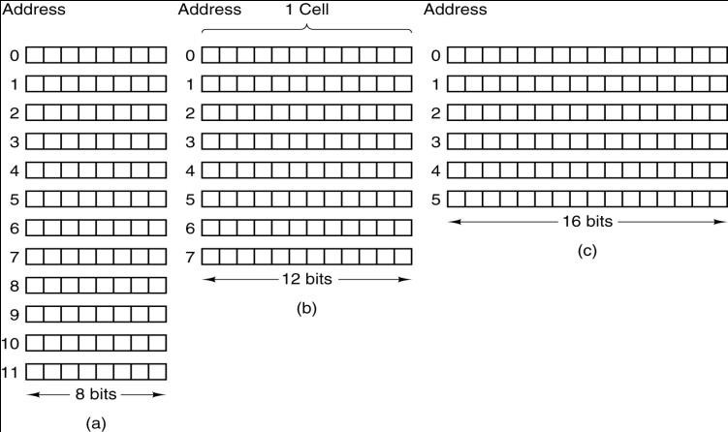

# 8. Instruction Set Design

As discussed in the book, the four princples of instruction set design are:

* 1. Simplicity favors regularity.
  2. Smaller is faster.
  3. Good design demands good compromises.
  4. Make the common case fast.

A number of design decisions in the MIPS Architecture are listed below. Fill in the blank with the design principles which were applied in making each decision.

1. The opcode field is in the same position in all instructions
2. All instructions are exactly 32 bits long
3. Immediate instructions allow the use of small constants
4. The lui instruction allows the use of larger constants

|  |  |  |
| --- | --- | --- |
| (e) | The rs and rt fields are in the same position in R-type and I-type instructions |  |
| f) | A linkage register is used to store the return address for “leaf procedures” (instead of the stack) |  |
| (g) | Only 32 general purpose registers are used for R-type instructions |  |