**IFT458/598 – Project 2**

Yuan Li & Edward Halper

**Introduction**

……???

**Description of your work**

|  |  |  |
| --- | --- | --- |
| Name | Item | description |
| Yuan Li | ER diagram | I used <https://app.diagrams.net/> to draw the conceptual ER diagram.  First: I Created simple entities, single valued attribute.  Second: I Created binary relationships between two entities  Third: I add attributes to the relationships  Fourth: I mapped the ER diagram to tables |
| Yuan Li | SQL script | I used MySQL to define the DDL script.  I installed MySQL on my PC and started define tables, columns, foreign keys, constrains according to the ER diagram and my partner’s relational diagram. |
|  |  |  |

**User Manual**

Step1: In the zip file, there is a file called ER diagram.drawio. That’s the ER diagram file

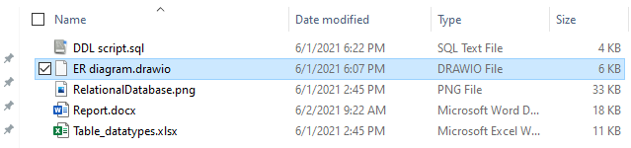

Step2: To be able to open it, you have to go to <http://app.diagrams.net>

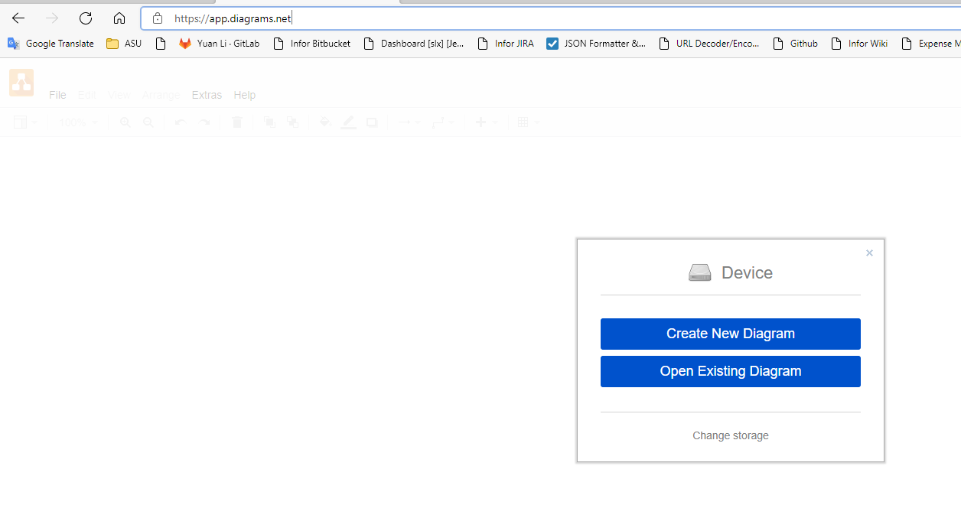

Step3: Then select Open Existing Diagram, and select ER diagram.drawio in your folder

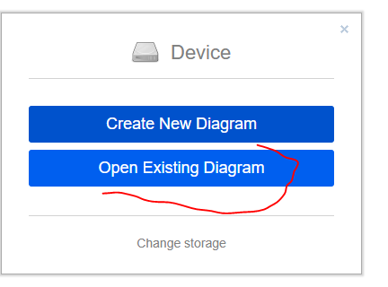

Step3: After you open the file, you will see the ER diagram, on top there is a simple table which defined simple entities and attributes.

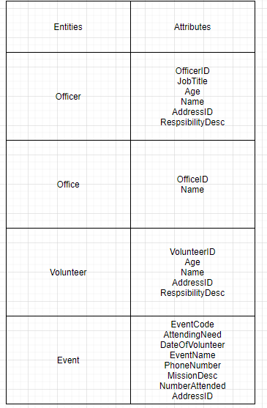

Step4: Scroll down, you will see the ER diagram including entities, attributes, and relations

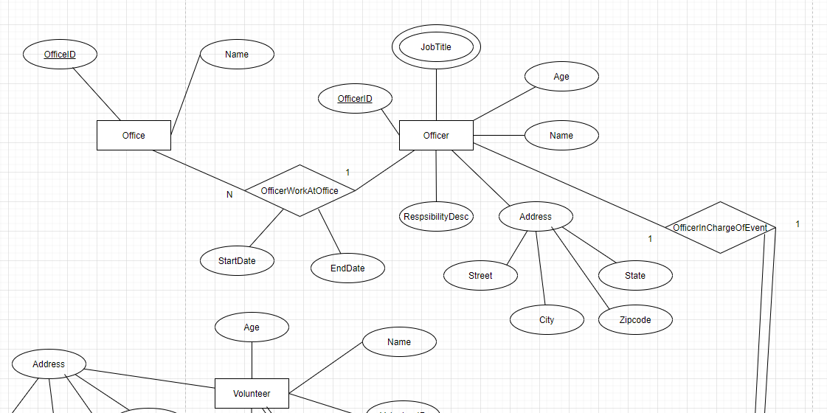

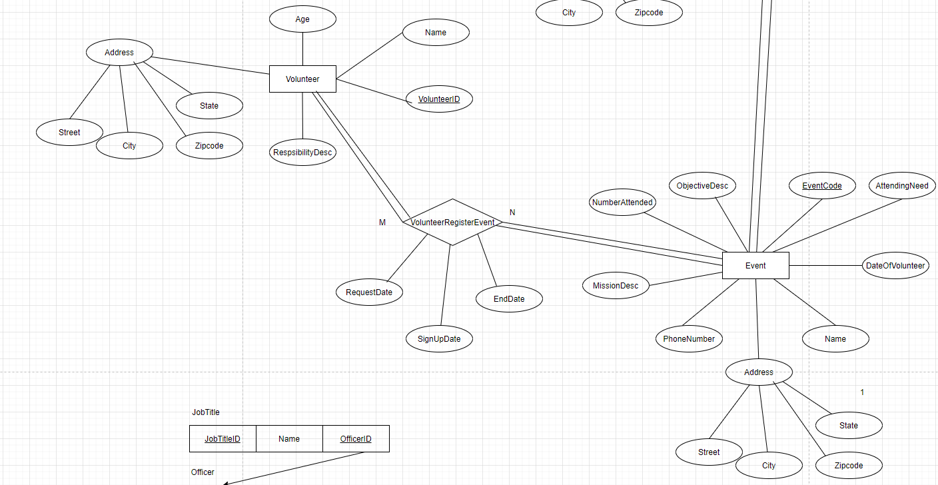

Step5: Continue scrolling down, you will see the relation diagram based on ER diagram. We first only had 4 simple entities but ended up with 7 entities. That’s because we have one M:N relationship and two multivalued attribute

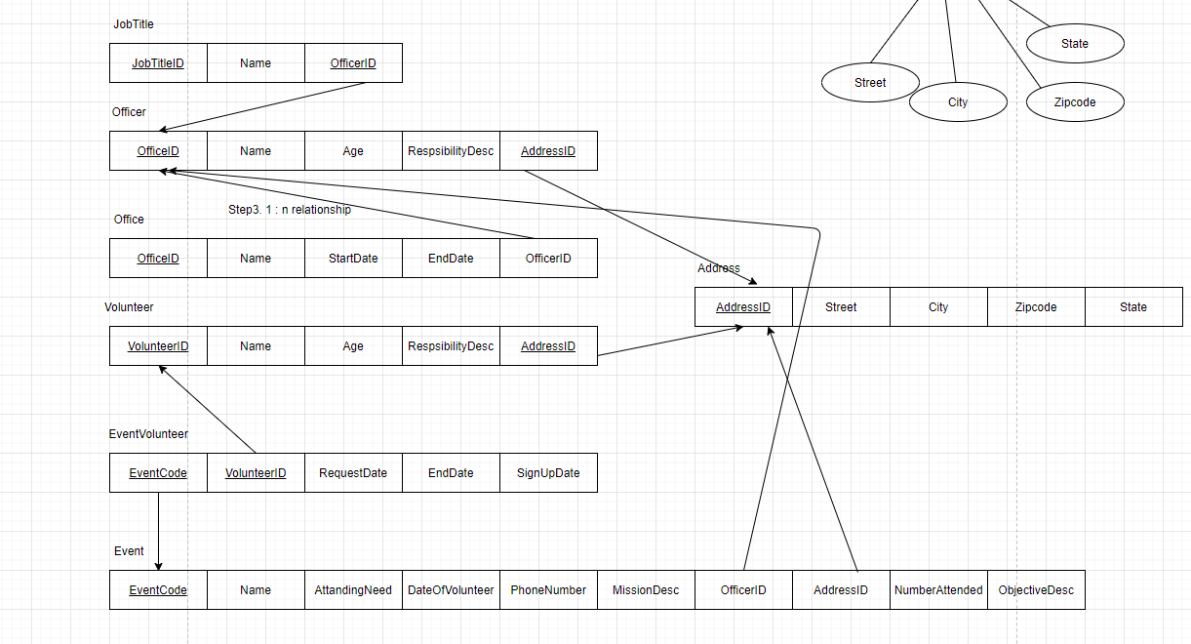

Step6: You can open the DDL scrip to check the detailed implementation.

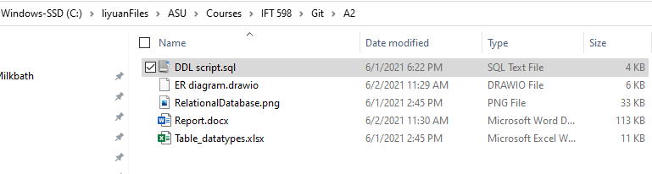

Ste7: Open the DDL script

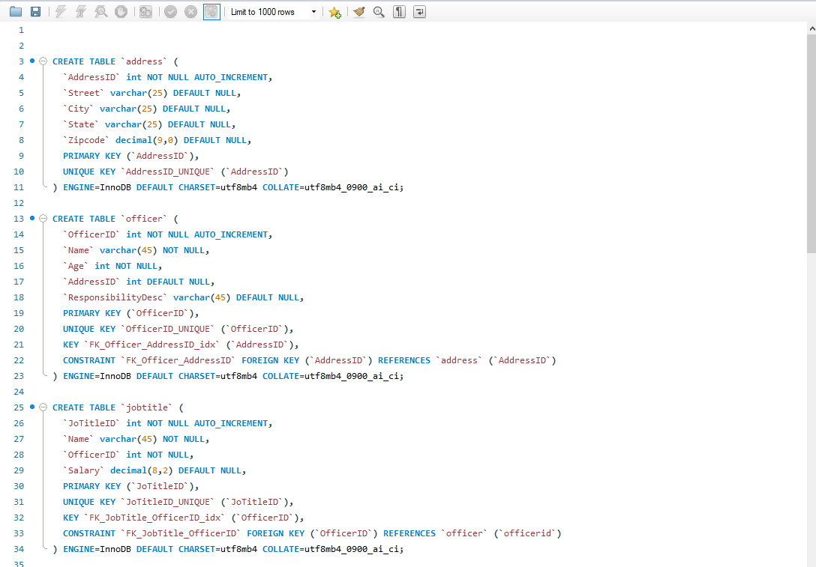

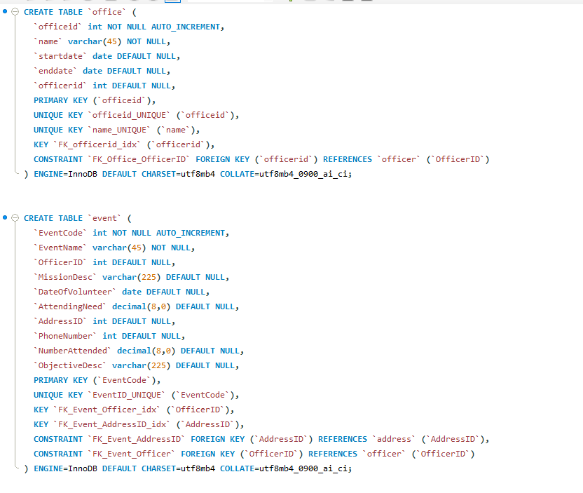

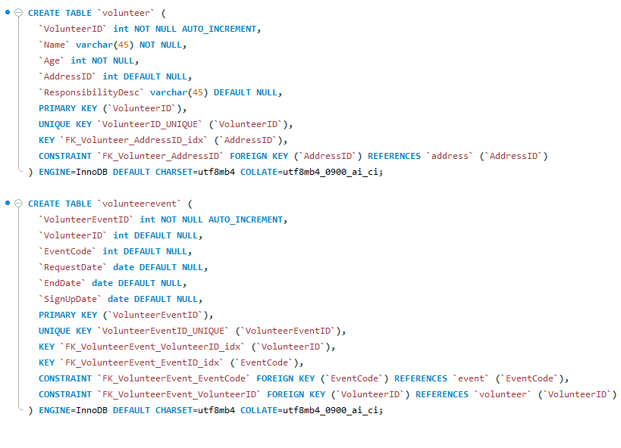

**Yuan’s Conclusion:**

I learned how to design database from the concept to implementation. I used to design the database directly from database, and then generate the diagram from database, it is kind of backwards process. I never followed the conceptual algorithm to design the ER diagram step by step. I think the step by step design will help catching all the requirements. I also learned the relationship attribute; a lot of attributes are only existing when the relationship exists, so we can add as many as attributes to the relationship entity/table.

Now if you give me an ER diagram, I think I will understand it and can implement it in database accordingly. I also learned MySQL, I never used MySql before. I installed MySQL and designed tables and created the DDL scripts. MySQL is very similar to SQL Server, it’s actually easy to pick it up. The improvement is the ER tool I am using, it is online ER too, you have to open their website to draw your diagram and open your existing diagram, and there is no an smart way to organize your diagram layout. Instead of dragging and dropping.

**Edward’s Conclusion:**