**IFT458/598 – Project 1**

Yuan Li & Edward Halper

**Introduction**

This is a donation web application. This website showcases our donation activities, and volunteer events. We encourage you to read our website and join us to help others. You can register now to volunteer and donate. The volunteer events will show as news, so you will find so many interesting volunteer events, so please join us and help others!

The application is built on top of html5, jQuery, and Boostrap css. It has all html5 cool features, like embedded video, drag and drop, Geolocation, friendly validation and SVG images that do not lose any quality when you zoom in. It works with all the browsers, and the display content fits different sizes of screens too.

**Description of your work**

|  |  |  |
| --- | --- | --- |
| Name | Item | description |
| Yuan | Logo | I used html5 SVG designed the logo. It has circle and text embedded in it. |
| Yuan | Navigation | I used html5 nav element to build the menu and menu items and I used jQuery to display the menu item when user clicks the menu. |
| Yuan | login page | I used Bootstrap modal component to design our login page. The login page has html5 validation features. Both email address and password are required fields. I also used jQuery and html5 web storage object window.sessionStorage to store and retrieve user login information |
| Yuan | News page | I used html5 drag and drop feature to allow user to drag news from one section to put into another section.  There is also a slideshow which allows user to cycle through a series of SVG images. |
| Yuan | Contact page | I used html video feature to embed a mp4 type video. User can play, pause, maximize, and change the sound of the video. |
| Yuan | Galleries page | I used Bootstrap card container to organize the picture and text. |
| Edward | Registration page | For the registration page I used a boostrap modal component to keep consistent design with the page. The registration form has all the required fields and a couple for the sake of verification like verifying password a second time. I used jquery to validate the majority of the fields to denote them as required or not and any significant things that were needed such as length of the field. For the password I incorporated both bootstrap validation on jquery validation in order to obtain the correct input format that was asked. This can be easily modified in the .js that is in use for the password. Validation requirements and messages where written in jquery. |
| Edward | Video on donation page | Video used on donate page is a reason for donating 10% of your income that was taken from youtube and embedded the code to the page using iframe in html5. |
| Edward | Geolocation | For Geolocation on the donate page I used a script directly in the html page in order for the user to be able to see and share their location. |

**Screenshots of code narrative from above**

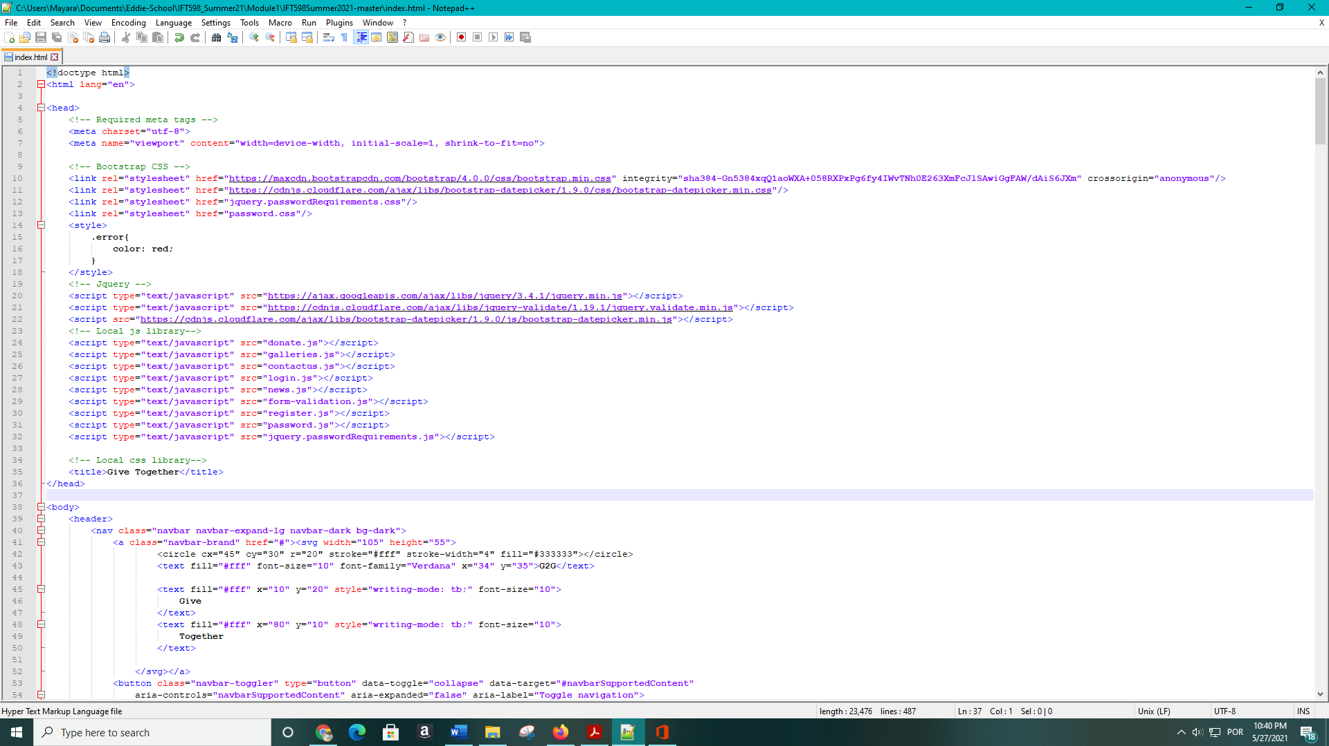

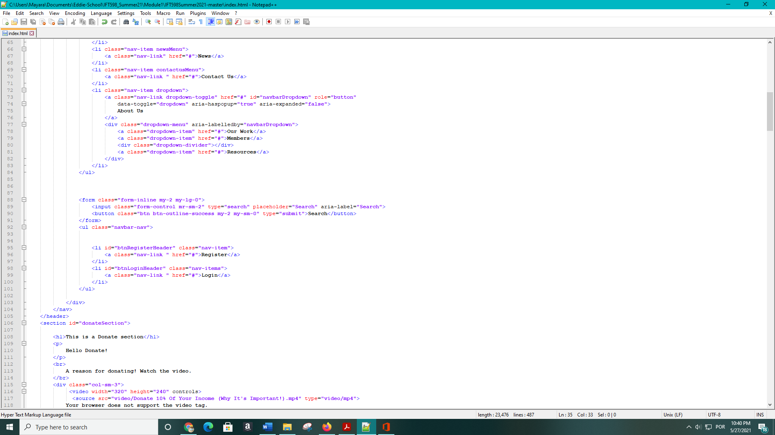

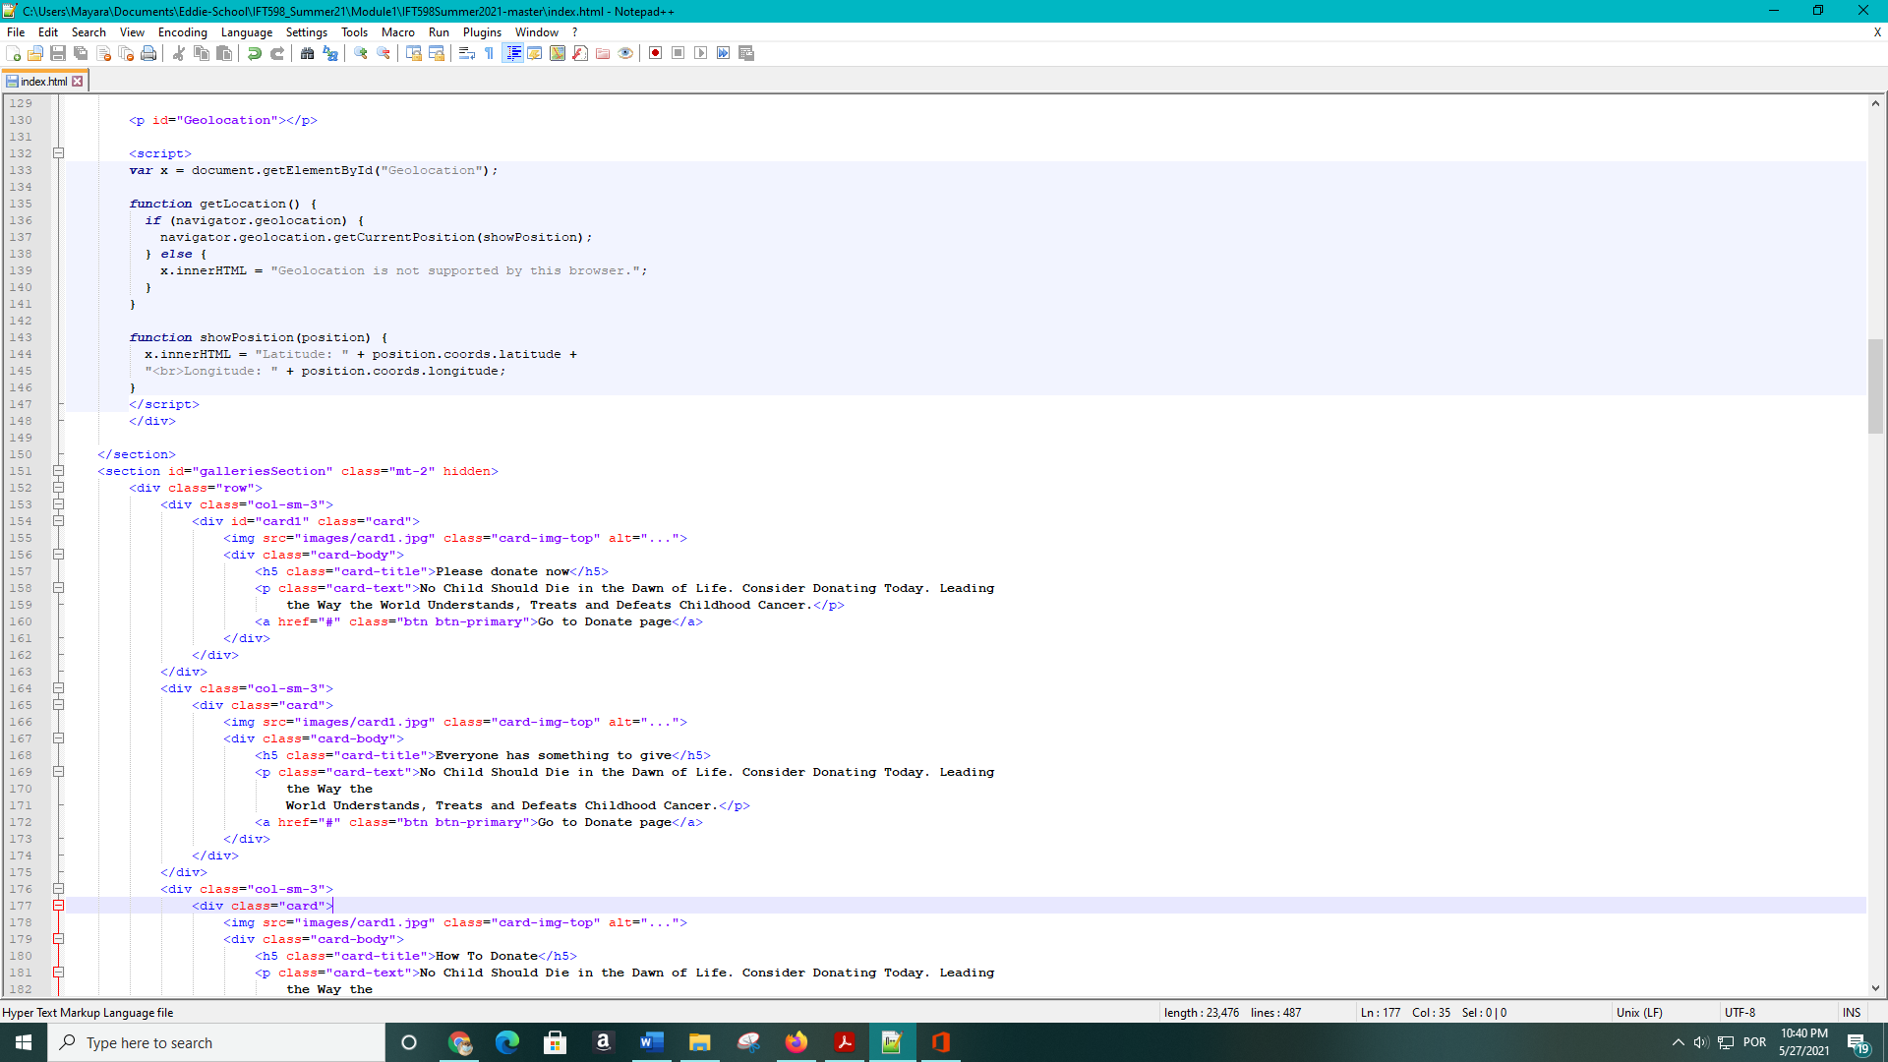

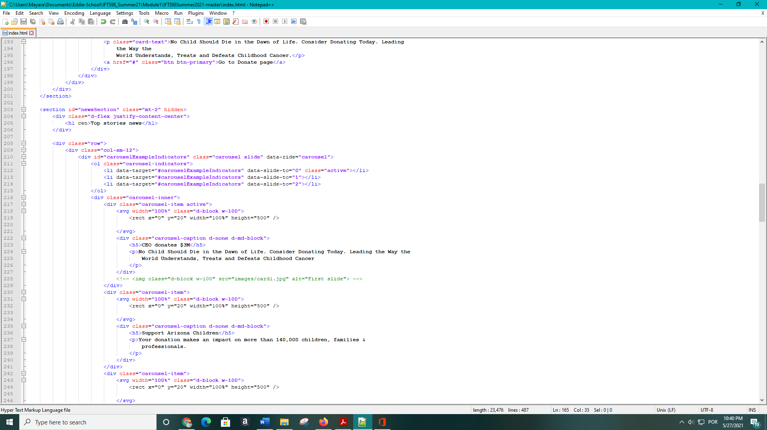

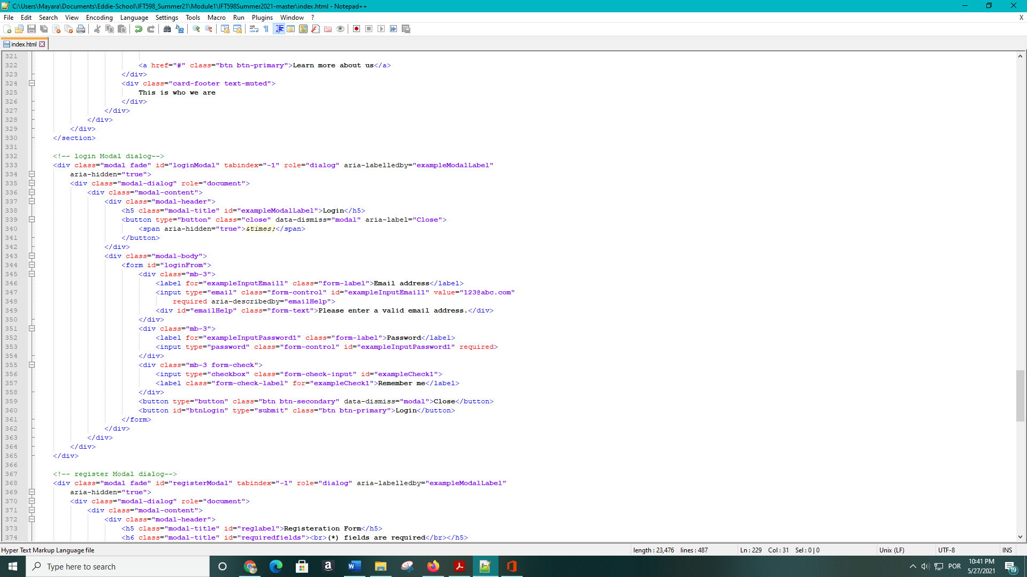

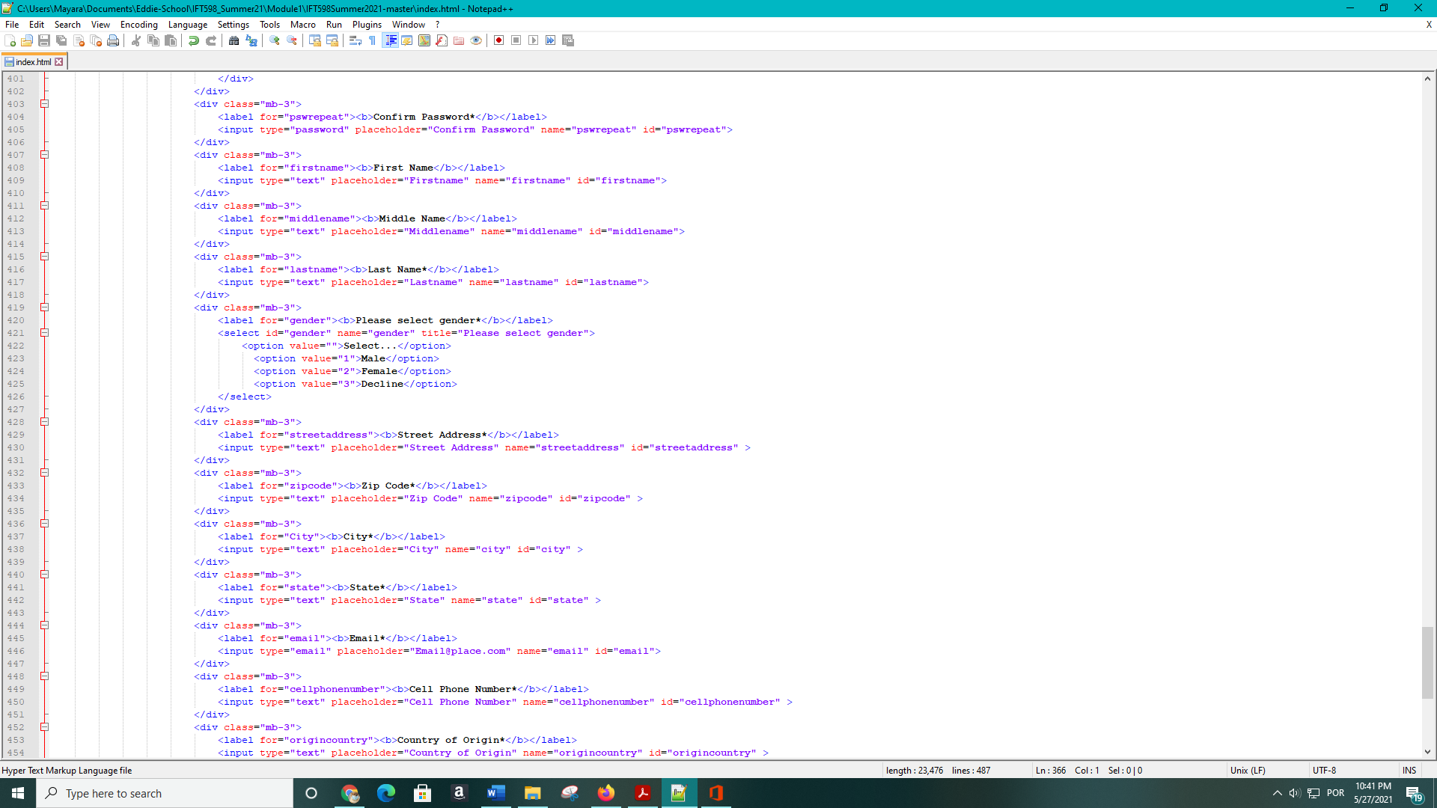

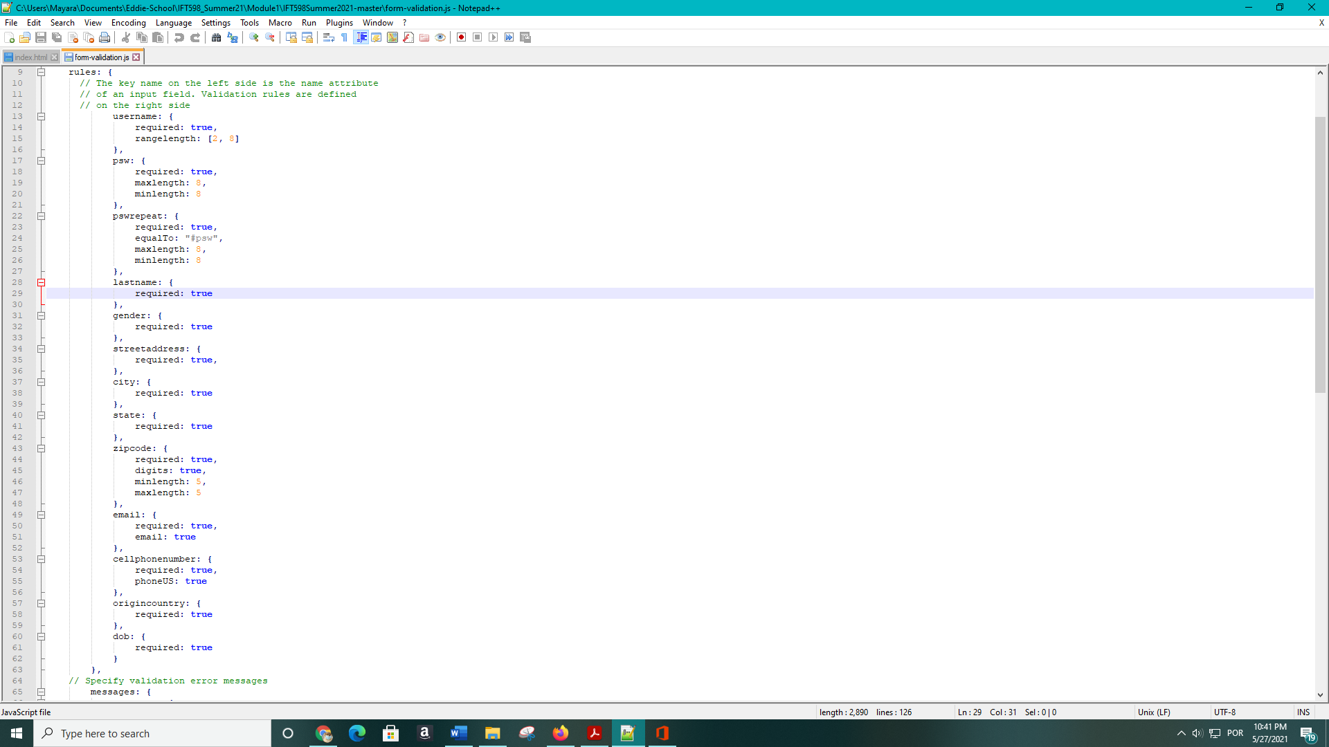

**User Manual**

1. First when user double clicks the index.html.

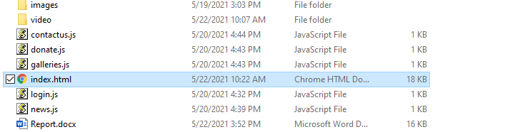

1. The login page will pop up to ask user to enter email and password. Both fields are required. You can put any correctly formatted email address, and any password.

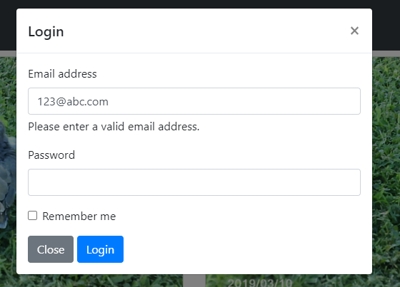

3. Click login button

4. You can click menus to go to each section. Like Donate, Galleries, News, Contact Us, etc.

5. If you click News menu and go to News page, then the page shows like below.

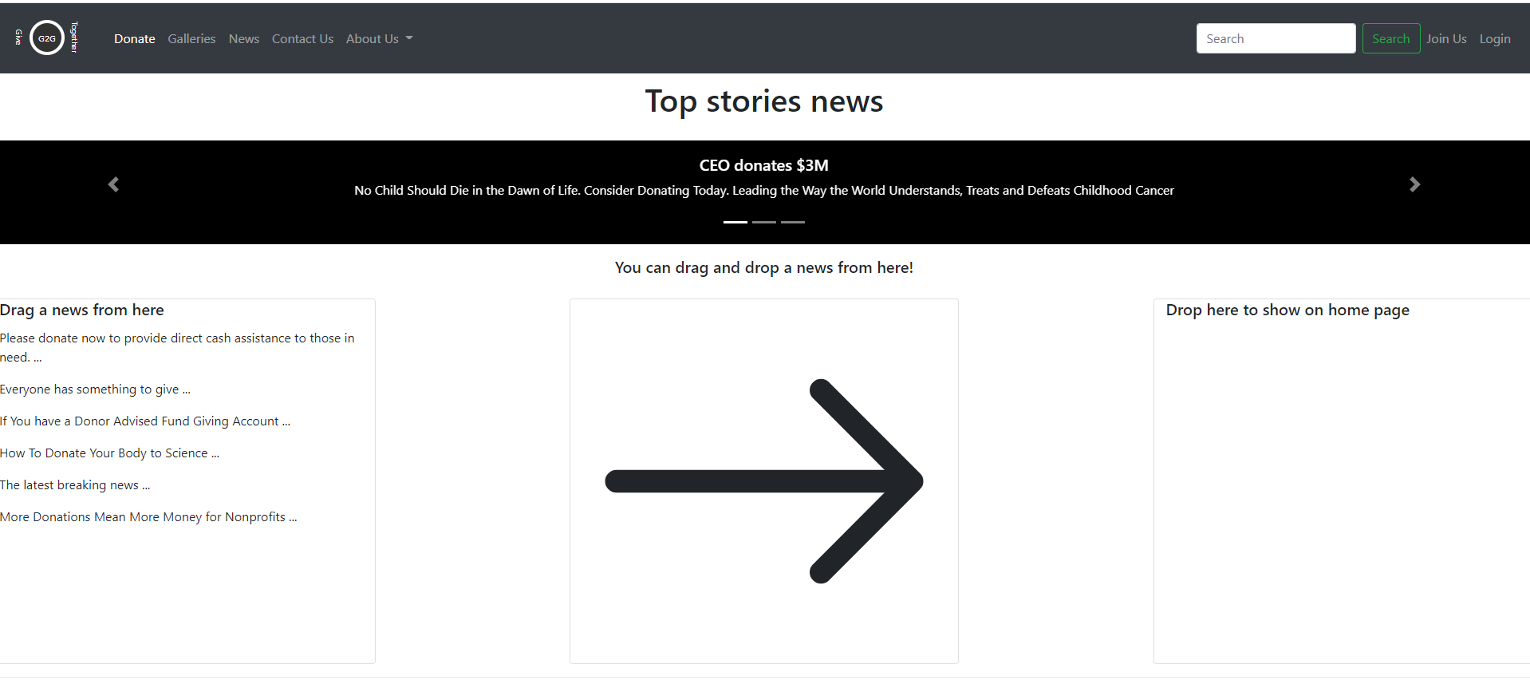

5.1. You can click both left and right arrows on the slideshow to cycle through the news.

5.2. You can drag news from left section and drop it to the right section.



6. If you click Contact Us page, you will see a video.

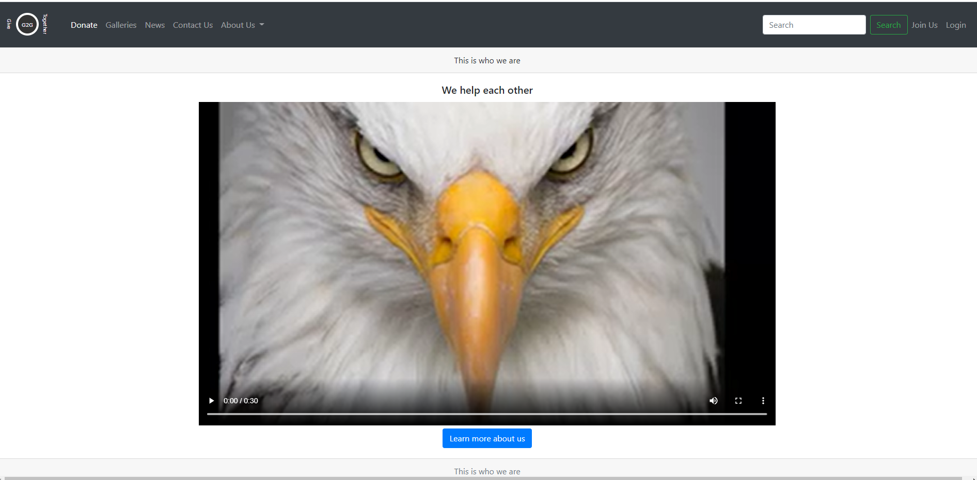

6.1 you can click start button to start watching the video.

7. On the donation page you may play a video by clicking on the play button. 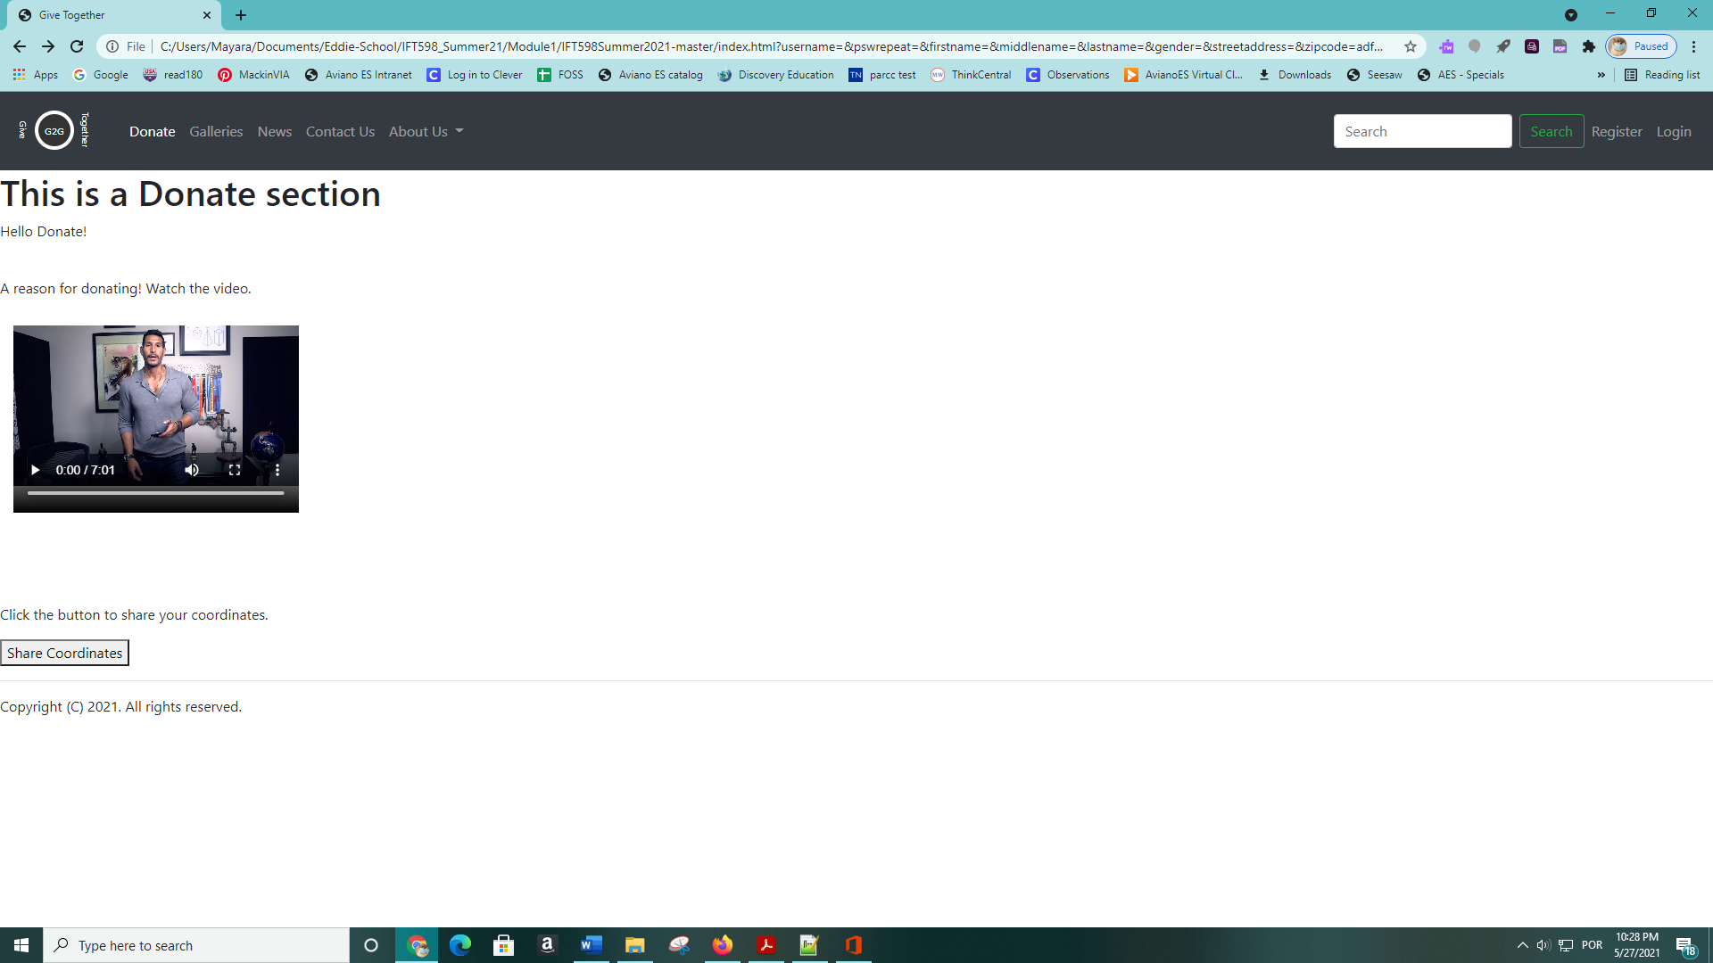

8. Also on the donation page is a place to see and share the geolocation of the observer by clicking the share coordinates button under the video.



9. The Join Us button will bring you to the registration form. Where all required fields are denoted by an asterisks and are validated in order to maintain proper information on the form. A submit button will display at the bottom to submit the form for registration.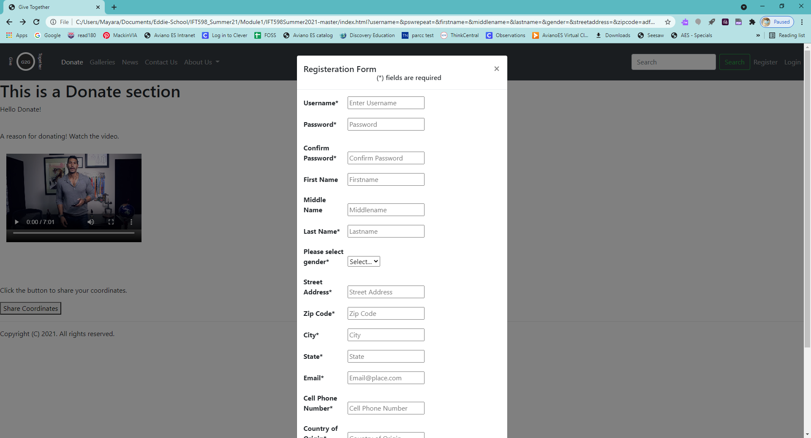

**Yuan’s Conclusion:**

I think jQuery is a very good JavaScript library, it’s very convenient to include it into your project. It helps us a lot for selecting an element and applying CSS to it. jQuery CDN is a very good way to include jQuery to your project, you don’t need to download any jQuery library locally.

I have learned html5 new features, like drag-and-drop, SVG, and video features. I first thought I had to heavily program drag-and-drop features, but the new feature makes it super easy. You just need to mark your source element draggable and tell jQuery where the target is, then transfer the data between them. The challenge I faced is that I forgot to assign the id to my target element, and this made the drop part break. Then I had to debug the code and understand the error messages.

I also learned html5 validation feature. Now with the feature, it is very easy to place some restrictions on your html elements. For example, when you want the user to only enter a correctly formatted email address, you don’t have to write code or regular expression to handle it, instead just place a type=”email” attribute to the input element, then the browser will do the validation for you.

Finally, the improvement I think we need is to find a good way to separate the html code. Right now, all the html code is in one html page. Me and my partner are working on the same page, we have to carefully avoid stepping on each other. If we can separate the html into different files, that will be great.

**Edward’s Conclusion:**

I agree with all that Yuan is saying in his conclusion. The jquery is a robust javascript with a lot of support that helped during this project. I have not had a chance to work with a lot of jquery in a school environment before and I found it to be easily understood and at a beginners level of understanding. While working on the validation part of the registration form I was able to use a lot of jquery and obtain the desired results.

I enjoyed learning about bootstrap and its different features that worked alongside the html5. This allowed me to focus on being able to obtain a standardized form while working with a partner. The validation used for the password was easily understood and I was able to portray the requirements to the user.

As I continue in this class I am excited to be working with a partner for the experience and his expertise. I know at one point we needed to work together on a call to get through some troubleshooting that had me stumped. The modal feature of bootstrap in html5 was not working correctly with jquery that I had written. After sometime Yuan was able to determine that the cdn was not working correctly and I was able to rebuild the registration form in the page.

Finally, I believe this to be a great start to this class and I look forward to continuing with my partner.