User Manual
VC8000D
HW Decoder OpenMAX IL Component
Version 2.1.0

Copyright Information
This document contains proprietary information of VeriSilicon, Inc. The information contained herein is not to be used by or disclosed to third parties without the express written permission of an officer of VeriSilicon, Inc. Nothing, whether in whole or in part, within this manual can be reproduced, duplicated, copied, changed, or disposed of in any form or by any means without prior written consent by VeriSilicon, Inc.

This document describes the HW Decoder OpenMAX IL User Manual and remains the official reference source for all revisions/releases of this product until rescinded by an update.

VeriSilicon, Inc. reserves the right to make changes to any products herein at any time without notice at any time for any reason, including but not limited to improvement of the product relating hereto. VeriSilicon, Inc., does not assume any obligation, responsibility, or liability arising out of the application or use of any product described herein, except for reasonable, careful and normal uses, or as expressly agreed to in writing by VeriSilicon, Inc.; nor does the purchase or use of a product from VeriSilicon convey a license under any patent rights, copyrights, trademark rights, or any other of the intellectual property rights of VeriSilicon, Inc. or third parties.

VeriSilicon Confidential. Copyright © 2004-2019 by VeriSilicon Inc. All rights reserved.

TRADEMARK ACKNOWLEDGMENT
VeriSilicon, the VeriSilicon logo design, and ZSP are trademarks or registered trademarks of VeriSilicon, Inc. All other brand and product names may be trademarks of their respective companies.

For our current distributors, sales offices, design resource centers, and product information, view our web page located at http://www.verisilicon.com.

For our technical support, email hantro_support@verisilicon.com.

Glossary
1080p High Definition resolution of 1920x1080 progressive video
API Application Programming Interface
AVS Audio Video Coding Standard of China
AVC Advanced Video Coding, same as H.264
BPP Bits Per Pixel
DivX DivX is a brand name of products created by DivX, Inc. The DivX codec uses MPEG-4 compression
EOS End of Sequence
H.264 Video Coding Standard (ITU-T)
H.263 Video Coding Standard (ITU-T)
HD High Definition
HEVC High Efficiency Video Coding, a video coding standard (JCT-VC)
HW Hardware
IL OpenMAX Integration Layer
JPEG Joint Photographic Experts Group, also a common term for still images
MJPEG Motion JPEG
MPEG-2 Motion Picture Experts Group standard 2 (ISO/IEC 13818-2)
MPEG-4 Motion Picture Experts Group standard 4 (ISO / IEC 14496-2)
NAL Network Abstraction Layer
OMX OpenMAX Multimedia interface developed and maintained by the Khronos group
OS Operating System
OSAL Operating System Abstraction Layer, a part of OpenMAX conformance testing package
RGB A color space representation, where red, green and blue light are added together in various ways to reproduce a broad array of colors
RV Real Video, a video coding specification developed by Real Media Inc.
Semi-planar A YCbCr storage format, where the luminance samples form one plane in memory, and the pixel by pixel interleaved Cb and Cr samples form another
VC-1 A Microsoft SMPTE 421M video codec
VP6 On2 Truemotion VP6 video coding standard
VP8 Compressed video data format created by On2 Technologies
VP9 Compressed video data format created by Google
WebP VP8 based still image compression
YCbCr A color space representation, where color and intensity data are in separate components: Y contains the black and white image (luminance), Cb and Cr the color information (chrominance)
YCbCr 4:2:0 YCbCr sampling format, where Cb and Cr components are sub-sampled by two both horizontally and vertically
YCbCr 4:2:2 YCbCr sampling format, where Cb and Cr components are sub-sampled by two horizontally
YUV Commonly used alternative for YCbCr

Table of Content
Copyright Information 2
Glossary 3
Table of Content 4
1 Introduction 6
2 API Version History 7
3 Features 8
3.1 OpenMAX IL API Functionality 8
3.2 OpenMAX IL Features 9
3.3 Decoder Features 9
3.4 Input Buffers 10
3.5 Output Buffers 11
4 Video Frame Storage Format 12
4.1 YCbCr 4:2:0 Semi-Planar Format 12
4.2 Tiled 4x4 Format 12
5 Interface Functions 14
5.1 HantroHwDecOmx_video_constructor 14
5.2 HantroHwDecOmx_image_constructor 14
5.3 GetComponentVersion 14
5.4 SendCommand 15
5.5 GetParameter 15
5.6 SetParameter 16
5.7 GetConfig 18
5.8 SetConfig 19
5.9 GetExtensionIndex 21
5.10 GetState 21
5.11 ComponentTunnelRequest 21
5.12 UseBuffer 22
5.13 AllocateBuffer 22
5.14 FreeBuffer 23
5.15 FillThisBuffer 23
5.16 EmptyThisBuffer 23
5.17 SetCallbacks 24
5.18 ComponentDeInit 24
6 Usage 25
6.1 Component creation 25
6.2 Decoding 26
References 27
Appendix 28
1.1 Buffer Flags 28
1.1.1 Second View Frame Flag 28
1.1.2 VP8 Temporal Layer Frame Flags 28
1.2 Enumerations 28
1.2.1 OMX_INDEXVSITYPE 28
1.2.2 OMX_VIDEO_CODINGVSITYPE 28
1.2.3 OMX_COLOR_FORMATVSITYPE 29
1.2.4 OMX_VIDEO_HEVCPROFILETYPE 29
1.2.5 OMX_VIDEO_HEVCLEVELTYPE 29
1.2.6 OMX_VIDEO_VP9PROFILETYPE 30
1.2.7 OMX_VIDEO_G2PIXELFORMAT 30
1.3 Data Structures 30
1.3.1 OMX_VIDEO_PARAM_MVCSTREAMTYPE 30
1.3.2 OMX_VIDEO_CONFIG_VP8TEMPORALLAYERTYPE 30
1.3.3 OMX_VIDEO_PARAM_HEVCTYPE 31
1.3.4 OMX_VIDEO_PARAM_VP9TYPE 31
1.3.5 OMX_VIDEO_PARAM_CONFIGTYPE 31
1.3.6 ALLOC_PRIVATE 32
1.3.7 RFC_TABLE 32
1.3.8 OUTPUT_BUFFER_PRIVATE 32

Introduction
This document presents the OpenMAX Integration Layer Application Programming Interface (API) of the VC8000D hardware based decoders. The OpenMAX IL API [1] is a standardized multimedia component interface that allows easier and faster integration of multimedia components into a multimedia system. The interface itself is independent of the execution environment and operating system.

The decoders are able to decode H.264 [2]ISO/IEC FDIS 14496-10: Information technology – Coding of audio-visual objects – Part 10: Advanced Video Coding., H.263 [3], MPEG-2 [4], MPEG-4 [5], VC-1 [6], SMPTE Standard for Television: VC-1 Compressed Video Bitstream Format and Decoding Process, SMPTE 421M (2006).Real0/G1),0/G1)0/G1), n G1)n G1),n G2) annG2) standards video streams, JPEG standard [8] still images and G1) still images. The decoders conform to the H.264 Baseline, Main and High profile, H.263 Baseline profile, MPEG-2 Main profile, MPEG-4 Simple and Advanced profile, VC-1 Simple, Main and Advanced profile, RV 8, 9 and 10, DivX 3, 4, 5 and 6, VP6 Simple and Advanced profiles, AVS Jizhun profile, VP8 Main Profile, HEVC Main and Main10 Profile, VP9 Profile 0 and can decode streams up to a maximum picture size of 4k x 4k. The overall performance and capabilities of the decoders is system dependent. Note that formats and features that are presented depend on the configuration that Licensee has chosen for the Decoder Hardware Product and only formats that are applicable to chosen configuration are supported.

The API is developed on Linux environment and the implementation uses an Operating System Abstraction Layer (OSAL) to isolate all OS specific functionality. The Bellagio open-source OMX IL Core for Linux (omxil.sourceforge.net) is used for development and testing purposes but the design allows flexible integration into other OMX Core systems as well.

The usage of the API is described in chapter 3. Chapter 4 gives guidelines to video frame storage formats. The detailed API function interfaces are introduced in chapter 5. References are presented in the end of the document.

In the document all functions, parameters, data types and code are described in Courier new (syntax style) font. Notes and filenames are written in italic expression.

This document assumes that the reader understands the fundamentals of C-language and the AVS, H.264, H.263, HEVC, MPEG-2, MPEG-4, VC-1, RV, DivX, VP6, VP8, VP9 and JPEG standards.

API Version History
Table 1 describes the released API versions, any changes introduced.

Table 1. API version history
API version | Changes/Comments
1.0 | Original version according to OMX IL specification v1.1.2
1.1 | Hardware configuration limitations explained
1.2 | G1 included
1.3 | Added AVS format, VP8 and WebP extension support
1.4 | Add MJPEG support, minor updates
1.5 | Rename custom coding types. Add VSI extension index to table 2.
1.6 | Update supported OMX IL indices and extensions. Add supported color formats for JPEG.
2.0 | Add G2 decoder support (HEVC and VP9)
2.0.4 | Add G2 tiled format and appendix for VSI vendor extension
2.0.6 | Update G2 features and VSI vendor extension appendix
2.0.9 | Update G1 features and VSI vendor extension appendix. Remove unsupported buffer format. Notes for externally allocated output buffer usage
2.0.23 | Support adaptive stream playback  Support SEEKing(OMX_CommandFlush/StateChange(idle->exec->idle))  Support Security playback  Support Presentation Time Stamp
2.1.0 | Support all VC8000D formats, all formats can be built together

Features
The OpenMAX IL API for VC8000D decoder is implemented in Linux environment. The Bellagio OMX IL Core for Linux is used for development and testing purposes. The OMX API is implemented on top of the VC8000D decoder AVS, H.264, H.263, HEVC, MPEG-2, MPEG-4, VC-1, RV, DivX, VP6, VP8, VP9, JPEG, WebP and post-processing APIs. The OMX API uses the specific OSAL functions to isolate all OS specific functionality. Figure 1 describes the blocks of the OpenMAX video decoder system.

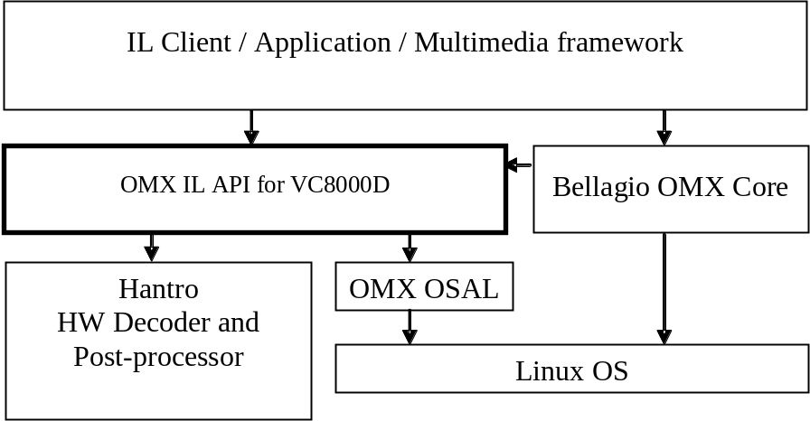

Figure 1. OMX API layer
Integration to other environments requires the OMX Core and OMX OSAL parts to be implemented for the target environment. The OMX Core handles the component library loading, component creation and tunnel setup as defined in the OMX IL Specification. The OMX OSAL is needed for OS independent implementation of memory allocation, thread and mutex handling.

OpenMAX IL API Functionality
The OpenMAX IL API is a standardized interface for multimedia components. The interface specifies the functions and their usage for controlling a multimedia object. The data flow from one component to other can be done in three different ways: non-tunneled, tunneled or proprietary communication. The API functions should be non-blocking which implies a threaded implementation of the component. The non-blocking commands must be queued to the component. A set of callback functions is used to inform the IL client (= the user of the IL components) of the component events.

The OMX Core is responsible of loading the component library and creating the component. The decoder API has an initialization function that is called by the OMX Core when creating a component instance.

The VC8000D decoder has one input ports and one output port. The first input port format is for compressed AVS, H.264, H.263, HEVC, MJPEG, MPEG-2, MPEG-4, VC-1, RV, DivX, VP6, VP8, VP9, JPEG or WebP stream and the output port format is uncompressed YUV/RGB video data. For post-processor input the port format is uncompressed YUV video data.

The decoder control software runs in its own thread. The OMX API functions queue the data to be handled in the decoder thread. The thread processes the commands, handles the decoding and issues callbacks and events to the IL client.

The VC8000D decoder supports non-tunneled and tunneled data flow. The component ports are described in Figure 2. Port 0 is used for video/image stream input. The supported parameters and configurations are listed under the interface functions in Chapter 5.

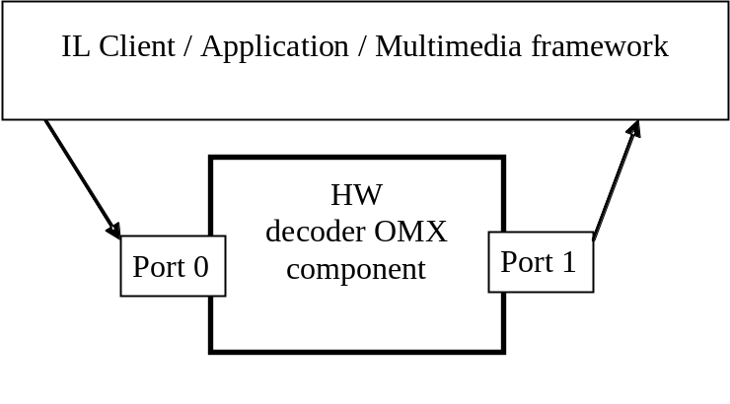
Figure 2. OMX component ports

OpenMAX IL Features
The VC8000D decoder OMX API implementation is done according to OMX IL API version 1.1.2 [1].

The implementation supports OMX IL base profile and tunneling.

The VC8000D decoder consists of two OMX components: video decoder component and image decoder component. The OMX names for these components are:

- OMX.hantro.VC8000D.video.decoder
- OMX.hantro.VC8000D.image.decoder

- Decoder Features
The VC8000D decoder has the following features:
- H.264 baseline profile, levels 1-4.1 decoding
- H.264 main and high profile, levels 1-5.1 decoding

  - Byte stream input
  - NAL unit input
- H.263 profile 0, levels 10-70 decoding

MPEG-2 main profile, low medium and high levels

- MPEG-4 simple and advanced simple profile, levels 0-5 decoding
- RV 8, 9 and 10 decoding
- DivX 3, 4, 5 and 6 decoding

- VC-1 simple and main profile, levels: low, medium and high, advanced profile, levels 0-3 decoding
  - RCV stream input

- RV 8, 9 and 10 decoding
- VP6.0, 6.1, 6.2, Simple and Advanced Profiles decoding
- VP8 decoding
- AVS Jizhun profile decoding
- WebP decoding
- JPEG baseline decoding
- HEVC Main and Main10 Profile decoding
- VP9 Profile 0 and Profile 2 decoding

Video post-processing features

  - Frame cropping

  - Frame scaling
  - Frame conversion from Tile4x4 to NV12

The post-processing features can be used in pipeline with the decoder. The post-processing features can also be used as stand-alone.

Input Buffers
For video frame input buffers the decoders support following compression formats:
- OMX_VIDEO_CodingAVC
- OMX_VIDEO_CodingMPEG2
- OMX_VIDEO_CodingMPEG4
- OMX_VIDEO_CodingH263
- OMX_VIDEO_CodingWMV
- OMX_VIDEO_CodingSORENSON
- OMX_VIDEO_CodingRV
- OMX_VIDEO_CodingDIVX
- OMX_VIDEO_CodingDIVX3
- OMX_VIDEO_CodingVP6
- OMX_VIDEO_CodingAVS
- OMX_VIDEO_CodingVP8
- OMX_VIDEO_CodingMJPEG
- OMX_VIDEO_CodingHEVC
- OMX_VIDEO_CodingVP9
- OMX_IMAGE_CodingJPEG
- OMX_IMAGE_CodingWebP

The decoder supports following payload formats as documented in OMX IL Specification chapter 2.1.12:
- Several complete decoding units/frames per buffer
- One complete decoding unit/frame per buffer

For H.264 NAL unit stream, VC-1, VP8 and VP9 stream only payload format 2 is supported. This is due to the fact that those streams don’t contain start codes that identify the start of a decoding unit.

For HEVC stream, only payload format 2 is supported.

The input buffer format and size indicate which payload format is used. For compressed input formats, when the input buffer is completely filled it is assumed to be of payload format 1. For uncompressed input formats, when the buffer size is not a multiple of frame size it is assumed to be of payload format 2.

When choosing the size of the input buffer it is recommended to use a size large enough to fit the biggest decoding unit, or the size of one complete uncompressed input frame.

Output Buffers
When initializing the decoder it is impossible to know the dimensions of the output frame. The decoding begins with the stream headers and once they are decoded the decoder dispatches a PortSettingsChanged-event to indicate that the output port dimensions are known.

When the client receives the PortSettingsChanged-event it should first disable the output port of the decoder. Then it should query the size of the output buffer from the decoder’s output port definition by using the GetParameter function. Finally the client should enable the output port and re-allocate the output buffers with the correct buffer size.

When the decoder dispatches a PortSettingsChanged-event to indicate that the output port dimensions and required number of output buffers (nBufferCountMin) are known, the client shall allocate at least nBufferCountMin number of output buffers. If additional buffers are allocated, the client sets the nBufferCountActual parameter accordingly. The client shall send nBufferCountActual number of buffers to the component using FillThisBuffer call and wait for FillBufferDone callback.

For output data the following color formats are supported:

- OMX_COLOR_FormatYUV420PackedSemiPlanar
- OMX_COLOR_FormatYUV420SemiPlanar4x4Tiled
- OMX_COLOR_FormatYUV420SemiPlanarP010 (when bit depth is 10)

For output buffers the only supported payload format is one complete frame per buffer. This means that the decoder stores each output frame in separate output buffer.

Video Frame Storage Format
This chapter describes the different output picture storage formats supported by the decoder and post-processor.

YCbCr 4:2:0 Semi-Planar Format
In semi-planar YCbCr 4:2:0 format the luminance samples form one plane in memory, and chrominance samples form another. The luminance and chrominance planes must be stored in a linear and contiguous memory block as presented in Figure 4. The luminance pixels are stored in raster-scan order Y₀Y₁Y₂Y₃Y₄…. The interleaved chrominance CbCr samples are stored in raster-scan order in memory as Cb₀Cr₀Cb₁Cr₁Cb₂Cr₂Cb₃....

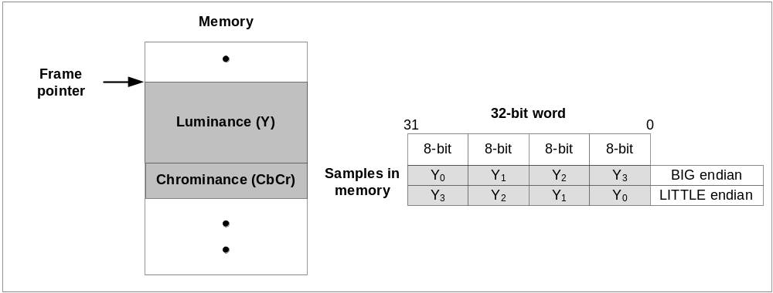
Figure 4. YCbCr 4:2:0 semi-planar format external memory usage.
The YCbCr 4:2:0 semi-planar format is supported as an output format for the post-processor. In this format each pixel takes 12 bits of memory. As the chrominance components are interleaved, the bus load caused by this format can be slightly lower than with the planar format due to the reduced amount of non-sequential memory addressing.

Tiled 4x4 Format
The output picture of the decoder is in semi-planar YCbCr 4:2:0 4x4 tiled format, i.e. luminance data forms one plane in memory, and chrominance data forms another. The distinction from raster scan format is that the output picture is grouped into tiles, which are then stored linearly and contiguously in the memory. The chrominance tiles have to be stored right after the luminance tiles in external memory as shown in Figure 6.

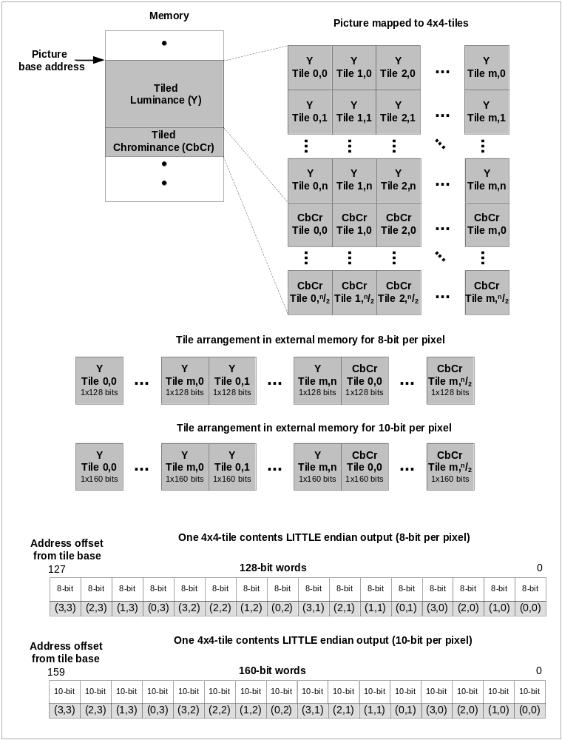
Figure 6. Tiled 4x4 format external memory usage

Interface Functions
This chapter describes the interface functions and parameters of the OpenMAX IL API as implemented for the VC8000D decoders. The complete documentation of the OMX API functions and their usage can be found in the OpenMAX IL Specification [1]. The Initialization function is called from the OMX Core when creating a component instance and after that the OMX defined macros (for example OMX_GetComponentVersion) should be used for invoking all the other functions.

HantroHwDecOmx_video_constructor
Syntax
OMX_ERRORTYPE HantroHwDecOmx_video_constructor(
OMX_OUT OMX_COMPONENTTYPE* comp,
OMX_IN OMX_STRING name)
Purpose
This function will allocate and initialize the private structures of a component instance. The handle pointing to OMX_COMPONENTTYPE structure should be allocated by the OMX Core before calling this function.

HantroHwDecOmx_image_constructor
Syntax
OMX_ERRORTYPE HantroHwDecOmx_image_constructor(
OMX_OUT OMX_COMPONENTTYPE* comp,
OMX_IN OMX_STRING name)
Purpose
This function will allocate and initialize the private structures of a component instance. The handle pointing to OMX_COMPONENTTYPE structure should be allocated by the OMX Core before calling this function.

GetComponentVersion
Syntax
OMX_ERRORTYPE GetComponentVersion(
OMX_IN OMX_HANDLETYPE hComponent,
OMX_OUT OMX_STRING pComponentName,
OMX_OUT OMX_VERSIONTYPE* pComponentVersion,
OMX_OUT OMX_VERSIONTYPE* pSpecVersion,
OMX_OUT OMX_UUIDTYPE* pComponentUUID)
Purpose
This function will return version information about the component.

The decoder will implement the referenced IL Specification version [1].

SendCommand
Syntax
OMX_ERRORTYPE SendCommand(
OMX_IN OMX_HANDLETYPE hComponent,
OMX_IN OMX_COMMANDTYPE Cmd,
OMX_IN OMX_U32 nParam1,
OMX_IN OMX_PTR pCmdData)
Purpose
Send a command to the component. This call is a non-blocking call. The component should check the parameters and then queue the command to the component thread to be executed. The component thread shall send the EventHandler() callback at the conclusion of the command.
Description
Following commands are supported:
- OMX_CommandStateSet
  - OMX_StateLoaded
  - OMX_StateIdle
  - OMX_StateExecuting
  - OMX_StatePause
  - OMX_StateInvalid
- OMX_CommandFlush
- OMX_CommandPortDisable
- OMX_CommandPortEnable
- OMX_CommandMarkBuffer

GetParameter
Syntax
OMX_ERRORTYPE GetParameter(
OMX_IN OMX_HANDLETYPE hComponent,
OMX_IN OMX_INDEXTYPE nParamIndex,
OMX_INOUT OMX_PTR ComponentParameterStructure)
Purpose
The function will get one of the current parameter settings from the component. The nParamIndex parameter is used to indicate which structure is being requested from the component. The application shall allocate the correct structure and shall fill in the structure size and version information before invoking this macro. When the parameter applies to a port, the caller shall fill in the appropriate nPortIndex value indicating the port on which the parameter applies. If the component has not had any settings changed, then the component should return a set of valid DEFAULT parameters for the component.

Some parameters may be disabled if not supported by the decoder HW, see Chapter 3 for more information.
Description
Table 2. Supported parameter indexes for GetParameter in video domain
Parameter index, port and parameter name | Parameter structure and description
OMX_IndexParamVideoInit | OMX_PORT_PARAM_TYPE
OMX_IndexParamCompBufferSupplier | OMX_PARAM_BUFFERSUPPLIERTYPE
OMX_IndexParamPortDefinition | OMX_PARAM_PORTDEFINITIONTYPE
OMX_IndexParamVideoPortFormat | OMX_VIDEO_PARAM_PORTFORMATTYPE
OMX_IndexParamVideoAvc | OMX_VIDEO_PARAM_AVCTYPE
OMX_IndexParamVideoMpeg4 | OMX_VIDEO_PARAM_MPEG4TYPE
OMX_IndexParamVideoMpeg2 | OMX_VIDEO_PARAM_MPEG2TYPE
OMX_IndexParamVideoH263 | OMX_VIDEO_PARAM_H263TYPE
OMX_IndexParamVideoWmv | OMX_VIDEO_PARAM_WMVTYPE
OMX_IndexParamVideoRv | OMX_VIDEO_PARAM_RVTYPE
OMX_IndexParamVp8 | OMX_VIDEO_PARAM_VP8TYPE
OMX_IndexParamVideoHevc | OMX_VIDEO_PARAM_HEVCTYPE  VSI vendor extension for HEVC format
OMX_IndexParamVideoVp9 | OMX_VIDEO_PARAM_VP9TYPE  VSI vendor extension for VP9 format
OMX_IndexParamVideoProfileLevelCurrent | OMX_VIDEO_PARAM_PROFILELEVELTYPE
OMX_IndexParamVideoProfileLevelQuerySupported | OMX_VIDEO_PARAM_PROFILELEVELTYPE
OMX_IndexParamCommonDeblocking | OMX_PARAM_DEBLOCKINGTYPE
OMX_IndexParamStandardComponentRole | OMX_PARAM_COMPONENTROLETYPE
OMX_IndexParamPriorityMgmt | OMX_PRIORITYMGMTTYPE
OMX_IndexParamVideoMvcStream | OMX_VIDEO_PARAM_MVCSTREAMTYPE  VSI vendor extension for configuring H.264 MVC mode
OMX_IndexParamVideoConfig | OMX_VIDEO_PARAM_CONFIGTYPE  VSI vendor extension for configuring VC8000D decoder

Table 3. Supported parameter indexes for GetParameter in image domain
Parameter index, port and parameter name | Parameter structure and description
OMX_IndexParamImageInit | OMX_PORT_PARAM_TYPE
OMX_IndexParamCompBufferSupplier | OMX_PARAM_BUFFERSUPPLIERTYPE
OMX_IndexParamPortDefinition | OMX_PARAM_PORTDEFINITIONTYPE
OMX_IndexParamImagePortFormat | OMX_IMAGE_PARAM_PORTFORMATTYPE
OMX_IndexParamStandardComponentRole | OMX_PARAM_COMPONENTROLETYPE
OMX_IndexParamPriorityMgmt | OMX_PRIORITYMGMTTYPE

SetParameter
Syntax
OMX_ERRORTYPE SetParameter(
OMX_IN OMX_HANDLETYPE hComponent,
OMX_IN OMX_INDEXTYPE nIndex,
OMX_IN OMX_PTR ComponentParameterStructure)
Purpose
The function will send an initialization parameter structure to a component. Each structure shall be sent one at a time, in a separate invocation of the macro. This macro can only be invoked when the component is in the OMX_LoadedState state, or the port is disabled (when the parameter applies to a port). The nParamIndex parameter is used to indicate which structure is being passed to the component. The application shall allocate the correct structure and shall fill in the structure size and version information (as well as the actual data) before invoking this macro. The application is free to dispose of this structure after the call as the component is required to copy any data it shall retain.

Some parameters may be disabled if not supported by the decoder HW, see Chapter 3 for more information.
Description
Table 4. Supported parameter indexes for SetParameter in video domain
Parameter index, port and parameter name |  | Parameter structure and description
OMX_IndexParamVideoInit |  | OMX_PORT_PARAM_TYPE
OMX_IndexParamCompBufferSupplier |  | OMX_PARAM_BUFFERSUPPLIERTYPE
OMX_IndexParamPortDefinition |  | OMX_PARAM_PORTDEFINITIONTYPE
port=0 | bFlagErrorConcealment | Enable/disable decoder error concealment
port=0 | eCompressionFormat | Defines the input stream type
port=0 | nFrameWidth, nFrameHeight | Defines the post-processor input frame resolution
port=0 | eColorFormat | Defines the post-processor input frame format
port=0 | eColorFormat | OMX_COLOR_FormatYUV420PackedPlanar
port=0 | eColorFormat | OMX_COLOR_FormatYUV420PackedSemiPlanar
port=0 | eColorFormat | OMX_COLOR_FormatYCbYCr
port=0 | eColorFormat | OMX_COLOR_FormatYCrYCb
port=0 | eColorFormat | OMX_COLOR_FormatCbYCrY
port=0 | eColorFormat | OMX_COLOR_FormatCrYCbY
port=1 | nFrameWidth, nFrameHeight | Defines the post-processor output frame resolution
port=1 | eColorFormat | OMX_COLOR_FormatYUV420PackedSemiPlanar
port=1 | eColorFormat | OMX_COLOR_FormatYCbYCr
port=1 | eColorFormat | OMX_COLOR_FormatCbYCrY
port=1 | eColorFormat | OMX_COLOR_FormatCrYCbY
port=1 | eColorFormat | OMX_COLOR_FormatCrYCbY
port=1 | eColorFormat | OMX_COLOR_Format16bitARGB1555
port=1 | eColorFormat | OMX_COLOR_Format16bitARGB4444
port=1 | eColorFormat | OMX_COLOR_Format16bitRGB565
port=1 | eColorFormat | OMX_COLOR_Format16bitBGR565
port=1 | eColorFormat | OMX_COLOR_Format25bitARGB1888
port=1 | eColorFormat | OMX_COLOR_Format32bitARGB8888
port=1 | eColorFormat | OMX_COLOR_Format32bitBGRA8888
port=2 | nFrameWidth, nFrameHeight | Defines the alpha-blending mask input resolution
OMX_IndexParamVideoPortFormat |  | OMX_VIDEO_PARAM_PORTFORMATTYPE
OMX_IndexParamVideoAvc |  | OMX_VIDEO_PARAM_AVCTYPE
OMX_IndexParamVideoMpeg4 |  | OMX_VIDEO_PARAM_MPEG4TYPE
OMX_IndexParamVideoMpeg2 |  | OMX_VIDEO_PARAM_MPEG2TYPE
OMX_IndexParamVideoH263 |  | OMX_VIDEO_PARAM_H263TYPE
OMX_IndexParamVideoWmv |  | OMX_VIDEO_PARAM_WMVTYPE
OMX_IndexParamVideoRv |  | OMX_VIDEO_PARAM_RVTYPE
OMX_IndexParamVp8 |  | OMX_VIDEO_PARAM_VP8TYPE
OMX_IndexParamCommonDeblocking |  | OMX_PARAM_DEBLOCKINGTYPE
port=0 | bDeblocking | Enable/disable MPEG-4/H.263 deblocking filter
OMX_IndexParamCommonDithering |  | OMX_PARAM_DITHERTYPE
OMX_IndexParamStandardComponentRole |  | OMX_PARAM_COMPONENTROLETYPE
OMX_IndexParamPriorityMgmt |  | OMX_PRIORITYMGMTTYPE
OMX_IndexParamVideoMvcStream |  | OMX_VIDEO_PARAM_MVCSTREAMTYPE  VSI vendor extension for configuring H.264 MVC mode
OMX_IndexParamVideoConfig |  | OMX_VIDEO_PARAM_CONFIGTYPE  VSI vendor extension for configuring VC8000D decoder

Table 5. Supported parameter indexes for SetParameter in image domain
Parameter index, port and parameter name |  | Parameter structure and description
OMX_IndexParamImageInit |  | OMX_PORT_PARAM_TYPE
OMX_IndexParamCompBufferSupplier |  | OMX_PARAM_BUFFERSUPPLIERTYPE
OMX_IndexParamPortDefinition |  | OMX_PARAM_PORTDEFINITIONTYPE
port=0 | nFrameWidth, nFrameHeight | Defines the post-processor input frame resolution
port=0 | eColorFormat | Defines the post-processor input frame format
port=0 | eColorFormat | OMX_COLOR_FormatYUV420PackedPlanar
port=0 | eColorFormat | OMX_COLOR_FormatYUV420PackedSemiPlanar
port=0 | eColorFormat | OMX_COLOR_FormatYCbYCr
port=0 | eColorFormat | OMX_COLOR_FormatCbYCrY
port=0 | eColorFormat | OMX_COLOR_FormatCrYCbY
port=0 | eColorFormat | OMX_COLOR_FormatCrYCbY
port=1 | nFrameWidth, nFrameHeight | Defines the post-processor output frame resolution
port=1 | eColorFormat | OMX_COLOR_FormatYUV420PackedSemiPlanar
port=1 | eColorFormat | OMX_COLOR_FormatYCbYCr
port=1 | eColorFormat | OMX_COLOR_FormatCbYCrY
port=1 | eColorFormat | OMX_COLOR_FormatCrYCbY
port=1 | eColorFormat | OMX_COLOR_FormatCrYCbY
port=1 | eColorFormat | OMX_COLOR_Format16bitARGB1555
port=1 | eColorFormat | OMX_COLOR_Format16bitARGB4444
port=1 | eColorFormat | OMX_COLOR_Format16bitRGB565
port=1 | eColorFormat | OMX_COLOR_Format16bitBGR565
port=1 | eColorFormat | OMX_COLOR_Format25bitARGB1888
port=1 | eColorFormat | OMX_COLOR_Format32bitARGB8888
port=1 | eColorFormat | OMX_COLOR_Format32bitBGRA8888
port=1 | eColorFormat | OMX_COLOR_FormatL8
port=1 | eColorFormat | OMX_COLOR_FormatYUV422PackedSemiPlanar
port=1 | eColorFormat | OMX_COLOR_FormatYUV411PackedSemiPlanar
port=1 | eColorFormat | OMX_COLOR_FormatYUV440PackedSemiPlanar
port=1 | eColorFormat | OMX_COLOR_FormatYUV444PackedSemiPlanar
OMX_IndexParamCommonDithering |  | OMX_PARAM_DITHERTYPE
OMX_IndexParamImagePortFormat |  | OMX_IMAGE_PARAM_PORTFORMATTYPE
OMX_IndexParamStandardComponentRole |  | OMX_PARAM_COMPONENTROLETYPE
OMX_IndexParamPriorityMgmt |  | OMX_PRIORITYMGMTTYPE

GetConfig
Syntax
OMX_ERRORTYPE GetConfig(
OMX_IN OMX_HANDLETYPE hComponent,
OMX_IN OMX_INDEXTYPE nIndex,
OMX_INOUT OMX_PTR pParam)
Purpose
The function will get one of the configuration structures from a component. This function can be invoked any time after the component has been loaded. The nParamIndex call parameter is used to indicate which structure is being requested from the component. The application shall allocate the correct structure and shall fill in the structure size and version information before invoking this function. If the component has not had this configuration parameter sent before, then the component should return a set of valid DEFAULT values for the component.

NOTE: Current VC8000D decoder post processor doesn’t support features below.
Description
Table 6. Supported parameter indexes for GetConfig in video domain
Parameter index, port and parameter name | Parameter structure and description
OMX_IndexConfigCommonRotate | OMX_CONFIG_ROTATIONTYPE
OMX_IndexConfigCommonMirror | OMX_CONFIG_MIRRORTYPE
OMX_IndexConfigCommonDithering | OMX_CONFIG_DITHERTYPE
OMX_IndexConfigCommonInputCrop | OMX_CONFIG_RECTTYPE
OMX_IndexConfigCommonContrast | OMX_CONFIG_CONTRASTTYPE
OMX_IndexConfigCommonBightness | OMX_CONFIG_BRIGHTNESSTYPE
OMX_IndexConfigCommonSaturation | OMX_CONFIG_SATURATIONTYPE
OMX_IndexConfigCommonPlaneBlend | OMX_CONFIG_PLANEBLENDTYPE
OMX_IndexConfigCommonOutputPosition | OMX_CONFIG_POINTTYPE
OMX_IndexConfigCommonExclusionRect | OMX_CONFIG_RECTTYPE
OMX_IndexConfigCommonOutputCrop | OMX_CONFIG_RECTTYPE
OMX_IndexConfigVideoVp8ReferenceFrameType | OMX_VIDEO_VP8REFERENCEFRAMEINFOTYPE

Table 7. Supported parameter indexes for GetConfig in image domain
Parameter index | Parameter structure
OMX_IndexConfigCommonRotate | OMX_CONFIG_ROTATIONTYPE
OMX_IndexConfigCommonMirror | OMX_CONFIG_MIRRORTYPE
OMX_IndexConfigCommonDithering | OMX_CONFIG_DITHERTYPE
OMX_IndexConfigCommonInputCrop | OMX_CONFIG_RECTTYPE
OMX_IndexConfigCommonContrast | OMX_CONFIG_CONTRASTTYPE
OMX_IndexConfigCommonBrightness | OMX_CONFIG_BRIGHTNESSTYPE
OMX_IndexConfigCommonSaturation | OMX_CONFIG_SATURATIONTYPE
OMX_IndexConfigCommonPlaneBlend | OMX_CONFIG_PLANEBLENDTYPE
OMX_IndexConfigCommonOutputPosition | OMX_CONFIG_POINTTYPE
OMX_IndexConfigCommonExclusionRect | OMX_CONFIG_RECTTYPE

SetConfig
Syntax
OMX_ERRORTYPE SetConfig(
OMX_IN OMX_HANDLETYPE hComponent,
OMX_IN OMX_INDEXTYPE nIndex,
OMX_IN OMX_PTR pParam)
Purpose
The function will send one of the configuration structures to a component. Each structure shall be sent one at a time, each in a separate invocation of the function. This macro can be invoked any time after the component has been loaded. The application shall allocate the correct structure and shall fill in the structure size and version information (as well as the actual data) before invoking this macro. The application is free to dispose of this structure after the call as the component is required to copy any data it shall retain.

NOTE: G2 decoder post processor doesn’t support features below.

Description
Table 8. Supported parameter indexes for SetConfig in video domain
Parameter index |  |  | Parameter structure
OMX_IndexConfigCommonRotate |  |  | OMX_CONFIG_ROTATIONTYPE
port=1 |  | nRotation | Defines the output frame rotation +- 90 degrees
OMX_IndexConfigCommonMirror |  |  | OMX_CONFIG_MIRRORTYPE
port=1 |  | eMirror | Defines the output frame horizontal/vertical mirroring
OMX_IndexConfigCommonInputCrop |  |  | OMX_CONFIG_RECTTYPE
port=1 |  | nTop | Defines the amount of cropped pixels on top edge of the input frame
 |  | nLeft | Defines the amount of cropped pixels on left edge of the input frame
 |  | nWidth | Defines the cropped frame horizontal resolution
 |  | nHeight | Defines the cropped frame vertical resolution
OMX_IndexConfigCommonContrast |  |  | OMX_CONFIG_CONTRASTTYPE
port=1 |  | nContrast | Defines the post-processing contrast adjustment
OMX_IndexConfigCommonBrightness |  |  | OMX_CONFIG_BRIGHTNESSTYPE
port=1 |  | nBrightness | Defines the post-processing brightness adjustment
OMX_IndexConfigCommonPlaneBlend |  |  | OMX_CONFIG_PLANEBLENDTYPE
port=1 |  | nAlpha | Defines the alpha value for output RGB frame
OMX_IndexConfigCommonDithering |  |  | OMX_CONFIG_DITHERTYPE
port=1 | eDither |  | Enable/Disable dithering
OMX_IndexConfigCommonSaturation |  |  | OMX_CONFIG_SATURATIONTYPE
port=1 |  | nSaturation | Defines the post-processing saturation adjustment
OMX_IndexConfigCommonExclusionRect |  |  | OMX_CONFIG_RECTTYPE
port=1 |  | nLeft, nTop, nWidth, nHeight | Defines the output mask position and dimensions
OMX_IndexConfigCommonOutputPosition |  |  | OMX_CONFIG_POINTTYPE
port=2 |  | nX, nY | Defines the alpha-blending mask position

Table 9. Supported parameter indexes for SetConfig in image domain
Parameter index |  |  | Parameter structure
OMX_IndexConfigCommonRotate |  |  | OMX_CONFIG_ROTATIONTYPE
port=1 |  | nRotation | Defines the input frame rotation +- 90 degrees
OMX_IndexConfigCommonMirror |  |  | OMX_CONFIG_MIRRORTYPE
port=1 |  | eMirror | Defines the output frame horizontal/vertical mirroring
OMX_IndexConfigCommonInputCrop |  |  | OMX_CONFIG_RECTTYPE
port=1 |  | nTop | Defines the amount of cropped pixels on top edge of the input frame
 |  | nLeft | Defines the amount of cropped pixels on left edge of the input frame
 |  | nWidth | Defines the cropped frame horizontal resolution
 |  | nHeight | Defines the cropped frame vertical resolution
OMX_IndexConfigCommonContrast |  |  | OMX_CONFIG_CONTRASTTYPE
port=1 |  | nContrast | Defines the post-processing contrast adjustment
OMX_IndexConfigCommonBrightness |  |  | OMX_CONFIG_BRIGHTNESSTYPE
port=1 |  | nBrightness | Defines the post-processing brightness adjustment
OMX_IndexConfigCommonPlaneBlend |  |  | OMX_CONFIG_PLANEBLENDTYPE
port=1 |  | nAlpha | Defines the alpha value for output RGB frame
OMX_IndexConfigCommonDithering |  |  | OMX_CONFIG_DITHERTYPE
port=1 | eDither |  | Enable/Disable dithering
OMX_IndexConfigCommonSaturation |  |  | OMX_CONFIG_SATURATIONTYPE
port=1 |  | nSaturation | Defines the post-processing saturation adjustment
OMX_IndexConfigCommonExclusionRect |  |  | OMX_CONFIG_RECTTYPE
port=1 |  | nLeft, nTop, nWidth, nHeight | Defines the output mask position and dimensions
OMX_IndexConfigCommonOutputPosition |  |  | OMX_CONFIG_POINTTYPE
port=2 |  | nX, nY | Defines the alpha-blending mask position

GetExtensionIndex
Syntax
OMX_ERRORTYPE GetExtensionIndex(
OMX_IN OMX_HANDLETYPE hComponent,
OMX_IN OMX_STRING cParameterName,
OMX_OUT OMX_INDEXTYPE* pIndexType)
Purpose
The function will invoke a component to translate a vendor specific configuration or parameter string into an OMX structure index. There is no requirement for the vendor to support this command for the indexes already found in the OMX_INDEXTYPE enumeration (this is done to save space in small components). The component shall support all vendor supplied extension indexes not found in the master OMX_INDEXTYPE enumeration.

Table 10. Supported extension indices in video domain
Parameter index | Parameter structure
OMX.google.android.index.enableAndroidNativeBuffers | EnableAndroidNativeBuffersParams
OMX.google.android.index.getAndroidNativeBufferUsage | GetAndroidNativeBufferUsageParams
OMX.google.android.index.useAndroidNativeBuffer2 | UseAndroidNativeBuffersParams

NOTE: User is responsible for low level implementation of Android native buffer allocation.

GetState
Syntax
OMX_ERRORTYPE GetState(
OMX_IN OMX_HANDLETYPE hComponent,
OMX_OUT OMX_STATETYPE* pState)
Purpose
The function will invoke the component to get the current state of the component and place the state value into the location pointed to by pState.

ComponentTunnelRequest
Syntax
OMX_ERRORTYPE ComponentTunnelRequest(
OMX_IN OMX_HANDLETYPE hComponent,
OMX_IN OMX_U32 nPort,
OMX_IN OMX_HANDLETYPE hTunneledPort,
OMX_IN OMX_U32 nTunneledPort,
OMX_INOUT OMX_TUNNELSETUPTYPE* pTunnelSetup)
Purpose
The function will interact with another OMX component to determine if tunneling is possible and to setup the tunneling. The return codes for this method can be used to determine if tunneling is not possible, or if tunneling is not supported.

When this method is invoked when nPort in an output port, the component will:
1. Populate the pTunnelSetup structure with the output port's requirements and constraints for the tunnel.

When this method is invoked when nPort in an input port, the component will:
1. Query the necessary parameters from the output port to determine if the ports are compatible for tunneling
2. If the ports are compatible, the component should store the tunnel step provided by the output port
3. Determine which port (either input or output) is the buffer supplier, and call OMX_SetParameter on the output port to indicate this selection.

UseBuffer
Syntax
OMX_ERRORTYPE UseBuffer(
OMX_IN OMX_HANDLETYPE hComponent,
OMX_INOUT OMX_BUFFERHEADERTYPE** ppBuffer,
OMX_IN OMX_U32 nPortIndex,
OMX_IN OMX_PTR pAppPrivate,
OMX_IN OMX_U32 nSizeBytes,
OMX_IN OMX_U8* pBuffer)
Purpose
The function will request that the component use a buffer (and allocate its own buffer header) already allocated by another component, or by the IL Client.

For description of the buffer payload formats and buffer sizes see Chapter 3.

AllocateBuffer
Syntax
OMX_ERRORTYPE AllocateBuffer(
OMX_IN OMX_HANDLETYPE hComponent,
OMX_INOUT OMX_BUFFERHEADERTYPE** ppBuffer,
OMX_IN OMX_U32 nPortIndex,
OMX_IN OMX_PTR pAppPrivate,
OMX_IN OMX_U32 nSizeBytes)
Purpose
The function will request that the component allocate a new buffer and buffer header. The component will allocate the buffer and the buffer header and return a pointer to the buffer header.

For description of the buffer payload formats and buffer sizes see Chapter 3.

FreeBuffer
Syntax
OMX_ERRORTYPE FreeBuffer(
OMX_IN OMX_HANDLETYPE hComponent,
OMX_IN OMX_U32 nPortIndex,
OMX_IN OMX_BUFFERHEADERTYPE* pBufferHeader)
Purpose
The function will release a buffer header from the component which was allocated using either OMX_AllocateBuffer or OMX_UseBuffer. If the component allocated the buffer (see OMX_UseBuffer) then the component shall free the buffer and buffer header.

FillThisBuffer
Syntax
OMX_ERRORTYPE FillThisBuffer(
OMX_IN OMX_HANDLETYPE hComponent,
OMX_IN OMX_BUFFERHEADERTYPE* pBufferHeader)
Purpose
The function will send an empty buffer to an output port of a component. The buffer will be filled by the component and returned to the application via the FillBufferDone call back. This is a non-blocking call in that the component will record the buffer and return immediately and then fill the buffer, later, at the proper time. As expected, this macro may be invoked only while the component is in the OMX_ExecutingState. If nPortIndex does not specify an output port, the component shall return an error.

NOTE! If usage of externally allocated frame buffers is enabled (-DUSE_EXTERNAL_BUFFER -DUSE_OUTPUT_RELEASE). The client shall send nBufferCountMin number of buffers to the component using FillThisBuffer call and wait for FillBufferDone callback before the additional output buffers (nBufferCountActual) are send to the component.

EmptyThisBuffer
Syntax
OMX_ERRORTYPE EmptyThisBuffer(
OMX_IN OMX_HANDLETYPE hComponent,
OMX_IN OMX_BUFFERHEADERTYPE* pBufferHeader)
Purpose
The function will send a buffer full of data to an input port of a component. The buffer will be emptied by the component and returned to the application via the EmptyBufferDone call back. This is a non-blocking call in that the component will record the buffer and return immediately and then empty the buffer, later, at the proper time. As expected, this macro may be invoked only while the component is in the OMX_ExecutingState. If nPortIndex does not specify an input port, the component shall return an error.

SetCallbacks
Syntax
OMX_ERRORTYPE SetCallbacks(
OMX_IN OMX_HANDLETYPE hComponent,
OMX_IN OMX_CALLBACKTYPE* pCallbacks,
OMX_IN OMX_PTR pAppData)
Purpose
The function is used by the core to specify the callback structure from the application to the component.

ComponentDeInit
Syntax
OMX_ERRORTYPE ComponentDeInit(
OMX_IN OMX_HANDLETYPE hComponent)
Purpose
The function is used to de-initialize the component providing a means to free any resources allocated at component initialization. After this call the component handle is not valid for further use.

Usage
This chapter demonstrates the basic usage of the VC8000D decoder OMX component. A thorough documentation of the OpenMAX API usage is in OMX IL API Specification [1].

Component creation
Figure 9 describes the process of creating a component instance and allocating buffers. Detailed description of this process can be found in the OMX IL Specification.

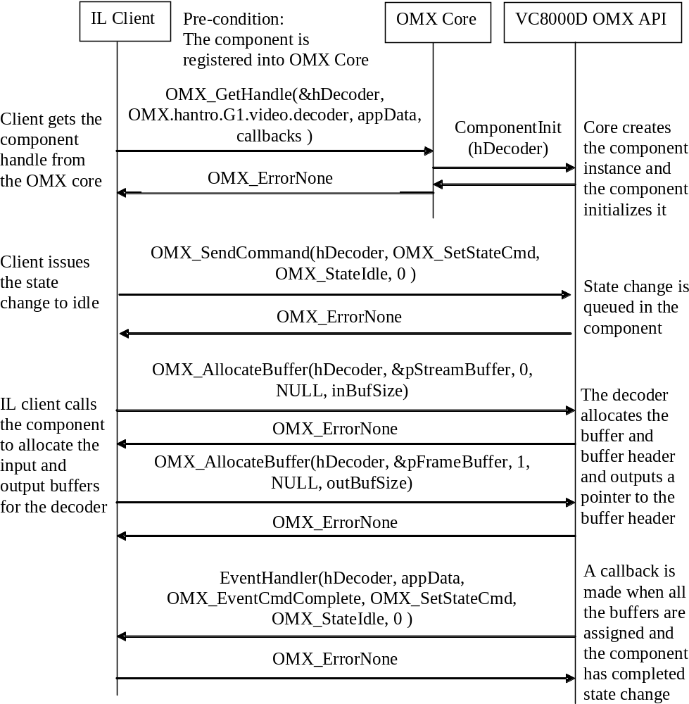
Figure 9. OMX API usage for component creation

Decoding
Figure 10 describes the usage of the component when decoding a frame with non-tunneled data flow. The component creation is done as described above.

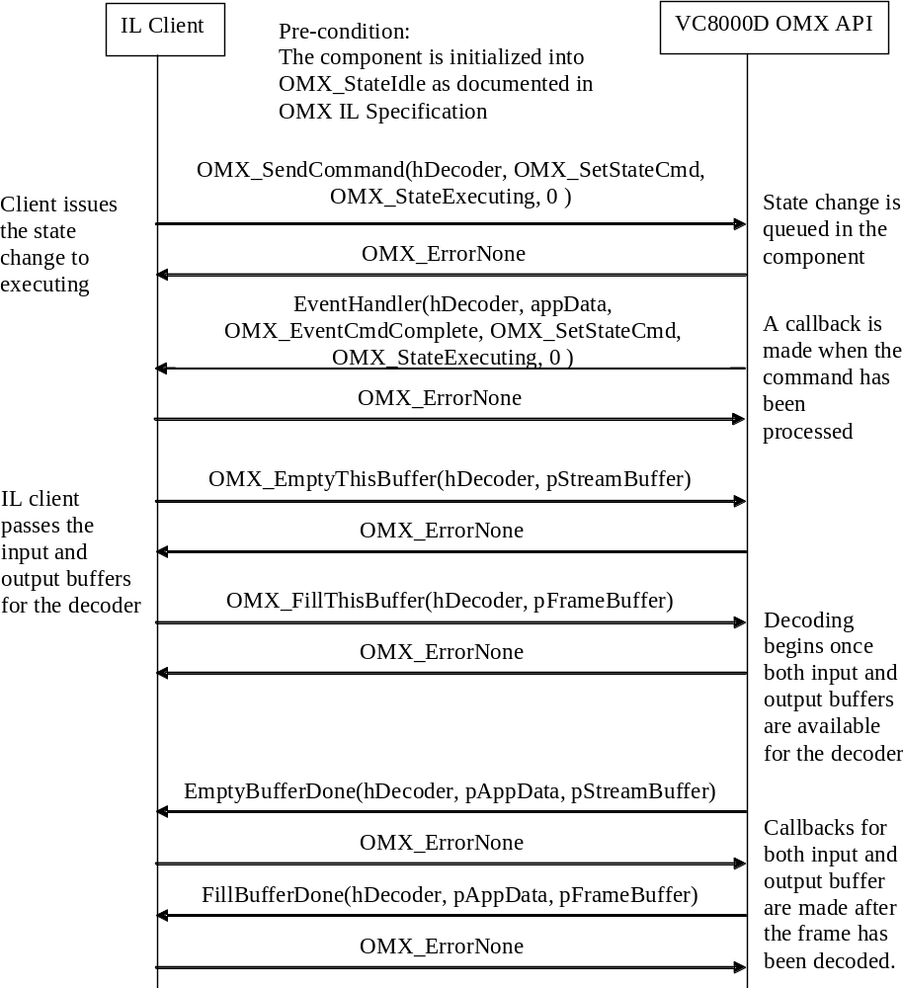
Figure 10. OMX API usage for decoding a frame

References
- OpenMAX IL API Specification v1.1.2, The Khronos Group, 2008.
- ISO/IEC FDIS 14496-10: Information technology – Coding of audio-visual objects – Part 10: Advanced Video Coding.
- ITU-T Recommendation H.263 (02/98), Video coding for low bit rate communication.
- INTERNATIONAL STANDARD ISO/IEC 13818-2, Information technology - Generic coding of moving pictures and associated audio information: Video.
- ISO/IEC 14496-2: Information technology – Coding of audio-visual objects – Part 2: Visual, Third edition 2004-06-01.
- SMPTE Standard for Television: VC-1 Compressed Video Bitstream Format and Decoding Process, SMPTE 421M (2006).
- The Standards of People’s Republic of China, Information technology – Advanced coding of audio and video – Part 2: Video
- ISO/IEC IS 10918-1: Information technology – Digital compression and coding of continuous-tone still images, Oct 20, 1999.

Appendix
VSI extension for OpenMAX IL Specification 1.1.2

Buffer Flags

Second View Frame Flag
This flag is set when the buffer content contains second view frame from MVC stream

#define OMX_BUFFERFLAG_SECOND_VIEW 0x00010000

VP8 Temporal Layer Frame Flags
One of these flags is set when the buffer contains encoded VP8 temporal layer frame

#define OMX_BUFFERFLAG_BASE_LAYER 0x00020000
#define OMX_BUFFERFLAG_FIRST_LAYER 0x00040000
#define OMX_BUFFERFLAG_SECOND_LAYER 0x00080000
#define OMX_BUFFERFLAG_THIRD_LAYER 0x00100000

Enumerations

OMX_INDEXVSITYPE
Extends OMX_INDEXTYPE defined in the OpenMAX IL API 1.1.2

typedef enum OMX_INDEXVSITYPE {
OMX_IndexVsiStartUnused = OMX_IndexVendorStartUnused + 0x00100000,
OMX_IndexParamVideoMvcStream,
OMX_IndexConfigVideoIntraArea,
OMX_IndexConfigVideoRoiArea,
OMX_IndexConfigVideoRoiDeltaQp,
OMX_IndexConfigVideoAdaptiveRoi,
OMX_IndexConfigVideoVp8TemporalLayers,
OMX_IndexParamVideoHevc,
OMX_IndexParamVideoVp9,

OMX_IndexParamVideoConfig
} OMX_INDEXVSITYPE;

OMX_VIDEO_CODINGVSITYPE
Extends OMX_VIDEO_CODINGTYPE defined in the OpenMAX IL API 1.1.2

typedef enum OMX_VIDEO_CODINGVSITYPE {
OMX_VIDEO_CodingVsiStartUnused = OMX_VIDEO_CodingVendorStartUnused + 0x00100000,
OMX_VIDEO_CodingSORENSON,
OMX_VIDEO_CodingDIVX,
OMX_VIDEO_CodingDIVX3,
OMX_VIDEO_CodingVP6,
OMX_VIDEO_CodingAVS,
OMX_VIDEO_CodingHEVC,
OMX_VIDEO_CodingVP9
} OMX_VIDEO_CODINGVSITYPE;

OMX_COLOR_FORMATVSITYPE
Extends OMX_COLOR_FORMATTYPE defined in the OpenMAX IL API 1.1.2

typedef enum OMX_COLOR_FORMATVSITYPE {
OMX_COLOR_FormatVsiStartUnused = OMX_COLOR_FormatVendorStartUnused + 0x00100000,
OMX_COLOR_FormatYUV411SemiPlanar,
OMX_COLOR_FormatYUV411PackedSemiPlanar,
OMX_COLOR_FormatYUV440SemiPlanar,
OMX_COLOR_FormatYUV440PackedSemiPlanar,
OMX_COLOR_FormatYUV444SemiPlanar,
OMX_COLOR_FormatYUV444PackedSemiPlanar,
OMX_COLOR_FormatYUV420SemiPlanar4x4Tiled, /* VC8000D tiled format */

OMX_COLOR_FormatYUV420SemiPlanarP010 /* P010 format */
} OMX_COLOR_FORMATVSITYPE;

OMX_VIDEO_HEVCPROFILETYPE
Defines HEVC/H.265 video profile types

typedef enum OMX_VIDEO_HEVCPROFILETYPE {
OMX_VIDEO_HEVCProfileMain = 0x01, /**< Main profile */
OMX_VIDEO_HEVCProfileMain10 = 0x02, /**< Main10 profile */
OMX_VIDEO_HEVCProfileMainStillPicture = 0x04, /**< Main still picture profile */
OMX_VIDEO_HEVCProfileKhronosExtensions = 0x6F000000, /**< Reserved region for introducing Khronos Standard Extensions */
OMX_VIDEO_HEVCProfileVendorStartUnused = 0x7F000000, /**< Reserved region for introducing Vendor Extensions */
OMX_VIDEO_HEVCProfileMax = 0x7FFFFFFF
} OMX_VIDEO_HEVCPROFILETYPE;

OMX_VIDEO_HEVCLEVELTYPE
Defines HEVC/H.265 video level types

typedef enum OMX_VIDEO_HEVCLEVELTYPE {
OMX_VIDEO_HEVCLevel1 = 0x01, /**< Level 1 */
OMX_VIDEO_HEVCLevel2 = 0x02, /**< Level 2 */
OMX_VIDEO_HEVCLevel21 = 0x04, /**< Level 2.1 */
OMX_VIDEO_HEVCLevel3 = 0x08, /**< Level 3 */
OMX_VIDEO_HEVCLevel31 = 0x10, /**< Level 3.1 */
OMX_VIDEO_HEVCLevel4 = 0x20, /**< Level 4 */
OMX_VIDEO_HEVCLevel41 = 0x40, /**< Level 4.1 */
OMX_VIDEO_HEVCLevel5 = 0x80, /**< Level 5 */
OMX_VIDEO_HEVCLevel51 = 0x100, /**< Level 5.1 */
OMX_VIDEO_HEVCLevel52 = 0x200, /**< Level 5.2 */
OMX_VIDEO_HEVCLevel6 = 0x400, /**< Level 6 */
OMX_VIDEO_HEVCLevel61 = 0x800, /**< Level 6.1 */
OMX_VIDEO_HEVCLevel62 = 0x1000, /**< Level 6.2 */
OMX_VIDEO_HEVCLevelKhronosExtensions = 0x6F000000, /**< Reserved region for introducing Khronos Standard Extensions */
OMX_VIDEO_HEVCLevelVendorStartUnused = 0x7F000000, /**< Reserved region for introducing Vendor Extensions */
OMX_VIDEO_HEVCLevelMax = 0x7FFFFFFF
} OMX_VIDEO_HEVCLEVELTYPE;

OMX_VIDEO_VP9PROFILETYPE
Defines VP9 video profile types

typedef enum OMX_VIDEO_VP9PROFILETYPE {
OMX_VIDEO_VP9Profile0 = 0x01, /* 8-bit 4:2:0 */
OMX_VIDEO_VP9Profile1 = 0x02, /* 8-bit 4:2:2, 4:4:4, alpha channel */
OMX_VIDEO_VP9Profile2 = 0x04, /* 10-bit/12-bit 4:2:0, YouTube Premium Content Profile */
OMX_VIDEO_VP9Profile3 = 0x08, /* 10-bit/12-bit 4:2:2, 4:4:4, alpha channel */
OMX_VIDEO_VP9ProfileUnknown = 0x6EFFFFFF,
OMX_VIDEO_VP9ProfileKhronosExtensions = 0x6F000000, /**< Reserved region for introducing Khronos Standard Extensions */
OMX_VIDEO_VP9ProfileVendorStartUnused = 0x7F000000, /**< Reserved region for introducing Vendor Extensions */
OMX_VIDEO_VP9ProfileMax = 0x7FFFFFFF
} OMX_VIDEO_VP9PROFILETYPE;

OMX_VIDEO_G2PIXELFORMAT
Defines G2 decoder pixel formats

/** G2 Decoder pixel formats */
typedef enum OMX_VIDEO_G2PIXELFORMAT {
OMX_VIDEO_G2PixelFormat_Default = 0x0,
OMX_VIDEO_G2PixelFormat_8bit = 0x01, /* 10 bit data is clamped to 8 bit per pixel */
OMX_VIDEO_G2PixelFormat_P010 = 0x02, /* MS P010 format */
OMX_VIDEO_G2PixelFormat_Custom1 = 0x03
} OMX_VIDEO_G2PIXELFORMAT;

Data Structures

OMX_VIDEO_PARAM_MVCSTREAMTYPE
Structure for configuring H.264 decoder to MVC mode

typedef struct OMX_VIDEO_PARAM_MVCSTREAMTYPE {
OMX_U32 nSize;
OMX_VERSIONTYPE nVersion;
OMX_U32 nPortIndex;
OMX_BOOL bIsMVCStream;
} OMX_VIDEO_PARAM_MVCSTREAMTYPE;

OMX_VIDEO_CONFIG_VP8TEMPORALLAYERTYPE
Structure for configuring VP8 temporal layers

typedef struct OMX_VIDEO_CONFIG_VP8TEMPORALLAYERTYPE {
OMX_U32 nSize;
OMX_VERSIONTYPE nVersion;
OMX_U32 nPortIndex;
OMX_U32 nBaseLayerBitrate; /* Bits per second [10000..40000000] */
OMX_U32 nLayer1Bitrate; /* Bits per second [10000..40000000] */
OMX_U32 nLayer2Bitrate; /* Bits per second [10000..40000000] */
OMX_U32 nLayer3Bitrate; /* Bits per second [10000..40000000] */
} OMX_VIDEO_CONFIG_VP8TEMPORALLAYERTYPE;

OMX_VIDEO_PARAM_HEVCTYPE
Defines parameters for HEVC/H.265 video standard

typedef struct OMX_VIDEO_PARAM_HEVCTYPE {
OMX_U32 nSize;
OMX_VERSIONTYPE nVersion;
OMX_U32 nPortIndex;
OMX_VIDEO_HEVCPROFILETYPE eProfile;
OMX_VIDEO_HEVCLEVELTYPE eLevel;
OMX_U32 nPFrames;
OMX_U32 nRefFrames;
OMX_U32 nBitDepthLuma;
OMX_U32 nBitDepthChroma;
OMX_BOOL bStrongIntraSmoothing;
OMX_S32 nTcOffset;
OMX_S32 nBetaOffset;
OMX_BOOL bEnableDeblockOverride;
OMX_BOOL bDeblockOverride;
OMX_BOOL bEnableSAO;
OMX_BOOL bEnableScalingList;
OMX_BOOL bCabacInitFlag;
} OMX_VIDEO_PARAM_HEVCTYPE;

OMX_VIDEO_PARAM_VP9TYPE
Defines parameters for VP9 video standard

typedef struct OMX_VIDEO_PARAM_VP9TYPE {
OMX_U32 nSize;
OMX_VERSIONTYPE nVersion;
OMX_U32 nPortIndex;
OMX_VIDEO_VP9PROFILETYPE eProfile;
OMX_U32 nBitDepthLuma;
OMX_U32 nBitDepthChroma;
} OMX_VIDEO_PARAM_VP9TYPE;

OMX_VIDEO_PARAM_CONFIGTYPE
Structure for configuring VC8000D decoder

typedef struct OMX_VIDEO_PARAM_CONFIGTYPE {

OMX_U32 nSize;

OMX_VERSIONTYPE nVersion;

OMX_U32 nPortIndex;

OMX_BOOL bEnableTiled;
OMX_U32 nGuardSize;
OMX_BOOL bEnableAdaptiveBuffers;
OMX_VIDEO_G2PIXELFORMAT ePixelFormat;
OMX_BOOL bEnableRFC;
OMX_BOOL bEnableRingBuffer;
OMX_BOOL bDisableReordering;
OMX_VIDEO_DECODER_MODE eDecMode;

} OMX_VIDEO_PARAM_CONFIGTYPE;

ALLOC_PRIVATE
This structure is used to communicate input/output buffer’s physical address when buffers are allocated and when using FillThisBuffer or EmptyThisBuffer. The data is accessed through pInputPortPrivate pointer.

typedef struct ALLOC_PRIVATE {
OMX_U8* pBufferData; // Virtual address of the buffer
OMX_U64 nBusAddress; // Physical address of the buffer
OMX_U32 nBufferSize; // Allocated size
} ALLOC_PRIVATE;

RFC_TABLE
Structure for accessing Reference Frame Compression (RFC) table data. H264/HEVC/VP9 only.

typedef struct RFC_TABLE {
OMX_U8* pLumaBase;
OMX_U64 nLumaBusAddress;
OMX_U8* pChromaBase;
OMX_U64 nChromaBusAddress;
} RFC_TABLE;

OUTPUT_BUFFER_PRIVATE
This structure is used for accessing output buffer’s physical address and RFC table when buffer is returned to the client with FillBufferDone callback. The data is accessed through pOutputPortPrivate pointer. Separate luminance and chrominance buffers are required when VP9 decoder is used in tiled mode.

typedef struct OUTPUT_BUFFER_PRIVATE {
OMX_U8* pLumaBase; // Virtual address of the luminance buffer
OMX_U64 nLumaBusAddress; // Physical address of the luminance buffer
OMX_U32 nLumaSize; // Size of the luminance data
OMX_U8* pChromaBase; // Virtual address of the chrominance buffer
OMX_U64 nChromaBusAddress; // Physical address of the chrominance buffer
OMX_U32 nChromaSize; // Size of the chrominance data
RFC_TABLE sRfcTable; // RFC table data
OMX_U32 nBitDepthLuma; // Luma component valid bit depth
OMX_U32 nBitDepthChroma; // Chroma component valid bit depth
OMX_U32 nFrameWidth; // Picture width in pixels
OMX_U32 nFrameHeight; // Picture height in pixels
OMX_U32 nStride; // Picture stride in bytes
OMX_U32 nPicId[2]; // Identifier of the picture in decoding order
// For H264 interlace stream, nPicId[0]/nPicId[1] are used for top/bottom field */
OMX_BOOL realloc;
OMX_BOOL singleField; // Flag to indicate single field in output buffer
}OUTPUT_BUFFER_PRIVATE;

