AX615D硬件设计用户指南
文档版本：V1.2
发布日期：2026/06/12

目 录
前 言 4
修订历史 5
1 原理图设计 6
1.1 小系统外部电路设计 6
1.1.1 系统时钟电路设计 6
1.1.2 芯片复位 6
1.1.3 启动项选择 7
1.1.4 RTC电路设计 7
1.1.5 ADC 9
1.1.6 SPI FLASH电路设计 11
1.1.7 eMMC电路设计 12
1.1.8 SD Card电路设计 13
1.1.9 Wakeup电路设计 13
1.2 电源设计 14
1.2.1 上电时序 14
1.2.2 VDDCORE电源设计 15
1.2.3 DDR电源设计 16
1.2.4 IO电源设计 17
1.3 外围接口设计 17
1.3.1 内置EPHY 17
1.3.2 Video In接口设计 18
1.3.3 Video Out接口设计 20
1.3.4 USB接口设计 22
1.3.5 模拟音频接口设计 22
1.3.6 I2C设计 23
1.3.7 SPI设计 23
1.3.8 UART设计 23
1.3.9 IIS设计 24
1.3.10 GPIO设计 24
2 PCB设计 25
2.1 PCB Stack Up 25
2.2 VDDCORE电源设计 25
2.3 晶体电路设计 26
2.4 eMMC信号设计 26
2.5 ePHY信号设计 27
2.6 USB信号设计 27
2.7 MIPI信号设计 27
2.8 过孔设计 27
3 整机ESD设计 28

权利声明
爱芯元智半导体股份有限公司或其许可人保留一切权利。
非经权利人书面许可，任何单位和个人不得擅自摘抄、复制本文档内容的部分或全部，并不得以任何形式传播。

注意
您购买的产品、服务或特性等应受商业合同和条款的约束，本文档中描述的全部或部分产品、服务或特性可能不在您的购买或使用范围之内。除非商业合同另有约定，本公司对本文档内容不做任何明示或默示的声明或保证。
由于产品版本升级或其他原因，本文档内容会不定期进行更新。除非另有约定，本文档仅作为使用指导，本文档中的所有陈述、信息和建议不构成任何明示或暗示的担保。

前 言
适用产品
AX615D
适读人群
- 软件开发工程师
- 硬件开发工程师
- 技术支持工程师
符号与格式定义
符号/格式 | 说明
xxx | 表示您可以执行的命令行。
斜体 | 表示变量。如，“安装目录/AX615D_SDK_Vx.x.x/build目录”中的“安装目录”是一个变量，由您的实际环境决定。
- 说明/备注： | 表示您在使用产品的过程中，我们向您说明的事项。
- 注意： | 表示您在使用产品的过程中，需要您特别注意的事项。

修订历史
文档版本 | 发布时间 | 修订说明
V0.5 | 2025/05/26 | Initial Release
V0.6 | 2025/09/19 | 更新 1.2.3 DDR电源设计 章节描述
V1.0 | 2026/01/07 | 更新 1.2.3 DDR电源设计 章节描述
V1.1 | 2026/04/30 | 更新 1.2.2 VDDCORE电源设计 章节描述
V1.2 | 2026/06/12 | 更新 上电时序图，增加长电模式的上电时序

原理图设计

小系统外部电路设计

系统时钟电路设计
AX615D系统时钟要求为24 MHz；
AX615D内部反馈电路与外部晶体振荡电路一起构成系统时钟电路。外部电路需预留反馈电阻与衰减电阻，取值分别为1 MΩ与100 Ω，可根据实际情况进行调整。外部负载电容取值需根据晶体要求来确定。
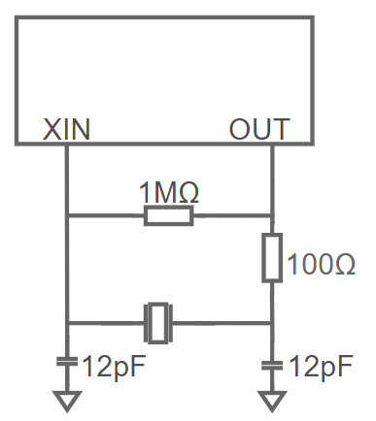
        - 晶体震荡电路

芯片复位
AX615D没有外部上电复位输入引脚。芯片级复位来源包括POR复位、看门狗复位、过热复位、软件复位。

启动项选择
AX615D通过检测Boot_Mode[2:0] 复位时的输入状态来选择启动项。Boot_Mode [2:0]复用管脚BOND1、BOND0、GPIO0_A20。默认从NOR FLASH启动。其他启动项，管脚配置请参考下表。
          - 系统启动项选择
 | Boot_Mode  [2] | Boot_Mode  [1] | Boot_Mode  [0] | Boot Option
复用管脚 | BOND1 | BOND0 | GPIO0_A20
 | 1 | 0 | 0 | EMMC BOOT
 | 1 | 0 | 1 | EMMC UDA
 | 1 | 1 | 0 | SPI NOR
 | 1 | 1 | 1 | SPI NAND
 | 0 | X | X | USB DL or SD Card or UART DL or EMAC DL
- 注意：
BOND1、BOND0、GPIO0_A20这三个PIN内部没有做上下拉配置，必须外部接上下拉电阻。默认使用47K阻值。

RTC电路设计
若需使用RTC功能时，系统掉电后使用纽扣电池给RTC模块供电，为VCC_PMU管脚供电。系统上电后，由于DVDD_3V3电压比纽扣电池的电压高，RTC模块从DVDD_3V3取电，降低了对电池的消耗。两个肖特基二极管需选用相同型号，导通电压不高于0.3V。
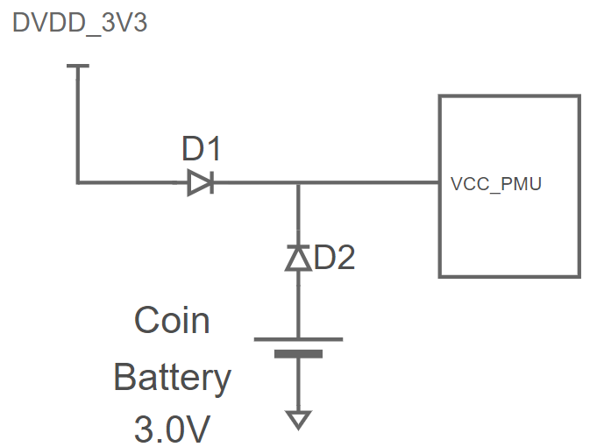
        - 使用不可充电电池的RTC外围电路
若采用可充电纽扣电池，使用电阻R1替换肖特基二极管D2。DVDD_3V3上电后，通过R1对电池进行充电，R1起到限流作用。R1的取值需具体参考电池的规格书。
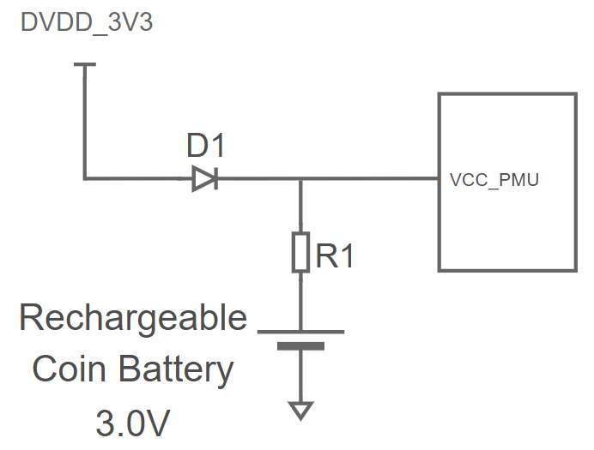
        - 使用可充电电池的RTC外围电路
RTC时钟电路由内部反馈电路与外部晶体振荡电路构成。负载电容的取值需要与实际使用的晶体负载电容相匹配。
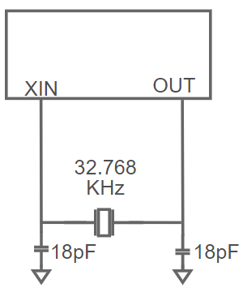
        - 32.768 KHz时钟电路
若采用外部的RTC芯片，AX615D的VCC_PMU电源管脚不可悬空，需连接到电源DVDD_3V3。

ADC
AX615D内部集成了一个10bit分辨率的ADC，可用于片内温度测量与片外电压测量。
ADC用于测量片内温度和测量片外电压信号时，参考电压1.8V。AX615D提供2个电压输入管脚，分别是THM_AIN0/1，可用于检测芯片外部电压信号。3CmxGraphModel%3E%3Croot%3E%3CmxCell%20id%3D%220%22%2F%3E%3CmxCell%20id%3D%221%22%20parent%3D%220%22%2F%3E%3CmxCell%20id%3D%222%22%20value%3D%22%22%20style%3D%22pointerEvents%3D1%3BverticalLabelPosition%3Dbottom%3Bshadow%3D0%3Bdashed%3D0%3Balign%3Dcenter%3Bhtml%3D1%3BverticalAlign%3Dtop%3Bshape%3Dmxgraph.electrical.resistors.resistor_1%3Bdirection%3Dsouth%3B%22%20vertex%3D%221%22%20parent%3D%221%22%3E%3CmxGeometry%20x%3D%22840%22%20y%3D%22480%22%20height%3D%22100%22%20as%3D%22geometry%22%2F%3E%3C%2FmxCell%3E%3CmxCell%20id%3D%223%22%20value%3D%22%22%20style%3D%22group%22%20vertex%3D%221%22%20connectable%3D%220%22%20parent%3D%221%22%3E%3CmxGeometry%20x%3D%22900%22%20y%3D%22150%22%20width%3D%22550%22%20height%3D%22490%22%20as%3D%22geometry%22%2F%3E%3C%2FmxCell%3E%3CmxCell%20id%3D%224%22%20value%3D%22%26lt%3Bfont%20style%3D%26quot%3Bfont-size%3A%2024px%3B%26quot%3B%26gt%3B1.8V%26amp%3Bnbsp%3B%26lt%3B%2Ffont%26gt%3B%22%20style%3D%22rounded%3D0%3BwhiteSpace%3Dwrap%3Bhtml%3D1%3Balign%3Dleft%3Bopacity%3D0%3B%22%20vertex%3D%221%22%20parent%3D%223%22%3E%3CmxGeometry%20x%3D%22430%22%20y%3D%22330%22%20width%3D%22120%22%20height%3D%2260%22%20as%3D%22geometry%22%2F%3E%3C%2FmxCell%3E%3CmxCell%20id%3D%225%22%20value%3D%22%22%20style%3D%22group%22%20vertex%3D%221%22%20connectable%3D%220%22%20parent%3D%223%22%3E%3CmxGeometry%20width%3D%22420%22%20height%3D%22490%22%20as%3D%22geometry%22%2F%3E%3C%2FmxCell%3E%3CmxCell%20id%3D%226%22%20style%3D%22edgeStyle%3Dnone%3Brounded%3D0%3BorthogonalLoop%3D1%3BjettySize%3Dauto%3Bhtml%3D1%3BexitDx%3D0%3BexitDy%3D0%3BexitPerimeter%3D0%3BendArrow%3Dnone%3BstartFill%3D0%3B%22%20edge%3D%221%22%20parent%3D%225%22%20source%3D%2217%22%20target%3D%228%22%3E%3CmxGeometry%20relative%3D%221%22%20as%3D%22geometry%22%2F%3E%3C%2FmxCell%3E%3CmxCell%20id%3D%227%22%20value%3D%22%22%20style%3D%22pointerEvents%3D1%3BverticalLabelPosition%3Dbottom%3Bshadow%3D0%3Bdashed%3D0%3Balign%3Dcenter%3Bhtml%3D1%3BverticalAlign%3Dtop%3Bshape%3Dmxgraph.electrical.resistors.resistor_1%3Bdirection%3Dsouth%3B%22%20vertex%3D%221%22%20parent%3D%225%22%3E%3CmxGeometry%20x%3D%22270%22%20y%3D%2220%22%20width%3D%2220%22%20height%3D%22100%22%20as%3D%22geometry%22%2F%3E%3C%2FmxCell%3E%3CmxCell%20id%3D%228%22%20value%3D%22%22%20style%3D%22pointerEvents%3D1%3BverticalLabelPosition%3Dbottom%3Bshadow%3D0%3Bdashed%3D0%3Balign%3Dcenter%3Bhtml%3D1%3BverticalAlign%3Dtop%3Bshape%3Dmxgraph.electrical.resistors.resistor_1%3Bdirection%3Dsouth%3B%22%20vertex%3D%221%22%20parent%3D%225%22%3E%3CmxGeometry%20x%3D%22270%22%20y%3D%22150%22%20width%3D%2220%22%20height%3D%22100%22%20as%3D%22geometry%22%2F%3E%3C%2FmxCell%3E%3CmxCell%20id%3D%229%22%20value%3D%22%22%20style%3D%22pointerEvents%3D1%3BverticalLabelPosition%3Dbottom%3Bshadow%3D0%3Bdashed%3D0%3Balign%3Dcenter%3Bhtml%3D1%3BverticalAlign%3Dtop%3Bshape%3Dmxgraph.electrical.signal_sources.signal_ground%3B%22%20vertex%3D%221%22%20parent%3D%225%22%3E%3CmxGeometry%20x%3D%22255%22%20y%3D%22260%22%20width%3D%2250%22%20height%3D%2230%22%20as%3D%22geometry%22%2F%3E%3C%2FmxCell%3E%3CmxCell%20id%3D%2210%22%20style%3D%22edgeStyle%3Dnone%3Brounded%3D0%3BorthogonalLoop%3D1%3BjettySize%3Dauto%3Bhtml%3D1%3BexitX%3D1%3BexitY%3D0.5%3BexitDx%3D0%3BexitDy%3D0%3BexitPerimeter%3D0%3BentryX%3D0.5%3BentryY%3D0%3BentryDx%3D0%3BentryDy%3D0%3BentryPerimeter%3D0%3BendArrow%3Dnone%3BstartFill%3D0%3B%22%20edge%3D%221%22%20parent%3D%225%22%20source%3D%228%22%20target%3D%229%22%3E%3CmxGeometry%20relative%3D%221%22%20as%3D%22geometry%22%2F%3E%3C%2FmxCell%3E%3CmxCell%20id%3D%2211%22%20value%3D%221.8V%22%20style%3D%22verticalLabelPosition%3Dtop%3BverticalAlign%3Dbottom%3Bshape%3Dmxgraph.electrical.signal_sources.vdd%3Bshadow%3D0%3Bdashed%3D0%3Balign%3Dcenter%3BstrokeWidth%3D1%3BfontSize%3D24%3Bhtml%3D1%3BflipV%3D1%3B%22%20vertex%3D%221%22%20parent%3D%225%22%3E%3CmxGeometry%20x%3D%22250%22%20width%3D%2260%22%20height%3D%2240%22%20as%3D%22geometry%22%2F%3E%3C%2FmxCell%3E%3CmxCell%20id%3D%2212%22%20style%3D%22edgeStyle%3Dnone%3Brounded%3D0%3BorthogonalLoop%3D1%3BjettySize%3Dauto%3Bhtml%3D1%3BexitX%3D0.5%3BexitY%3D0%3BexitDx%3D0%3BexitDy%3D0%3BexitPerimeter%3D0%3BentryX%3D0%3BentryY%3D0.5%3BentryDx%3D0%3BentryDy%3D0%3BentryPerimeter%3D0%3BendArrow%3Dnone%3BstartFill%3D0%3B%22%20edge%3D%221%22%20parent%3D%225%22%20source%3D%2211%22%20target%3D%227%22%3E%3CmxGeometry%20relative%3D%221%22%20as%3D%22geometry%22%2F%3E%3C%2FmxCell%3E%3CmxCell%20id%3D%2213%22%20value%3D%22%22%20style%3D%22rounded%3D0%3BwhiteSpace%3Dwrap%3Bhtml%3D1%3B%22%20vertex%3D%221%22%20parent%3D%225%22%3E%3CmxGeometry%20y%3D%2240%22%20width%3D%22200%22%20height%3D%22360%22%20as%3D%22geometry%22%2F%3E%3C%2FmxCell%3E%3CmxCell%20id%3D%2214%22%20value%3D%22%26lt%3Bfont%20style%3D%26quot%3Bfont-size%3A%2024px%3B%26quot%3B%26gt%3BADC0%2F1%26amp%3Bnbsp%3B%26amp%3Bnbsp%3B%26lt%3B%2Ffont%26gt%3B%22%20style%3D%22rounded%3D0%3BwhiteSpace%3Dwrap%3Bhtml%3D1%3Balign%3Dright%3Bopacity%3D0%3B%22%20vertex%3D%221%22%20parent%3D%225%22%3E%3CmxGeometry%20x%3D%2280%22%20y%3D%22110%22%20width%3D%22120%22%20height%3D%2260%22%20as%3D%22geometry%22%2F%3E%3C%2FmxCell%3E%3CmxCell%20id%3D%2215%22%20value%3D%22%22%20style%3D%22endArrow%3Dnone%3Bhtml%3D1%3Brounded%3D0%3BexitX%3D1%3BexitY%3D0.5%3BexitDx%3D0%3BexitDy%3D0%3B%22%20edge%3D%221%22%20parent%3D%225%22%3E%3CmxGeometry%20width%3D%2250%22%20height%3D%2250%22%20relative%3D%221%22%20as%3D%22geometry%22%3E%3CmxPoint%20x%3D%22200%22%20y%3D%22140%22%20as%3D%22sourcePoint%22%2F%3E%3CmxPoint%20x%3D%22280%22%20y%3D%22140%22%20as%3D%22targetPoint%22%2F%3E%3C%2FmxGeometry%3E%3C%2FmxCell%3E%3CmxCell%20id%3D%2216%22%20value%3D%22%22%20style%3D%22edgeStyle%3Dnone%3Brounded%3D0%3BorthogonalLoop%3D1%3BjettySize%3Dauto%3Bhtml%3D1%3BexitX%3D1%3BexitY%3D0.5%3BexitDx%3D0%3BexitDy%3D0%3BexitPerimeter%3D0%3BendArrow%3Dnone%3BstartFill%3D0%3B%22%20edge%3D%221%22%20parent%3D%225%22%20source%3D%227%22%20target%3D%2217%22%3E%3CmxGeometry%20relative%3D%221%22%20as%3D%22geometry%22%3E%3CmxPoint%20x%3D%22280%22%20y%3D%22120%22%20as%3D%22sourcePoint%22%2F%3E%3CmxPoint%20x%3D%22280%22%20y%3D%22160%22%20as%3D%22targetPoint%22%2F%3E%3C%2FmxGeometry%3E%3C%2FmxCell%3E%3CmxCell%20id%3D%2217%22%20value%3D%22%22%20style%3D%22shape%3Dwaypoint%3Bsketch%3D0%3BfillStyle%3Dsolid%3Bsize%3D6%3BpointerEvents%3D1%3Bpoints%3D%5B%5D%3BfillColor%3Dnone%3Bresizable%3D0%3Brotatable%3D0%3Bperimeter%3DcenterPerimeter%3BsnapToPoint%3D1%3B%22%20vertex%3D%221%22%20parent%3D%225%22%3E%3CmxGeometry%20x%3D%22270%22%20y%3D%22130%22%20width%3D%2220%22%20height%3D%2220%22%20as%3D%22geometry%22%2F%3E%3C%2FmxCell%3E%3CmxCell%20id%3D%2218%22%20value%3D%22%26lt%3Bfont%20style%3D%26quot%3Bfont-size%3A%2016px%3B%26quot%3B%26gt%3BVDDIO18_AON%26amp%3Bnbsp%3B%26amp%3Bnbsp%3B%26lt%3B%2Ffont%26gt%3B%22%20style%3D%22rounded%3D0%3BwhiteSpace%3Dwrap%3Bhtml%3D1%3Balign%3Dright%3Bopacity%3D0%3B%22%20vertex%3D%221%22%20parent%3D%225%22%3E%3CmxGeometry%20x%3D%2280%22%20y%3D%22330%22%20width%3D%22120%22%20height%3D%2260%22%20as%3D%22geometry%22%2F%3E%3C%2FmxCell%3E%3CmxCell%20id%3D%2219%22%20value%3D%22%22%20style%3D%22pointerEvents%3D1%3BverticalLabelPosition%3Dbottom%3Bshadow%3D0%3Bdashed%3D0%3Balign%3Dcenter%3Bhtml%3D1%3BverticalAlign%3Dtop%3Bshape%3Dmxgraph.electrical.resistors.resistor_1%3Bdirection%3Dwest%3B%22%20vertex%3D%221%22%20parent%3D%225%22%3E%3CmxGeometry%20x%3D%22280%22%20y%3D%22350%22%20width%3D%22100%22%20height%3D%2220%22%20as%3D%22geometry%22%2F%3E%3C%2FmxCell%3E%3CmxCell%20id%3D%2220%22%20value%3D%22%22%20style%3D%22endArrow%3Dnone%3Bhtml%3D1%3Brounded%3D0%3BexitX%3D1%3BexitY%3D0.5%3BexitDx%3D0%3BexitDy%3D0%3B%22%20edge%3D%221%22%20parent%3D%225%22%20source%3D%2218%22%3E%3CmxGeometry%20width%3D%2250%22%20height%3D%2250%22%20relative%3D%221%22%20as%3D%22geometry%22%3E%3CmxPoint%20x%3D%22230%22%20y%3D%22410%22%20as%3D%22sourcePoint%22%2F%3E%3CmxPoint%20x%3D%22280%22%20y%3D%22360%22%20as%3D%22targetPoint%22%2F%3E%3C%2FmxGeometry%3E%3C%2FmxCell%3E%3CmxCell%20id%3D%2221%22%20value%3D%22%22%20style%3D%22pointerEvents%3D1%3BverticalLabelPosition%3Dbottom%3Bshadow%3D0%3Bdashed%3D0%3Balign%3Dcenter%3Bhtml%3D1%3BverticalAlign%3Dtop%3Bshape%3Dmxgraph.electrical.capacitors.capacitor_1%3Bdirection%3Dsouth%3B%22%20vertex%3D%221%22%20parent%3D%225%22%3E%3CmxGeometry%20x%3D%22210%22%20y%3D%22360%22%20width%3D%2260%22%20height%3D%22100%22%20as%3D%22geometry%22%2F%3E%3C%2FmxCell%3E%3CmxCell%20id%3D%2222%22%20value%3D%22%22%20style%3D%22pointerEvents%3D1%3BverticalLabelPosition%3Dbottom%3Bshadow%3D0%3Bdashed%3D0%3Balign%3Dcenter%3Bhtml%3D1%3BverticalAlign%3Dtop%3Bshape%3Dmxgraph.electrical.signal_sources.signal_ground%3B%22%20vertex%3D%221%22%20parent%3D%225%22%3E%3CmxGeometry%20x%3D%22215%22%20y%3D%22460%22%20width%3D%2250%22%20height%3D%2230%22%20as%3D%22geometry%22%2F%3E%3C%2FmxCell%3E%3CmxCell%20id%3D%2223%22%20value%3D%22%22%20style%3D%22verticalLabelPosition%3Dtop%3BverticalAlign%3Dbottom%3Bshape%3Dmxgraph.electrical.signal_sources.vdd%3Bshadow%3D0%3Bdashed%3D0%3Balign%3Dcenter%3BstrokeWidth%3D1%3BfontSize%3D24%3Bhtml%3D1%3BflipV%3D1%3Bcontainer%3D0%3Bdirection%3Dnorth%3B%22%20vertex%3D%221%22%20parent%3D%225%22%3E%3CmxGeometry%20x%3D%22380%22%20y%3D%22330%22%20width%3D%2240%22%20height%3D%2260%22%20as%3D%22geometry%22%2F%3E%3C%2FmxCell%3E%3CmxCell%20id%3D%2224%22%20value%3D%22%26lt%3Bfont%20style%3D%26quot%3Bfont-size%3A%2024px%3B%26quot%3B%26gt%3B2.2uF%26lt%3B%2Ffont%26gt%3B%22%20style%3D%22rounded%3D0%3BwhiteSpace%3Dwrap%3Bhtml%3D1%3Balign%3Dleft%3Bopacity%3D0%3B%22%20vertex%3D%221%22%20parent%3D%225%22%3E%3CmxGeometry%20x%3D%22280%22%20y%3D%22380%22%20width%3D%2270%22%20height%3D%2260%22%20as%3D%22geometry%22%2F%3E%3C%2FmxCell%3E%3C%2Froot%3E%3C%2FmxGraphModel%3E%3CmxGraphModel%3E%3Croot%3E%3CmxCell%20id%3D%220%22%2F%3E%3CmxCell%20id%3D%221%22%20parent%3D%220%22%2F%3E%3CmxCell%20id%3D%222%22%20value%3D%22%22%20style%3D%22group%22%20vertex%3D%221%22%20connectable%3D%220%22%20parent%3D%221%22%3E%3CmxGeometry%20x%3D%22840%22%20y%3D%22150%22%20width%3D%22610%22%20height%3D%22490%22%20as%3D%22geometry%22%2F%3E%3C%2FmxCell%3E%3CmxCell%20id%3D%223%22%20value%3D%22%22%20style%3D%22pointerEvents%3D1%3BverticalLabelPosition%3Dbottom%3Bshadow%3D0%3Bdashed%3D0%3Balign%3Dcenter%3Bhtml%3D1%3BverticalAlign%3Dtop%3Bshape%3Dmxgraph.electrical.resistors.resistor_1%3Bdirection%3Dsouth%3B%22%20vertex%3D%221%22%20parent%3D%222%22%3E%3CmxGeometry%20y%3D%22330%22%20height%3D%22100%22%20as%3D%22geometry%22%2F%3E%3C%2FmxCell%3E%3CmxCell%20id%3D%224%22%20value%3D%22%22%20style%3D%22group%22%20vertex%3D%221%22%20connectable%3D%220%22%20parent%3D%222%22%3E%3CmxGeometry%20x%3D%2260%22%20width%3D%22550%22%20height%3D%22490%22%20as%3D%22geometry%22%2F%3E%3C%2FmxCell%3E%3CmxCell%20id%3D%225%22%20value%3D%22%26lt%3Bfont%20style%3D%26quot%3Bfont-size%3A%2024px%3B%26quot%3B%26gt%3B1.8V%26amp%3Bnbsp%3B%26lt%3B%2Ffont%26gt%3B%22%20style%3D%22rounded%3D0%3BwhiteSpace%3Dwrap%3Bhtml%3D1%3Balign%3Dleft%3Bopacity%3D0%3B%22%20vertex%3D%221%22%20parent%3D%224%22%3E%3CmxGeometry%20x%3D%22430%22%20y%3D%22330%22%20width%3D%22120%22%20height%3D%2260%22%20as%3D%22geometry%22%2F%3E%3C%2FmxCell%3E%3CmxCell%20id%3D%226%22%20value%3D%22%22%20style%3D%22group%22%20vertex%3D%221%22%20connectable%3D%220%22%20parent%3D%224%22%3E%3CmxGeometry%20width%3D%22420%22%20height%3D%22490%22%20as%3D%22geometry%22%2F%3E%3C%2FmxCell%3E%3CmxCell%20id%3D%227%22%20style%3D%22edgeStyle%3Dnone%3Brounded%3D0%3BorthogonalLoop%3D1%3BjettySize%3Dauto%3Bhtml%3D1%3BexitDx%3D0%3BexitDy%3D0%3BexitPerimeter%3D0%3BendArrow%3Dnone%3BstartFill%3D0%3B%22%20edge%3D%221%22%20parent%3D%226%22%20source%3D%2218%22%20target%3D%229%22%3E%3CmxGeometry%20relative%3D%221%22%20as%3D%22geometry%22%2F%3E%3C%2FmxCell%3E%3CmxCell%20id%3D%228%22%20value%3D%22%22%20style%3D%22pointerEvents%3D1%3BverticalLabelPosition%3Dbottom%3Bshadow%3D0%3Bdashed%3D0%3Balign%3Dcenter%3Bhtml%3D1%3BverticalAlign%3Dtop%3Bshape%3Dmxgraph.electrical.resistors.resistor_1%3Bdirection%3Dsouth%3B%22%20vertex%3D%221%22%20parent%3D%226%22%3E%3CmxGeometry%20x%3D%22270%22%20y%3D%2220%22%20width%3D%2220%22%20height%3D%22100%22%20as%3D%22geometry%22%2F%3E%3C%2FmxCell%3E%3CmxCell%20id%3D%229%22%20value%3D%22%22%20style%3D%22pointerEvents%3D1%3BverticalLabelPosition%3Dbottom%3Bshadow%3D0%3Bdashed%3D0%3Balign%3Dcenter%3Bhtml%3D1%3BverticalAlign%3Dtop%3Bshape%3Dmxgraph.electrical.resistors.resistor_1%3Bdirection%3Dsouth%3B%22%20vertex%3D%221%22%20parent%3D%226%22%3E%3CmxGeometry%20x%3D%22270%22%20y%3D%22150%22%20width%3D%2220%22%20height%3D%22100%22%20as%3D%22geometry%22%2F%3E%3C%2FmxCell%3E%3CmxCell%20id%3D%2210%22%20value%3D%22%22%20style%3D%22pointerEvents%3D1%3BverticalLabelPosition%3Dbottom%3Bshadow%3D0%3Bdashed%3D0%3Balign%3Dcenter%3Bhtml%3D1%3BverticalAlign%3Dtop%3Bshape%3Dmxgraph.electrical.signal_sources.signal_ground%3B%22%20vertex%3D%221%22%20parent%3D%226%22%3E%3CmxGeometry%20x%3D%22255%22%20y%3D%22260%22%20width%3D%2250%22%20height%3D%2230%22%20as%3D%22geometry%22%2F%3E%3C%2FmxCell%3E%3CmxCell%20id%3D%2211%22%20style%3D%22edgeStyle%3Dnone%3Brounded%3D0%3BorthogonalLoop%3D1%3BjettySize%3Dauto%3Bhtml%3D1%3BexitX%3D1%3BexitY%3D0.5%3BexitDx%3D0%3BexitDy%3D0%3BexitPerimeter%3D0%3BentryX%3D0.5%3BentryY%3D0%3BentryDx%3D0%3BentryDy%3D0%3BentryPerimeter%3D0%3BendArrow%3Dnone%3BstartFill%3D0%3B%22%20edge%3D%221%22%20parent%3D%226%22%20source%3D%229%22%20target%3D%2210%22%3E%3CmxGeometry%20relative%3D%221%22%20as%3D%22geometry%22%2F%3E%3C%2FmxCell%3E%3CmxCell%20id%3D%2212%22%20value%3D%221.8V%22%20style%3D%22verticalLabelPosition%3Dtop%3BverticalAlign%3Dbottom%3Bshape%3Dmxgraph.electrical.signal_sources.vdd%3Bshadow%3D0%3Bdashed%3D0%3Balign%3Dcenter%3BstrokeWidth%3D1%3BfontSize%3D24%3Bhtml%3D1%3BflipV%3D1%3B%22%20vertex%3D%221%22%20parent%3D%226%22%3E%3CmxGeometry%20x%3D%22250%22%20width%3D%2260%22%20height%3D%2240%22%20as%3D%22geometry%22%2F%3E%3C%2FmxCell%3E%3CmxCell%20id%3D%2213%22%20style%3D%22edgeStyle%3Dnone%3Brounded%3D0%3BorthogonalLoop%3D1%3BjettySize%3Dauto%3Bhtml%3D1%3BexitX%3D0.5%3BexitY%3D0%3BexitDx%3D0%3BexitDy%3D0%3BexitPerimeter%3D0%3BentryX%3D0%3BentryY%3D0.5%3BentryDx%3D0%3BentryDy%3D0%3BentryPerimeter%3D0%3BendArrow%3Dnone%3BstartFill%3D0%3B%22%20edge%3D%221%22%20parent%3D%226%22%20source%3D%2212%22%20target%3D%228%22%3E%3CmxGeometry%20relative%3D%221%22%20as%3D%22geometry%22%2F%3E%3C%2FmxCell%3E%3CmxCell%20id%3D%2214%22%20value%3D%22%22%20style%3D%22rounded%3D0%3BwhiteSpace%3Dwrap%3Bhtml%3D1%3B%22%20vertex%3D%221%22%20parent%3D%226%22%3E%3CmxGeometry%20y%3D%2240%22%20width%3D%22200%22%20height%3D%22360%22%20as%3D%22geometry%22%2F%3E%3C%2FmxCell%3E%3CmxCell%20id%3D%2215%22%20value%3D%22%26lt%3Bfont%20style%3D%26quot%3Bfont-size%3A%2024px%3B%26quot%3B%26gt%3BADC0%2F1%26amp%3Bnbsp%3B%26amp%3Bnbsp%3B%26lt%3B%2Ffont%26gt%3B%22%20style%3D%22rounded%3D0%3BwhiteSpace%3Dwrap%3Bhtml%3D1%3Balign%3Dright%3Bopacity%3D0%3B%22%20vertex%3D%221%22%20parent%3D%226%22%3E%3CmxGeometry%20x%3D%2280%22%20y%3D%22110%22%20width%3D%22120%22%20height%3D%2260%22%20as%3D%22geometry%22%2F%3E%3C%2FmxCell%3E%3CmxCell%20id%3D%2216%22%20value%3D%22%22%20style%3D%22endArrow%3Dnone%3Bhtml%3D1%3Brounded%3D0%3BexitX%3D1%3BexitY%3D0.5%3BexitDx%3D0%3BexitDy%3D0%3B%22%20edge%3D%221%22%20parent%3D%226%22%3E%3CmxGeometry%20width%3D%2250%22%20height%3D%2250%22%20relative%3D%221%22%20as%3D%22geometry%22%3E%3CmxPoint%20x%3D%22200%22%20y%3D%22140%22%20as%3D%22sourcePoint%22%2F%3E%3CmxPoint%20x%3D%22280%22%20y%3D%22140%22%20as%3D%22targetPoint%22%2F%3E%3C%2FmxGeometry%3E%3C%2FmxCell%3E%3CmxCell%20id%3D%2217%22%20value%3D%22%22%20style%3D%22edgeStyle%3Dnone%3Brounded%3D0%3BorthogonalLoop%3D1%3BjettySize%3Dauto%3Bhtml%3D1%3BexitX%3D1%3BexitY%3D0.5%3BexitDx%3D0%3BexitDy%3D0%3BexitPerimeter%3D0%3BendArrow%3Dnone%3BstartFill%3D0%3B%22%20edge%3D%221%22%20parent%3D%226%22%20source%3D%228%22%20target%3D%2218%22%3E%3CmxGeometry%20relative%3D%221%22%20as%3D%22geometry%22%3E%3CmxPoint%20x%3D%22280%22%20y%3D%22120%22%20as%3D%22sourcePoint%22%2F%3E%3CmxPoint%20x%3D%22280%22%20y%3D%22160%22%20as%3D%22targetPoint%22%2F%3E%3C%2FmxGeometry%3E%3C%2FmxCell%3E%3CmxCell%20id%3D%2218%22%20value%3D%22%22%20style%3D%22shape%3Dwaypoint%3Bsketch%3D0%3BfillStyle%3Dsolid%3Bsize%3D6%3BpointerEvents%3D1%3Bpoints%3D%5B%5D%3BfillColor%3Dnone%3Bresizable%3D0%3Brotatable%3D0%3Bperimeter%3DcenterPerimeter%3BsnapToPoint%3D1%3B%22%20vertex%3D%221%22%20parent%3D%226%22%3E%3CmxGeometry%20x%3D%22270%22%20y%3D%22130%22%20width%3D%2220%22%20height%3D%2220%22%20as%3D%22geometry%22%2F%3E%3C%2FmxCell%3E%3CmxCell%20id%3D%2219%22%20value%3D%22%26lt%3Bfont%20style%3D%26quot%3Bfont-size%3A%2016px%3B%26quot%3B%26gt%3BVDDIO18_AON%26amp%3Bnbsp%3B%26amp%3Bnbsp%3B%26lt%3B%2Ffont%26gt%3B%22%20style%3D%22rounded%3D0%3BwhiteSpace%3Dwrap%3Bhtml%3D1%3Balign%3Dright%3Bopacity%3D0%3B%22%20vertex%3D%221%22%20parent%3D%226%22%3E%3CmxGeometry%20x%3D%2280%22%20y%3D%22330%22%20width%3D%22120%22%20height%3D%2260%22%20as%3D%22geometry%22%2F%3E%3C%2FmxCell%3E%3CmxCell%20id%3D%2220%22%20value%3D%22%22%20style%3D%22pointerEvents%3D1%3BverticalLabelPosition%3Dbottom%3Bshadow%3D0%3Bdashed%3D0%3Balign%3Dcenter%3Bhtml%3D1%3BverticalAlign%3Dtop%3Bshape%3Dmxgraph.electrical.resistors.resistor_1%3Bdirection%3Dwest%3B%22%20vertex%3D%221%22%20parent%3D%226%22%3E%3CmxGeometry%20x%3D%22280%22%20y%3D%22350%22%20width%3D%22100%22%20height%3D%2220%22%20as%3D%22geometry%22%2F%3E%3C%2FmxCell%3E%3CmxCell%20id%3D%2221%22%20value%3D%22%22%20style%3D%22endArrow%3Dnone%3Bhtml%3D1%3Brounded%3D0%3BexitX%3D1%3BexitY%3D0.5%3BexitDx%3D0%3BexitDy%3D0%3B%22%20edge%3D%221%22%20parent%3D%226%22%20source%3D%2219%22%3E%3CmxGeometry%20width%3D%2250%22%20height%3D%2250%22%20relative%3D%221%22%20as%3D%22geometry%22%3E%3CmxPoint%20x%3D%22230%22%20y%3D%22410%22%20as%3D%22sourcePoint%22%2F%3E%3CmxPoint%20x%3D%22280%22%20y%3D%22360%22%20as%3D%22targetPoint%22%2F%3E%3C%2FmxGeometry%3E%3C%2FmxCell%3E%3CmxCell%20id%3D%2222%22%20value%3D%22%22%20style%3D%22pointerEvents%3D1%3BverticalLabelPosition%3Dbottom%3Bshadow%3D0%3Bdashed%3D0%3Balign%3Dcenter%3Bhtml%3D1%3BverticalAlign%3Dtop%3Bshape%3Dmxgraph.electrical.capacitors.capacitor_1%3Bdirection%3Dsouth%3B%22%20vertex%3D%221%22%20parent%3D%226%22%3E%3CmxGeometry%20x%3D%22210%22%20y%3D%22360%22%20width%3D%2260%22%20height%3D%22100%22%20as%3D%22geometry%22%2F%3E%3C%2FmxCell%3E%3CmxCell%20id%3D%2223%22%20value%3D%22%22%20style%3D%22pointerEvents%3D1%3BverticalLabelPosition%3Dbottom%3Bshadow%3D0%3Bdashed%3D0%3Balign%3Dcenter%3Bhtml%3D1%3BverticalAlign%3Dtop%3Bshape%3Dmxgraph.electrical.signal_sources.signal_ground%3B%22%20vertex%3D%221%22%20parent%3D%226%22%3E%3CmxGeometry%20x%3D%22215%22%20y%3D%22460%22%20width%3D%2250%22%20height%3D%2230%22%20as%3D%22geometry%22%2F%3E%3C%2FmxCell%3E%3CmxCell%20id%3D%2224%22%20value%3D%22%22%20style%3D%22verticalLabelPosition%3Dtop%3BverticalAlign%3Dbottom%3Bshape%3Dmxgraph.electrical.signal_sources.vdd%3Bshadow%3D0%3Bdashed%3D0%3Balign%3Dcenter%3BstrokeWidth%3D1%3BfontSize%3D24%3Bhtml%3D1%3BflipV%3D1%3Bcontainer%3D0%3Bdirection%3Dnorth%3B%22%20vertex%3D%221%22%20parent%3D%226%22%3E%3CmxGeometry%20x%3D%22380%22%20y%3D%22330%22%20width%3D%2240%22%20height%3D%2260%22%20as%3D%22geometry%22%2F%3E%3C%2FmxCell%3E%3CmxCell%20id%3D%2225%22%20value%3D%22%26lt%3Bfont%20style%3D%26quot%3Bfont-size%3A%2024px%3B%26quot%3B%26gt%3B2.2uF%26lt%3B%2Ffont%26gt%3B%22%20style%3D%22rounded%3D0%3BwhiteSpace%3Dwrap%3Bhtml%3D1%3Balign%3Dleft%3Bopacity%3D0%3B%22%20vertex%3D%221%22%20parent%3D%226%22%3E%3CmxGeometry%20x%3D%22280%22%20y%3D%22380%22%20width%3D%2270%22%20height%3D%2260%22%20as%3D%22geometry%22%2F%3E%3C%2FmxCell%3E%3C%2Froot%3E%3C%2FmxGraphModel%3E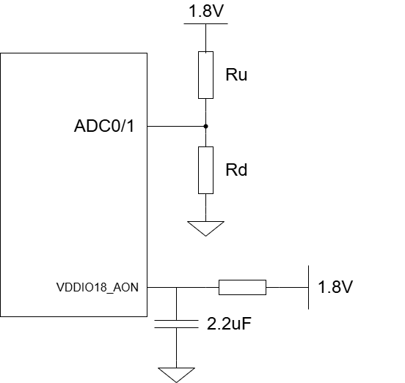
        - ADC电路
在需要硬件版本管理的产品中，可使用两个电阻RU、RD对1.8 V进行分压后连接至其中一个管脚，建议配置RU、RD阻值如下表所示，通过ADC可区分共计17个硬件版本。
          - Board ID电阻配置
Board ID | ADC DATA[9:0] | RU (Ω) | RD (Ω)
0 | 0x000~0x020 | NC | 0
1 | 0x020~0x060 | 1.5K | 100
2 | 0x060~0x0A0 | 1.4K | 200
3 | 0x0A0~0x0E0 | 1.3K | 300
4 | 0x0E0~0x120 | 1.2K | 402
5 | 0x120~0x160 | 1.1K | 510
6 | 0x160~0x1A0 | 1K | 604
7 | 0x1A0~0x1E0 | 909 | 715
8 | 0x1E0~0x220 | 806 | 806
9 | 0x220~0x260 | 715 | 909
10 | 0x260~0x2A0 | 604 | 1K
11 | 0x2A0~0x2E0 | 510 | 1.1K
12 | 0x2E0~0x320 | 402 | 1.2K
13 | 0x320~0x360 | 300 | 1.3K
14 | 0x360~0x3A0 | 200 | 1.4K
15 | 0x3A0~0x3E0 | 100 | 1.5K
16 | 0x3E0~0x3FF | 0 | NC

SPI FLASH电路设计
AX615D支持SPI Flash，可选用NOR或者NAND Flash。
SPI Flash连接方式如下图所示。SFC_WP_IO2需要下拉，推荐下拉电阻阻值为4.7 KΩ。SFC_HOLD_IO3、SFC_CSN0信号需要上拉，推荐上拉电阻阻值为4.7 KΩ。
AX615D的SPI FLASH IO电压支持1.8 V和3.3 V，可以选用支持1.8 V或3.3 V IO电平的Flash芯片。
注：AX615D的SPI Flash信号与EMMC信号管脚复用，设计上不可同时使用SPI Flash与EMMC。
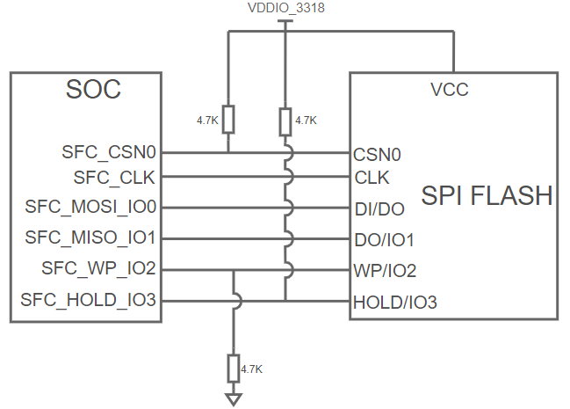
        - SPI FLASH电路

eMMC电路设计
AX615D仅支持四线模式，没有专用EMMC_RSTN管脚，颗粒端RSTN接到GPIO1_A0。
AX615D的EMMC IO电压支持1.8 V和3.3 V，可以选用支持1.8 V或3.3 V IO电平的EMMC芯片。
AX615D的EMMC连接如下图所示。
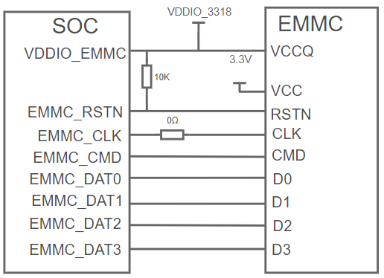
        - eMMC电路

SD Card电路设计
AX615D通过SD_PWR_EN控制Load Switch为SD Card提供3.3 V工作电源，SD_PWR_EN高电平时，Load Switch开启。AX615D不支持UHS-I模式，电路设计如下图所示。
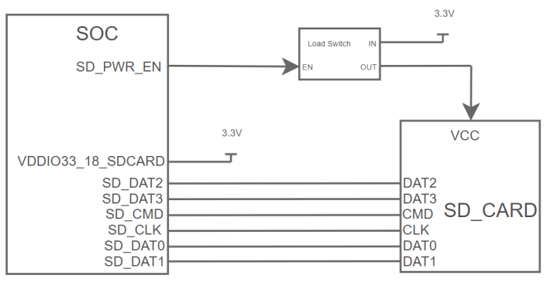
        - 不支持UHS-I模式的SDCard电路设计

Wakeup电路设计
AX615D可进入睡眠模式降低系统功耗，进入睡眠模式后可通过外部信号唤醒。Wake Up引脚默认下拉，高电平唤醒。硬件设计参考下图，管脚收到中断之后，系统进入唤醒流程。
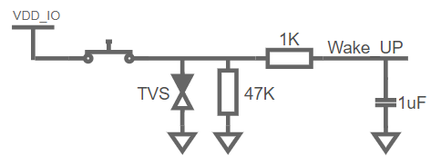
        - Wakeup电路设计
支持唤醒功能的PIN脚如下表：

PIN NO. | PIN NAME
78 | I2C0_SCL
79 | I2C0_SDA
80 | I2C1_SCL
81 | I2C1_SDA
82 | PWM10
83 | PWM11
84 | BOND0
85 | BOND1
86 | BOND2
92 | THM_AIN0
93 | THM_AIN1

电源设计

上电时序
电源上电时序需满足要求如下图所示。
- 注意：
如果IO电源使用了DVDD_3V3，需确保DVDD_3V3晚于DVDD_1V8上电至少大于100us。
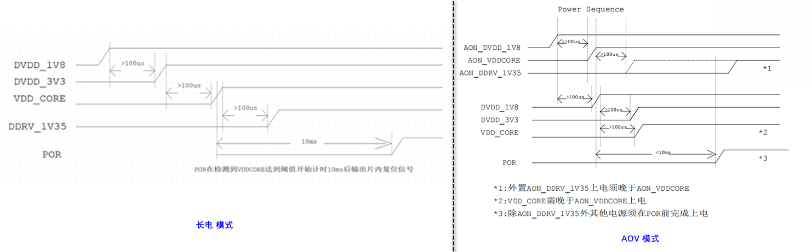
        - 上电时序

VDDCORE电源设计
VDDCORE典型值0.9 V。需选择具有3A电流输出能力（Ipeak必须大于4A）、开关频率尽可能高的DC-DC；在电源纹波允许范围内，尽量减小电感值（建议选择0.47 uH或者0.33 uH），以提高负载瞬态响应。
VDDCORE必须支持动态电压调节功能，AX615D可以配置PWM输出，调节PWM波形的占空比，通过DVS滤波电路微调DC-DC FB引脚电压，从而实现对VDDCORE电压的动态调节。电压调节电路如下图所示：
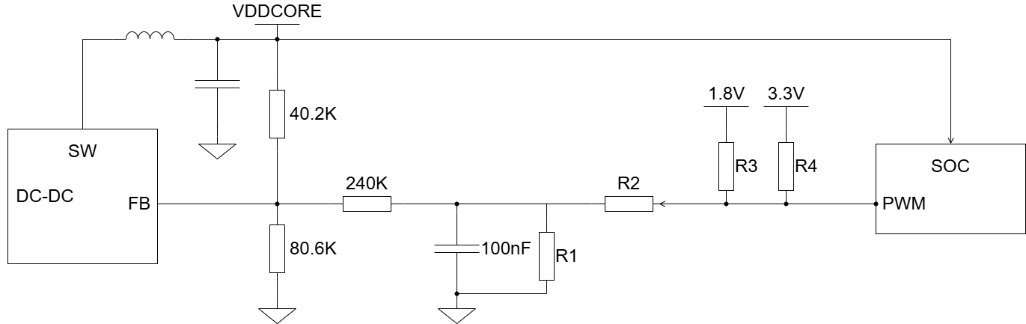
        - VDDCORE动态电压调节电路
PWM默认使用PWM7管脚，选择PWM功能，PWM输出频率设置为240KHz。
PWM占空比与VDDCORE电压之间的关系为：
$$Duty=\frac{6-6×VDDCORE}{1.2}×100\%$$
占空比取值范围0~100%，对应VDDCORE调节范围为0.8 V ~ 1V。占空比默认设置为50%，对应VDDCORE输出为0.9 V。
PWM的IO电源域为1.8 V或者3.3 V。
          - VDDCORE电压调节电路的电阻选择
PWM VIO | R1 | R2 | R3 | R4
1.8 V | 20K | 10K | 30K | NC
3.3 V | 12K | 21K | NC | 33K
- 注意：
- VDDCORE的DCDC的分压电阻40.2K、80.6K，PWM调压通路上的电阻240K、电容值100nF必须跟Demo板完全一样，R1、R2、R3、R4的值必须按上表选择。不能修改。

DDR电源设计
AX615D内置DDR。需使用外置DCDC提供DDR电源，典型值如下列表、供电能力为1A。供电参考DEMO板。
          - SIP DDR电压对照表
Chip PN | SIP DDR type | DRAM Size | DDR_VDDQ
AX615DV100 | DDR2L | 64MB | 1.5V
AX615DV110 | LPDDR2 | 64MB | 1.2V
AX615DV200 | DDR3L | 128MB | 1.35V
AX615DV201 | DDR3L | 256MB | 1.35V
AX615DV210 | LPDDR3 | 128MB | 1.2V
AX615DV220 | DDR3 | 128MB | 1.5V

IO电源设计
硬件设计需提供DVDD_1V8、DVDD_3V3两路IO电源。
AX615D的IO包含多个Group，不同Group的IO电平以及所支持的电压如下表所示。其中G1、G2、G3、G4、G5支持1.8 V或者3.3 V电压，但G1、G4这两个Group共用一个电源Pin，只能使用同一种电压，G2、G3这两个Group共用一个电源Pin，只能使用同一种电压，硬件设计根据具体的需求进行选择。
- 注意：
- G1、G4这两个Group共用一个电源Pin，只能使用同一种电压，G2、G3这两个Group共用一个电源Pin，只能使用同一种电压，上电复位后不可切换。
          - IO电源
Pin Group | IO电源引脚 | 支持电压
G1 | VDDIO3318_G1G4 | 1.8 V或3.3 V
G4 | VDDIO3318_G1G4 | 1.8 V或3.3 V
G2 | VDDIO3318_G2G3 | 1.8 V或3.3 V
G3 | VDDIO3318_G2G3 | 1.8 V或3.3 V
G5 | VDDIO3318_G5 | 1.8 V或3.3 V

外围接口设计

内置EPHY
AX615D的内置EPHY支持100 M/10 M。使用内置EPHY时，外围器件只需要连接Transformer电路即可。
- 注意:
RJ45座子LED指示灯，连接EPHY_LED0和EPHY_LED1。请注意G5域的VDDIO3318_G5电源，如果接的是1.8 V，需确认RJ45座子LED指示灯在1.8 V下驱动电流是否足够。

Video In接口设计
AX615D Video In接口管脚复用MIPI_RX、BT_IN、DVP输入功能。
          - Video In接口引脚复用关系
 | MIPI | VI | BT656
VI |  | VI_BT1120_D0 | BT656_DATA0
 |  | VI_BT1120_D1 | BT656_DATA1
 |  | VI_BT1120_D2 | BT656_DATA2
 |  | VI_BT1120_D3 | BT656_DATA3
 |  | VI_BT1120_D4 | BT656_DATA4
 |  | VI_BT1120_D5 | BT656_DATA5
 |  | VI_BT1120_D6 | BT656_DATA6
 |  | VI_BT1120_D7 | BT656_DATA7
 |  | VI_BT1120_D8
 |  | VI_BT1120_BT1120_CLK0 | BT656_CLK
MIPI_RX | RX_CD0_P | VI_BT1120_D11
MIPI_RX | RX_CD0_N | VI_BT1120_D10
MIPI_RX | RX_CD1_P | VI_BT1120_D13
MIPI_RX | RX_CD1_N | VI_BT1120_D12
MIPI_RX | RX_CD2_P | VI_BT1120_D15
MIPI_RX | RX_CD2_N | VI_BT1120_D14
MIPI_RX | RX_CD3_P | VI_BT1120_D17
MIPI_RX | RX_CD3_N | VI_BT1120_D16
MIPI_RX | RX_CD4_P | VI_BT1120_D19
MIPI_RX | RX_CD4_N | VI_BT1120_D18
MIPI_RX | RX_CD5_P | VI_BT1120_D20
MIPI_RX | RX_CD5_N | VI_BT1120_CLK1

MIPI
AX615D MIPI DPHY输入，包含6对Lane。可配置为1x(4D1C)模式，连接1个4Lane的Sensor；或者配置为2x(2D1C)模式，连接2个2Lane的Sensor。具体配置如下表所示：
          - MIPI RX配置
MIPI | 2x2Lane | 1x 4Lane
RX_CD0_P | CD0~2中任意1对Lane可配置为Clock Lane；  另外2对配置为Data Lane；  建议配置CD2为Clock Lane；  CD0/1为Data Lane  CD3~5中任意1对Lane可配置为Clock Lane；  另外2对配置为Data Lane；  建议配置CD5为Clock Lane；  CD3/4为Data Lane。 | CD0~5中任意1对Lane可以配置为Clock Lane；  另外5对中任意选择4对配置为Data Lane；  建议配置CD2为Clock Lane；  CD0/1/3/4为Data Lane。
RX_CD0_N
RX_CD1_P
RX_CD1_N
RX_CD2_P
RX_CD2_N
RX_CD3_P
RX_CD3_N
RX_CD4_P
RX_CD4_N
RX_CD5_P
RX_CD5_N

BT
AX615D Video Input支持BT.1120、BT.656、BT.601接口。当接BT信号时，BT data in在ISP支持内部全映射，亦即，任何一个Data In都可以作为pixel bits，vsync，hsync。VI_BT1120_CLK0、VI_BT1120_CLK1这两个信号需要连接在一起对接device侧的PCLK。管脚配置请参考《AX615D_SENSOR输入接口场景文档》

DVP
VI | DVP
VI_BT1120_D11
VI_BT1120_D10
VI_BT1120_D13
VI_BT1120_D12
VI_BT1120_D15
VI_BT1120_D14
VI_BT1120_D17 | DVP_DATA6
VI_BT1120_D16 | DVP_DATA5
VI_BT1120_D19 | DVP_HS
VI_BT1120_D18 | DVP_DATA7
VI_BT1120_D20 | DVP_VS
VI_BT1120_CLK1 | DVP_PCLK
VI_BT1120_D0 | DVP_DATA0
VI_BT1120_D1 | DVP_DATA1
VI_BT1120_D2 | DVP_DATA2
VI_BT1120_D3 | DVP_DATA3
VI_BT1120_D4 | DVP_DATA4
VI_BT1120_CLK0 | DVP_PCLK

Video Out接口设计
AX615D Video Out支持sRGB，BT. 656输出接口。
AX615D提供1组sRGB信号。
          - sRGB配置
VO | sRGB
VO_BT1120_D0 | D0
VO_BT1120_D1 | D1
VO_BT1120_D2 | D2
VO_BT1120_D3 | D3
VO_BT1120_D4 | D4
VO_BT1120_D5 | D5
VO_BT1120_D6 | D6
VO_BT1120_D7 | D7
VO_BT1120_D8 | HS
VO_BT1120_D9 | VS
VO_BT1120_CLK | CLK

AX615D提供1组BT.656_OUT信号。
          - BT输出信号引脚复用
VO | BT.656_OUT
VO_BT1120_D0 | D0
VO_BT1120_D1 | D1
VO_BT1120_D2 | D2
VO_BT1120_D3 | D3
VO_BT1120_D4 | D4
VO_BT1120_D5 | D5
VO_BT1120_D6 | D6
VO_BT1120_D7 | D7
VO_BT1120_D8 | HS
VO_BT1120_D9 | VS
VO_BT1120_CLK | CLK

USB接口设计
AX615D支持一个USB 2.0接口，支持OTG。
当使用Micro USB接口时，电路连接如下图所示。USB_ID无专用管脚，使用可用的GPIO管脚即可，用于OTG检测，当USB_ID与GND之间的电阻小于10 Ω时，AX615D作为Host，AX615D使能USB_PWR_EN，开启Load Switch给VBUS提供5V电源输出；反之AX615D作为Device，关闭Load Switch；电容C1取值≥ 100 uF，电容C2取值≤ 10 uF。
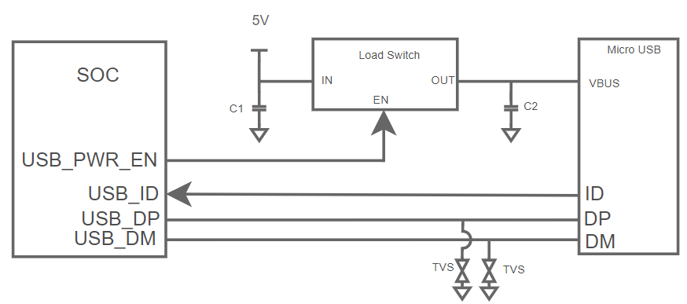
        - USB电路连接图
USB 2.0接口的D+/D-/VBUS信号需要ESD保护，ESD器件的寄生电容要求小于3 pF；ESD器件靠近USB接口放置。

模拟音频接口设计
AX615D提供2组双声道音频输入接口（MIC_INL/R），1组单声道输出接口。
VCAP引脚上需接100nF去耦电容。
Audio模块的输入接口均可作为LINE IN或者MIC_IN的输入通道。如果输入设备为无源MIC,则需要提供MIC_BIAS偏置电压。如果输入设备为有源LINE输出设备（例如：PC），则不需要。
音频输入信号上的隔直电容靠近AX615D放置，电容容值推荐选择1 uF。
为获得较好的音频质量，建议在音频输出管脚Line OUT的外围增加音频放大器以及滤波电路。

I2C设计
AX615D I2C控制器为3个Master，3个Master都为High Speed，最大支持3.4 Mbit/s。AX615D可连接多路Camera Sensor，sensor0/sensor1用一路I2C控制，I2C地址在sensor端做区分。I2C总线分配如下表所示，其他I2C总线根据实际情况而定。
          - I2C总线分配
Pin Name | Func Name | 分配情况
I2C0 | I2C_0 | 用于MIPI RX0所连接的Camera Sensor 0的配置总线
I2C0 | I2C_0 | 用于MIPI RX1所连接的Camera Sensor 1的配置总线
I2C1 | I2C_1 | 用于系统I2C的配置总线
I2C2 | I2C_2 | 用于外设I2C的配置总线

SPI设计
AX615D支持三组Master SPI，分别是SPI_m0、SPI_m1、SPI_m2，硬件设计时需根据Pin的Func Name来选择。

UART设计
AX615D支持多组UART，硬件设计时需根据Pin的Func Name来选择。
IO电源供3.3V，UART做打印log功能。防止SOC掉电时，串口小板倒灌电流给SOC，串口电路设计如下：
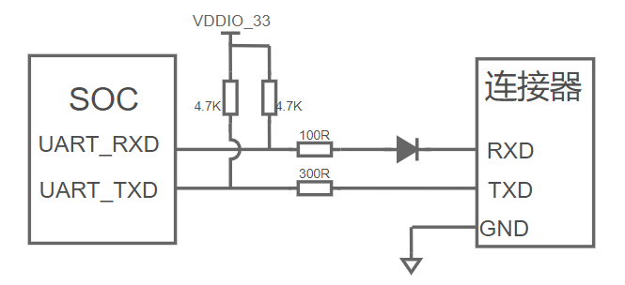
        - 串口电路连接图

IIS设计
AX615D支持两组IIS，硬件设计时需根据Pin的Func Name来选择。

GPIO设计
AX615D所有GPIO都具备中断和施密特触发功能，可独立使用。
软件配置可参考《AX外围设备驱动开发指南》的第2.2小节。

PCB设计

PCB Stack Up
AX615D芯片支持通孔板PCB，建议采用至少4层的层叠结构。
板厚1.6mm的4层通孔PCB层叠结构请参考下表：
          - 4层通孔PCB层叠结构
Subclass Name | Type | Material | Thickness (mm)
 | Silk screen |  | 0.015
 | solder mask |  | 0.02
L1 Top | conductor | 1/3 OZ + PT | 0.035
 | pp | 1080（RC65%） | 0.07
L2 GND | conductor | 1 OZ copper | 0.035
 | core | CORE | 1.23
L3 Signal | conductor | 1 OZ copper | 0.035
 | pp | 1080（RC65%） | 0.07
L4 Bottom | conductor | 1/3 OZ + PT | 0.035
 | solder mask |  | 0.02
 | Silk screen |  | 0.015
Total |  |  | 1.58

VDDCORE电源设计
VDDCORE电源设计、去耦电容类型与数量请复制Demo板的设计。
DC-DC输出电压反馈建议采用Remote Sense，检测节点放着在AX615D 下方的电源过孔上。VDDCORE Remote Sense走线如图所示。
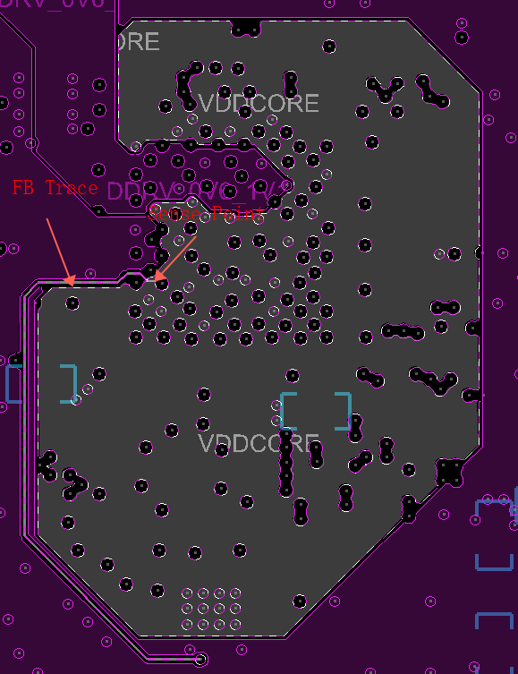
        - VDDCORE Remote Sense

晶体电路设计
晶体的XIN，XOUT走线全程做包地处理，并保证这些信号有完整的参考平面。晶体电路下方不能有高速信号穿过。

eMMC信号设计
eMMC走线阻抗控制50 Ω；EMMC_DAT[0:3]，EMMC_CMD参考EMMC_CLK做等长约束，差值控制在±300 mil以内；
信号走线以GND为参考平面，并保持参考平面完整；
信号过孔附近放置GND过孔，保证回流路径连续。

ePHY信号设计
MDI0+/-、MDI1+/-差分阻抗控制100 Ω，对内等长约束，误差控制在±5mil以内；信号以GND_EARTH为参考平面，并保持参考平面完整；
GND_EARTH与GND之间用0 Ω电阻单点连接。若产品机壳接地，GND_EARTH铜皮需留螺丝孔，通过螺丝连接到产品机壳上；
Transformer正下方铜皮挖空处理。

USB信号设计
USB差分阻抗控制90 Ω，对内等长偏差控制在±5 mil；
差分信号以GND为参考平面，并保持参考平面完整；
差分信号过孔附近放置GND过孔，保证回流路径连续。

MIPI信号设计
MIPI差分阻抗控制100 Ω，对内等长偏差控制在±10 mil；Data Lane参考Clock Lane做等长约束，差值控制在-10 mil ~ +60 mil以内；
差分信号以GND为参考平面，并保持参考平面完整；
差分信号过孔附近放置GND过孔，保证回流路径连续。

过孔设计
过孔需使能“Unused Via Suppression”选项，可降低过孔的寄生电容，并且有利于过孔之间电源、GND铜皮的铺设。特别是DDR等高速信号需特别注意处理。

整机ESD设计
AX615D芯片自身的ESD测试，通过±2KV测试，符合行业标准。客户需根据产品整机ESD测试标准，对接口等部位做相应的ESD防护设计。本文针对整机ESD设计提供了一些设计建议供参考：
- PCB布局时，注意把DDR/EMMC/Crystal等小系统电路远离金属接口；
- 对外接口，例如音频输入输出接口、USB、网口等信号/电源网络需要在靠近接口的位置放置TVS等ESD防护器件，并充分接地；
- 定位孔采用金属化孔，并与GND连接，确保GND通过螺丝与金属外壳充分连接；
- 整机设备如果接地，保护地（GND_EARTH）与数字地（GND）需分割并采用单点连接；
- 接口连机器外壳建议采用金属外壳，并与整机外壳充分接触，必要时采用导电泡棉实现连接器与外壳的充分接触。

