Izzie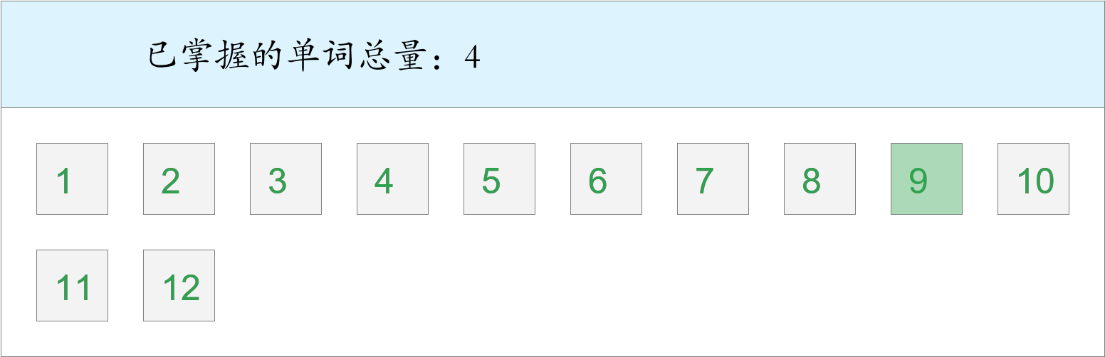

时间：2023-02-23 22:47:00

考察范围：第9单元

|  |  |  |
| --- | --- | --- |
| Ben is Janet's .（n. 亲戚） | | |
| a strong man in the photo.（存在；有） | | |
| I have a .（n. 表/堂兄弟姐妹） | | |
| The lady is my aunt.（adj. 矮的；短的） | | |
| This is a of my family.（n. 照片） | | |
| My is very thin.（n. 奶奶；外婆） | | |
| My brother is very .（adj. 重的） | | |
| He is over .（adv. 那里；在那里） | | |
| The old man is my .（n. 爷爷；外公） | | |
| Who is this girl?（adj. 可爱的） | | |