牛悦时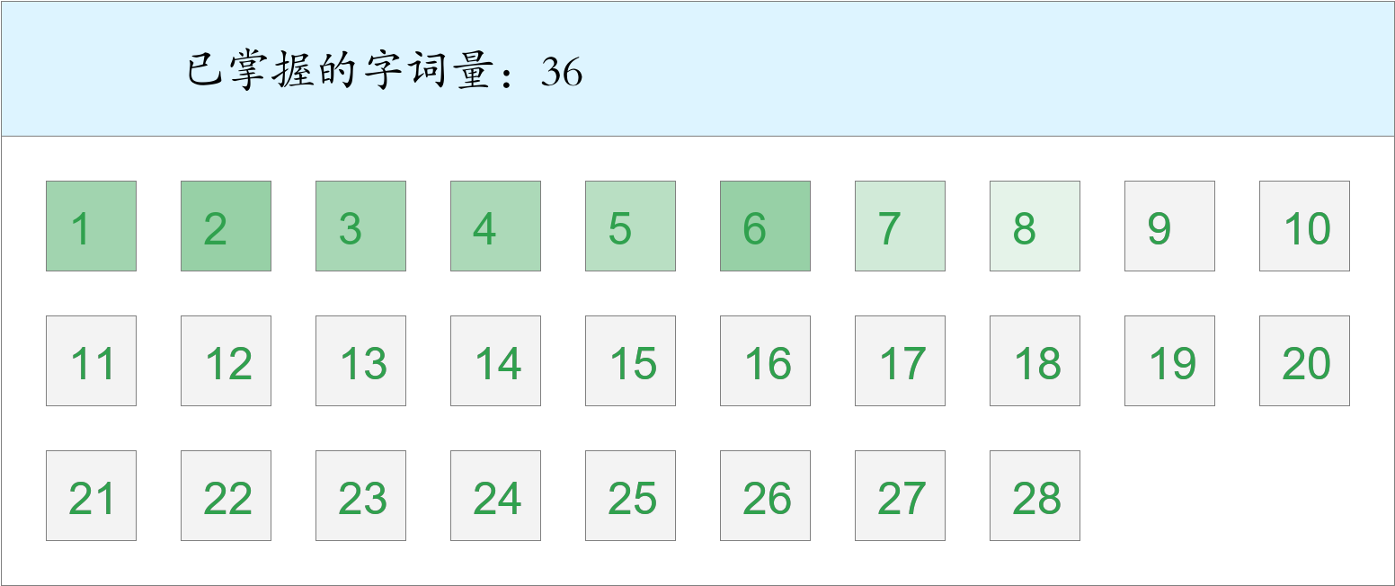 *🚩🚩🚩勇冠三军！*

时间：2023-03-01 12:37:05

考察范围：第3、4、5、6、8、9、10课

|  |  |  |
| --- | --- | --- |
| píng jiǎng | kāi xīn | hǎo shì |
|  |  |  |
| yǐ qián | hái yǒu | qián fāng |
|  |  |  |
| lái bù jí | dēng guāng | yuán zhū bǐ |
|  |  |  |
| yān | tái dēng | jìn |
|  |  |  |
| zhōng yāng | nèi xiē | suì |
|  |  |  |
| yáng guāng | guǒ rán | jīn guāng shǎn shǎn |
|  |  |  |
| zhī shí | yún hǎi |  |
|  |  |  |

莫子彦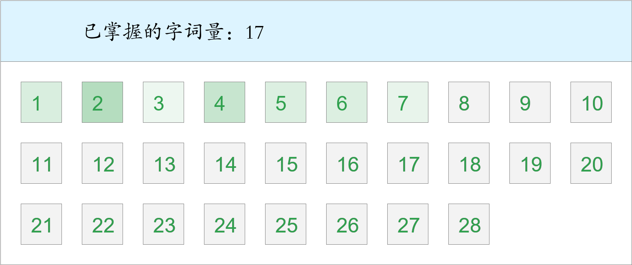 *🚩🚩🚩Triple kill！*

时间：2023-03-01 12:37:05

考察范围：第2、4、5、6、7、8、9课

|  |  |  |
| --- | --- | --- |
| tóu fà | zhào | kāi xīn |
|  |  |  |
| gōng zuò | shān dǐng | yún hǎi |
|  |  |  |
| shì qíng | zhù zi | yān |
|  |  |  |
| huā duǒ | yǐ qián |  |
|  |  |  |

李子瑞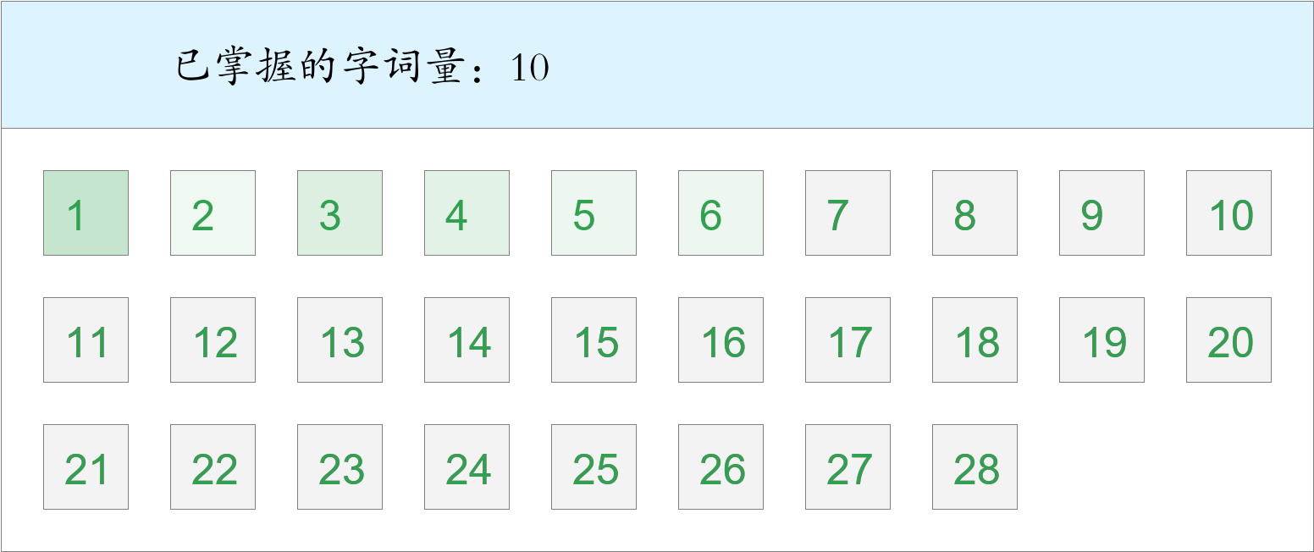

时间：2023-03-01 12:37:05

考察范围：第1、5、6、8、9课

|  |  |  |
| --- | --- | --- |
| tóu dǐng | yī | dù pí |
|  |  |  |
| lú | bìng | lái bù jí |
|  |  |  |
| gǒu | yǐ qián | nà biān |
|  |  |  |
| guà |  |  |
|  |  |  |

汤敬同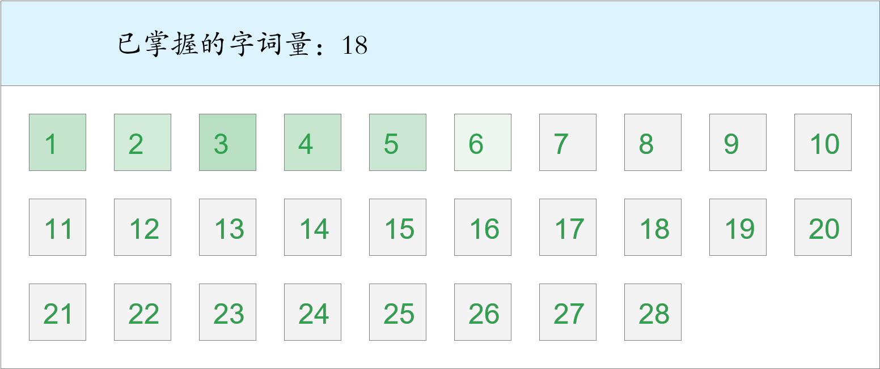 *🚩🚩🚩勇冠三军！*

时间：2023-03-01 12:37:05

考察范围：第1、3、4、5、6、7、8、10课

|  |  |  |
| --- | --- | --- |
| yī biān | bàn fǎ | guà |
|  |  |  |
| diàn yǐng | bào zhǐ | bì |
|  |  |  |
| shù mù | hái zi | zhōng yāng |
|  |  |  |
| nà biān | zhōng wǔ |  |
|  |  |  |

吴怀谷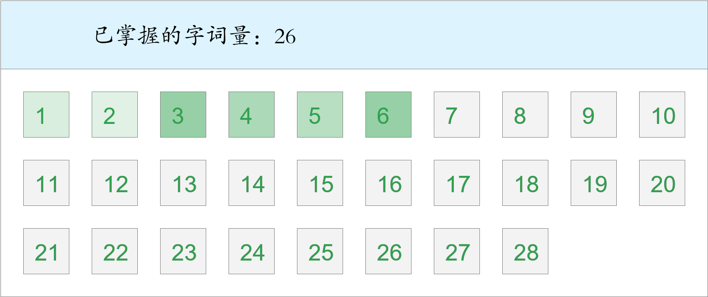 *🚩🚩Double kill！*

时间：2023-03-01 12:37:05

考察范围：第3、4、5、6、7、9、10课

|  |  |  |
| --- | --- | --- |
| gù shì | chuán shēn | dào dǐ |
|  |  |  |
| tái dēng | shēng | nèi xiē |
|  |  |  |
| gǒu | měi lì | shān dǐng |
|  |  |  |
| zhī shí | huà | pí máo |
|  |  |  |
| zhī |  |  |
|  |  |  |

冯思语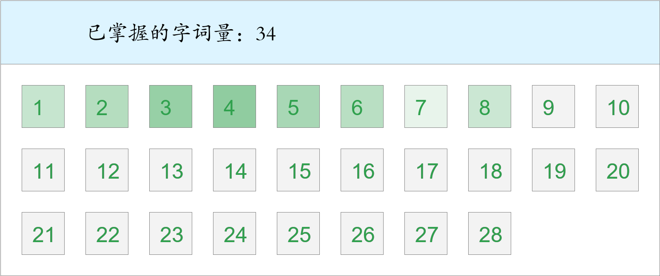 *🚩🚩🚩Triple kill！*

时间：2023-03-01 12:37:05

考察范围：第2、4、5、6、7、8、9、10课

|  |  |  |
| --- | --- | --- |
| bìng | yǐ qián | kāi xīn |
|  |  |  |
| piàn | huài shì | shān dǐng |
|  |  |  |
| zhào | shí tou | xiān |
|  |  |  |
| zhōng yāng | qún shān | zhè shí |
|  |  |  |
| ná | tā men | nán bù |
|  |  |  |
| shí jiān | chū lái | tái dēng |
|  |  |  |
| chuán shēn | jìn |  |
|  |  |  |

陈浩轩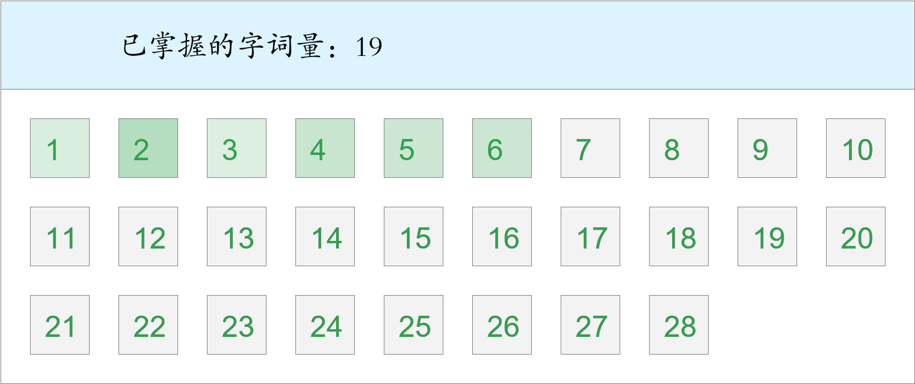 *🚩旗开得胜！*

时间：2023-03-01 12:37:05

考察范围：第4、5、6、7、8、9、10课

|  |  |  |
| --- | --- | --- |
| ná | yī tóng | bì |
|  |  |  |
| chēng | chū guó | hǎo shì |
|  |  |  |
| huài shì | yī biān | qián fāng |
|  |  |  |
| fú | míng liàng | chèng gǎn |
|  |  |  |
| zhī | dì fāng | guà |
|  |  |  |
| lái bù jí | zhōng yāng |  |
|  |  |  |

张宝贤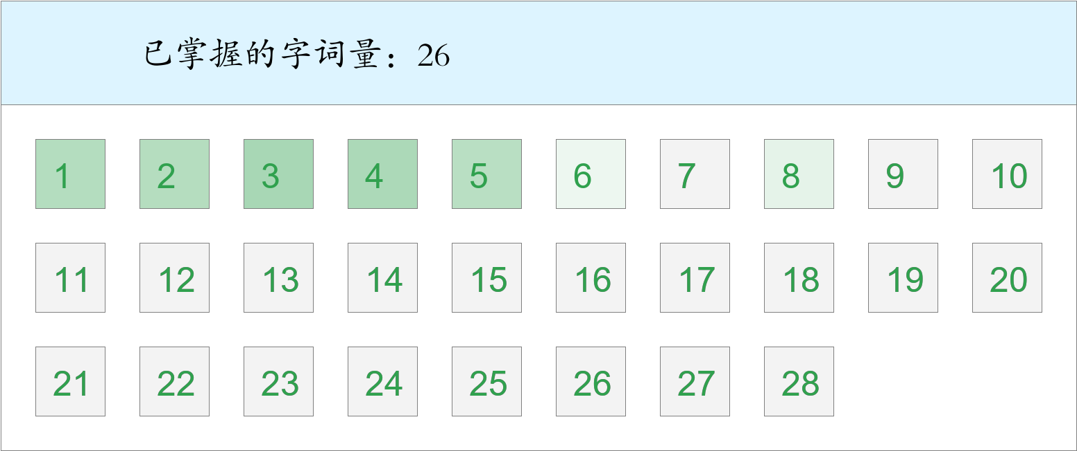 *🚩首胜！*

时间：2023-03-01 12:37:05

考察范围：第2、3、4、5、6、7、9、10课

|  |  |  |
| --- | --- | --- |
| fēng | gōng zuò | zhǐ yào |
|  |  |  |
| zuò | liǎn | shì qíng |
|  |  |  |
| yī dòng bù dòng | huài shì | shēng |
|  |  |  |
| dì fāng | yáng guāng | sì hǎi wéi jiā |
|  |  |  |
| míng shèng gǔ jī | xiān | bàn fǎ |
|  |  |  |
| zhǎn xiàn |  |  |
|  |  |  |

黄乐奇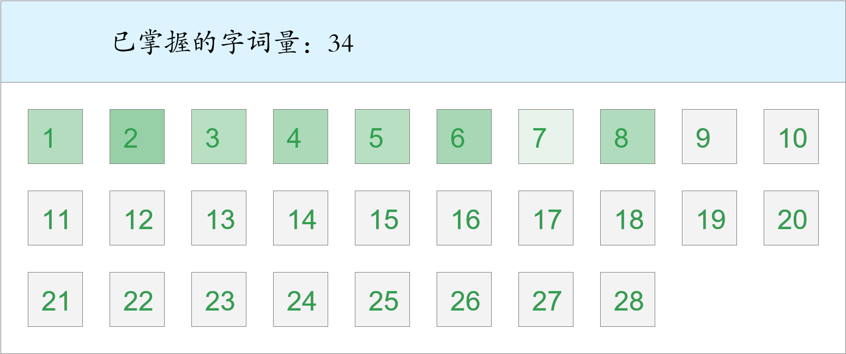 *🚩🚩🚩Triple kill！*

时间：2023-03-01 12:37:05

考察范围：第2、3、4、5、6、7、8、9、10课

|  |  |  |
| --- | --- | --- |
| dào dǐ | fú | rú guǒ |
|  |  |  |
| zhù zi | yī biān | chuán shēn |
|  |  |  |
| zhī | jìn | chū guó |
|  |  |  |
| shí tou | diàn yǐng | dēng guāng |
|  |  |  |
| liǎn | jīn guāng shǎn shǎn | gù shì |
|  |  |  |
| hái yǒu | píng jiǎng | tóu fà |
|  |  |  |
| huài shì | gōng zuò | qián fāng |
|  |  |  |

周瑶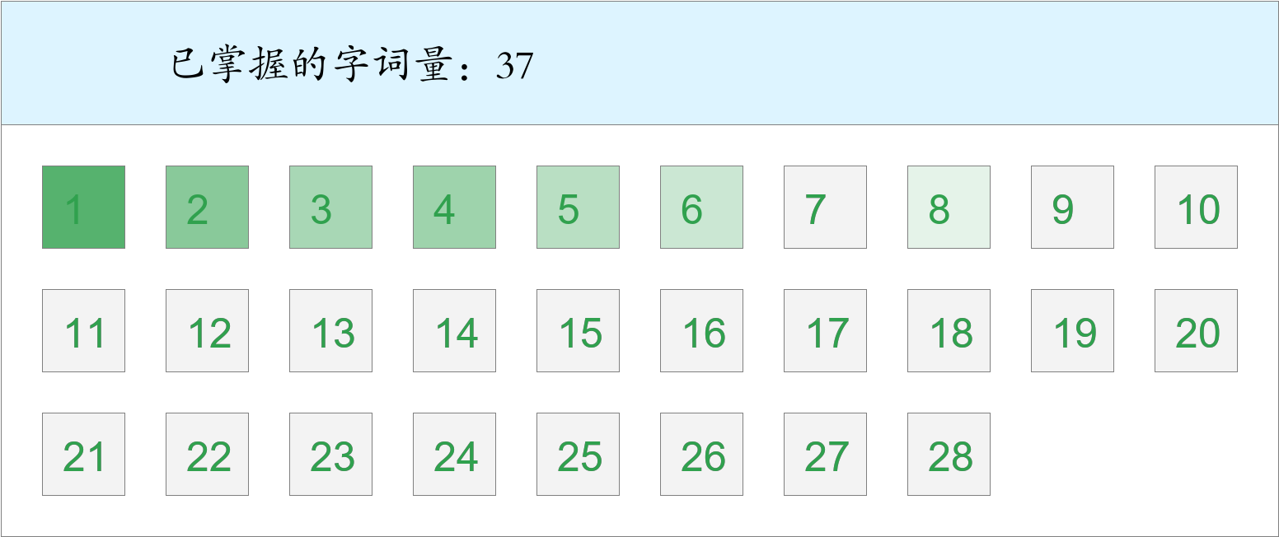 *🚩🚩两胜！*

时间：2023-03-01 12:37:05

考察范围：第2、3、4、5、6、7、8、9、10课

|  |  |  |
| --- | --- | --- |
| dào dǐ | sì hǎi wéi jiā | bì |
|  |  |  |
| hái yǒu | piàn | hǎo shì |
|  |  |  |
| lái bù jí | wān | fēng |
|  |  |  |
| yún hǎi | suì | zhàn |
|  |  |  |
| yī | jù shí | shù mù |
|  |  |  |
| céng | dēng guāng | bào zhǐ |
|  |  |  |
| shān dǐng | guǒ rán | nèi xiē |
|  |  |  |

周浚霖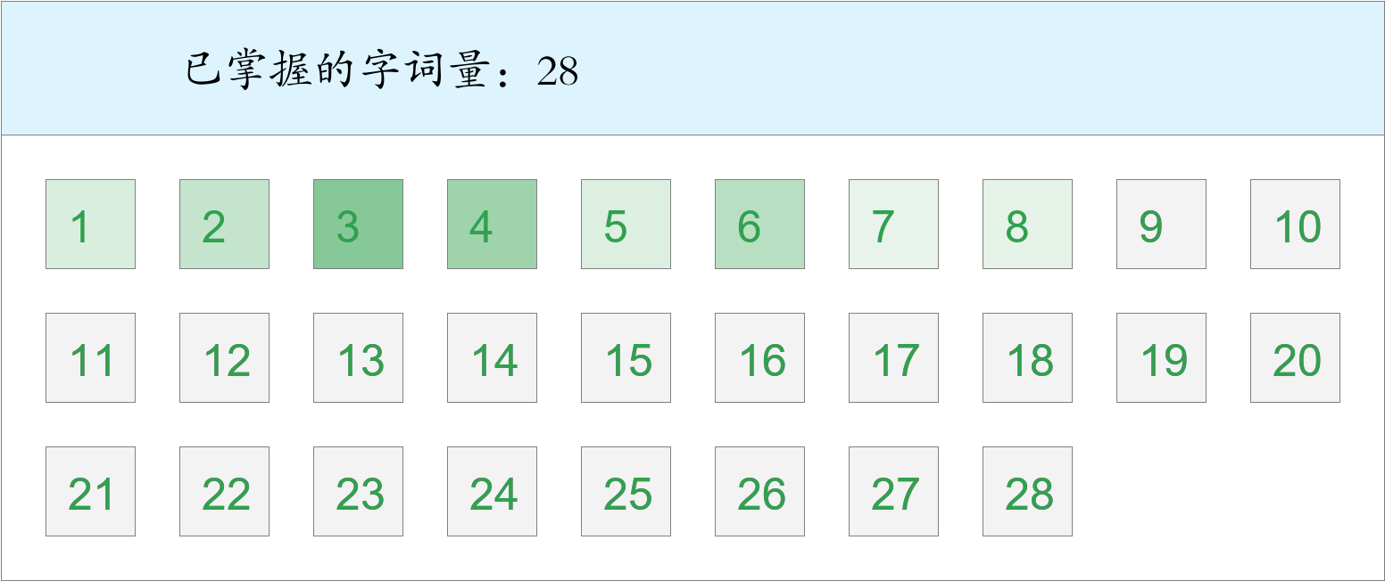

时间：2023-03-01 12:37:05

考察范围：第1、2、3、4、5、6、7、8、9、10课

|  |  |  |
| --- | --- | --- |
| shì qíng | zhè shí | liǎn |
|  |  |  |
| zhī | pí máo | jí |
|  |  |  |
| chū guó | yuán zhū bǐ | yān |
|  |  |  |
| yáng guāng | chèng gǎn | jìn |
|  |  |  |
| shù mù | yī biān | lú |
|  |  |  |
| shí jiān | zhào | qún shān |
|  |  |  |
| nǎ lǐ | nán bù |  |
|  |  |  |

侯正霖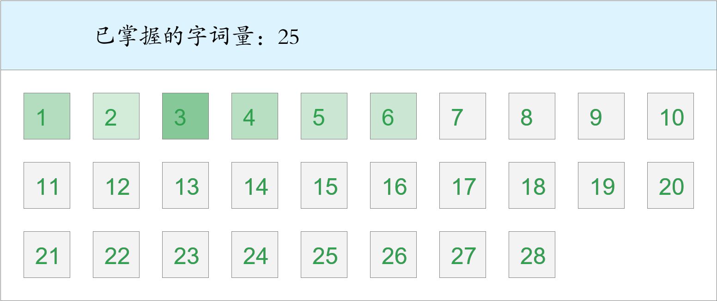 *🚩旗开得胜！*

时间：2023-03-01 12:37:05

考察范围：第2、3、4、5、6、8、9、10课

|  |  |  |
| --- | --- | --- |
| bào zhǐ | ná | guà |
|  |  |  |
| zhè shí | píng jiǎng | biàn |
|  |  |  |
| bàn fǎ | zuò | yáng guāng |
|  |  |  |
| tái dēng | hǎo shì | chū lái |
|  |  |  |
| guǒ rán | chū guó | dào dǐ |
|  |  |  |
| nán bù | zhù zi | yān |
|  |  |  |
| qún shān | měi lì |  |
|  |  |  |

钱芷霖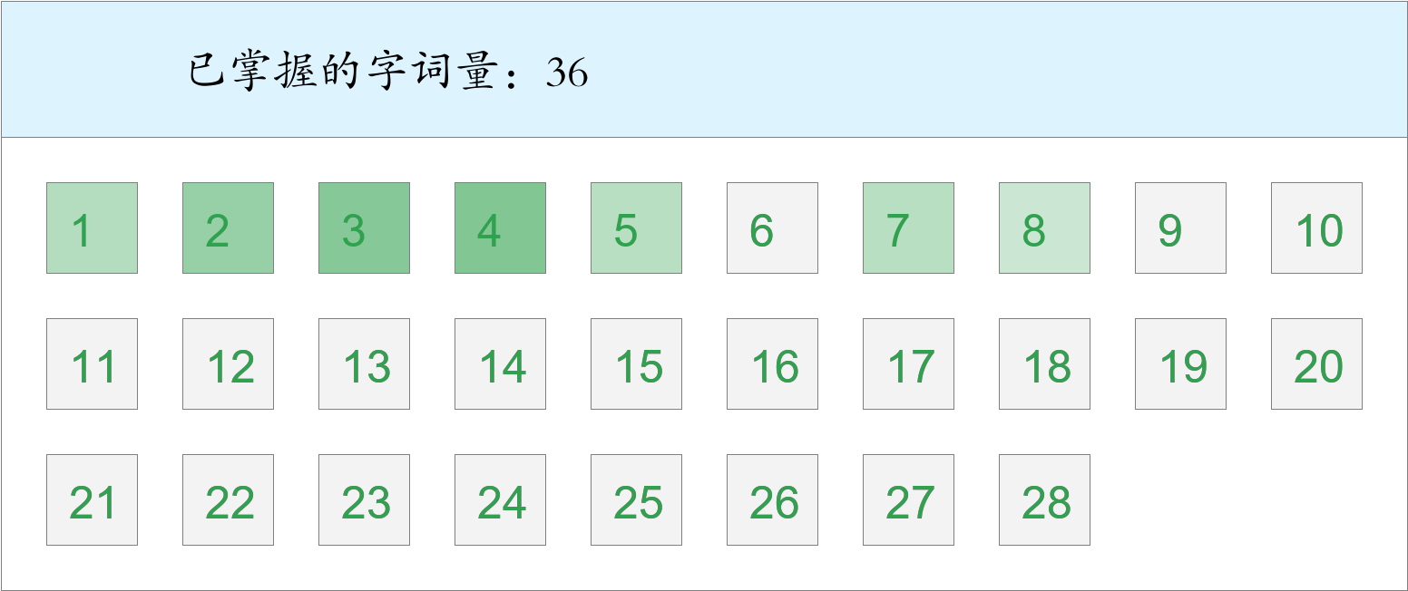 *🚩🚩🚩三捷！*

时间：2023-03-01 12:37:05

考察范围：第2、3、4、5、6、8、9、10课

|  |  |  |
| --- | --- | --- |
| rén men | gèng | lì qì |
|  |  |  |
| nà lǐ | chū lái | rú guǒ |
|  |  |  |
| zhè shí | yǐ qián | měi dāng |
|  |  |  |
| nán bù | fēng | lú |
|  |  |  |
| zhōng wǔ | zhī | chēng |
|  |  |  |
| shēng | huài shì | huà |
|  |  |  |
| yī tóng | gōng zuò | míng shèng gǔ jī |
|  |  |  |

莫韦暄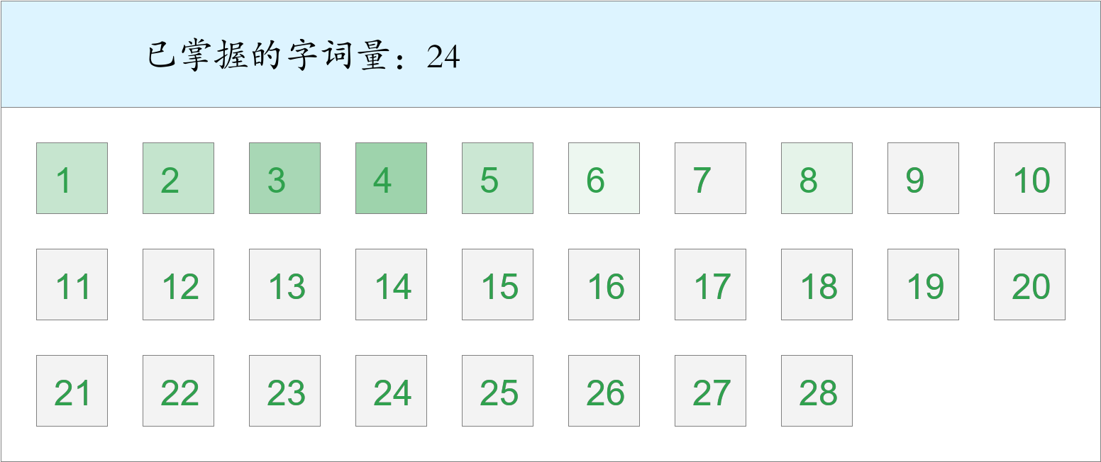 *🚩🚩Double kill！*

时间：2023-03-01 12:37:05

考察范围：第2、4、5、6、8、10课

|  |  |  |
| --- | --- | --- |
| zhào | huā duǒ | kāi xīn |
|  |  |  |
| tái dēng | shì qíng | zhǎn xiàn |
|  |  |  |
| zhōng yāng | chuán shēn | yī |
|  |  |  |
| biàn | fēng | ná |
|  |  |  |
| píng jiǎng |  |  |
|  |  |  |

陈盈彤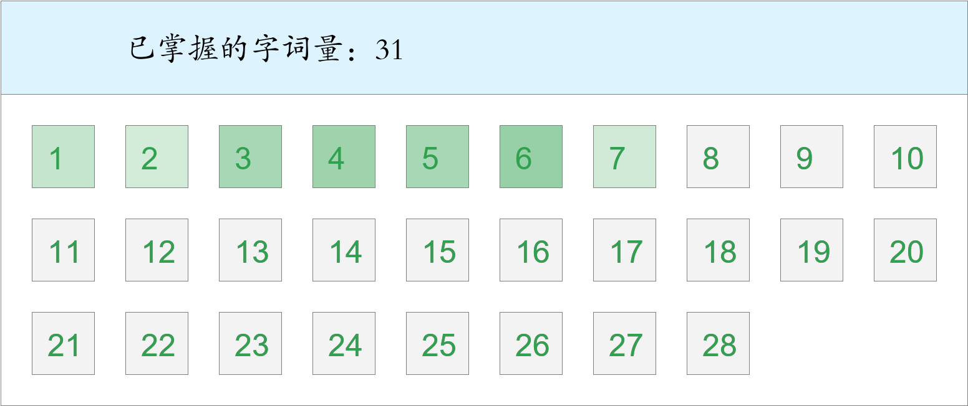 *🚩🚩Double kill！*

时间：2023-03-01 12:37:05

考察范围：第1、2、3、5、6、7、8、9、10课

|  |  |  |
| --- | --- | --- |
| zhào | yǐ qián | zhī shí |
|  |  |  |
| lú | huài shì | jīn tiān |
|  |  |  |
| nà biān | bào zhǐ | píng jiǎng |
|  |  |  |
| zhǎn xiàn | shì qíng | dēng guāng |
|  |  |  |
| hǒng | bì | shēng |
|  |  |  |
| zhī | qián fāng | guà |
|  |  |  |
| céng | biàn | zhōng wǔ |
|  |  |  |

连贺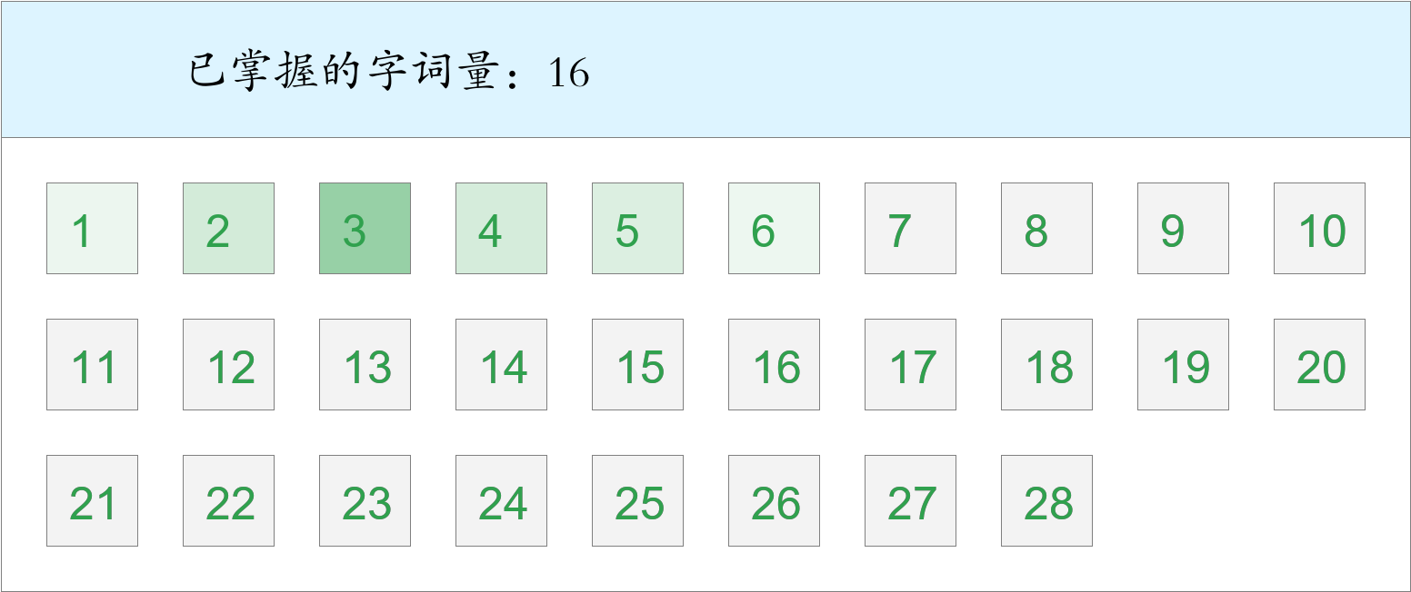

时间：2023-03-01 12:37:05

考察范围：第1、3、4、5、6、7、8、10课

|  |  |  |
| --- | --- | --- |
| guǒ rán | píng jiǎng | yī tóng |
|  |  |  |
| liǎng | shí tou | yī |
|  |  |  |
| bào zhǐ | tóu fà | dēng guāng |
|  |  |  |
| sì hǎi wéi jiā | hái yǒu |  |
|  |  |  |

张陈煜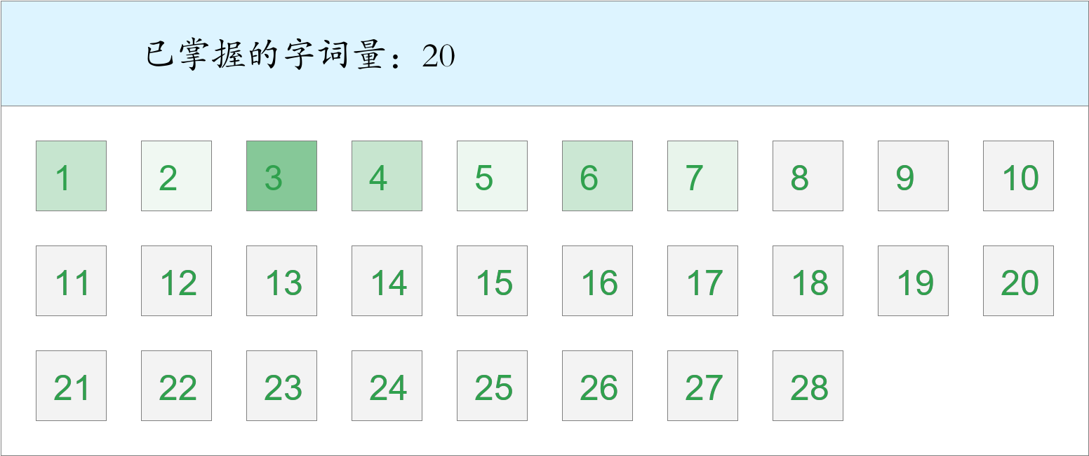 *🚩First Blood！*

时间：2023-03-01 12:37:05

考察范围：第1、3、4、5、6、7、8、9、10课

|  |  |  |
| --- | --- | --- |
| chuán shēn | fú | tiào |
|  |  |  |
| kuān | tā | gèng |
|  |  |  |
| zhī shí | měi dāng | hǒng |
|  |  |  |
| shān dǐng | zhōng wǔ | gù shì |
|  |  |  |
| jīn guāng shǎn shǎn | diàn yǐng | bào zhǐ |
|  |  |  |
| kàn jiàn | lú |  |
|  |  |  |