牛悦时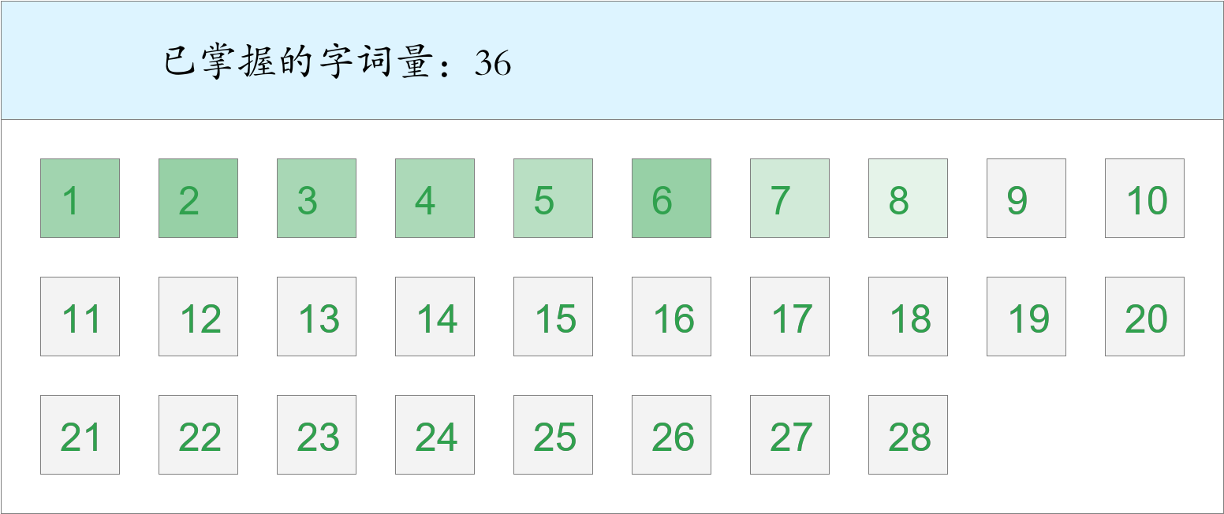 *🚩🚩🚩Triple kill！*

时间：2023-03-01 12:41:09

考察范围：第3、4、5、6、7、8、9、10课

|  |  |  |
| --- | --- | --- |
| píng jiǎng | kāi xīn | hǎo shì |
|  |  |  |
| yǐ qián | hái yǒu | shēng |
|  |  |  |
| zhǎn xiàn | bì | yī |
|  |  |  |
| chuāng wài | shān dǐng | wèi |
|  |  |  |
| jīn tiān | diàn yǐng | shí tou |
|  |  |  |
| yáng guāng | zhōng yāng | chēng |
|  |  |  |
| zhī shí | dēng guāng |  |
|  |  |  |