牛悦时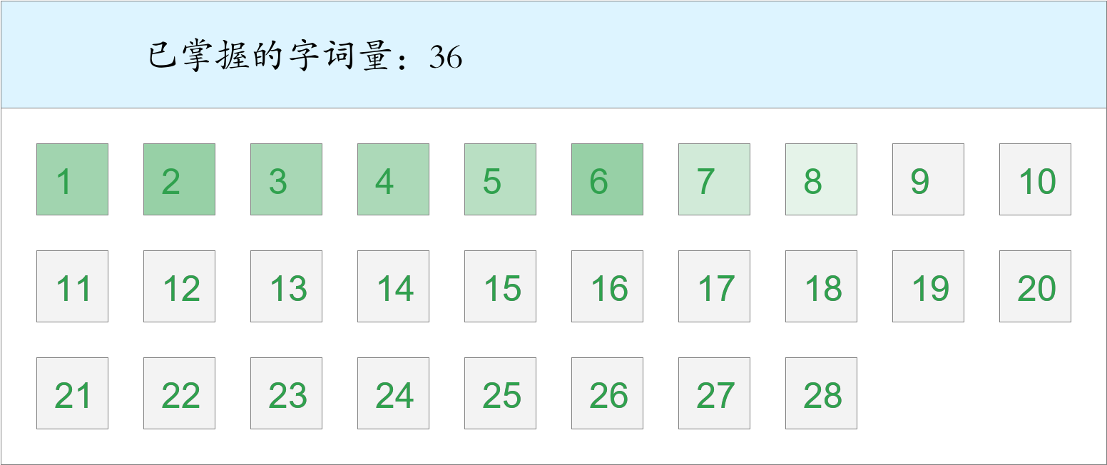 *🚩🚩🚩勇冠三军！*

时间：2023-03-01 12:42:07

考察范围：第3、4、5、6、7、8、9、10课

|  |  |  |
| --- | --- | --- |
| píng jiǎng | kāi xīn | hǎo shì |
|  |  |  |
| yǐ qián | hái yǒu | chuān |
|  |  |  |
| jīn tiān | jù shí | zhōng yāng |
|  |  |  |
| qián fāng | xiān | jīn guāng shǎn shǎn |
|  |  |  |
| xiàng | fú | yī dòng bù dòng |
|  |  |  |
| yáng guāng | huài shì | chū lái |
|  |  |  |
| zhī shí | guǒ rán |  |
|  |  |  |