牛悦时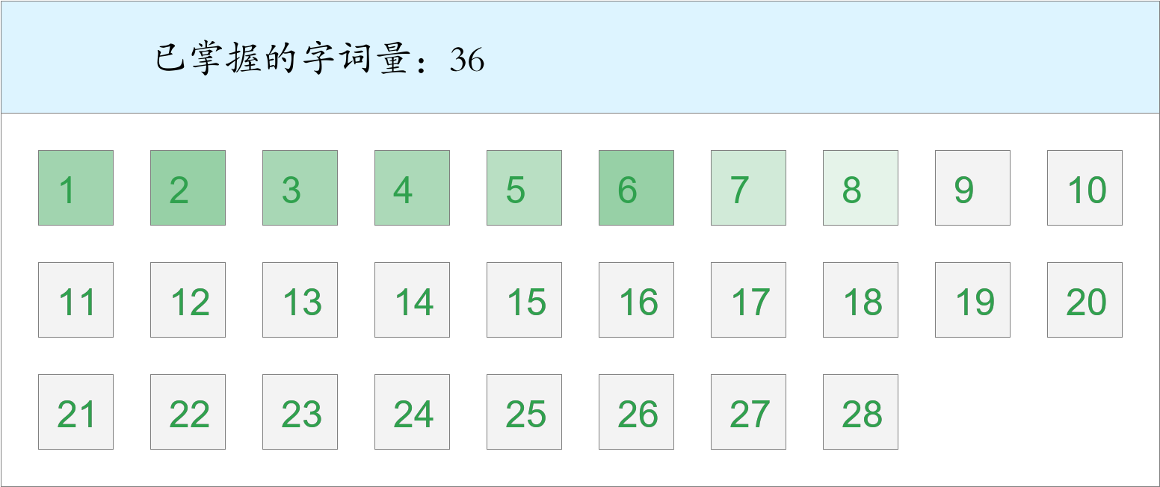 *🚩🚩🚩三捷！*

时间：2023-03-01 12:42:26

考察范围：第3、4、5、6、7、8、9、10课

|  |  |  |
| --- | --- | --- |
| píng jiǎng | kāi xīn | hǎo shì |
|  |  |  |
| yǐ qián | hái yǒu | dēng guāng |
|  |  |  |
| suì | wān | xiān |
|  |  |  |
| jìn | chuán shēn | tā men |
|  |  |  |
| shān dǐng | tóu fà | jīn tiān |
|  |  |  |
| yáng guāng | qún shān | qián fāng |
|  |  |  |
| zhī shí | ná |  |
|  |  |  |