牛悦时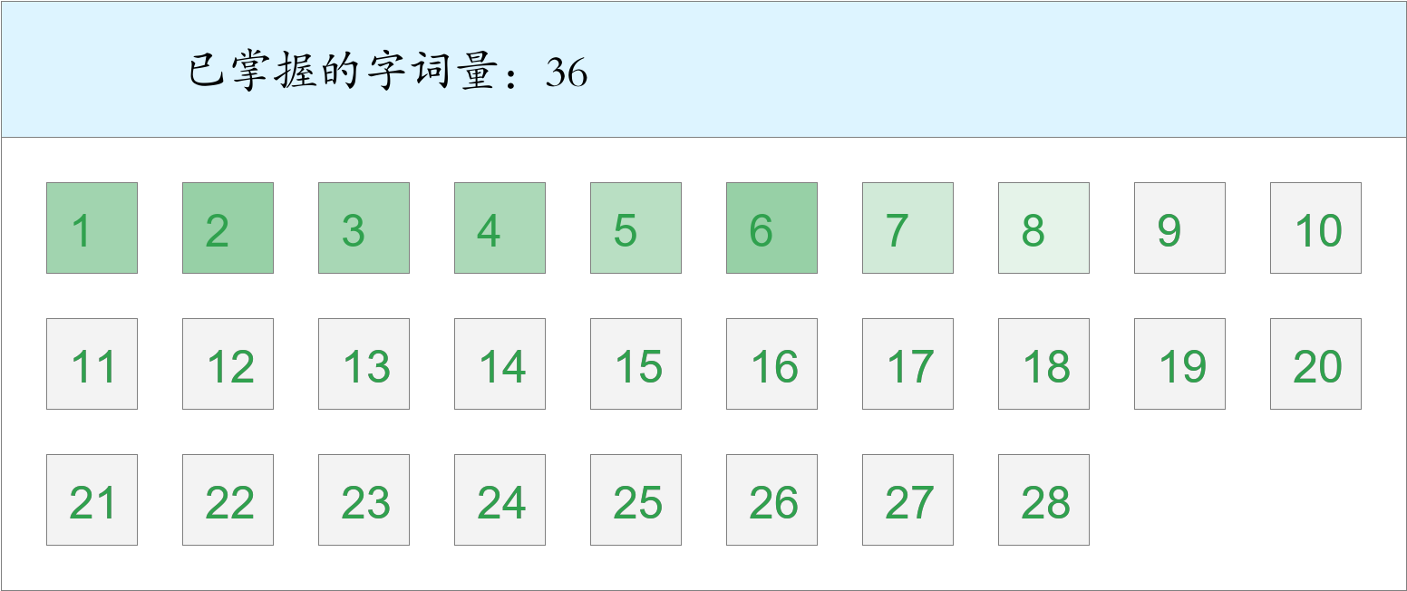 *🚩🚩🚩Triple kill！*

时间：2023-03-01 12:43:54

考察范围：第3、4、5、6、7、8、9课

|  |  |  |
| --- | --- | --- |
| píng jiǎng | kāi xīn | hǎo shì |
|  |  |  |
| yǐ qián | hái yǒu | jù shí |
|  |  |  |
| gù shì | shā | chuán shēn |
|  |  |  |
| tóu fà | jīn tiān | hǒng |
|  |  |  |
| qián fāng | guǒ rán | jìn |
|  |  |  |
| yáng guāng | zhè shí | yī |
|  |  |  |
| zhī shí | yī dòng bù dòng |  |
|  |  |  |