牛悦时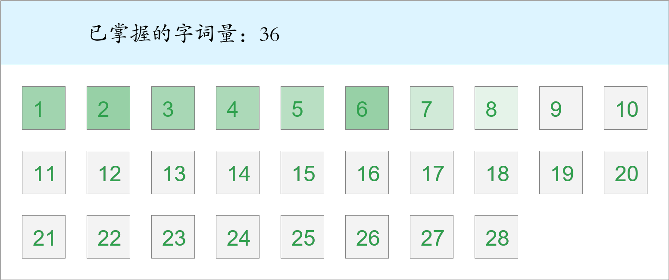 *🚩🚩🚩Triple kill！*

时间：2023-03-01 12:44:06

考察范围：第3、4、5、6、7、8、9课

|  |  |  |
| --- | --- | --- |
| píng jiǎng | kāi xīn | hǎo shì |
|  |  |  |
| yǐ qián | hái yǒu | nèi xiē |
|  |  |  |
| dì fāng | chuāng wài | wèi |
|  |  |  |
| chuán shēn | jìn | shí jiān |
|  |  |  |
| jīn tiān | guà | hǒng |
|  |  |  |
| yáng guāng | qián fāng | chū lái |
|  |  |  |
| zhī shí | yún hǎi |  |
|  |  |  |