牛悦时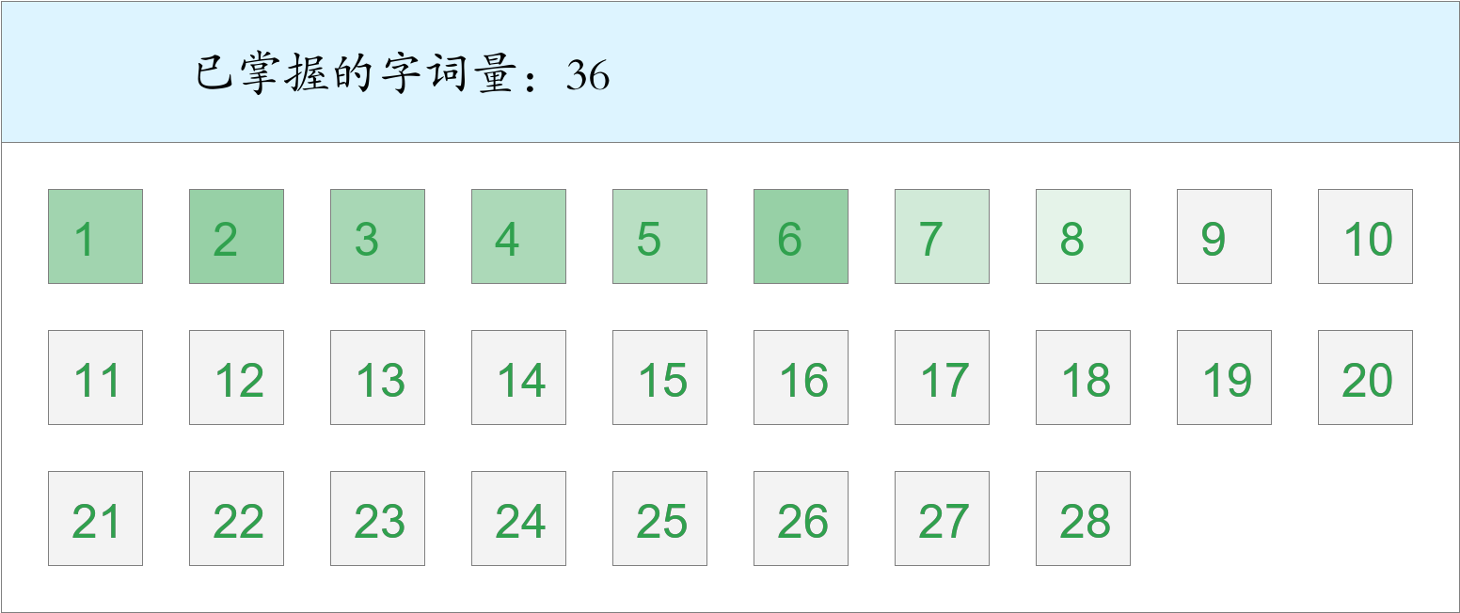 *🚩🚩🚩三捷！*

时间：2023-03-01 12:45:57

考察范围：第3、4、5、6、7、8、9、10课

|  |  |  |
| --- | --- | --- |
| píng jiǎng | kāi xīn | hǎo shì |
|  |  |  |
| yǐ qián | hái yǒu | ná |
|  |  |  |
| hǒng | tóu fà | huà |
|  |  |  |
| chū guó | dēng guāng | gù shì |
|  |  |  |
| yī biān | guà | tā men |
|  |  |  |
| yáng guāng | zhè shí | jīn guāng shǎn shǎn |
|  |  |  |
| zhī shí | jù shí |  |
|  |  |  |