牛悦时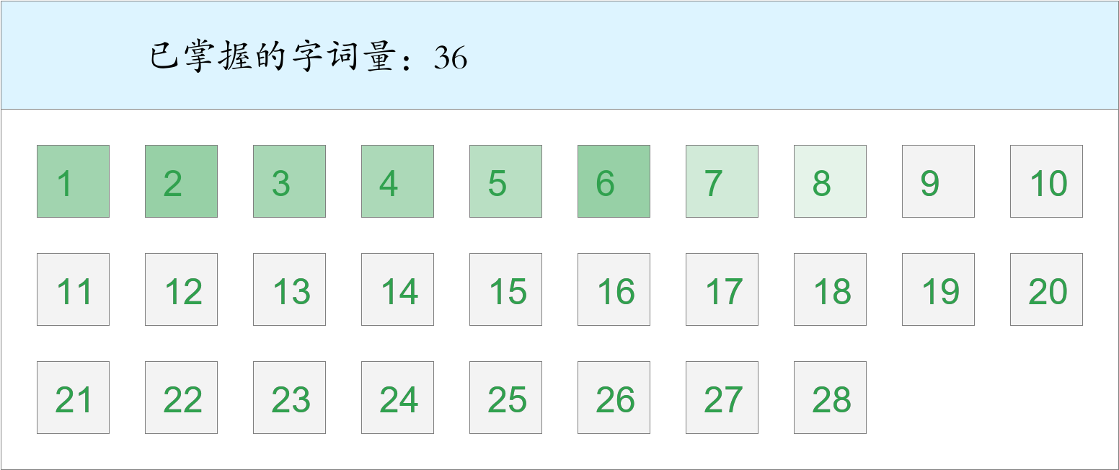 *🚩🚩🚩勇冠三军！*

时间：2023-03-01 12:48:31

考察范围：第3、4、5、6、7、8、9、10课

|  |  |  |
| --- | --- | --- |
| píng jiǎng | kāi xīn | hǎo shì |
|  |  |  |
| yǐ qián | hái yǒu | dì fāng |
|  |  |  |
| jù shí | míng shèng gǔ jī | zhōng yāng |
|  |  |  |
| chuán shēn | shēng | dào dǐ |
|  |  |  |
| chēng | měi dāng | shù mù |
|  |  |  |
| yáng guāng | jìn | zhè shí |
|  |  |  |
| zhī shí | shā |  |
|  |  |  |