牛悦时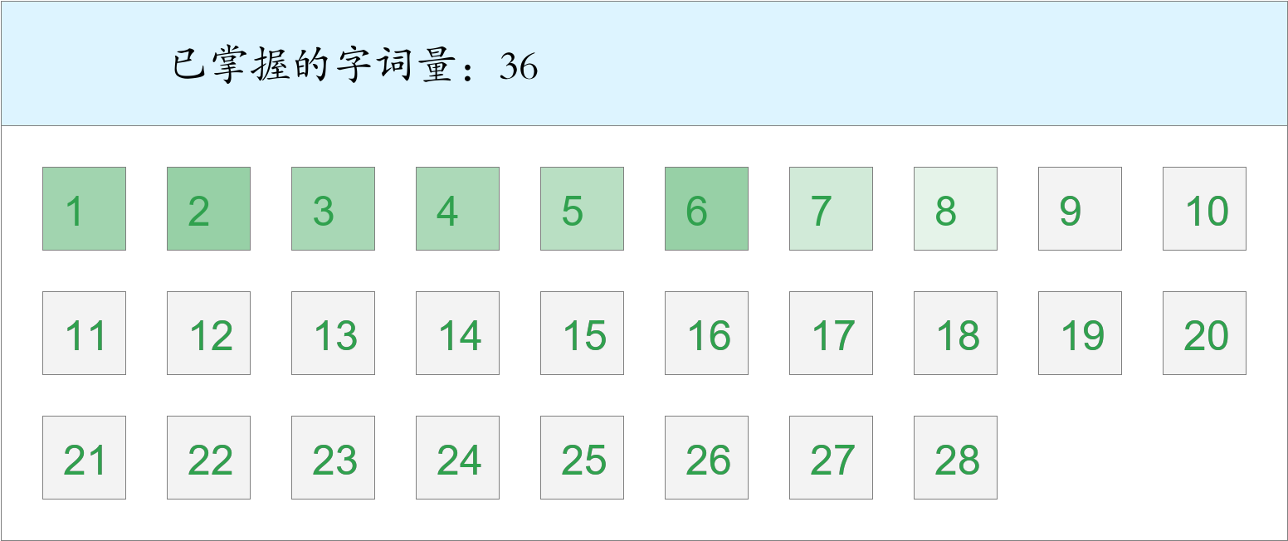 *🚩🚩🚩Triple kill！*

时间：2023-03-01 12:49:14

考察范围：第3、4、5、6、7、8、9、10课

|  |  |  |
| --- | --- | --- |
| píng jiǎng | kāi xīn | hǎo shì |
|  |  |  |
| yǐ qián | hái yǒu | dào dǐ |
|  |  |  |
| qún shān | zhè shí | yī biān |
|  |  |  |
| jīn guāng shǎn shǎn | měi lì | fú |
|  |  |  |
| ná | gù shì | bì |
|  |  |  |
| yáng guāng | suì | shí jiān |
|  |  |  |
| zhī shí | jìn |  |
|  |  |  |