STM32F103C8T6核心板BOOT启动方式

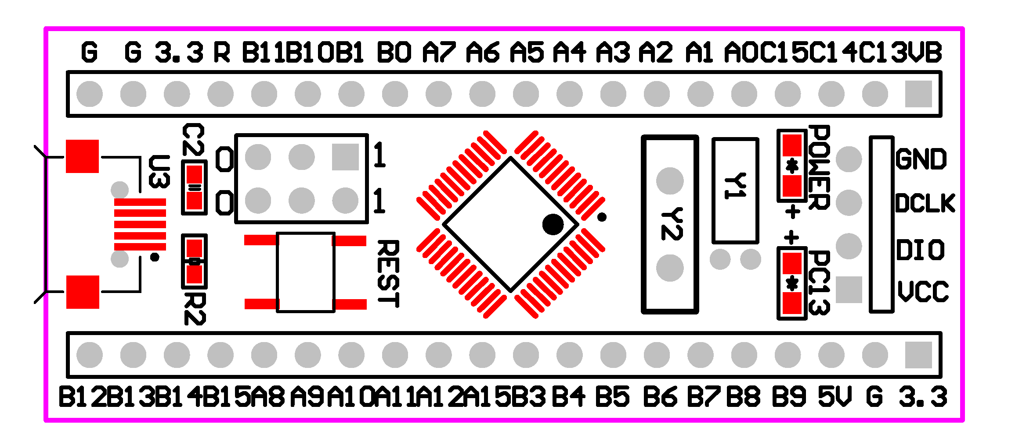

0-BOOT0-1

0-BOOT1-1

|  |  |  |
| --- | --- | --- |
| BOOT0 | BOOT1 | MODE |
| 0 | X | FLASH |
| 1 | 1 | SRAM |
| 1 | 0 | ISP |