**SAP对接MES接口功能模块说明**

**1. 软件开发介绍**

1.1 开发环境

数据库服务器：SQL Server服务器

开发语言：C#，SQL

开发工具：Visual Studio 2013,SQL Server 2014，log4net日志插件

开发系统环境：Windows10，Windows7

1.2 系统功能描述

1. 系统描述

SAP对接MES接口可以实现MES数据库与SAP数据库数据交互

2. 数据段的接收与发送

2.1 SAP调用MES接口，将工厂库存地，销售出库，其它出库等信息下发到MES

2.2 MES调用SAP接口，将生产订单收货，生产订单发货，采购申请等信息发送给SAP，获取SAP返回的数据

1.3. 系统流程图



1.4 SAP对接MES接口功能流程

1.4.1 SAP对接MES接口功能SAP调用MES接口功能简介

SAP调用MES接口有移动类型下发，采购订单数据同步，销售出库下发MES接口，

工厂库存地下发，其它出库下发接口，销售出库取消下发接口（修改移动类型）6个接口。

SAP调用MES接口下发过来XML字符串，MES根据SAP传过来的字符串进行读取，转换为表类型的数据，然后将数据存放到MES数据库，返回给保存是否成功。

MES新建一个WCF服务端，创建以上6个接口。SAP下发过来XML字符串后，MES实例化XML读取对象（XmlDocument和XmlNode，XmlElement），根据XML结构进行读取XML数据，用XML读取对象转换为Table类型的表数据，然后实例化SqlBulkCopy对象调用SqlBulkCopy对象将表数据复制到数据库。在SAP下发给MES数据的同时对系统关键点进行记录，用Log4net插件进行记录，将记录结果日志保存在服务器上。

1.4.2 SAP对接MES接口功能MES调用SAP接口功能简介

MES调用SAP接口有生产订单收货接口，生产订单发货接口，生产订单发货接口2，生产订单发货接口3，生产订单发货接口4，采购申请创建接口，销售出库回传接口（成品出库），销售订单冲销，取消销售出库下发订单(删除之前下发的数据)，采购订单出库回传，采购订单冲销接口，其他出库回传接口，其它出库冲销，库内转移，取消采购订单下发15个接口。MES根据订单号等信息从数据库读取数据，将数据转换为XML字符串回传给SAP，接收SAP返回的消息，保存SAP生成的凭证。

MES调用SAP服务接口，根据订单号等信息将数据读取得到dataset类型的数据，然后实例化XML读取对象（XmlDocument和XmlNode，XmlElement），根据XML读取对象将dataset里面的数据转换为XML字符串，然后传入对应的XML字符串，FCODE，调用SAP服务器对象，传入对应的终结点信息，实例化SAP输出对象ZFUN_MZResponse接收SAP返回的信息，保存生成的凭证。

**2.软件使用说明**

2.1 SAP对接MES接口功能操作方法

[数据库调用MES接口方法：set@Result1=dbo.InvokeWebServService('e('http://192.168.124.66:8080/SAP_Docking_MES.asmx/Order_Delivery_ToSAP3](mailto:数据库调用MES接口方法：set@Result1=dbo.InvokeWebServService('e('http://192.168.124.66:8080/SAP_Docking_MES.asmx/Order_Delivery_ToSAP3)（要调用的接口名称）','Id='+参数1+'&'+'ResourceId='+参数2+'&'+'WorkcenterId='+参数3)（注：具体参数按照接口规定传输）

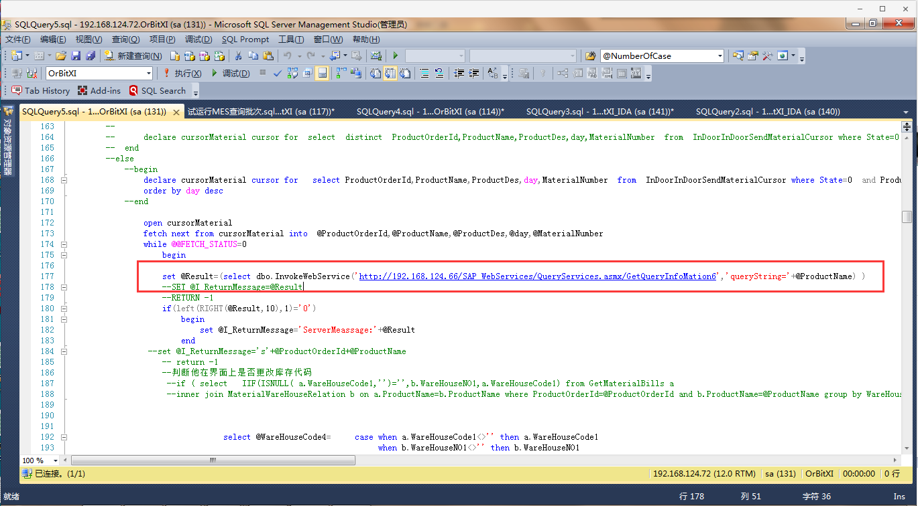

**3.服务器地址等信息**

1. SQL Server服务器地址：192.168.124.72

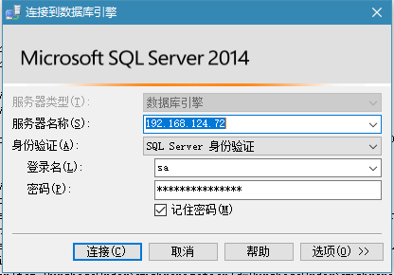

2. 日志保存服务器地址：192.168.124.66/D/App_Log2/

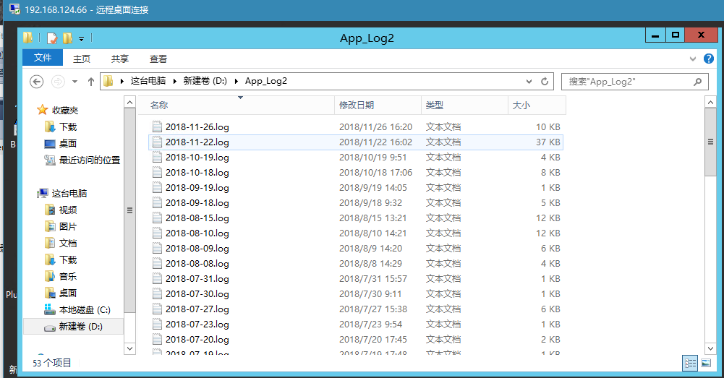

3. MES WCF服务以及文件地址

3.1 WCF服务

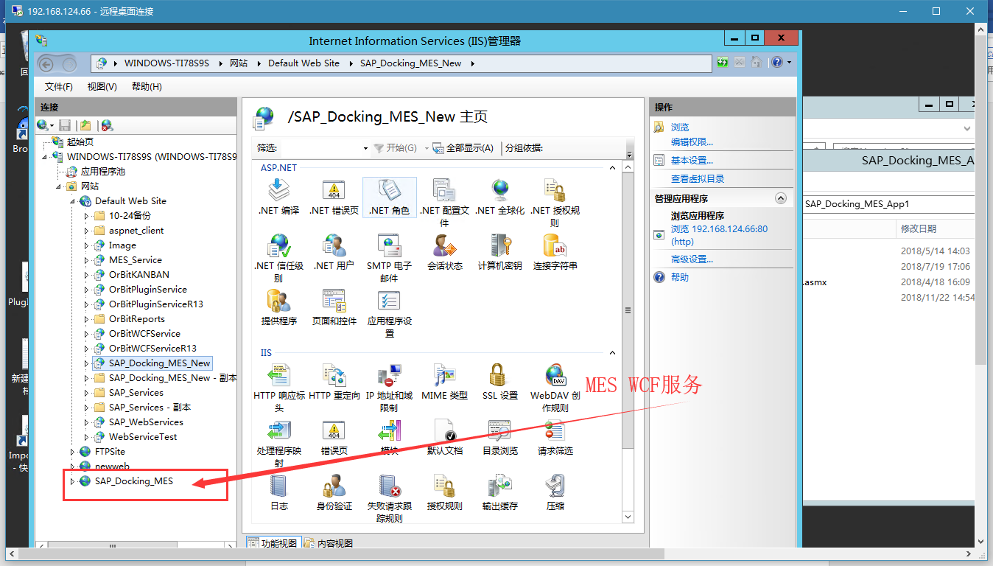

3.2 WCF文件地址

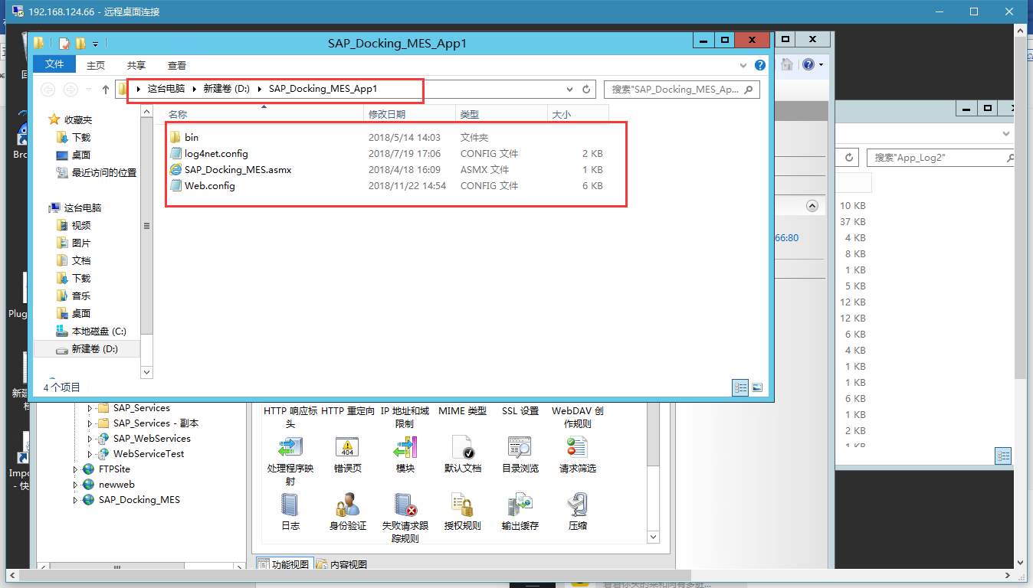

3.3 接口MES服务地址：<http://192.168.124.66:8080/SAP_Docking_MES.asmx>

**MES接口端口号为8080**

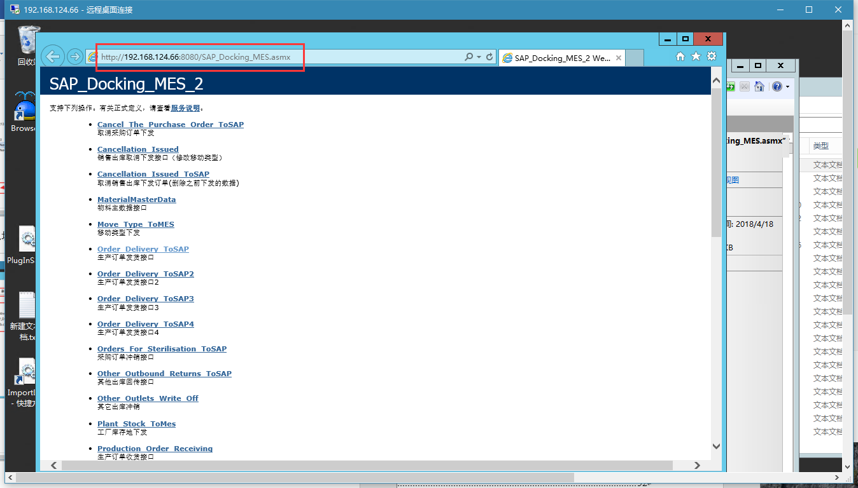

**3.4 SAP接口服务地址：**

测试库：http://192.168.0.80:8000/sap/bc/srt/wsdl/srvc_00237DDEA5F21ED6B1E92E443413AB49/wsdl11/allinone/ws_policy/document?sap-client=600

用户名：ABAP2

密码:789abc

正式库：http://192.168.254.11:8000/sap/bc/srt/wsdl/srvc_9C8E99214C001EE6BFE53E154BA38912/wsdl11/allinone/ws_policy/document?sap-client=800

用户名：dyrs_rfc

密码：dyrs@800

**3.5 OMS接口服务地址**

http://192.168.0.216:9099/OMSForMESService.svc

**4接口信息**

**4.1 SAP调用MES接口**

**4.1.1物料主数据接口（MaterialMasterData（Input））**

数据保存在MaterialMasterData表中

字段见SAP与MES接口对接文档-20180408V1.0.xlsx文件

XML格式见MES接口下发格式V1.0-20180201.xlsx文件

**4.1.2移动类型下发（MaterialMasterData（Input））**

数据保存在SAPToMESTable表中

字段见SAP与MES接口对接文档-20180408V1.0.xlsx文件

Input为SAP传递过来的XML字符串

XML格式见MES接口下发格式V1.0-20180201.xlsx文件

**4.1.3 采购订单数据同步（MaterialMasterData（Input））**

数据保存在PurchaseOrderSynchronization，PurchaseOrderSynchronizationItem表中

字段见SAP与MES接口对接文档-20180408V1.0.xlsx文件

Input为SAP传递过来的XML字符串

XML格式见MES接口下发格式V1.0-20180201.xlsx文件

**4.1.4 销售出库下发MES接口（MaterialMasterData（Input））**

数据保存在SellOutOfTheWarehouseTable，Items表中

字段见SAP与MES接口对接文档-20180408V1.0.xlsx文件

Input为SAP传递过来的XML字符串

XML格式见MES接口下发格式V1.0-20180201.xlsx文件

**4.1.5 工厂库存地下发（Plant_Stock_ToMes（Input））**

数据保存在Plant_Stock_Table表中

字段见SAP与MES接口对接文档-20180408V1.0.xlsx文件

Input为SAP传递过来的XML字符串

XML格式见MES接口下发格式V1.0-20180201.xlsx文件

**4.1.6 其它出库下发接口（Other_Outbound_Shipments（Input））**

数据保存在Other_Outbound_Shipments_Table，Other_Outbound_Shipments_Item表中

字段见SAP与MES接口对接文档-20180408V1.0.xlsx文件

Input为SAP传递过来的XML字符串

XML格式见MES接口下发格式V1.0-20180201.xlsx文件

**4.1.7 销售出库取消下发接口（修改移动类型）（Cancellation_Issued（Input））**

修改SellOutOfTheWarehouseTable表数据中

字段见SAP与MES接口对接文档-20180408V1.0.xlsx文件

Input为SAP传递过来的XML字符串

XML格式见MES接口下发格式V1.0-20180201.xlsx文件

**4.1.8 SAP价格变更下发（SAP_MES_GetPrice（Input））**

修改MarketOrderTable表数据中

字段见SAP与MES接口对接文档-20180408V1.0.xlsx文件

Input为SAP传递过来的XML字符串

XML格式见MES接口下发格式V1.0-20180201.xlsx文件

**4.2 MES调用SAP接口**

**4.2.1 生产订单收货接口（Production_Order_Receiving(string Id)）**

修改MarketOrderTable表数据中

字段格式见SAP与MES接口对接文档-20180408V1.0.xlsx文件

XML格式见MES接口下发格式V1.0-20180201.xlsx文件

Id为productorder 表中的productorderid

ProductOrder 表中Inbound_Credentials为SAP生成的凭证

读取数据SQL语句为

1. string SQL1 = string.Format("select ProductOrderNO as AUFNR,101 as BWART,'' as SOBKZ,case when DatePart (DD,getdate())<27 then getdate() else replace(CONVERT(varchar(100), dateadd(month,1,getdate()), 21),SUBSTRING ( CONVERT(varchar(100), dateadd(month,1,getdate()), 21) , 9 , 2 ),'01') end as BUDAT,case when DatePart (DD,getdate())<27 then getdate() else replace(CONVERT(varchar(100), dateadd(month,1,getdate()), 21),SUBSTRING ( CONVERT(varchar(100), dateadd(month,1,getdate()), 21) , 9 , 2 ),'01') end as BLDAT from productorder where productorderid='{0}'", Id);

2. string SQL2 = string.Format("select '' as EBELP,productname as MATNR,''as CHARG,3001 as LGORT,1 as MENGE,6006 as WERKS,'套' as MEINS from ProductOrder where productorderid='{0}'", Id);

3.保存凭证SQL语句为

string SQL = string.Format("select Inbound_Credentials from ProductOrder where ProductOrderId='{0}'", Id);

string sql = string.Format("Update ProductOrder set Inbound_Credentials='{0}' where ProductOrderId='{1}'", Inbound_Credentials1.ToString()+","+Inbound_Credentials, Id);

**4.2.2 生产订单发货接口，2,3,4（Order_Delivery_ToSAP(string Id, string ResourceId)）生产订单发货共四个接口**

修改MarketOrderTable表数据中

字段见SAP与MES接口对接文档-20180408V1.0.xlsx文件

XML格式见MES接口下发格式V1.0-20180201.xlsx文件

Id为productorder 表中的ProductOrderNo

读取数据SQL语句为：

1. string SQL1 = string.Format("select ProductOrderNo as AUFNR,'261' AS BWART,'' AS SOBKZ,case when DatePart (DD,getdate())<27 then getdate() else replace(CONVERT(varchar(100), dateadd(month,1,getdate()), 21),SUBSTRING ( CONVERT(varchar(100), dateadd(month,1,getdate()), 21) , 9 , 2 ),'01') end AS BUDAT,case when DatePart (DD,getdate())<27 then getdate() else replace(CONVERT(varchar(100), dateadd(month,1,getdate()), 21),SUBSTRING ( CONVERT(varchar(100), dateadd(month,1,getdate()), 21) , 9 , 2 ),'01') end AS BLDAT,case when ProductType in(select UserCodeName from OrBitXI.dbo.UserCode where ParentUserCodeId='URC1000001IX') then 'CC60062004' else 'CC60062001' end KOSTL from ProductOrder where ProductOrderNo='{0}'", Id);

2. string SQL2 = string.Format("select distinct '' as EBELP, GetMaterialbills.ProductName as MATNR,'' AS CHARG,SendMaterialRepertory.WareHouseCode as LGORT, SendMaterialRepertory.QTY AS MENGE,'6006' AS WERKS,'' AS MEINS FROM GetMaterialbills join ProductOrder on GetMaterialbills.ProductOrderId=ProductOrder.ProductOrderId left join MaterialTypeName on GetMaterialbills.ProductName=MaterialTypeName.ProductName inner join SendMaterialRepertory on GetMaterialBills.ProductOrderId=SendMaterialRepertory.ProductOrderId and GetMaterialBills.ProductName=SendMaterialRepertory.ProductName where ProductOrder.ProductOrderNO='{0}' and SendMaterialRepertory.ResourceId='{1}' and SendMaterialRepertory.State=0 group by GetMaterialbills.ProductName,GetMaterialbills.Unit,GetMaterialbills.WareHouseCode,SendMaterialRepertory.WareHouseCode,SendMaterialRepertory.QTY", Id, ResourceId);

3.保存凭证SQL语句为

string SQL1 = string.Format("select Outbound_Credentials from ProductOrder where ProductOrderNO='{0}'", Id);

string SQL = string.Format("Update ProductOrder set Outbound_Credentials='{0}' where ProductOrderNO='{1}'",Outbound_Credentials1.ToString()+","+Outbound_Credentials, Id);

**4.2.3 获取结算金额（Get_PriceByProductOrderNo(string ProductOrderNo)）**

修改MarketOrderTable表数据中

字段见SAP与MES接口对接文档-20180408V1.0.xlsx文件

XML格式见MES接口下发格式V1.0-20180201.xlsx文件

ProductOrderNo为 S300134172, S300134172,的字符串（订单号+，号结尾的字符串）

SQL语句为：

string SQL = string.Format("update MarketOrderTable set SettlementAmount='{0}',BY1='{1}',BY2='{2}' where Saleno='{3}'", DT.Rows[i]["SettlementAmount"], DT.Rows[i]["BY1"], DT.Rows[i]["BY2"], DT.Rows[i]["ProductOrderNo"]);

**4.2.4 采购申请创建接口（Purchase_Application_Creation_ToSAP(string Str)）**

字段见SAP与MES接口对接文档-20180408V1.0.xlsx文件

XML格式见MES接口下发格式V1.0-20180201.xlsx文件

SQL语句为：

string SQL1 = string.Format(" select 'NB' as BSART,'' as ITEXT1,10 as BNFPO,ProductName as MATNR,PurchaseQty as MENGE,PurchaseUnit as MEINS, Factory as WERKS,StoreLocation as LGORT,'' as FIFNR,FixedVendor as FLTEF,PlanDate as LFDAT,PurchaseTissue as EKORG from PurchaseDetails where PurchaseDetailsId='{0}'", Id);

保存SAP返回的信息

string SQL = string.Format("update PurchaseDetails set DATA='{0}' where PurchaseDetailsId='{1}'", DATA, PurchaseDetailsId);

**4.2.5 销售出库回传接口（成品出库）（string Sell_The_Outbound_Return_ToSAP(string Str)）**

字段见SAP与MES接口对接文档-20180408V1.0.xlsx文件

XML格式见MES接口下发格式V1.0-20180201.xlsx文件

SQL语句为：

String SQl1 = string.Format("SELECT VBELN AS VBELN_IM,BWART,KUNNR AS ZWLGINUM,ZYJCHSJ AS BUDAT FROM SellOutOfTheWarehouseTable WHERE SellOutOfTheWarehouseId='{0}'", Id);

string SQl2 = string.Format("SELECT POSNR,MATNR,LGORT,CHARG,LFIMG,MEINS FROM Items WHERE SellOutOfTheWarehouseId='{0}'", Id);

保存SAP返回的信息

string SQL = string.Format("update Items set [Credentials]='{0}' where SellOutOfTheWarehouseId='{1}'", Credentials, Id);

**4.2.6 销售订单冲销（Sell_The_Outbound_Return_Sterilisation(string Str)）**

字段见SAP与MES接口对接文档-20180408V1.0.xlsx文件

XML格式见MES接口下发格式V1.0-20180201.xlsx文件

SQL语句为：

string SQL = string.Format("select '1' as BS,DATA,Items.[Credentials] as MBLNR,MJAHR,SellOutOfTheWarehouseTable.VBELN,'6006' as VSTEL FROM Items join SellOutOfTheWarehouseTable on Items.SellOutOfTheWarehouseId=SellOutOfTheWarehouseTable.SellOutOfTheWarehouseId where Items.SellOutOfTheWarehouseId='{0}'", Str);

保存SAP返回的信息

string SQL = string.Format("update Items set [Credentials]='{0}' where SellOutOfTheWarehouseId='{1}'", Credentials, Id);

**4.2.7 取消销售出库下发订单(删除之前下发的数据)（Cancellation_Issued_ToSAP(string Str, string ZYYTM, string UserName, string ZMMI001, string ZMMI002)）**

字段见SAP与MES接口对接文档-20180408V1.0.xlsx文件

XML格式见MES接口下发格式V1.0-20180201.xlsx文件

SQL语句为：

string SQL = string.Format("select SellOutOfTheWarehouseTable.SellOutOfTheWarehouseId from Items join SellOutOfTheWarehouseTable on Items.SellOutOfTheWarehouseId=SellOutOfTheWarehouseTable.SellOutOfTheWarehouseId where SellOutOfTheWarehouseTable.VBELN='{0}'", Str);保存SAP返回的信息

string sql2 = string.Format("DELETE FROM SellOutOfTheWarehouseTable WHERE SellOutOfTheWarehouseId='{0}' and ZCHANGE_IND='Q'", SellOutOfTheWarehouseId);

string sql3 = string.Format("DELETE FROM Items WHERE SellOutOfTheWarehouseId='{0}'", SellOutOfTheWarehouseId);

**4.2.8 取消销售出库下发订单(删除之前下发的数据)（Cancellation_Issued_ToSAP(string Str, string ZYYTM, string UserName, string ZMMI001, string ZMMI002)）**

字段见SAP与MES接口对接文档-20180408V1.0.xlsx文件

XML格式见MES接口下发格式V1.0-20180201.xlsx文件

SQL语句为：

string SQL = string.Format("select SellOutOfTheWarehouseTable.SellOutOfTheWarehouseId from Items join SellOutOfTheWarehouseTable on Items.SellOutOfTheWarehouseId=SellOutOfTheWarehouseTable.SellOutOfTheWarehouseId where SellOutOfTheWarehouseTable.VBELN='{0}'", Str);保存SAP返回的信息

string sql2 = string.Format("DELETE FROM SellOutOfTheWarehouseTable WHERE SellOutOfTheWarehouseId='{0}' and ZCHANGE_IND='Q'", SellOutOfTheWarehouseId);

string sql3 = string.Format("DELETE FROM Items WHERE SellOutOfTheWarehouseId='{0}'", SellOutOfTheWarehouseId);

**4.2.9 采购订单出库回传（Return_Of_Purchase_Order_ToSAP(string Str)）**

字段见SAP与MES接口对接文档-20180408V1.0.xlsx文件

XML格式见MES接口下发格式V1.0-20180201.xlsx文件

SQL语句为：

string SQL1 = string.Format("SELECT PurchaseOrderSynchronization.VBELN AS EBELN,BWART,SOBKZ,PurchaseOrderSynchronizationId AS ZWLGRNUM,BEDAT AS BUDAT,BEDAT AS BLDAT FROM PurchaseOrderSynchronization where PurchaseOrderSynchronizationId='{0}'", Str);

string SQL2 = string.Format("SELECT EBELP,MATNR,CHARG,LGORT,Qty as MENGE,'' as ZMENGE,WERKS,MEINS FROM PurchaseOrderSynchronizationItem JOIN PurchaseOrderSynchronization ON PurchaseOrderSynchronizationItem.PurchaseOrderSynchronizationId=PurchaseOrderSynchronization.PurchaseOrderSynchronizationId WHERE PurchaseOrderSynchronization.PurchaseOrderSynchronizationId='{0}'", Str);

保存凭证：

string SQL = string.Format("update PurchaseOrderSynchronizationItem set [Credentials]='{0}' where PurchaseOrderSynchronizationId='{1}'", 凭证号, Str);

**4.2.10 采购订单冲销接口（Orders_For_Sterilisation_ToSAP(string Id)）**

字段见SAP与MES接口对接文档-20180408V1.0.xlsx文件

XML格式见MES接口下发格式V1.0-20180201.xlsx文件

SQL语句为：

string SQL1 = string.Format("select distinct BS,DATA,PurchaseOrderSynchronizationItem.[Credentials] as MBLNR,MJAHR,PurchaseOrderSynchronizationItem.VBELN,VSTEL FROM PurchaseOrderSynchronizationItem join PurchaseOrderSynchronization on PurchaseOrderSynchronizationItem.PurchaseOrderSynchronizationId=PurchaseOrderSynchronization.PurchaseOrderSynchronizationId where PurchaseOrderSynchronization.PurchaseOrderSynchronizationId='{0}'", Id);

保存凭证：

string SQL = string.Format("update PurchaseOrderSynchronizationItem set [Credentials]='{0}' where PurchaseOrderSynchronizationId='{1}'", 凭证号，Id);

**4.2.11 其他出库回传接口（Other_Outbound_Returns_ToSAP(string Str)）**

字段见SAP与MES接口对接文档-20180408V1.0.xlsx文件

XML格式见MES接口下发格式V1.0-20180201.xlsx文件

SQL语句为：

string SQl1 = string.Format(" select ProjectOutPutNO as VBELN , CompanyProof as ZWLGINUM , Factory as WERKS, MoveType as BWART, SpecificalStore as SOBKZ , CostCenter as KOSTL, PostDate as BLDAT, ProofDate as BUDAT from OrderOutPutRecords where OrderOutPutRecordsId='{0}'", Id);

string SQL2 = string.Format("select LineProjectNO as POSNR,MatetialNO as MATNR, MaterialDescription as MAKTX, StoragePlace as LGORT, SNNO as CHARG, OutStorageQty as LFIMG, Unit as MEINS, SaleOrderNO as KDAUF from OrderOutPutRecords where OrderOutPutRecordsId='{0}'", Id);

保存凭证：

string Sql = string.Format("Update OrderOutPutRecords set SAPOrder='{0}' where OrderOutPutRecordsId='{1}'",凭证号, Str);

**4.2.12 其它出库冲销（Other_Outlets_Write_Off(string Str)）**

字段见SAP与MES接口对接文档-20180408V1.0.xlsx文件

XML格式见MES接口下发格式V1.0-20180201.xlsx文件

SQL语句为：

string SQL = string.Format("select '0' as BS,PostDate as [DATA],SAPOrder as MBLNR,SAPData as MJAHR,ProjectOutPutNO as VBELN,'6006' as VSTEL from OrderOutPutRecords where OrderOutPutRecordsId='{0}'", Id);

保存凭证：

string SQL = string.Format("update OrderOutPutRecords set SAPOrder='{0}' where OrderOutPutRecordsId='{1}'", 凭证号, Str);

**4.2.13 库内转移（Transfer_The_Rolls_ToSAP(string Id)）**

字段见SAP与MES接口对接文档-20180408V1.0.xlsx文件

XML格式见MES接口下发格式V1.0-20180201.xlsx文件

SQL语句为：

string SQL1 = string.Format("select CompanyProof as ZWLTRNUM,MoveTypeName as BWART, PostDate as BUDAT, Factory as WERKS from StorageInMove where StorageInMoveId='{0}'", Id);

string SQL2 = string.Format("select '' as POSNR, MaterialNO as MATNR,ChangeMaterialNO as UMMAT, Vendor as LIFNR, SendStoragePlace as LGORT, SpecificalStore as FCSOBKZ, SendProjectNO as FCPSPID, ReceiveStoragePlace as UMLGO, ReceiveSpecificalStore as JSSOBKZ, ReceivePorjectNO as JSPSPID, BeforeChanceSN as CHARG, BehindChanceSN as UMCHA, Qty as MENGE, SendSalesOrderNO as FCVBELN, ReceiveSalesOrderNO as JSVBELN, BeforeChanceStoreStatus as INSMK, BehindChanceStoreStatus as BESTQ, MoveReason as ZGRUND from StorageInMove where StorageInMoveId='{0}'", Id);

保存凭证：

string SQL = string.Format("Update OrderOutPutRecords set CompanyProof1='{0}' where OrderOutPutRecordsId='{1}'", 凭证号, Id);

**4.2.14 取消采购订单下发（Cancel_The_Purchase_Order_ToSAP(string VBELN, string ZYYTM, string UserName, string ZMMI001, string ZMMI002)）**

字段见SAP与MES接口对接文档-20180408V1.0.xlsx文件

XML格式见MES接口下发格式V1.0-20180201.xlsx文件

SQL语句为：

string SQL = string.Format("delete from PurchaseOrderSynchronization where VBELN='{0}'", VBELN);

string sql2 = string.Format("delete from PurchaseOrderSynchronizationItem where VBELN='{0}'", VBELN);

保存凭证：

string SQL = string.Format("Update OrderOutPutRecords set CompanyProof1='{0}' where OrderOutPutRecordsId='{1}'", 凭证号, Id);

**4.3 MES调用OMS接口**

**4.3.1 2020销售金额字段从OMS系统获取（Get_OMS_PriceByProductOrderNo(string ProductOrderNo)）**

调用OMS服务Get2020SalesPrice(ProductOrderNo);方法获取价格信息接收OMS回传的XML字符串

解析后的结果调用Get_OMS2020_PriceByProductOrderNo存储过程（参数@StringXml）

OMS回传的XML字符串格式

<?xml version="1.0" encoding="utf-8"?><Response><SIGN>Y</SIGN><MESSAGE>成功</MESSAGE><Data><SalesOrder><OrderNo>S300134172</OrderNo><Price>1283.04</Price></SalesOrder></Data></Response>

**4.4 OMS调用MES接口**

**4.4.1 OMS获取接单日期状态等信息OMS_MES_GetDates(string Input)**

调用存储过程OMSGetDateByProductOrderNo传入参数@ProductOrderNo

Input为OMS传递过来的XML字符串

返回给OMS的XML的字符串格式

<?xml version="1.0" encoding="gb2312"?>  
<ITEMS>  
  <ITEM>  
    <VBELN>S300134170</VBELN>S单号  
    <DATES>  
    <FactoryOrdersTime>6005.76 </FactoryOrdersTime>工厂接单日期  
    <DateofprocessDisassembly></DateofprocessDisassembly>工艺拆解日期  
    <OrderAcceptanceDate></OrderAcceptanceDate>订单科接单日期  
    <PlanningAcceptanceDate></PlanningAcceptanceDate>计划科接单日期  
    <></>排产日期  
    <DischargeDate></DischargeDate>下料日期  
    <StorageTime></StorageTime>入库日期  
    <ShipmentsTime></ShipmentsTime>发货日期  
    <StopOrderDate></StopOrderDate>停单日期  
      <DATES>  
  </ITEM>  
  <ITEM>  
    <VBELN>S300134171</VBELN>S单号  
    <DATES>  
    <FactoryOrdersTime>6005.76 </FactoryOrdersTime>工厂接单日期  
    <DateofprocessDisassembly></DateofprocessDisassembly>工艺拆解日期  
    <OrderAcceptanceDate></OrderAcceptanceDate>订单科接单日期  
    <PlanningAcceptanceDate></PlanningAcceptanceDate>计划科接单日期  
    <></>排产日期  
    <DischargeDate></DischargeDate>下料日期  
    <StorageTime></StorageTime>入库日期  
    <ShipmentsTime></ShipmentsTime>发货日期  
    <StopOrderDate></StopOrderDate>停单日期  
    </DATES>  
  </ITEM>  
  <ITEM>  
    <VBELN>S300134170</VBELN>S单号  
    <DATES>如果s单mes里没有就不要dates里面的标签了  
        
    </DATES>  
  </ITEM>  
</ITEMS>

**4.5 MES内部调用接口**

**4.5.1 OMS获取接单日期状态等更改信息（OMS_MES_GetDates2(string Input)）**

MES调用接口，接口调用OMS服务

调用存储过程OMSGetDateByProductOrderNo传入参数@ProductOrderNo

Input为MES内部传过来的单号，根据单号获取到OMS需要的信息拼接成XML

调用OMS服务 SynchronizeOrderTimes(string input)返回给OMS

返回给OMS的XML的字符串格式

<?xml version="1.0" encoding="gb2312"?>  
<ITEMS>  
  <ITEM>  
    <VBELN>S300134170</VBELN>S单号  
    <DATES>  
    <FactoryOrdersTime>6005.76 </FactoryOrdersTime>工厂接单日期  
    <DateofprocessDisassembly></DateofprocessDisassembly>工艺拆解日期  
    <OrderAcceptanceDate></OrderAcceptanceDate>订单科接单日期  
    <PlanningAcceptanceDate></PlanningAcceptanceDate>计划科接单日期  
    <></>排产日期  
    <DischargeDate></DischargeDate>下料日期  
    <StorageTime></StorageTime>入库日期  
    <ShipmentsTime></ShipmentsTime>发货日期  
    <StopOrderDate></StopOrderDate>停单日期  
      <DATES>  
  </ITEM>  
  <ITEM>  
    <VBELN>S300134171</VBELN>S单号  
    <DATES>  
    <FactoryOrdersTime>6005.76 </FactoryOrdersTime>工厂接单日期  
    <DateofprocessDisassembly></DateofprocessDisassembly>工艺拆解日期  
    <OrderAcceptanceDate></OrderAcceptanceDate>订单科接单日期  
    <PlanningAcceptanceDate></PlanningAcceptanceDate>计划科接单日期  
    <></>排产日期  
    <DischargeDate></DischargeDate>下料日期  
    <StorageTime></StorageTime>入库日期  
    <ShipmentsTime></ShipmentsTime>发货日期  
    <StopOrderDate></StopOrderDate>停单日期  
    </DATES>  
  </ITEM>  
  <ITEM>  
    <VBELN>S300134170</VBELN>S单号  
    <DATES>如果s单mes里没有就不要dates里面的标签了  
        
    </DATES>  
  </ITEM>  
</ITEMS>