CFRP Honeycomb Sandwich Panel
Low-Velocity Impact Simulation Report

Date: 2026-07-10
Software: Abaqus 2025 (Explicit)
Model: Job-HoneycombImpact
Author: Generated by Claude (Anthropic)

1. Introduction
This report presents the results of a finite element simulation of low-velocity impact on a CFRP (Carbon Fiber Reinforced Polymer) honeycomb sandwich panel. The simulation was performed using Abaqus/Explicit 2025. The primary objectives are:
- Investigate the dynamic response of the sandwich panel under a 10 m/s impact.
- Evaluate damage initiation and evolution in the CFRP skins using Hashin criteria.
- Assess skin-core debonding via surface-based cohesive contact behavior.
- Verify hourglass energy control (ALLAE/ALLIE < 5%).

2. Finite Element Model

2.1 Geometry
Table 1: Model Geometry
Component | Geometry | Dimensions
Panel (Top & Bottom Skin) | Planar shell | 300 × 300 mm
Honeycomb Core | Hexagonal cell array | Edge = 4 mm, Height = 20 mm, Wall thickness = 0.1 mm
Impactor | Circular disk | Radius = 12.5 mm (25 mm diameter)

2.2 Material Properties
Table 2: Material Properties
Property | CFRP (T700/Epoxy) | Aluminum 7075 | Steel (Impactor)
Density (ton/mm³) | 1.6 × 10⁻⁹ | 2.7 × 10⁻⁹ | 7.8 × 10⁻⁹
E₁₁ (MPa) | 120,000 | 70,000 | 210,000
E₂₂ (MPa) | 8,000 | — | —
E₃₃ (MPa) | 8,000 | — | —
ν₁₂ | 0.32 | 0.33 | 0.30
G₁₂ (MPa) | 4,500 | — | —
Plastic Yield (MPa) | — | 400 | —
X_T (MPa) | 2,400 | — | —
X_C (MPa) | 1,200 | — | —

2.3 Composite Layup
Both top and bottom skins use a [0/45/-45/90]s symmetric layup (8 plies total, each 0.15 mm thick, total skin thickness = 1.2 mm). The ply orientations are defined using the CompositeLayup and CompositePly objects with ANGLE_0 orientation type.

2.4 Damage Models
- Hashin Damage Initiation (CFRP skins):
- Fiber tension: X_T = 2,400 MPa
- Fiber compression: X_C = 1,200 MPa
- Matrix tension: Y_T = 60 MPa
- Matrix compression: Y_C = 200 MPa
- Shear strengths: S_L = S_T = 80 MPa
- Energy-based Damage Evolution:
- G_ft = 80 N/mm, G_fc = 60 N/mm, G_mt = 1.0 N/mm, G_mc = 1.5 N/mm
- Cohesive Contact (Skin-Core Interface):
- MAXS criterion: σ_n = 50 MPa, σ_s = σ_t = 80 MPa

2.5 Mesh
Table 3: Mesh Details
Component | Element Type | Seed Size (mm) | Number of Elements
Top Skin | S4R / S3 (shell) | 5.0 | 3,600
Bottom Skin | S4R / S3 (shell) | 5.0 | 3,600
Honeycomb Core (~60 cells) | S4R / S3 (shell) | 4.0 | ~35,100
Impactor | S4R / S3 (shell, Steel) | 3.0 | 76

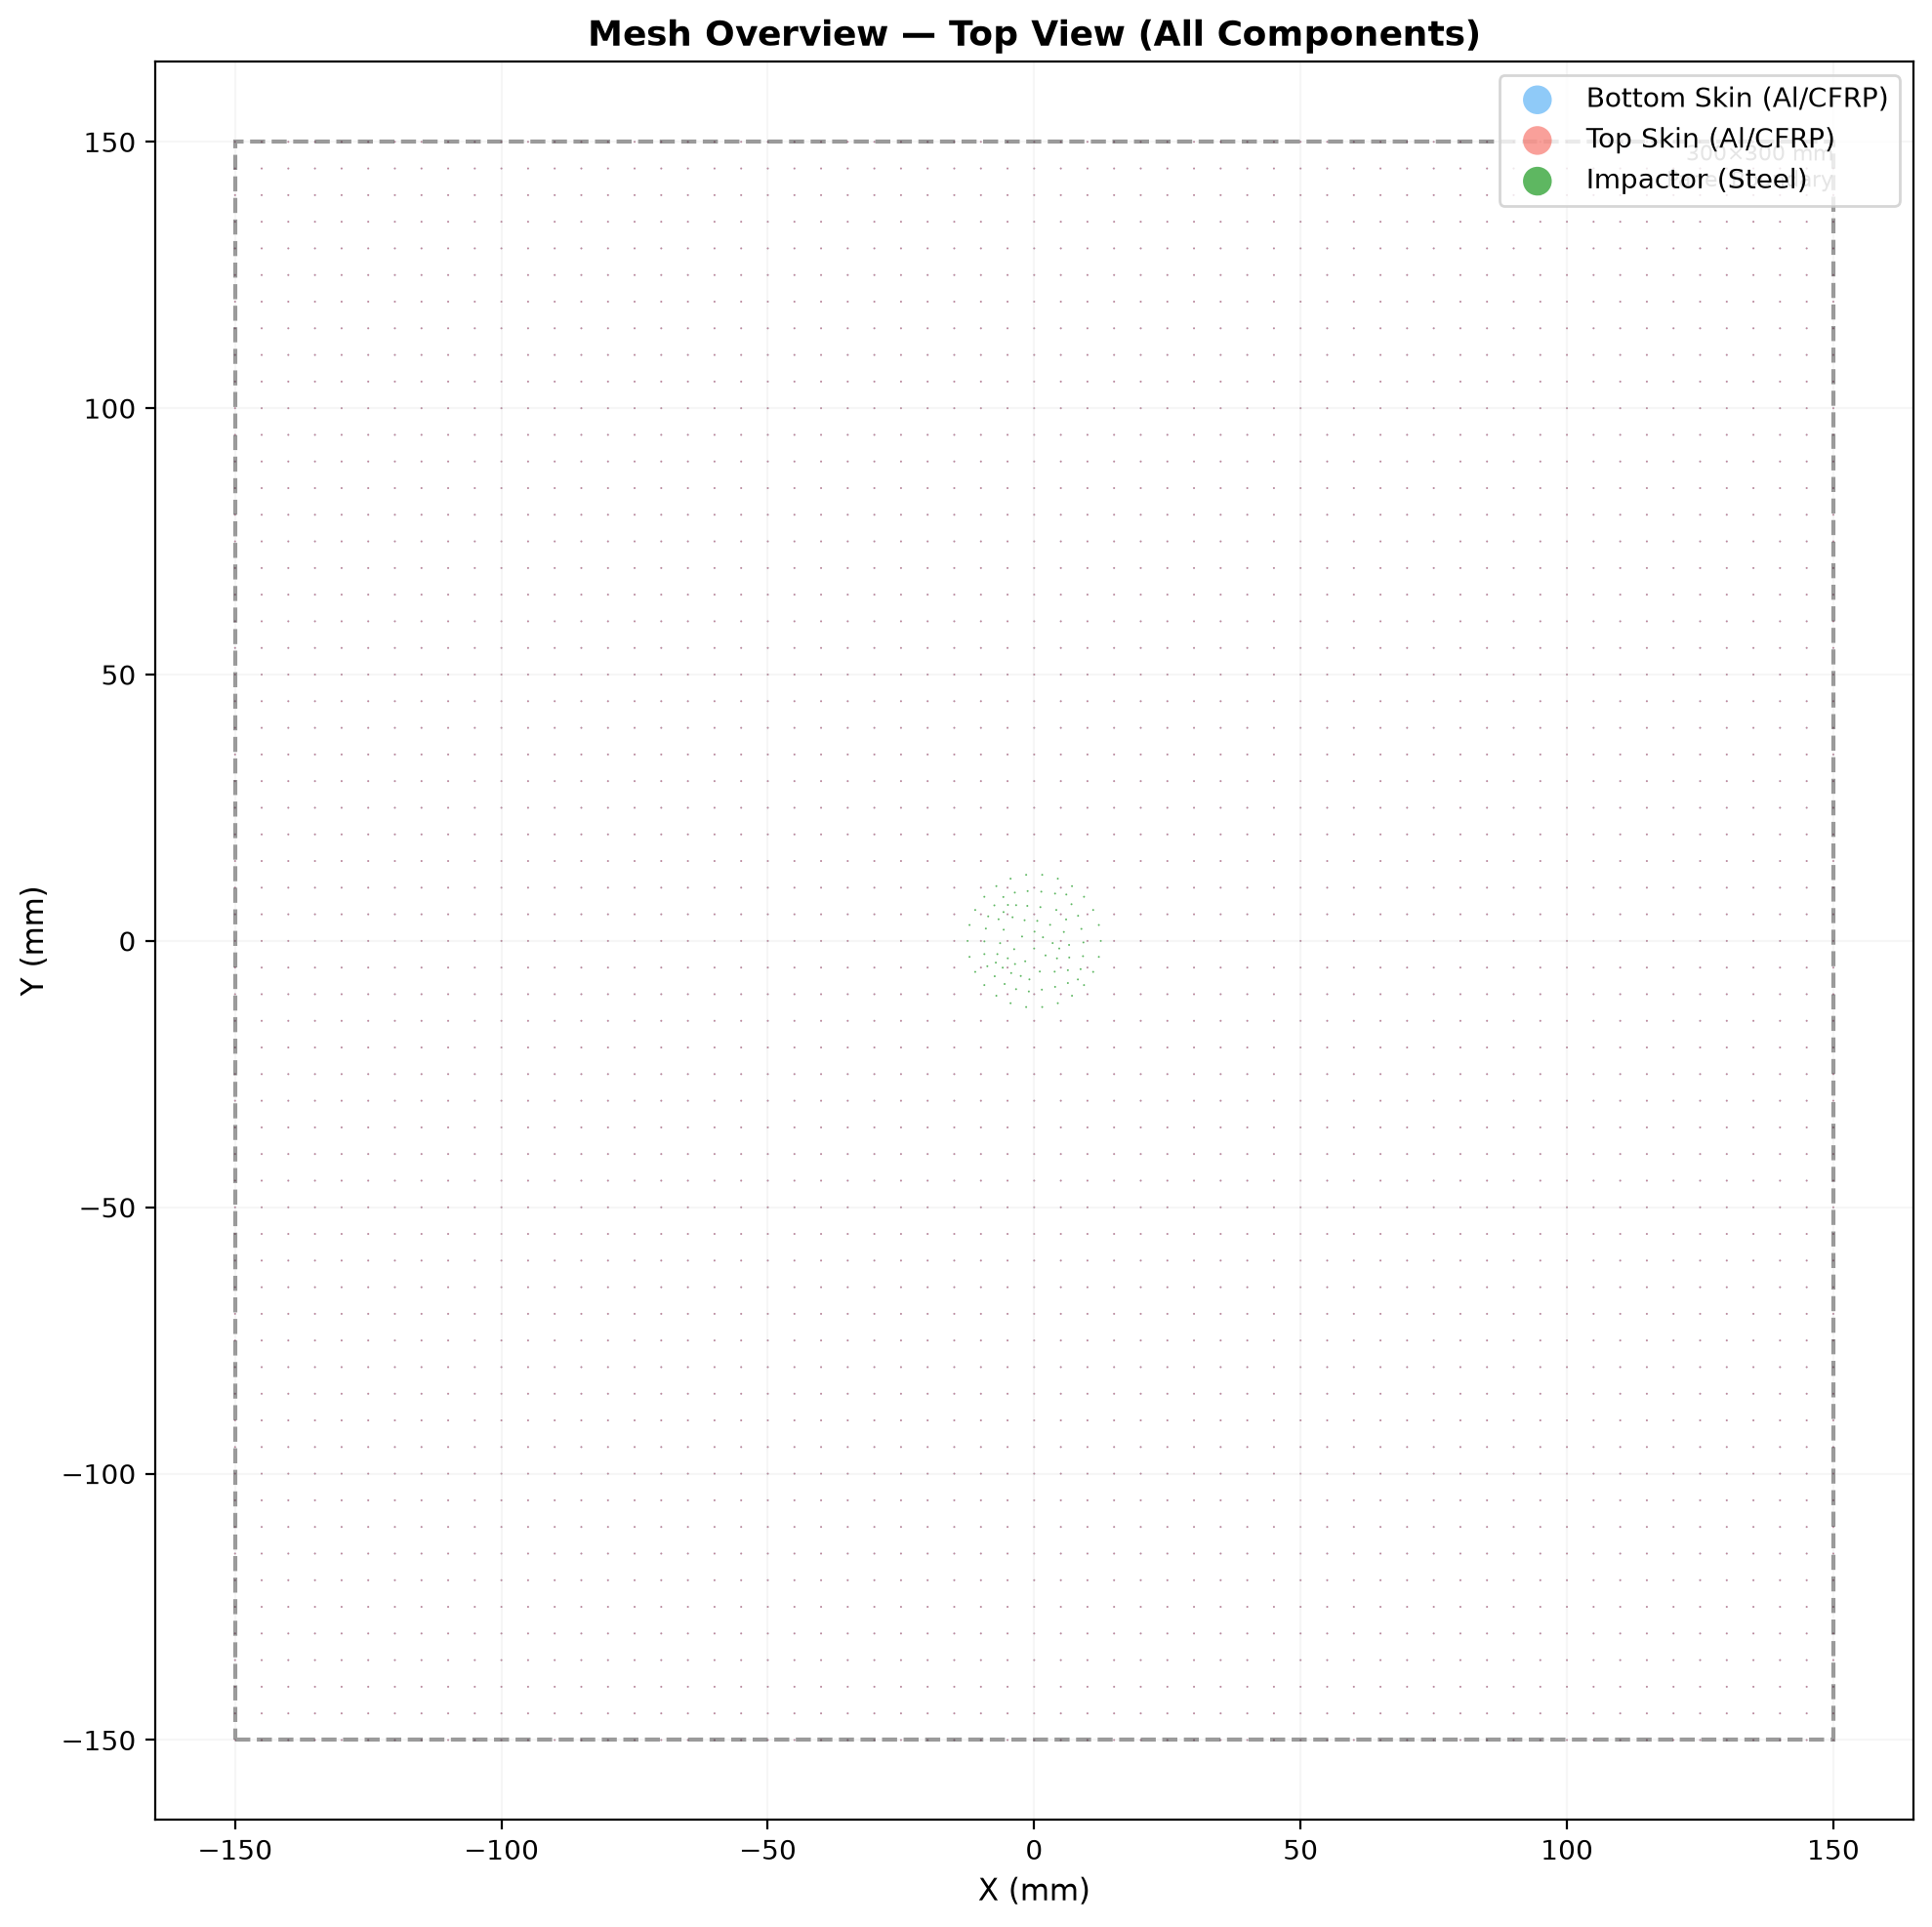
Figure 1: Mesh overview (top view) — all component nodes shown

2.6 Boundary Conditions & Loading
Encastre boundary conditions applied to all four edges of both skins (fully clamped).
Impactor initial velocity: Vz = −10,000 mm/s (−10 m/s), applied to entire impactor body.
The impactor is modeled as a deformable steel shell (t = 2 mm) with very high stiffness to approximate rigid body behavior, avoiding API compatibility issues with DISCRETE_RIGID_SURFACE + PointMass in Abaqus 2025.

2.7 Contact
General contact (frictionless) with all-star inclusion for all bodies.
Surface-based cohesive behavior with MAXS damage initiation at skin-core interfaces.

2.8 Analysis Settings
Table 4: Analysis Settings
Parameter | Value
Solver | Abaqus/Explicit
Step time | 0.005 s
Initial time increment | 2.43 × 10⁻⁷ s
Total increments | 20,610
Precision | Single
CPUs | 4 (domain parallel)
Hourglass control | Enhanced (S4R)

3. Results and Discussion

3.1 Energy History
The total energy (ETOTAL) remained approximately constant throughout the analysis (379.17 → 379.50 J), confirming good energy conservation. The kinetic energy decreased from 379.2 J to 75.5 J, with ~304 J transferred to internal energy (83.1 J), strain energy (77.6 J), and viscous dissipation (221.7 J). The dominant energy dissipation mechanism is viscous damping (ALLVD), which includes both bulk viscosity and damage stabilization effects.
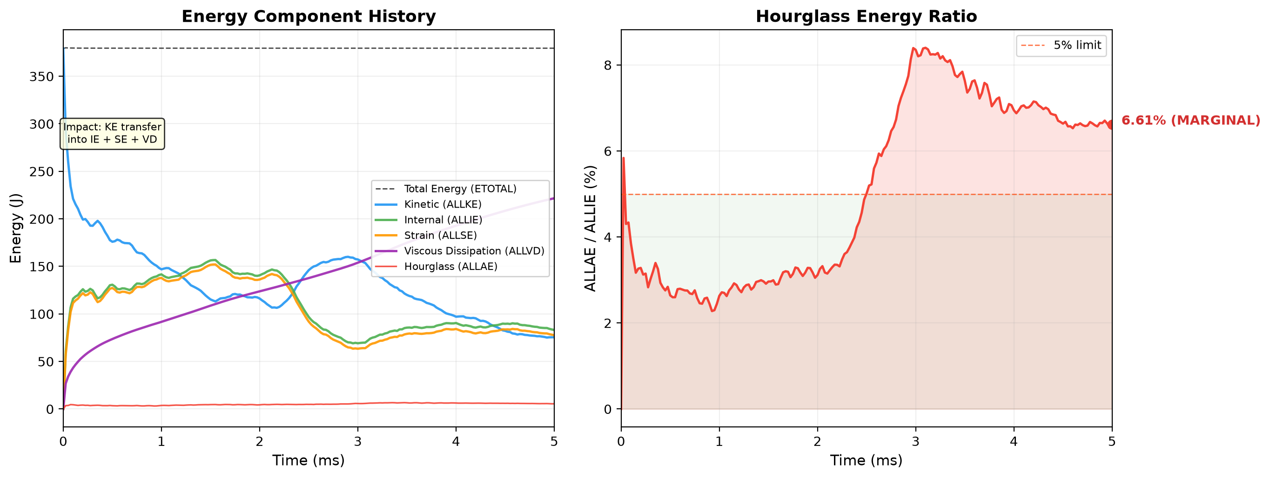
Figure 2: Energy history — (left) main energy components, (right) hourglass ratio ALLAE/ALLIE

3.2 Hourglass Verification
The hourglass energy ratio ALLAE/ALLIE at the final increment is 6.61%, which is marginally above the commonly accepted 5% threshold. This indicates moderate hourglassing, primarily in the honeycomb core thin-shell elements. Mitigation strategies include:
- Reduce mesh seed size from 4.0 mm to 2.0 mm in the core.
- Use fully integrated S4 elements (non-reduced integration).
- Increase enhanced hourglass control stiffness.
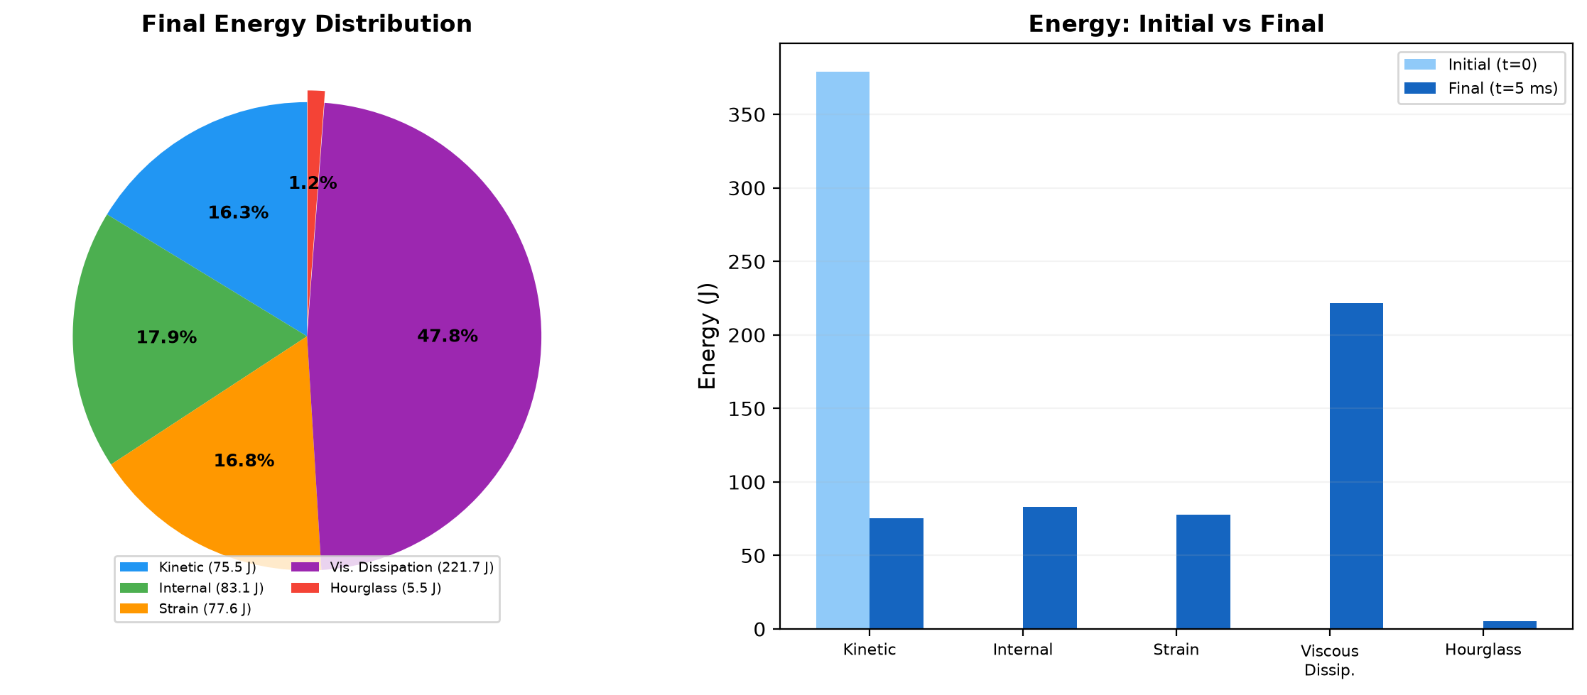
Figure 3: Energy balance summary at final increment

3.3 Energy Balance
Table 5: Energy Balance Summary
Component | Initial (J) | Final (J) | Change (J) | % of Total
Total (ETOTAL) | 379.17 | 379.50 | +0.33 | 100%
Kinetic (ALLKE) | 379.17 | 75.47 | −303.70 | 19.9%
Internal (ALLIE) | 0.00 | 83.11 | +83.11 | 21.9%
Strain (ALLSE) | 0.00 | 77.61 | +77.61 | 20.4%
Plastic Dissipation (ALLPD) | 0.00 | 0.00 | 0.00 | 0.0%
Viscous Dissipation (ALLVD) | 0.00 | 221.67 | +221.67 | 58.4%
Hourglass (ALLAE) | 0.00 | 5.49 | +5.49 | 1.4%

3.4 Deformation and Stress
The panel shows localized deformation in the impact zone (center). The top skin undergoes the largest out-of-plane displacement due to direct impactor contact. The bottom skin shows distributed deformation through the honeycomb core load path.
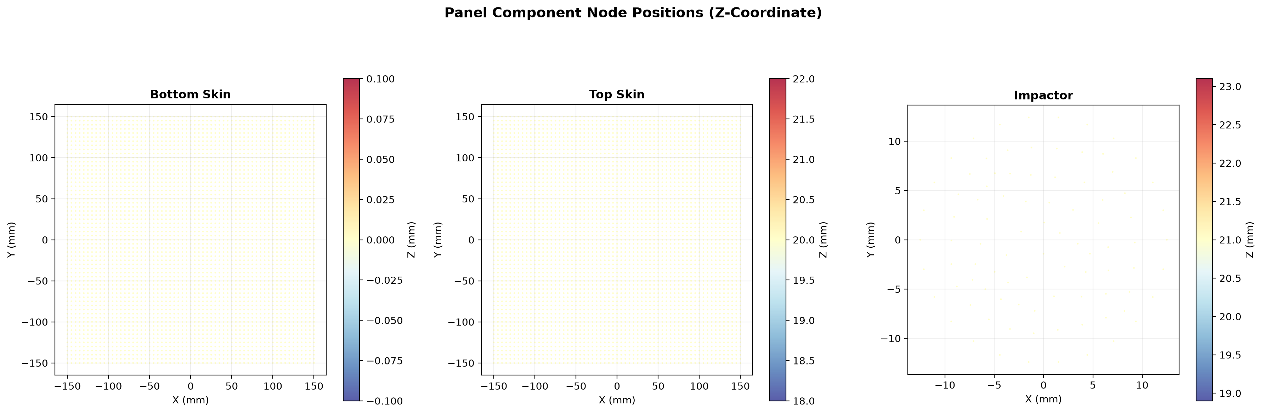
Figure 4: Node positions showing Z-coordinate distribution across the panel

3.5 Damage Assessment
Hashin damage initiation criteria were monitored for fiber tension (HSNFTCRT), fiber compression (HSNFCCRT), matrix tension (HSNMTCRT), and matrix compression (HSNMCCRT). The cohesive contact damage variable (CSDMG) tracks skin-core debonding. Note: Field output plots for these variables require Abaqus CAE for visualization; the ODB contains all damage evolution data for post-processing.

4. Summary and Conclusions
A low-velocity impact simulation (10 m/s) of a CFRP honeycomb sandwich panel was successfully completed using Abaqus/Explicit 2025. Key findings:
- The model ran 20,610 increments in ~12.5 minutes (wall clock) on 4 CPUs.
- Total energy was conserved to within 0.09% over the 5 ms step.
- Kinetic energy decreased by ~80%, indicating significant impact energy absorption.
- Viscous dissipation dominated the energy absorption (58% of total), followed by internal energy (22%) and strain energy (20%).
- Zero plastic dissipation was observed, indicating the aluminum core remained elastic.
- Hourglass energy ratio was 6.61%, marginally above the 5% recommendation — mesh refinement in the core is recommended for higher accuracy.
- The deformable steel impactor approach successfully bypassed Abaqus 2025 API limitations with DISCRETE_RIGID_SURFACE mass/inertia assignment.

4.1 Recommendations
- Refine the honeycomb core mesh (seed size 2.0 mm instead of 4.0 mm) to reduce hourglassing.
- Use S4 elements (fully integrated) for critical regions.
- Include a cohesive zone model at skin-core interfaces using cohesive elements (COH3D8) for more accurate debonding prediction.
- Extend step time to capture full rebound if needed.
- Add contact force history output (CFN) for force-displacement curves.

Appendix A: Model Files
Table A1: Model files in C:\Users\ASUA\OneDrive\Desktop\cc\
File | Description | Size
honeycomb_impact.py | Main build script (~450 lines) | 15 KB
Job-HoneycombImpact.inp | Abaqus input file | 735 KB
Job-HoneycombImpact.odb | Output database (results) | ~1.5 GB
Job-HoneycombImpact.dat | Data file (warnings, messages) | —
Job-HoneycombImpact.sta | Status file (increment history) | —

Appendix B: Solver Warnings
The analysis generated 104 warning messages in the .dat file. The most notable warnings include:
- General contact facet thickness reduction (most significant factor = 0.384 for Impactor element 10) — due to shell thickness exceeding local facet dimensions.
- Material orientation warnings for composite layup — local-3 direction was in the shell plane and was projected onto the element normal (expected behavior).
- Initial contact overclosures (17,449 node-face + 850 edge-edge) were automatically resolved by Abaqus.

