Information-based policy tools facilitate California farmers’ learning about nitrogen management

## In Markdown

|  |  |  |  |  |
| --- | --- | --- | --- | --- |
| Table 1a. Independent variable summary statistics |  |  |  |  |
|  | Mean | Median | Min | Max |
| *Farm and farmer resources* |  |  |  |  |
| Farm Size (acres) | 355 | 52 | 1 | 11,969 |
| Income | $100-200K | $100-200K | < $50K | > $1M |
| Education | Associate degree | Associate degree | Primary school | Graduate degree |
| *Awareness, attitudes, and perceptions* |  |  |  |  |
| Aware of ag. impact | 3.47 | 3.33 | 1 | 5 |
| Stewardship attitudes | 3.86 | 4 | 1 | 5 |
| Farm-as-business attitudes | 4.2 | 4.4 | 1 | 5 |
| Coalition perception | 3.48 | 3.43 | 1 | 5 |
| *Informational support* |  |  |  |  |
| Information source count | 3.38 | 3 | 0 | 15 |
| Attends self-certification course | 0.57 | 1 | 0 | 1 |
|  |  |  |  |  |
| Table 1b. Learning statements: proportions of respondents in each category. The NMP/FEP… |  |  |  |  |
|  |  | No | Sometimes | Yes |
| Helps me analyze connections between N use and water movement |  | 0.36/0.40 | 0.32/0.32 | 0.32/0.28 |
| Helps me identify areas in my operations for increased efficiency |  | 0.36/0.40 | 0.34/0.32 | 0.30/0.28 |
| Helps me improve my N management |  | 0.31/0.38 | 0.34/0.33 | 0.35/0.29 |
| Has made me change my farm management significantly |  | 0.64/0.63 | 0.26/0.27 | 0.10/0.10 |
|  |  |  |  |  |
| Table 1c. Learning stages: proportions of respondents in each category for NMP/FEP |  |  |  |  |
|  |  | None | Conceptual | Applied |
| Learning stage |  | 0.29/0.35 | 0.37/0.30 | 0.34/0.35 |

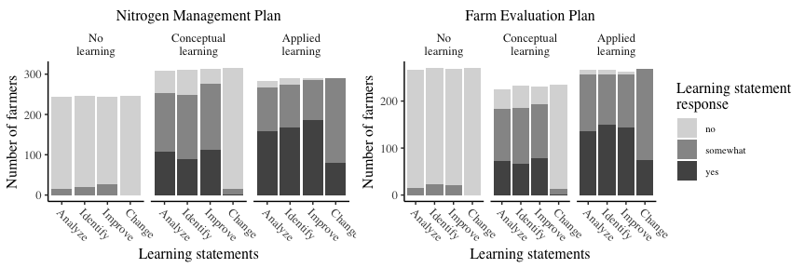

## Markdown

|  |  |  |  |  |  |  |  |  |
| --- | --- | --- | --- | --- | --- | --- | --- | --- |
| Table 2. Sequential logit exponentiated coefficients and confidence intervals for learning stages of NMP and FEP |  |  |  |  |  |  |  |  |
|  | Nitrogen Management Plan (NMP) |  |  |  | Farm Evaluation Plan (FEP) |  |  |  |
|  | Conceptual |  | Applied |  | Conceptual |  | Applied |  |
|  | Odds | 95% CI | Odds | 95% CI | Odds | 95% CI | Odds | 95% CI |
| (Intercept) | 0.005 $​^{***}$ | (0.001, 0.021) | 0.473 | (0.095, 2.371) | 0.009 $​^{***}$ | (0.002, 0.039) | 1.065 | (0.173, 6.555) |
| Farm size (log acres) | 0.952 | (0.817, 1.11) | 0.966 | (0.837, 1.116) | 0.985 | (0.848, 1.144) | 0.988 | (0.84, 1.161) |
| Income | 0.882 | (0.751, 1.035) | 0.922 | (0.795, 1.07) | 0.857 $​^{.}$ | (0.733, 1.002) | 0.975 | (0.826, 1.151) |
| Education | 0.927 | (0.81, 1.059) | 0.854 $​^{*}$ | (0.749, 0.974) | 0.899 | (0.782, 1.032) | 0.832 $​^{*}$ | (0.714, 0.968) |
| Aware of ag. impact | 1.51 $​^{***}$ | (1.225, 1.862) | 1.347 $​^{**}$ | (1.102, 1.647) | 1.491 $​^{***}$ | (1.207, 1.843) | 1.377 $​^{**}$ | (1.093, 1.735) |
| Stewardship attitude | 1.475 $​^{***}$ | (1.198, 1.817) | 1.107 | (0.874, 1.402) | 1.43 $​^{**}$ | (1.155, 1.77) | 1.052 | (0.803, 1.378) |
| Farm-as-business attitude | 1.24 | (0.951, 1.615) | 0.722 $​^{*}$ | (0.538, 0.969) | 1.198 | (0.91, 1.579) | 0.636 $​^{*}$ | (0.45, 0.899) |
| Coalition perception | 2.491 $​^{***}$ | (1.868, 3.322) | 1.353 $​^{*}$ | (1.011, 1.81) | 2.205 $​^{***}$ | (1.659, 2.931) | 1.245 | (0.902, 1.72) |
| Info. source count | 1.075 $​^{.}$ | (0.989, 1.168) | 1.145 $​^{***}$ | (1.066, 1.23) | 1.085 $​^{*}$ | (1, 1.177) | 1.205 $​^{***}$ | (1.108, 1.312) |
| Self-certification | 1.788 $​^{**}$ | (1.192, 2.682) | 1.207 | (0.809, 1.802) | 1.275 | (0.849, 1.914) | 1.154 | (0.738, 1.804) |
| $​^{*}$ p < 0.05, $​^{**}$ p < 0.01, $​^{***}$ p < 0.001 |  |  |  |  |  |  |  |  |

