Target journal: Agricultural systems or or Agriculture and Human Values or Journal of Environmental Management or Journal of Agriculture, Food Systems, and Community Development (2.4)
- AS submission guidelines: max 10,000 words
- JEM: no word limit but LaTeX template
- Food policy?

Author names: 1. Wood, Liza; 2. Zystro, Jared; 2. Hubbard, Kiki
Affiliations: 1. University of California, Davis; 2. Organic Seed Alliance
Corresponding author: Liza Wood, belwood@ucdavis.edu
Address: 1. One Shields Ave, Davis CA 95616; 2.

The double-edged sword of flexible environmental policy: The case of the seed loophole in certified organic production
\chaptermark{organic seed policy}
```{r setup, warning = F, message = F, results = F}
library(kableExtra) ; library(dplyr)
```

1. Introduction
(Why environmental policy is important, environmental challenges, etc.?)

Effective environmental policy has to walk the line between being stringent enough to improve environmental outcomes, while also flexible enough so that the policies don't backfire (Barreiro-Hurle et al. 2023; Sunstein 2017). Overly stringent policies may cause industries to opt-out/exit or find methods for creative compliance if the burden is too high (Bartel and Barclay 2011). Yet, too flexible of policies can also be taken advantage of by free-riders, enabling industries to shirk environmental responsibilities while still gaining (Prakash and Potoski 2007). In this paper we ask: Do flexible environmental standards spare firms from undue burden or enable free-riders?

To answer this question we study a flexible voluntary environmental policy: the organic certification in the United States and its so-called seed loophole. Organic standards require growers to comply with a wide range of practices and sourcing rules that support soil health and biodiversity and reduce environmental impact. Using certified organic seed is one of the sourcing requirements, however, the policy permits exceptions if the variety is not "commercially available". This exception, mirrored in organic policies around the world, gives flexibility to growers with their seed sourcing to ideally limit the burden when organic seeds are unavailable.

This paper analyzes organic growers' reliance on the organic seed exception using three cross-sectional surveys over the last fifteen years. We measure organic growers' use of conventional seed (i.e. their reliance on the loophole) as well as their experiences with seed sourcing barriers, perceptions about organic seed, and their farm operational attributes. Using these data, we model the relationship between conventional seed use and grower attributes to test hypotheses about the sparing and/or enabling effect of the flexible policy.

We find evidence that the flexibility of the organic seed loophole is both supporting growers who need it, as well as enabling more 'conventionalized'/'practical' organic farmers. The use of conventional seed is associated with growers who experience the highest barriers to sourcing organic seed, meaning that the policy does help reduce the burden on growers who cannot find suitable seed in organic form. At the same time, the policy also allows a certain profile of farmers to avoid organic seed use. Farmers of this profile appear to be those that represent the 'conventionalization' of organic agriculture – larger, less diverse farm operations who don't see organic seed as important for the success or integrity of organic production.

These results track with the idea that actors have different motivations for compliance with environmental policy (Bartel and Barlcay 2011) and that policy design needs to account for different motivations (Piniero 2020). Though policy design research tends to treat firms as purely rational actors (Timbe and Winter 2015, Prakash and Potoski), farmers especially have different motivations and embrace business models that balance economic and environmental values (Thompson, Brown et al. 2021). These come through as two identities of organic, practical and principled (Darnhofer), which affect the ways that growers engage with the policy. Not only can reckoning with these identities help strike a better balance within the policy, it also opens up a broader conversation about the different kinds of 'sustainability' that the policy wants to support. (Draft: For organic seed, this means creating a mix of policies that support traditional expansion of organic seed availability and enforcement of the policy, as well as alternative initiatives for principled, grassroots programs)

2. Background

2.1 Environmental policy flexibility
Environmental policy has to strike a balance between stringency and flexibility. Stringent environmental policies often take a command and control approach, where firms are required to meet specific criteria such as defined contributions, reduction targets, or technology standards (Barreiro-Hurle et al. 2023; Pettersson and Soderholm 2014). These types of regulatory measures reduce uncertainty in the achievement of environmental outcomes so long as enforcement is in place (Pineiro et al. 2020). However, stringency has its drawbacks. The increase of regulation may reduce competitiveness of firms (), counteract voluntary behavior (Barreiro-Hurle et al. 2023), prompt relocation to an area with more lenient policies (), or resistance/creative compliance (Bartel and Barclay 2011).

Flexible environmental policies, on the other hand, use a range of tools to motivate firms via incentives to improve environmental outcomes (Gunningham 1999; Pineiro et al. 2020), and at times permit exceptions/derogations if the regulation is overly burdensome (Romero-Castro et al. 2022). The benefits of flexible policies include reduced tension between firms and government (), as well as room for innovation to ultimately improve environmental outcomes (Loonie et al. 2011; Yuan and Zhang 2020). The drawback of flexible policy tools, however, is that participation can be low, adherence needs to be monitored to avoid free-riding (Prakash and Poroski 2007), and there is less certainty around the environmental benefits (Stuart et al. 2014). Furthermore, vague criteria for exceptions/derogations like the use of 'best available technology' gives wide latitude to firms' discretion (Romero-Castro et al. 2022).

In this paper we are interested in environmental policy that provides flexibility in the form of exceptions. For example, the European Union industrial emissions directive mandates firms to reduce emissions using 'best available technology', but grant derogations if the costs of complying (as calculated by the firm) are too high (Romero-Castro et al. 2022, Soderholm et al. 2021). In the United States, regulation of manure discharge by animal feeding operations has several exceptions to regulation based on nutrient management plans (Rosov et al. 2020). Who takes advantage of these exceptions is an open question, prompting our research question: Do flexible environmental standards spare firms from undue burden or enable free-riders?

2.2 Organic agricultural standards

2.2.1 Flexibility of organic certification
Organic certification is a voluntary program that agricultural producers and food processors opt into, and are then monitored according to the certification standards. These kinds of programs are considered high-cost clubs – stringent voluntary standards that gain participants premiums (Prakash and Potoski 2007). However, the certification standards are generally accompanied by listed exceptions for using non-organic products. These exceptions are proposed to reduce excessive burdens and barriers facing growers and processors (e.g. NOSB 2004, NOSB 2006) in an otherwise stringent and often challenging certification process (Flaten et al. 2010, Carter er al. 2022).

One such exception in the organic label is related to seed sourcing. Organic standards generally require organic growers to use organic seed. However, so-called 'loopholes' are often put into place (Endres, Liveseed), where organic growers are allowed to use conventional seed if organic seed is not commercially available. This kind of exception is shared in organic standards around the world, for example the United States' National Organic Program, United Kingdom's Soil Association, European Union's Organic Standard, and the East Africa Organic Standard all have equivalent exceptions based availability.

In the United States, "the goal \[of the exception\] is to promote the continued growth and improvement in organic seed production and subsequent usage by organic growers, without hurting or putting undo \[sic\] burdens on growers." (NOSB 2008). The intention is that this exception can excuse farmers who experience challenges, particularly as the organic seed market develops (Hubbard 2011, 2016). While there is evidence that the seed system is growing through increased public research spending and the development of new organic varieties (Hubbard et al. 2021; Liveseed?), there is still widespread uncertainty as to how the seed loophole is used by organic growers (Hubbard et al. 2021).

2.2.2 Different models of organic farming
To develop an understanding of how farmers are using the organic seed loophole, we first recognize that farmers (and firms more generally) have different motivations (Bartel and Barclay 2011). Many policy design studies tend to treat firms as purely rational actors (Timbe and Winter 2015). As Prakash and Potoski describe it, 'firms choose to join a voluntary club (and produce the environmental externalities it requires) in response to the costs of externality production and the returns from affiliating with the voluntary club brand' (p. 287, 2007). But in reality, firm-level decisions are made by actors with varying risk tolerances, entrepreneurial initiatives, and environmental values and strategies (CITES, Ambec). This is especially true for agricultural settings, where securing economic returns exists on balance with other values and operational attributes (Prokopy et al. 2018, Floress et al. 2017).

Farmers make decisions based on a gradient of values ranging from 'farm-as-business' to 'environmental stewardship', though the two are not mutually exclusive (Thompson et al. 2015, dolaglu?). Additionally, operational attributes such as farm size can influence the willingness and ability to innovate. In some cases large operations may be the ones that have the resources to take on risk and experiment with new practices ((Feder and Umali 1993), Dunn et al., 2016), but in other cases it may hinder the willingness to try something new at a large scale, especially if there is no visible economic return (Napier 2000, (Buttel, Jr, and Larson 1990)).

Variation in grower motivations is especially prominent in organic agriculture. Organic farming originated as a grassroots movement, centered around holistic environmental and social farming principles (Youngberg & DeMuth, 2013). This vision of sustainability emphasizes soil health, biodiversity, social justice, and community food systems as a contrast to the industrialized model of conventional farms (ibid, Coleman). But when codified into practice as certified organic standards, there was quickly a trend towards 'conventionalization' of organic. In this conventionalization, growers participate in organic practices (as defined by the standard) but not organic principles (as defined by the movement's broader social-environmental ethos), mainly to gain the price premium (Darnhofer et al. 2010, Guthman).

The division between 'principled' and 'practical' organic farmers has created tension around the identity of organic farming (von Shlen 2007, Coleman 2001). This tension has come to bear throughout the process of setting and revising the certification standards, such as the bi-annual discussion of the National Organic Standards Board, where exceptions are reviewed and updated (DuPuis). Indeed, these discussions reflect a wider conversation about the vision of what organic is and the appropriate path to achieve it. Though the division between 'principled' and 'practical' organic farmers does not fully represent the diversity of farmer profiles involved in organic (Guthman, Darnhofer), they help us typify different ways that growers may be engaging with the organic standard and its flexibility.

3. Hypotheses
We use the case of the organic agricultural standard to ask: Do flexible environmental standards spare farmers from undue burden or enable free-riders? We propose two sets of hypotheses.

The first proposition tests whether environmental policies add flexibility in order to reduce excessive burden on firms. Organic farming is certainly challenging (Sahm et al. 2012), and barriers to complying with the standard are high, especially in the early phases of the certification's establishment. As such, we expect to see evidence that growers who are relying on the seed loophole (i.e. planting conventional seed) are those who experience the greatest barriers to accessing organic seed. Furthermore, we expect that as the organic seed market develops over time, fewer growers are using conventional seed.

H1a. Conventional seed use will be highest among growers experiencing more significant organic seed sourcing barriers
H1b. Conventional seed use will decline over time

The second proposition tests whether policy flexibility enables some farmers to take advantage of the policy's leniency (Prakash; Stuart 2014). In the organic seed policy, though guidance for growers and certifiers has tried to define and operationalize the 'commercial availability' exception (NOSB 2018), there is still opportunity for shirking. We propose that those particularly inclined to take advantage of the policy's leniency are farmers fitting the 'practical' profile, given that they have little principled motivation to adopt organic seed. In this case, we expect to see evidence that growers relying on the seed loophole are those who align with that profile – farmers who place low value on organic seeds' role in organic integrity and have operations that resemble conventional farms: large acreage and low crop diversity.

H2a. Conventional seed use will be highest among those with who place low value on organic seeds' contribution to organic integrity
H2b. Conventional seed use will be highest on large farms
H2c. Conventional seed use will be highest on low-diversity farms

4. Methods

4.1 Case: USDA National Organic Program and organic seed
In this paper we focus on the case of the US Department of Agriculture (USDA) certified organic label. The organic movement in the US began prominently organizing in the 1970s, and it is through their collective action that the Organic Foods Production Act was passed as part of the 1990 Farm Bill and ultimately ratified in 2002 (Youngberg). In the arrangement, the USDA National Organic Program (NOP) determines the standards, though they are advised by the National Organic Standards Board (NOSB) – a panel of industry representatives that meets regularly to continuously discuss exceptions and general guidance with input from the public.

The general idea of certified organic crop production is that growers use only biological inputs (e.g. no pesticides or genetically modified seeds) to create an agro-ecosystem with healthy soil, diverse crop rotations, and minimal environmental impact (USDA NOP 2015). From start to finish of the certified organic supply chain, inputs should be organic to 'protect the integrity' of the label, including seeds. In practical terms, organic seeds are those that are cultivated under certified organic conditions, meaning that using organic seed contributes to environmental outcomes by having more acreage managed under organic practices. The principle of organic seed, however, extends even further. Organic seeds ought to support genetic and crop diversity maintenance, be adapted to organic growing conditions, and suitable for regional environments (Hubbard et al., 2022; Rohe et al., 2022). Furthermore, organic breeding is often collaborative, where seed sovereignty and social needs are included as project considerations (Colley, 2022; Dawson et al., 2011). Altogether, organic seed is a foundational part of organic production, especially for more principled organic growers (Hubbard et al. 2022).

There are exceptions to several of the organic requirements, as mentioned in Section 2.2.1. Of focus in this paper is that USDA NOP organic growers are allowed to use conventional seed if "an equivalent organically produced variety is not commercially available" (7 CFR § 205.204). Third-party organic certifiers, or accredited certifying agencies, are responsible for evaluating organic growers' compliance with the organic standard, and whether or not a farm qualifies for the organic seed exemption is at their discretion. Now that more than twenty years have passed since the ratification of the NOP, we draw on data to understand trends in seed use and the attributes of growers that have been unable to source organic seed. Such an assessment can help policymakers rethink the organic seed policy as the US organic standard enters into its third decade.

4.2 Data: Organic grower survey
This research combines three cross-sectional surveys of organic seed producers in the United States. These data were collected in 2009-2011, 2014-2016, and 2019-2021, which we will refer to as the 2010, 2015, and 2020 time periods. The nation-wide organic grower survey, orchestrated by the national non-profit organization Organic Seed Alliance, covers four topics: Farm profile, use of organic seed, barriers to organic seed and sourcing, and attitudes towards organic seed.

In each data collection period, grower surveys were distributed using one or both of the following methods: a random sample from the USDA NOP INTEGRITY database and a convenience sample from an open-access web survey. Responses from both the combined random and convenience samples resulted in a total of 899 responses in 2010, 1,162 responses in 2015, and 760 responses in 2020 that had identifiable regions and crops. The points on the maps in Figure 1.1 represent the distribution of our survey respondents. We cannot associate a response rate with our convenience sampling, but the response rates for the random samples were 25% in 2015 and 22.5% in 2020 (convenience sampling only in 2010). Of these responses, 545 (2010), 799 (2015) and 408 (2020) were complete and therefore usable for data analysis for a total of 1,770.
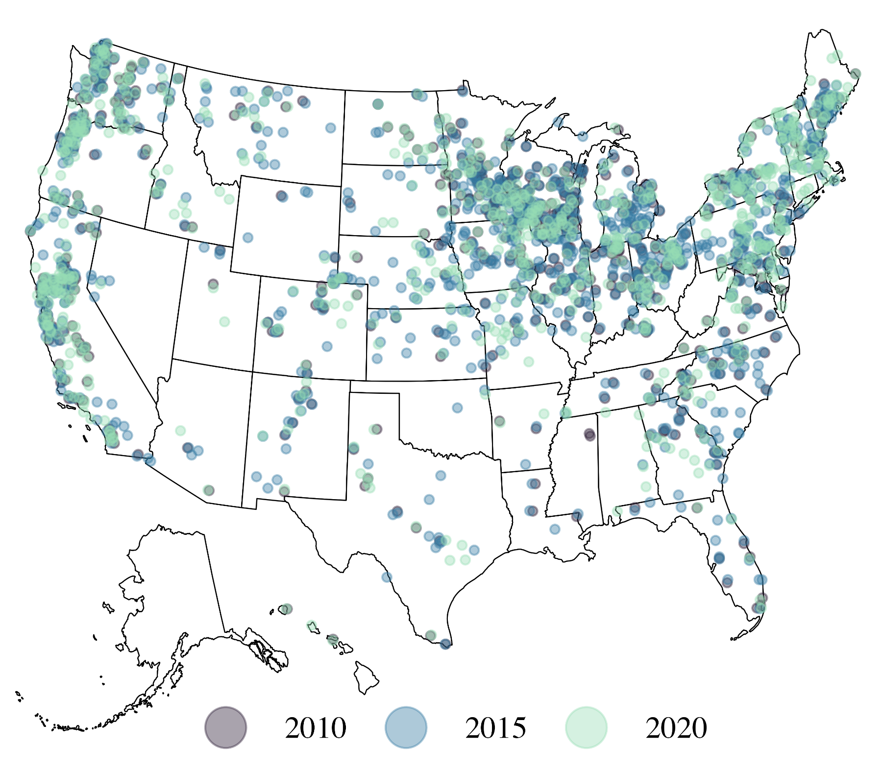
```{r figure1.1, echo = F, out.width = '80%', fig.align = 'center', fig.cap = 'Map of the United States depicting survey responses (points) over three time periods, 2010 (purple), 2015 (blue), 2020 (green).'}
knitr::include_graphics('~/Documents/Davis/R-Projects/organicseed_adoption/figures/figure1.png')
```

4.3 Quantitative analysis

4.3.1 Variables
Descriptions of the variables used in our model are described in Table 1.1. The key dependent variable in our model is acreage planted to conventional seed. The survey asks respondents: "Last year, what approximate percentage of total acreage of \[vegetable/forage/field crops\] was planted with certified organic seed?". The response to this question is a continuous variable between 0 and 100, which was converted into a proportion. Then we subtracted this value from one to represent the proportion of acreage planted to conventional seed.

Our analysis includes eight independent variables for predicting adoption. The first five variables are relevant to our first hypotheses. This includes four variables describing barriers to sourcing organic seed. Growers were asked, "Over the last three years, how much were each of the following a factor in your decision NOT to purchase organic seed?". The top reasons include: Variety is not available as organic, lack of desirable genetic traits, insufficient quantity of seed, and processor/buyer requires or supplies varieties that are not available in organic form. Responses were Likert-scale ratings from "Not a factor" (1) to "Significant factor" (4). Additionally, the survey year captures how the organic seed market has changed over time.

The next three variables are relevant to our second hypothesis. Organic growers' principled value of organic seed are derived based on respondents' agreement with the statement: "Organic seed is important in maintaining the integrity of organic food production." Agreement ranged from strongly disagree (1) to strongly agree (5). Farm size, measured as acreage ranging from 1-17,000 acres, is a representation of scale and farm resources. And crop diversity is the number of crop categories growers produce, which include field, vegetable, and forage crops.

Last, we include four variables in our model as controls: variables we know to influence adoption but are not of theoretical interest to this paper. These include the amount of seed sourced via seed saving or trading, represented as the percentage of seeds that farmers report sourcing from either their own farm or from other farmers, ranging between 0 and 100 percent. Certifiers request organic seed use is the growers' reported experience with certifiers' regulatory enforcement. Growers were asked the yes-no question: "Over the last three years has your certifier requested that you take greater steps to source organic seed?". Last, we include the region in which the farmer is located and the main crop of that grower based on their percent acreage planted to that crop, to account for variation in the development and availability of organic seed in these different subsystems.
TABLE1.1 need to insert
<!---
```{r table1.1, echo = F, eval = F}
table1.1 <- read.csv('~/Documents/Davis/R-Projects/organicseed_adoption/tables/table1.csv') ;
kbl(table1.1, booktabs = T) %>% kable_styling(latex_options = "scale_down")
```

Data description | Hypothesis | Variable  name | Data  type
Dependent variable
Last year, what approximate percentage of total acreage of \[crop\] was planted with conventional seed? |  | Acreage planted to conventional seed | Proportion  (0-1)
Independent variables
Over the last three years, how much were each of the following a factor in your decision NOT to purchase organic seed?
Specific variety not available as  organic seed | H1a | Barrier: Organic availability | Likert scale  (1-4)
Insufficient quantity of seed | H1a | Barrier: Insufficient quantity | Likert scale  (1-4)
Lack of desirable genetic traits | H1a | Barrier: Undesirable  traits | Likert scale  (1-4)
Processor/buyer requires or supplies  varieties that are not available | H1a | Barrier: Buyer requirements | Likert scale  (1-4)
Survey year | H1b | Survey year | Categorical  (2010, 2015, 2020)
Please indicate your level of agreement with the statement: Organic seed is important in maintaining the integrity of organic food production | H2a | Values organic seed | Likert scale  (1-5)
Total acreage | H2b | Farm size (acres) | Numeric  (0-17,000)
Crop diversity | H2c | Crop diversity | Numeric  (1-3)
Control variables
Has your certifier requested that you take greater steps to source organic seed? |  | Certifiers request organic seed use | Binary  (0-1)
Sources seed from self or other farmers |  | Seed saved or traded (%) | Percent  (0-100)
Main crop |  | Crop | Categorical  (Field, Forage, Vegetable)
Region |  | Region | Categorical  (N. Central, West, Northeast, South)
--->

4.3.2 Modeling approach

We use a beta regression model to estimate the relationships between organic growers' use of conventional seed and their attributes. The beta distribution is best suited for our model given that the dependent variable of conventional seed use is bounded by 0 and 1, representing the proportion of acreage. Prior to fitting the model, we transformed the data in two ways. First, the acreage proportion data was truncated by 0.001 so that observations fall within (but not equal to) the 0-1 boundaries of a beta distribution (INLA Documentation: Beta). Second, all independent variables are mean-centered and scaled for easier interpretation of coefficients. This way, the values of the coefficients represent the proportion increase in conventional seed used based on a unit change from the mean of the variable.

We ran our analysis using the INLA package (Rue et al. 2009) available in R Statistical software (R Core Team 2023). INLA uses an Integrated Nested Laplace Approximation – a deterministic Bayesian method for estimating its models. Analysis is available at github.com/liza-wood/organicseed_adoption. Variable selection is informed largely by theory rather than model fitting exercises. However, we compare several models and provide measures of model fit in Appendix Section A.

4.4 Descriptive analysis??

5. Results

5.1 State of organic seed
Across the three time periods of our survey (2010, 2015, 2020), the mean values and their standard deviations are reported in Table 1.2. Conventional seed use has been moderately low since the inception of the organic certification. The mean proportion of organic crop acreage planted to conventional seed decreased from 43% to 32% between 2010 and 2015, then to 29% in 2020, with high standard deviations. These numbers suggest that most farmers are planting at least some organic seed, though those planting 100% organic seed represented only 21%, 27%, and 26% of growers in 2010, 2015, and 2020, respectively.

The most significant barrier that growers report as limiting their organic seed sourcing is that a specific variety is not available in organic form, which is ranked greater than 3 (between moderate and significant factor) in all three survey periods. The barriers of insufficient quantity and desirable genetic traits score an average of 2.6 (between low and moderate factor) in 2010, and that score decreases by 2020. Buyer requirements are the least significant barrier to sourcing organic seed, but it does remain a consistent, low ranked factor over time.

Across the three survey periods, growers' perceived value of organic seed as important to the integrity of organic has remained consistently high. In the 2010 survey, the average agreement score with the statement that organic seed is important to the success of organic production was 4 (somewhat important), which increased to 4.3 in 2015 and 2020. The operational profile of organic growers matches the profile of agricultural production more generally in that farm sizes are increasing ((Sumner 2014)). The average farm size over the three survey periods was 180, 275, and 346 acres. This increase is most pronounced in field and forage crops. Further, the number of crop categories planted by growers has been declining, with an average of 1.7 crop types in 2010 down to an average of 1.3 in 2020.

The relationship between certifiers and organic growers has shifted over the years, as it appears that organic certifiers are becoming less strict. When non-compliant growers (i.e. growers not already using 100% organic seed) were asked whether or not their certifier had requested the increase their organic seed use, 61% responded yes in 2010, decreasing to 56% in 2015 and 46% in 2020. This decline suggests that certifiers are becoming less insistent to ensure that growers are taking measures to source organic seed. Further, reliance on non-commercial seed sources, via seed saving and seed exchange, has decreased from 23% and 24% in 2010 and 2015 to 15% in 2020.

```{r table1.2, echo = F}
table1.2 <- read.csv('~/Documents/Davis/R-Projects/organicseed_adoption/tables/table2.csv') ;
kbl(table1.2, booktabs = T,
caption = 'Mean values and standard deviations (reported in pathenses) for the key variables from the organic grower survey for each time period') %>% kable_styling(latex_options = "scale_down")
```
<!---
Table 1.2. Mean values and standard deviations (reported in pathenses) for the key variables from the organic grower survey for each time period
Organic grower survey questions | 2010 | 2015 | 2020
Proportion of acreage planted to conventional seed | 0.43 (0.38) | 0.32 (0.36) | 0.29 (0.36)
Barrier: Organic availability | 3.55 (0.95) | 3.05 (1.22) | 3.19 (1.15)
Barrier: Insufficient quantity of organic seed | 2.62 (1.29) | 2.22 (1.23) | 2 (1.16)
Barrier: Lack of desirable genetic traits | 2.63 (1.33) | 2.15 (1.26) | 2.31 (1.27)
Barrier: Buyer requirements | 1.87 (1.26) | 1.63 (1.13) | 1.9 (1.25)
Values organic seed | 4.03 (1.07) | 4.29 (0.96) | 4.32 (0.89)
Farm size (acres) | 181.05 (342.15) | 275.16 (645.05) | 346.98 (999.54)
Vegetable Crop Acreage | 27.58 (90.34) | 62.79 (427.81) | 12.3 (47.81)
Field Crop Acreage | 178.21 (347.15) | 259.32 (490.56) | 351.51 (812.27)
Forage Crop Acreage | 98.96 (124.74) | 122.03 (197.63) | 172.11 (548.85)
Crop diversity | 1.66 (0.64) | 1.5 (0.6) | 1.25 (0.56)
Certifiers request organic seed use (% yes) | 61% | 56% | 46%
Seed saved or traded (%) | 22.54 (29.95) | 23.67 (31.69) | 14.63 (24.05)
Number of respondents (no missing data) | 545 | 799 | 408
--->

5.2 Policy flexibility for those facing barriers
In this section we present model results related to our first set of hypotheses, which propose that environmental policies add flexibility in order to reduce excessive burden on organic producers. We present the mean coefficient estimates and credible intervals of our model results in Figure 1.2. Full model results are available in Appendix B.

Of the four organic seed sourcing barriers facing organic growers, three have a significant positive relationship with planting conventional seed. The barriers related to organic seed variety availability, lacking desirable genetic traits, and limitations in choice via buyer requirements have effect sizes of 0.14, 0.13, and 0.11, respectively. In other words, for each unit higher that a grower ranks the barrier of organic variety availability, for example, the proportion of acreage planted to convention seed increases by a mean estimate of 0.14 (14%). This estimate is based on all other variables being held constant at their mean or baseline, so for example, these effects are calculated based on having an average farm size, number of crops, and value rating of organic seed, among other variables. The barrier related to insufficient quantity of an organic variety was not significantly related to conventional seed use.

Regarding survey year, we find that conventional seed use significantly decreased over time. In 2015, the coefficient estimate is -0.17, suggesting that compared to the baseline data in 2010, growers are planting 17% less of their acreage to conventional seed. Likewise in 2015, growers are planting 33% less of their acreage to conventional seed.

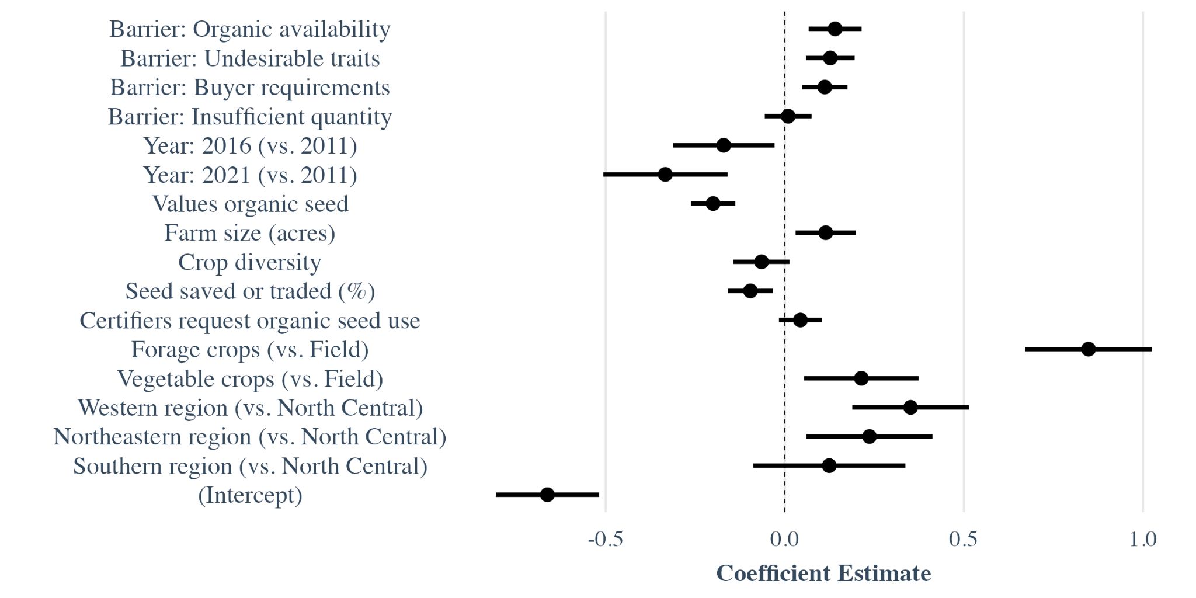
```{r figure1.2, echo = F, out.width = '100%', fig.align = 'center', fig.cap = 'Coefficient estimates and credible intervals for the beta regression assessing the proportion of total acreage of a growers main crop planted with conventional seed.'}
knitr::include_graphics('~/Documents/Davis/R-Projects/organicseed_adoption/figures/figure2.png')
```

These results support our first hypotheses: H1a) Conventional seed use will be highest among growers experiencing more significant organic seed sourcing barriers and H1b) Conventional seed use will decline over time. Together, they suggest that the flexibility of the organic seed policy is being used by those with the highest seed sourcing burden, and as the organic seed market develops over time, growers rely less on the seed policy exception.

5.3 'Practical' farmer profiles rely more on policy flexibility
Next we address our second set of hypotheses, which propose that policy flexibility enables some farmers to take advantage of the policy's leniency. A grower's rating of organic seed's value has a significant negative relationship with planting conventional seed. Our model estimates an effect size of -0.2, meaning that for every unit higher that a grower ranks the value of organic seed, the acreage planted to conventional seed decreases by 20%. All else held equal – so for example farmers who experience the same barriers and have the same farm sizes – the principled belief that organic seed is important to the integrity of organic farming has a considerable effect on how much of acreage is planted to conventional versus organic seed.

Regarding operational characteristics, farm size has a significant positive relationship with planting conventional seed. For every unit larger a farm is, growers plant 11% more of their acreage to conventional seed. Crop diversity has a negative relationship with planting conventional seed, with an effect size of -0.07, but credible intervals that span between -0.14 and 0.01.

These results support all three of our second hypotheses: H2a) Conventional seed use will be highest among those with who place low value on organic seeds' contribution to organic integrity, H2b) Conventional seed use will be highest on large farms, and H2c) Conventional seed use will be highest on low-diversity farms. These results suggest that certain farmers' profiles – notably those that align with a 'practical' organic grower – rely more on the organic seed policy exception than more 'principled' organic growers.

The crop and regional controls in our model highlight considerable variation in adoption based on these different organic subsystems. Forage crop growers plant an estimated 85% more of their acreage to conventional seed compared to field crop growers, while vegetables crop growers plant an estimated 21% more. Regionally, compared to the baseline of the North Central region, growers from both the West and the Northeast regions plant significantly more of their acreage to conventional seed, with coefficient estimates of 0.35 and 0.24, respectively. The estimate for the Southern region is also higher than the baseline (0.12), though the credible intervals of this estimate cross over zero.

We take results related to our second set of hypotheses and visualize the differences between two typified farmer profiles: practical and principled. A practical farmer profile is defined by a low value of organic seed (25th percentile), large farm size (75th percentile), and low crop diversity (25th percentile). A principled farmer profile is the opposite, characterized by a high value of organic seed (75th percentile), small farms (25th percentile), and high crop diversity (75th percentile). We calculate these profiles for each region in the United States and use the example of vegetable crops, with all other variables fixed at their median value. Using these two profiles we estimate their predicted acreage planted to conventional seed using our model.

Figure 1.3 visualizes model predictions of conventional seed use by hypothetical vegetable growers from these two farmer profiles across regions in the United States. From the predicted values we see a consistent difference between the two farm profiles: practical farmers rely more on the seed policy loophole, planting between 20-39% more acreage to conventional seed than principled farmers in 2010, 22-73% in 2015, and 8-20% in 2020. The standard errors around these estimates are plotted, but are so small that they cannot be seen in the figure. We run these same predictions for Field and Forage crops (available in Appendix C) and observe even higher differences between the two farm profiles over the three time periods.

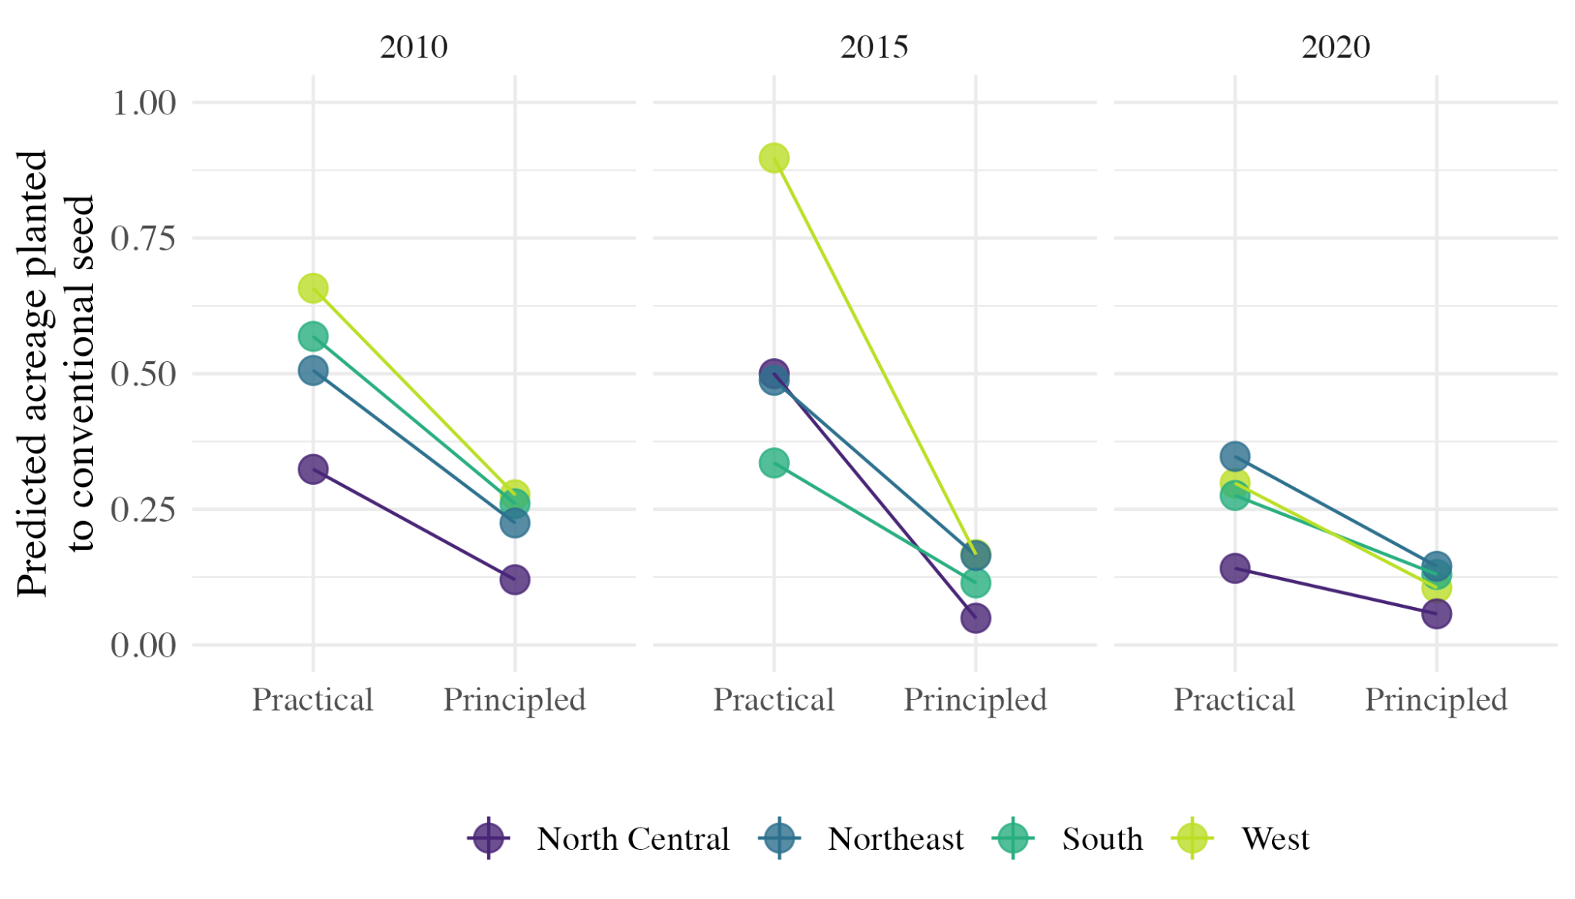
```{r figure1.3, echo = F, out.width = '100%', fig.align = 'center', fig.cap = 'Predicted mean estimates and their credible intervals (not visible due to small size) for vegetable growers of two farmer profiles. Estimates are made for each region of the US, represented by the different colored points (see legend). The points represent the mean estimates and lines connecting points highlight the difference between practical and principled growers in each time period.
'}
knitr::include_graphics('~/Documents/Davis/R-Projects/organicseed_adoption/figures/figure3.png')
```

5.4 Descriptive??

6. Discussion and conclusion

6.1 Flexibility in the organic standard is double-edged
We find support for both our hypotheses related to the role of environmental policy flexibility in the organic standard: the seed loophole is being used by those with the highest seed sourcing burden, as well as those with more 'practical' farm profiles. These results suggest that the flexibility of the organic policy is both sparing firms from undue burden and enabling free-riders. Simply put, the standard's flexibility is a double-edged sword, as pointed out by plant breeder John Navazio in an interview about the seed loophole (Roseboro, 2018).

What do I actually contribute? (struggling here)
- These results move beyond a singular assessment: flexible market-based policies are good because they support innovation (Ramanathan) or flexible voluntary standards are bad (Angus 2015). It generates a more nuanced discussion around how to tweak policy to account for the different motivations of growers.
- These results track with the idea that actors have different motivations for compliance with environmental policy (Bartel and Barlcay 2011) and that policy design needs to account for different motivations (Piniero 2020). Though policy design research tends to treat firms as purely rational actors (Timbe and Winter 2015, Prakash and Potoski), farmers especially have different motivations and embrace business models that balance economic and environmental values (Thompson, Brown et al. 2021). We make the point that firms, farmers, and people generally respond to environmental policy stringency (and flexibility) differently, and so tools need to be designed to account for this (Pinero et al. 2020)..

This is also an innovation system/innovation policy problem
- By identifying that there are barriers to sourcing, this calls upon innovation policy for organic seed. Namely, to get the balance right, the organic seed standard may require complementary policies that support innovation to build a stronger organic seed innovation system more generally (Rogge and Rechiart). In short, we need a wider mix of policies if we really want to improve organic seed sourcing.
  - Basically we need to look beyond single policies and think more broadly about the mix that they're in
- Though the standard supports organic seed market development and innovation by requiring its use, it simultaneously creates challenges for incentivizing entrepreneurial activity due to this exception, and leaves the decision to certifiers for assessing commercial availability and viable alternatives (Renaud et al., 2016).

6.2 Reckoning with identities of environmental movements

While finding the right policy tool is central to improving environmental outcomes (Gunn), it bypasses broader discussion about the identities that motivate firms, farmers, and people generally to participate in 'sustainability transitions' (). Our results highlight a tension in the organic movement, between practical and principled farmers, that exists across efforts for social and environmental change more generally (Smith 2012).

On one hand, participants in grassroots, alternative sustainability movements often do not want to replicate the systems they developed as an alternative to (Smith and Raven; Pasucci). For example, farms like Bee Heaven Farm in Florida produce mixed vegetables for direct sales on five acres, and grow out seed for use on their operation. Though organic, farms like these are re-asserting their ethic through initiatives like the "Real Organic" label, that oppose what is perceived as the industrial co-opting of the organic standard (www.realorganicproject.org). This is true for some parts of the organic movement (Youngberg) but also movements like the open source software initiative (Jain et al. 2023), open-source seed initiatives (Montenegro de Wit), community energy initiatives (Smith 2013), and Hackerlabs (Smith).

On the other hand, participants in more traditional sustainability initiatives want to scale to replace the mainstream modes of production in order to have the widest impact (Smith and Raven). For example, the Cal-Organic farm has grown from a quarter of an acre of organic production to one of the nation's largest organic vegetable providers, in part due to merger with conventional operations and industrial supply chain connection with Whole Foods (https://calorganicfarms.com/our-story/). Likewise, Bayer CropScience, one of the largest agri-chemical and seed companies in the world, has recently announced its entry into the organic seed market (Bayer 2021). This same model is aspired to for several alternative energy technologies like wind () and fuel cells ().

By and large, environmental sustainability initiatives are designed and evaluated based on the metrics of the latter, traditional approach. As a result, the focus is largely on getting incentive structures right so that pro-environmental behavior and innovation can flourish and scale (Prakash and Potoski). Yet, our results point to the coexistence of both alternative and traditional visions of sustainability transitions through the clear difference in seed sourcing behavior by principled and practical farmer profiles. Based on these findings, we propose that designing a well-balanced environmental policy needs to reckon with these multiple, sometimes competing identities. This reckoning includes recognition of how different policies cater to different identities and visions within sustainability transitions.

6.3 Organic policy recommendations

In this section we propose recommendations related to the United States organic standard, recognizing the multiple identities within organic farming. Recommendations relate to the organic seed policy itself, as well as innovation policy more broadly that shapes the way organic seed is developed and made available.

Make more seed available
- Support innovation via: Continue funding for research and organic variety development and support seed producer education and expansion
  - Not just through traditional pipelines like plant patenting, but also grassroots initiatives like commons-based breeding/open-source seed initiative
  - Direct resources towards a diverse portfolio of ‘pre-competitive’ agricultural programs to support diversity – climate change adaptation, minor crop work, etc
  - Continue funding public seed collections

Strengthen the organic seed requirement
- Require organic growers to demonstrate improvement in organic seed sourcing
  - This was recommended by NOSB in 2018 – has it been taken on? Not by the time of the SOS 2022 report.
  - For example, growers over a certain income threshold should contract/take on research
- Improve availability resources
  - Measuring availability has been addressed in the EU through the creation of an organic seed database, in which all organic seeds must be registered (LiveSeed). And consequently, these derogations are slated to be phased out by 2036. The US has tried this but failed…
- Increase certifiers enforcement ability
  - First, focus on substantive non-compliance notices, rather than administrative (Carter et al. 2022)
  - Consider who exceptions are for: biggest farmers? Or most diverse?
- Ultimately, goal is to consider tightening or closing the seed loophole

The goal should be not to preference practical or principled, completely. In order to give principled a chance of staying in it, there should also be policies that challenge the highly consolidated nature of seed in the US. Enforcing anti-trust and protecting access to plant genetic material

In this way mixes are not just about utilizing a wide range of tools, but also supporting a diversity of pathways towards compliance, without preferencing a select farmer profile.

'When there are no organic or in-conversion seeds or vegetative propagating material of a suitable variety available you may use non-organic' (UK Soil Association, (EC) 834/2007 Art. 22(2)(b) (EC) 889/2008 Art. 45(1)(b))
Seeds, seedlings and planting materials from organic production shall be used. If organic seeds, seedlings and planting materials are not commercially available, then conventional, chemically untreated seed, seedlings and planting material may be used. Only if these are not commercially available may chemically treated seeds, seedlings and planting materials be used. The operator shall demonstrate the apparent need for such use. (Kilimohai Organic)
'an equivalent organically produced variety is not commercially available' (7 CFR § 205.204).

