**I. HTML Structure and Taxonomy**

Follow the following rules when making HTML markup:

1. name the **file** “res_element_name” or “bus_element_name”.
2. Name the **first div id** “res_element_name_geos_here” or “bus_element_name_geos_here”

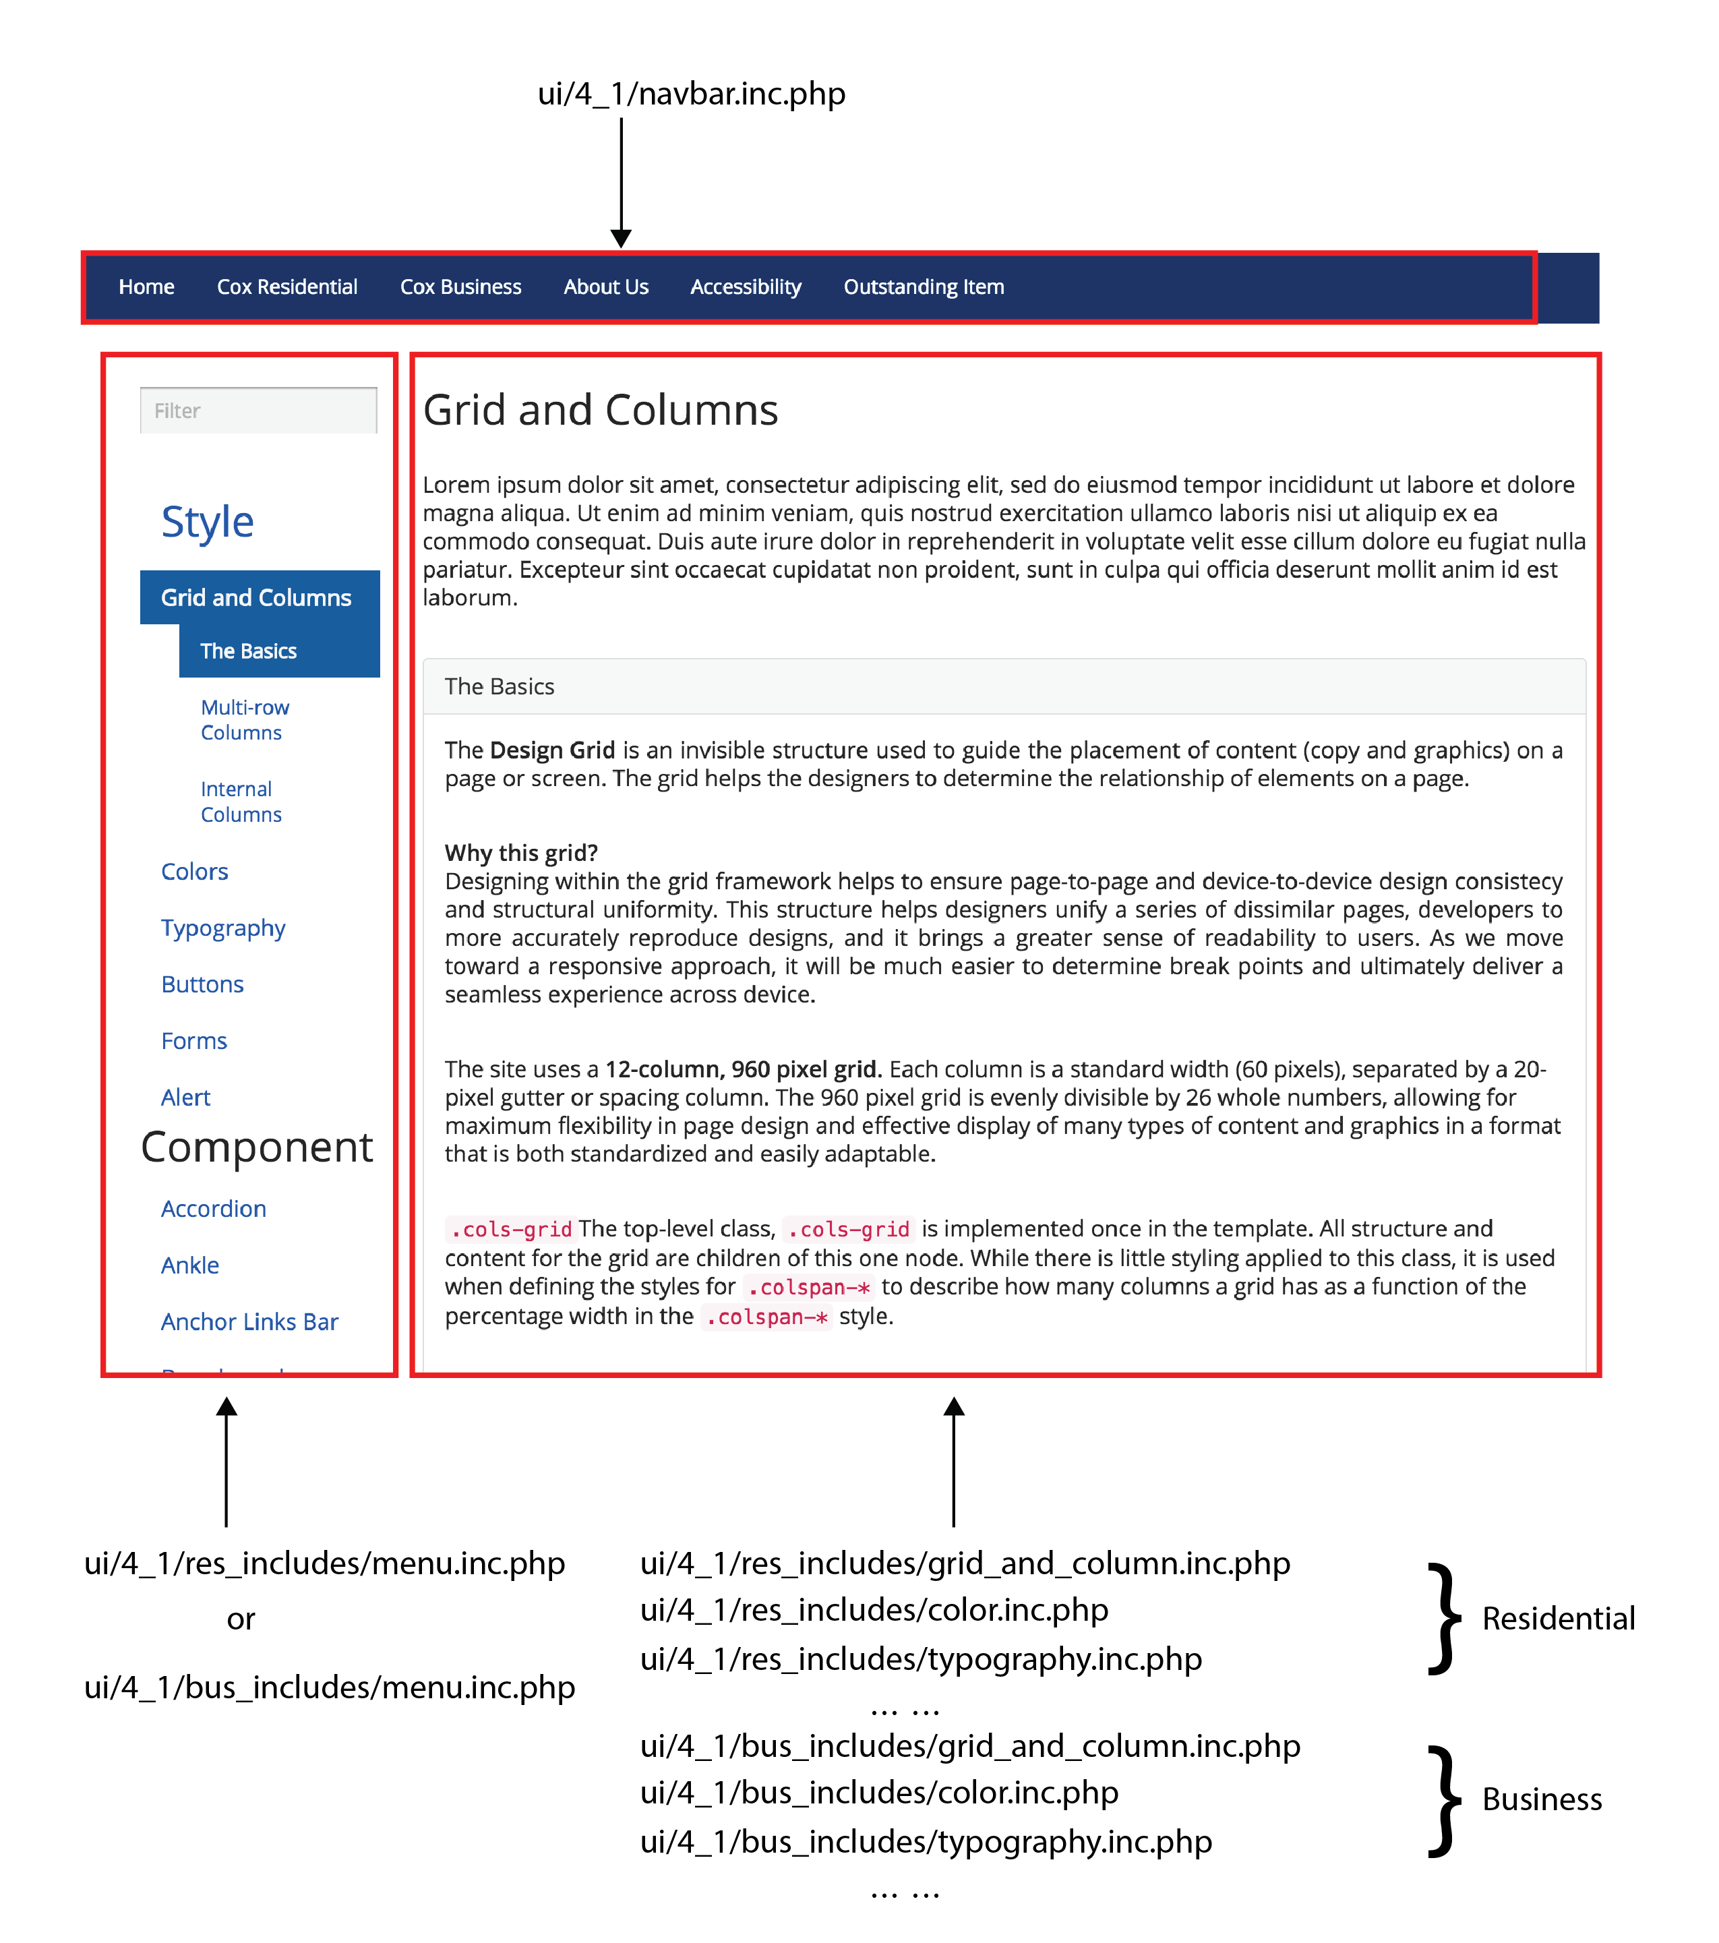

Here is a piece of example code:

<div id="res_divider”>[1]

<h2>Text and Image <code>.text-image</code></h2>

<div class="row">

<div class="panel panel-default" id="res_image_left">

<div class="panel-heading">

<h3 class="panel-title"> ***Title*** <code>.image-left</code></h3>

</div>

<div class="panel-body">

<div class="cols-grid">[2]

**… …**

***Paste Code Here from Web Pattern Library***

**… …**

</div>

</div>

<div class="panel-footer">[3]

<div class="center-block toggle_code" style="text-align:center;"></div>

<div class="sourcecode" id="test">

<div class="clipboard">

<span class="btn-clipboard">Copy</span> </div><!--clipboard--> <pre>

<code class="language-markup">

<script type="prism-html-markup"> **… …**

***Paste Code Here from Web Pattern Library[4]***

**… …**

</script> </code>

</pre>

</div><!--sourcecode--> </div><!--panel-footer-->

</div><!--panel-->

1. Highest level in “divider.php” document. This id is linked to corresponding item in “menu_inc.php” file.
2. “cols-grid” class is added here individually to make sure the code below works. You can add on the highest level, i.e. below “container” in your document.)

  
3. “panel-footer” contains the sourcecode snippets from “panel-body”. Don’t include “cols-grid” class in this section.
4. Make sure the code has no indentation to the left, because this script recognizes space as it is.