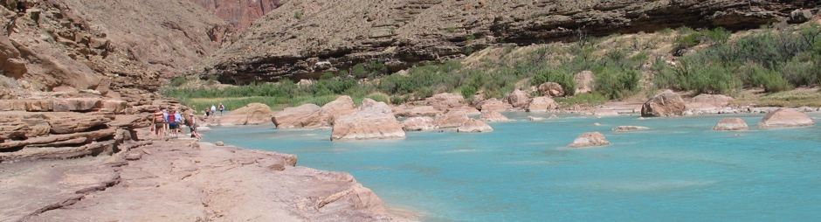
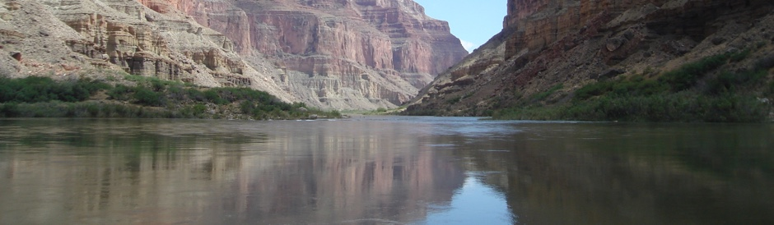
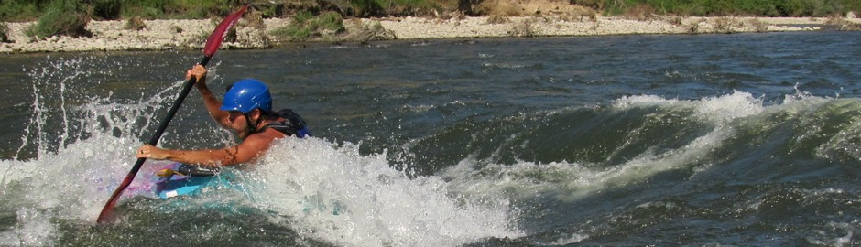

Rivers

Main Fork of the Salmon River, Idaho
Let's not forget the rapids! They range from class I-IV. The Salmon is one of the longest undammed rivers in the United States. As a free flowing river the water is higher, faster, and colder in the early summer and lower, slower, and warmer in the late summer. There are good rapids all summer...but families with children who like to swim tend to appreciate the late summer's slower, warmer water more.

Desolation and Gray Canyon, Utah
Winding through canyons in central Utah, in some of the most desolate land anywhere, the Green river flows towards the mighty Colorado river and the sea. High grey stone cliffs, beautiful desert scenery, and great rapids have made this run famous. This 84-mile trip runs from from Sand Wash to Swaseys Rapid (just outside Green River Utah) and boasts outstanding scenery, interesting geologic formations, evidence of prehistoric and historic human activity, and great whitewater opportunities.

Grand Canyon, Arizona
This is the grand daddy of all canyons and the grand daddy of all river trips. You will never forget your visit to the Grand Canyon. Grand Canyon river rafting combines world-class whitewater with breathtaking scenery to make one truly unforgettable river experience. The canyon is filled not only with exhilarating whitewater rapids, but with side canyons and ancient indian ruins accessible only by river.

footer

