Выполнила: Есакова Елизавета
Группа: Б9123-01.03.02
Дз7: H/w: p. 42 ex. 2 (true-false, correct false option), ex. 3 (12 paragraphs)

№2
- The scientific method can be applied to all types of questions.
True

- A hypothesis must be a statement that cannot be disproven.
False: A hypothesis must be a statement that can be disprove

- The first step in the scientific method is conducting background research.
False: The first step in the scientific method is formulating a question
- The purpose of an experiment is to prove your hypothesis correct.
False: The purpose of an experiment is to test your hypothesis and potentially disprove it.

- The scientific method allows for tweaking the experiment to fit desired results.
False: The scientific method does not allow for tweaking the experiment to make the results fit what you want.

- Troubleshooting an experiment involves analyzing the data and looking for consistent trends.
True

- Analyzing data is an optional step in the scientific method.
False: Analyzing data is a necessary step in the scientific method

- Drawing conclusions is not necessary if the hypothesis consistently makes accurate predictions.
False: Drawing conclusions is necessary regardless of whether the hypothesis consistently makes accurate predictions, it is important to keep in mind that even if your hypothesis gave predictions consistent with this experiment, it is still a falsifiable hypothesis
- For an experiment to be scientific in nature, its results must be replicable.
True
- The scientific method does not require multiple versions of an experiment to be carried out.
False: The scientific method often requires multiple versions of an experiment to be carried out to ensure reliability and replicability of results.
№3
1. Introduction to the scientific method
2. The wording of the question
3. Conducting a background Research
4. Development of a hypothesis
5. Making forecasts
6. Experiment planning
7. Conducting an experiment
8. Troubleshooting the experiment
9. Data analysis
10. Drawing conclusions
11. The importance of reproducibility
12. Repetition of experiments and confirmation of the hypothesis

Дз8: H/w: p. 43 ex. 2, p. 53-54 ex. 3
№2
- background 2. gather 3. knowledgeable 4. unique 5. predict 6. receipt 7. bias 8. falsifiable 9. consistent 10. procedure 11. compound 12. explanation 13. behavior 14. assumption 15. spreadsheet 16. Measurable 17. benefit 18. support 19. test/trial 20. explore 21. property 22. bond 23. seek 24. examination 25. Monitor
№3
- a 2. b 3. e 4. b 5. b 6. d 7. d 8. c 9. e 10. A

Дз9: H/w: p. 58 ex. 2, p. 59 ex. 3, 7, p. 60 ex. 1 - watch the videos and write down the examples and all mathematical expressions in words.
№2
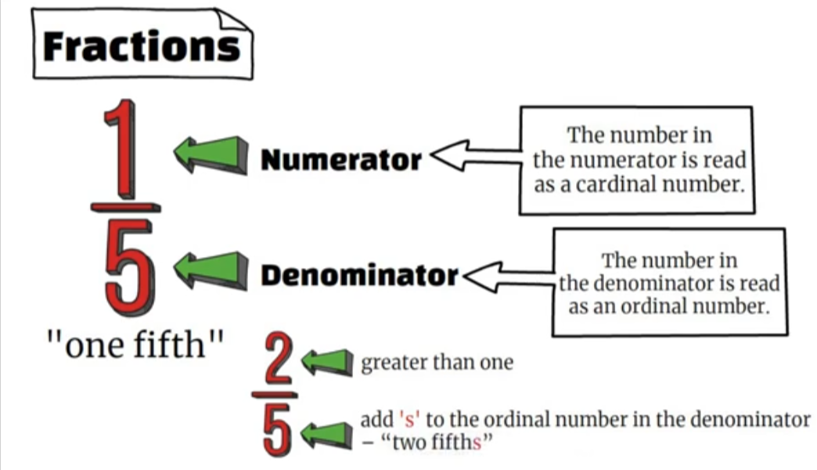
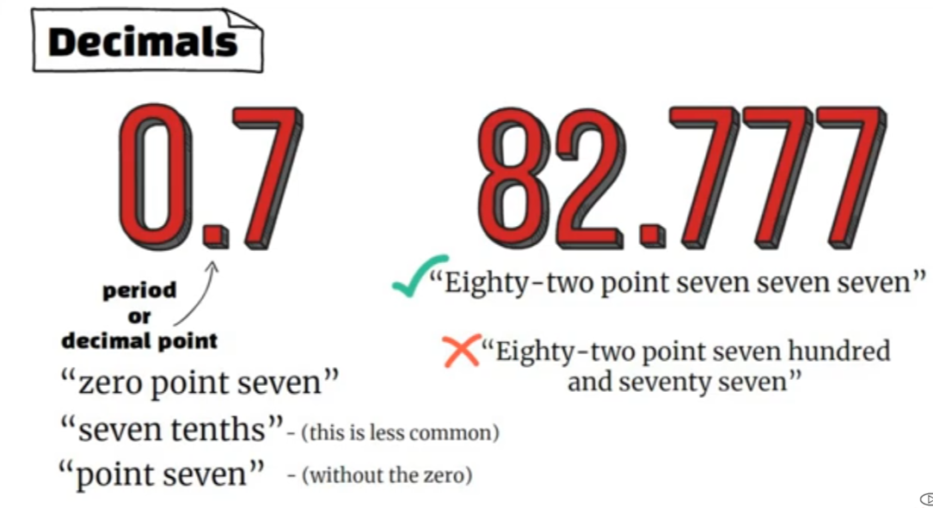
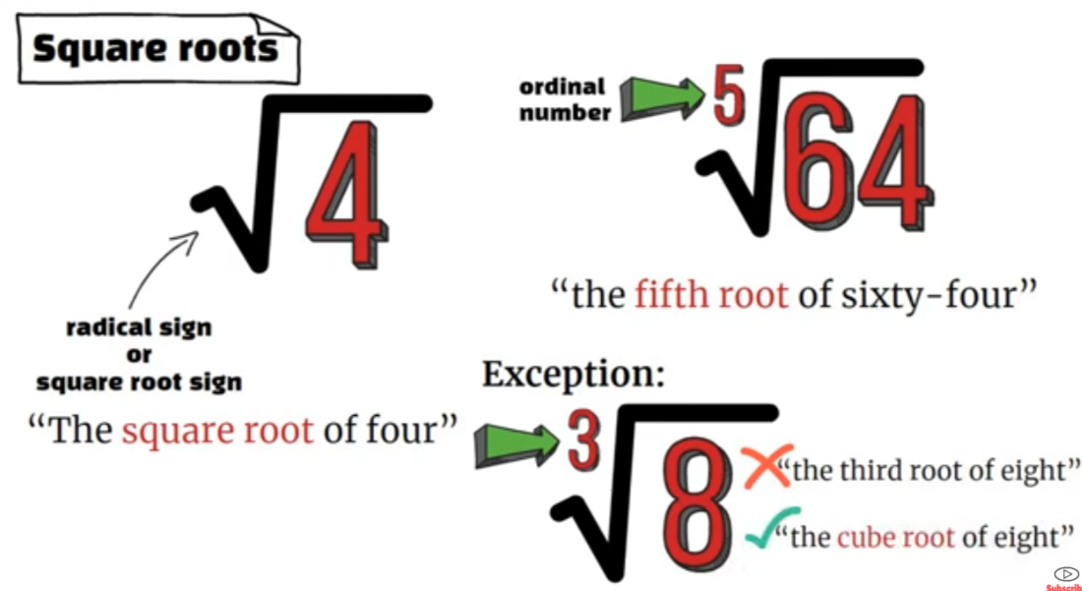

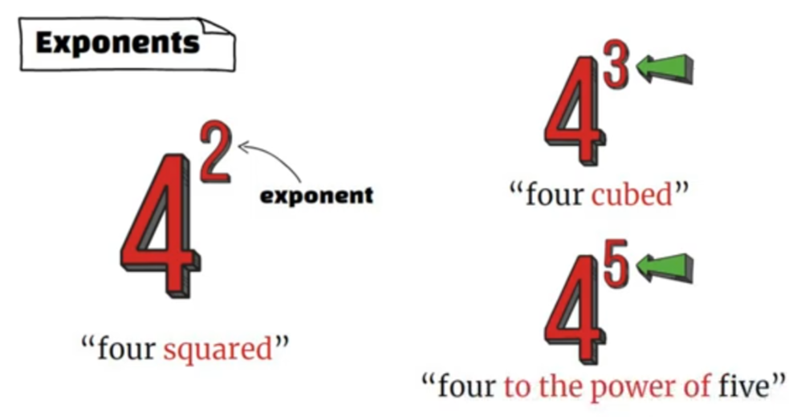

1. 1,692
"Zero point six nine two" or "zero comma six hundred ninety-two"
2. 11^3
"Eleven cubed" or "eleven raised to the power of three".
3. 1/2
"One-half" or "one over two".
4. √125
"The square root of one hundred twenty-five".
5. 579^(-10)
"Five hundred seventy-nine to the power of negative ten" or "five hundred seventy-nine raised to the power of negative ten".
6. 5/4
"Five-fourths" or "five over four".
7. 138^n
"One hundred thirty-eight raised to the power of n" (where n is a variable).
8. 6 8/15
"Six and eight-fifteenths".
9. 284.00569
"Two hundred eighty-four point zero zero five six nine».
10. 32^(√(-3))
"Thirty-two raised to the power of the square root of negative three" or "thirty-two to the root of negative three».

№3
1. Addition
Result: Sum
Сумма

2. Subtraction
Result: Difference
Разность

3. Multiplication
Result: Product
Произведение

4. Division
Result: Quotient
Частное

№6,7
1. x / y
x divided by y
2. 4x / 21
four x over twenty-one
3. x + y / x - y
x plus y over x minus y
4. x^2y^2
x squared y squared.
5. (x + y)
x plus y
6. (x + 7) / (y + x^2)
x plus seven over y plus x squared
7. 2^y * 5
two raised to the power of y, multiplied by five
8. 11 + x / x^3 + 2x(5 - x)
eleven plus x over x cubed plus two x times (five minus x)
9. 1 = 11 + 2(5 - x)
This is an equation, one equals eleven plus two times (five minus x)

№1,2

1. The limit of f of x as n approaches 0.
2. The limit of the cube root of x as x approaches 2 from the left.
3. The limit of e raised to the power of x as x approaches 1 from the right.
4. The derivative of y with respect to x.
5. The derivative of v with respect to r evaluated at r equals 1.
6. The derivative of x squared plus 1 with respect to x.
7. The derivative of the logarithm of x with base a equals 1 over x times the natural logarithm of a.
8. The derivative of the derivative of y with respect to x equals the second derivative of y with respect to x.
9. The derivative of f of x equals the sine of x minus x.
10. The second derivative of h evaluated at 1 equals 1.
11. The third derivative of S with respect to t.
12. f raised to the power of n of x.
13. The integral from 0 to pi over 2 of 2 pi x cosine x dx.
14. The integral of t with respect to t.
15. The integral from t1 to t2 of the absolute value of v of t with respect to t.
16. The limit as n approaches infinity of the sum from i equals 1 to n of 2x_i delta x equals the integral from 0 to 100 of 2x dx.

