Выполнила: Есакова Елизавета
Группа: Б9123-01.03.02

На 25.03
Дз4: H/w: p. 113 ex. 14, ex. 17 (write about 60 -70 words).
№13
Human progress has reached the stage of intensive exploration of nuclear and solar energy, the World Ocean and outer space, and the problem of man and his environment has become one of the most difficult problems for many sciences due to its great significance for the whole mankind. Today the contradictions between man and nature have dramatically increased.
Industrialization and globalization are accompanied by a dramatic increase in the consumption of energy and raw materials and in the output of pollutants and industrial wastes. There are several kinds of environmental pollution: air pollution, water pollution, soil pollution, and pollution caused by solid wastes, noise and radiation.
The increasing noise level is a special problem nowadays. We need silence as much as we need fresh air and unpolluted water. Noise does not only do physical damage to the hearer but can weaken his energy and break down his nerves. Many cities now are too noisy to live in. In fact, progress can be blamed for many environmental problems.
Transport is a major source of environmental pollution. Every car consumes many tons of air. Its exhaust gases contain poisonous carbon dioxide which makes difficult the emission of the earth's heat into space.
One more aspect of the problem is water pollution. Humans and other organisms depend on clean water for nutrients. Unfortunately, human activities cause worldwide water pollution. To protect ourselves, we must also protect our water supply.
The other problem is that our forests are dying from acid rains. Deforestation, especially destruction of tropical forests, affects the balance of nature in many ways. It kills animals, changes the climate and ecosystem in the world. Deforestation continues to be a worldwide problem, over 78% million acres of trees are cut down every year.
The greenhouse effect is another topical problem. It is the result of heat absorption by certain gases in the atmosphere (called greenhouse gases because they trap heat) and re-radiation downward of a part of that heat. Water vapor is the most important greenhouse gas, followed by carbon dioxide and other trace gases. Human activities lead to the enhancement of the greenhouse effect. An enhanced 114 greenhouse effect is expected to bring about the effect of global warming which may result in ecological problems and disasters. Scientists say the temperature of the earth can rise by 3˚C over the next 50 years. This may cause droughts in some parts of the world and floods in others.
Soil pollution and soil degradation are major problems facing agriculture today. These problems result from a variety of problems. Salinity can have a negative impact on soil and plant growth. Any time you use chemical fertilizers, pesticides, or herbicides, they must be carefully controlled to prevent damage. Use of chemicals should be minimized whenever possible.
The major aspect of solving environmental problems is the restoration of the unity between man and nature. Today’s man commonly feels a certain responsibility to nature. As the most powerful being on earth, he feels he must protect the welfare of his world and all it contains. Nature protection is everyone’s concern and we are all responsible for taking care of our environment to save it for the sake of the future.
Titles:
- Human progress and environmental challenge
- Industrialization and globalization cause the pollution
- The increasing noise levels
- Transport is a major source of pollution
- Water pollution
- Deforestation
- The greenhouse effects
- Soil pollution and soil degradation
- Solving environmental problems is very important for nowadays

№17
I know that my efforts alone may not save the entire planet, but I always strive to do what is right. I sort a trash so it can be recycled and reused. I avoid using plastic bags and instead carry items in a reusable cloth bag. Also, I try to conserve water and energy in my daily life by turning them off when it not in use.

На 01.04
Дз5: p. 125 ex. 6 - do the crossword and make up your own 10 sentences with these vocabulary
ACROSS
1. Huge – extremely large in size
3. Fraction – a numerical value that is a part of a whole
4. Advancement – a development or improvement made in a particular field or area
9. Impact – powerful effect or influence that something has on a person, thing, or situation
10. Unprecedented – never done or known before; extraordinary
13. Enable – to give someone the authority, means, or opportunity to do something
14. Debilitate – to make someone weak and infirm
15. Equation – a mathematical statement that says two things are equal
DOWN
2. Unrecognizable – not able to be recognized or identified
5. Vicinity – the area or region near or surrounding a particular place or object
6. Proliferation – rapid increase or growth in numbers
7. Consume – to use up or take in something completely or entirely
8. Share – to give a portion or part of something
11. Accessible – able to be reached, entered, or used
12. Execute – to carry out or perform a task or action
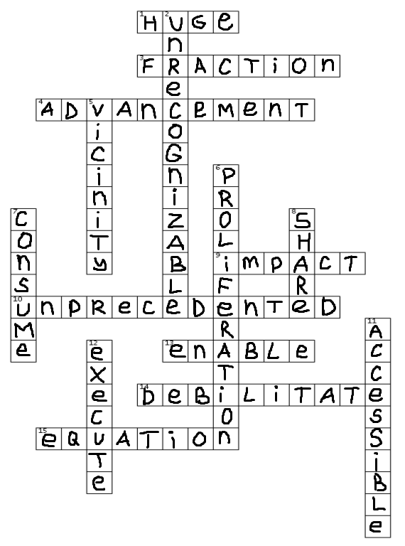
10 sentences with these vocabulary:
- She decided to share her dessert with a friend because it was too big for one person.
- To pass the exam, you need to solve a complex mathematical equation.
- The huge tower in the city center is a popular place for tourists to take photos.
- Only a small fraction of the employees received the bonus.
- This program will enable more people to work remotely.
- The rude reprimand left him feeling so debilitated that he hadn't been able to get a good night's sleep.
- The museum is now more accessible to visitors after they added a wheelchair ramp.
- After years of use, his slippers became unrecognizable even to his friends.
- Grandma and grandpa moved to the vicinity of the city to breathe clean air.
- The proliferation of online shopping has changed the way we buy things.

На 08.04
Дз6: H/w: p. 131-132 Text H-J - Choose the correct heading for each passage and write out 2-3 sentences from every passage, p. 133-134 ex. 1, 2.

A – 6. Improved & Advanced Communication
The continuous developments in technology have improved modern communication methods.
These electronic and digital communication tools have helped us eradicate time and distance to make communication more comfortable, effective, and better.
Modern technology also helps users connect with multiple people on online audio or video calls using video conferencing.

B- 3.Advanced Business and Marketing
Modern technology benefits customers by making it easy for them to buy products or services online.
Companies can sell their products and services to customers living on opposite ends of the globe, and transactions are made quickly in real-time.
Business tech solutions like CRM-enabled POS systems, telematics, productivity tracking software, accounting solutions, and mobile payments have made various business operations and processes accessible and efficient by minimizing the possibility of errors.
C- 9. Better Housing and Lifestyle
Thanks to smart home devices and gadgets, the latest technology has made our life organized, easier, and safer.
The smart home tech industry has made thousands of smart home gadgets that are automatic and controllable via mobile apps.
We can turn the lights on, open the door, keep an eye on the main gate, and even make coffee using our smartphones.
D – 4. High-tech Traveling & Transportation Facilities
Modern technology used in the transportation sector has made it easier for people to travel long distances, conveniently and comfortably.
Moreover, technologies like GPS trackers for car and fleet tracking solutions have made it easier to keep the vehicles secure and keep track of traveling efficiently.
. Driverless vehicles are on their way to eliminate the need for drivers for traveling and transportation.
E – 10. Distance Education and Modern Learning
Technology has changed education in many ways.
Students can watch informative videos on YouTube to enhance their knowledge in a specific subject or field of life.
These virtual educational institutes allow students to earn degrees from the comfort of their homes. Students can communicate with their teachers and educators in real-time by using the latest communication methods to learn more effectively.

F – 8. Easy Accessibility to Healthcare Facility
We have seen the impact of technology on our lives, especially in the healthcare sector.
The invention of the latest medications has also made it possible to treat illnesses like heart disease, cancer, etc.
Modern health or fitness tracking devices have changed the way we take care of ourselves.
Technology today also allows us to consult a doctor and share his medical history online.
G – 5. Online Shopping and Secured Bill Payment
Online shopping is becoming more famous in recent years, all thanks to technology in everyday life.
It has made it quite convenient for people with busy schedules to shop and have all necessary things delivered to their doorstep.
The most significant impact of technology is it allows the customer to pay money online, saving him the hassle of carrying cash or entering a pin.
H – 1. Easy Accessibility to Information
But with the use of technology in daily life, we can search for anything on the internet without even leaving our spot.
There are many dedicated apps available that will solve your queries within a few seconds. One such example is Google Maps.
Modern technology has changed the way we learn, date, dine, or converse online.
I – 2. Instant Connection using Social Media
Social media handles are another significant advancement and example of the impact of technology on our lives.
People access services like Facebook, Instagram, WhatsApp, Snapchat, Twitter, TikTok, etc., to have an insight into others’ lives, be it someone we know from the neighbors or a celebrity.
Social media has also impacted the business world and provided them a platform for marketing their brand and product.
The urge to stay connected and updated with what’s happening worldwide has made us more dependent or addicted to these platforms.

J – 7. Flexibility in Work Life
Technology has helped us stay connected to the office and work while staying at home.
For example, an employee doesn’t have to commute from home to the office, gets more flexible working hours, chooses where to work, etc.
Some productivity apps and software help in time management, organization, goal focus, and keeping track of employees’ activity.

№1

1. (v) consume less power
2. (v) perform tasks
3. (n) fraction of a second
4. (n) advancements in technology
5. to have a significant impact (n)
6. (adj) unprecedented levels of precision and efficiency
7. a complex system (n)
8. (v) share information
9. (adj) convenient online shopping
10. (adj) digital world
№2
1. Advancements in technology enable connectivity on a global scale.
2. The impact of social media has been significant in shaping modern society.
3. Computers have enabled access to vast amounts of information, making it more accessible than ever before.
4. Technological developments have revolutionized the way we communicate and share information.
5. The ability to execute tasks quickly and efficiently has been enhanced by technological innovations.
6. Unprecedented opportunities for learning and growth are available through online education.
7. The lack of access to modern technology can debilitate in their pursuit of educational and career opportunities.
8. Technology has had a huge impact on various industries, from healthcare to agriculture.
9. The accessibility of smartphones and laptops has enabled people to stay connected wherever they go.
10. Sharing data securely has become vital in the digital age.

