# Chapter 3- Design

## Chapter 3.1- Introduction to design

Design is the construction or activity specification or plan or the result of that plan in the form of a prototype, finish product or process. It is also the plan to show how the look and function of the system.

## Chapter 3.2- Structural Design/ Model

Structural modelling is the modelling based on the mathematical model, computer algorithm and statistical model that fits network of constructs to data.

## Chapter 3.2.1- Final Class Diagram

Class diagram is the illustration of relationship and source code dependency among classes in UML.

This approach is taken to as it shows the static structure of classifier in the system and its helpful for developers and other team members too.

## Chapter 3.3- Behavioral Model

Behavioral Model mean using the available and relevant customer and business spending data to estimate future behavior.

## Chapter 3.3.1- Activity Diagram

In UML, activity diagram is defined as the graphical representation of an executed set of procedural system activities and considered a state chart diagram variation.

This approach is taken to describe how the work flow in the system. This approach tells us what the users are capable of accomplishing in the system.

|  |  |  |
| --- | --- | --- |
| Notation used | Notation | Description |
| Action |  | Shows what activity is done |
| Initial |  | Denotes start of the activity |
| Final |  | Denotes end of the activity |
| Fork |  | split a single incoming flow into multiple concurrent flows |
| Join |  | Joins two action into one |
| Decision |  | Decides the condition |
| Control Flow |  | Show the flow of activity |
| Send Signal |  | Send message through the system |
| Accept Signal |  | Receive the message from send signal |
| Swimlane |  | group related activities into one column |
| Activity Interrupt |  | interrupts the flow denoted with a lightning bolt. |
| Accept Time Event |  | event that stops the flow for a time |
| Interruptible Activity Region |  | Activity terminated if interruption occurs |

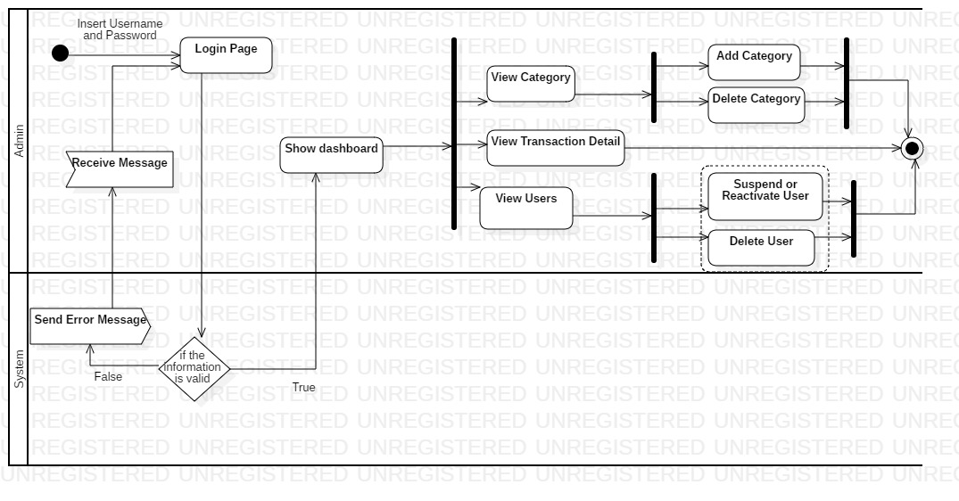

Figure : Admin Activity Diagram

The following activity diagram show how the activity flow of the admin. Admin login the system providing the username and password which is validated in the system. If true then admin is sent to dashboard else back to login page. In the dashboard there are two option: View category where the admin either add or delete category and View Users where admin either suspend user or reactivates the suspended user and delete user and also can see the total transaction details. Finally, the activity flow ends.

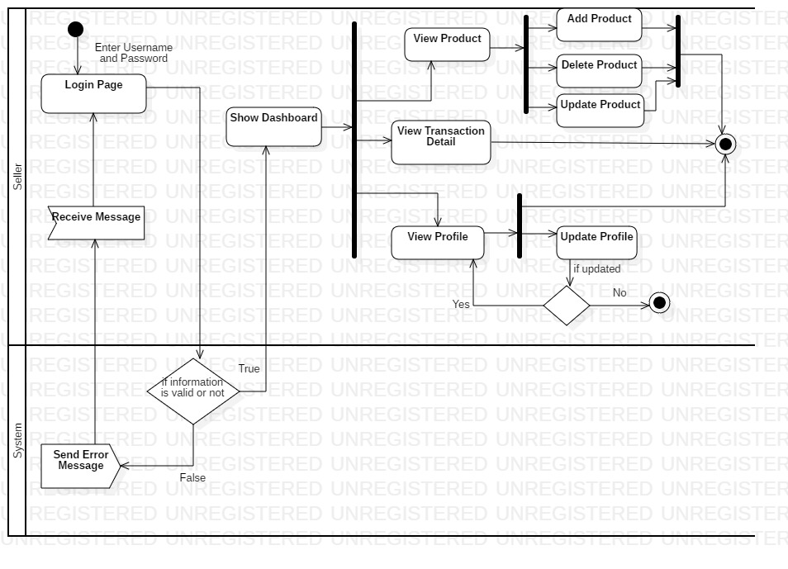

Figure : Seller Activity Diagram

The following activity diagram is based on the seller where he/she enters his login information and If correct sent to dashboard else back to login page. In dashboard he/she can view the product he/she have listed where if needed can add product, update any product if needed and delete the product if he don’t want to keep, he/she can also see the transaction detail of his/her product and he/she can view his/her profile and update it if needed. Finally, the activity flow ends.

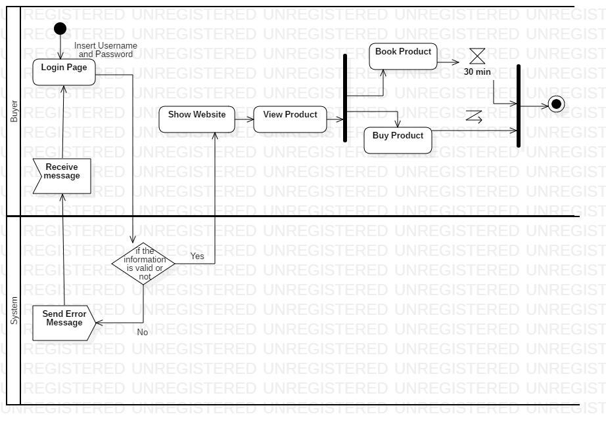

Figure : Buyer Activity Diagram

The following activity flow show how buyer works where buyer login the system and if correct value is provided sent to website where he views the product and if buyer likes it can either book it or buy it. If product is booked then the booking last for thirty minutes and after that it ends. If buyer click buy and don’t want to buy it can be interrupted and the flow ends here.

## Chapter 3.3.2- Sequence Diagram

A sequence diagram shows object interactions arranged in time sequence. It depicts the objects and classes involved in the scenario and the sequence of messages exchanged between the objects needed to carry out the functionality of the scenario.

This approach is taken to show at what time what interaction occurs in the system. This allows to know after what process what will occur.

|  |  |  |
| --- | --- | --- |
| Notation Used | Diagram | Description |
| Actor |  | the particular sequence diagram is owned by a use case. |
| Lifeline |  | interact with each other in the system during the sequence. |
| Message Arrow |  | Describes flow of message |
| Alternate frame |  | It models ‘if…else’ logic |
| Loop Frame |  | Represents repetitive sequence | |

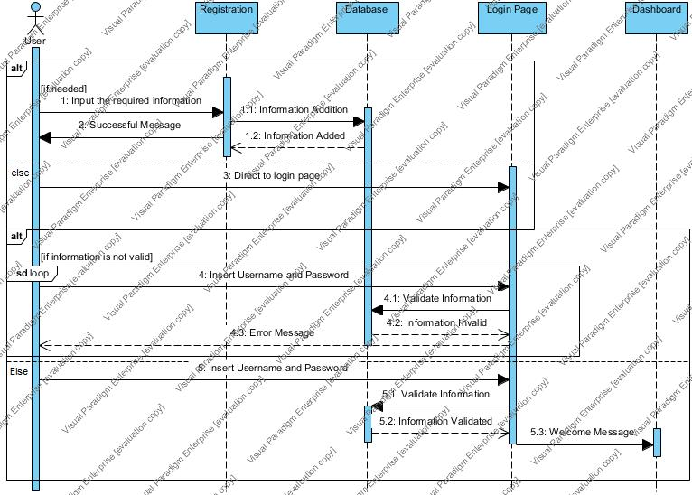

Figure : Login and registration Sequence

The following sequence show how the user registers and login in the system. If the required field in registration is filled then the user is created and directed to login page. Here the user provides the login credentials and if correct sent to dashboard else error message is displayed.

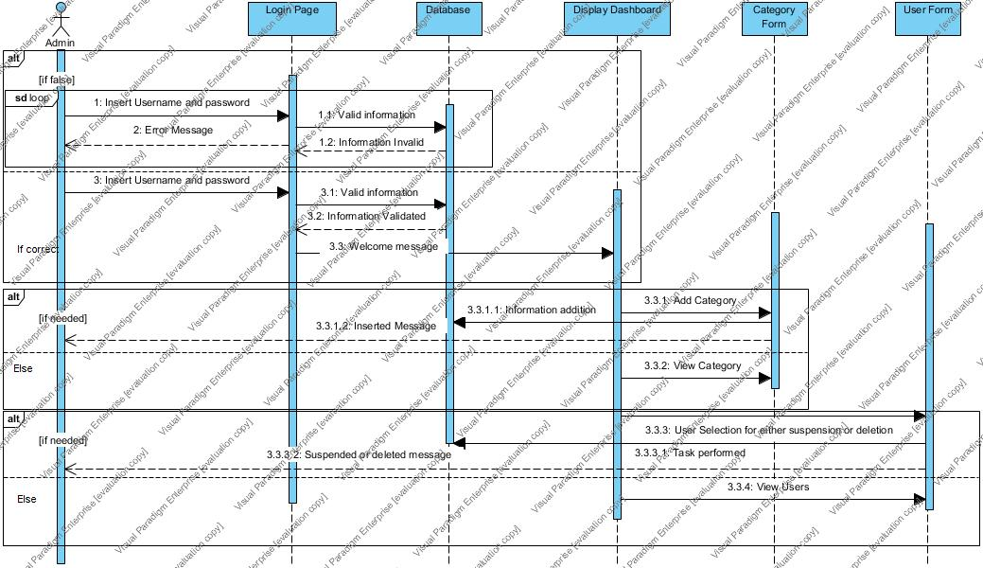

Figure : Admin Sequence

The following sequence diagram show how the admin interacts with the system. First the admin provides login credentials if correct sent to dashboard else error message is generated. In dashboard admin can add category and manage users. In category form if the admin adds the category then added message is displayed and if the admin either delete or suspend or reactivate the user the message is displayed as per the action.

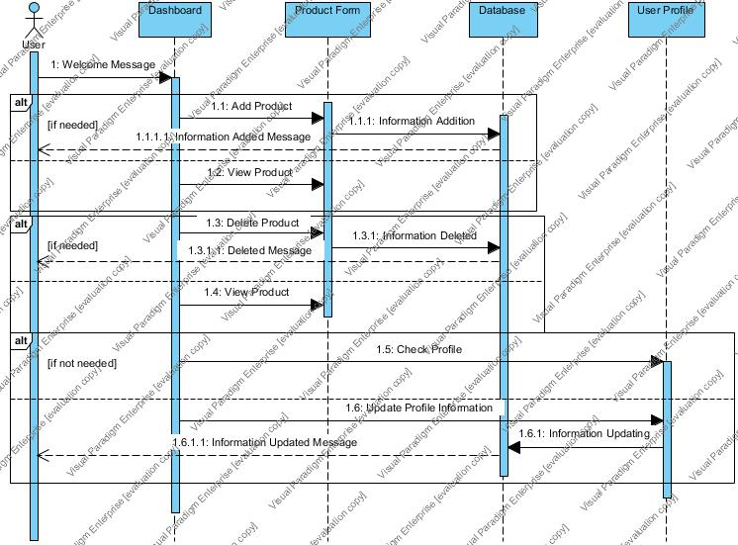

Figure : User Sequence

The following sequence show how the user add the product and manage their profile. When the product is added, added message is sent to the user. If deleted, deleted message and if no action is performed user can just view the product. The user can change profile information as he needed and if done updated message is provided.

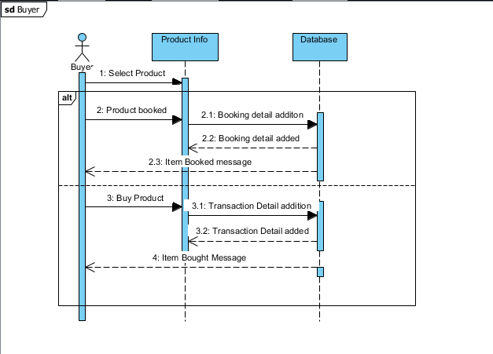

Figure : Buyer Sequence

The following diagram show the buyer sequence diagram. Here the buyer first selects the product then he either book it or buy it as he needed where corresponding message is sent to the buyer as per his action.

## Chapter 3.4- Database Model

A database model refers to the logical structure, representation or layout of a database and how the data will be stored, managed and processed within it.

## Chapter 3.4.1- Data Dictionary

Data dictionary is the set of files that contains the database’s metadata which is the crucial component of any relational database.

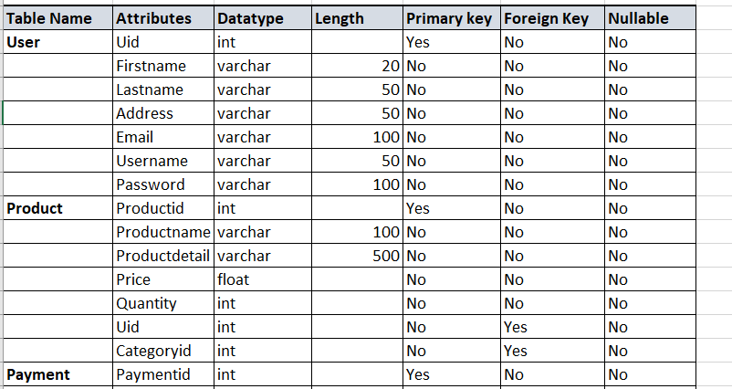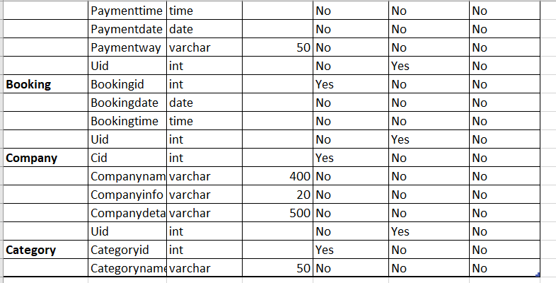

Figure : Data Dictionary

## Chapter 3.4.2- ER Diagram

An entity–relationship model describes interrelated things of interest in a specific domain of knowledge. A basic ER model is composed of entity types and specifies relationships that can exist between entities.

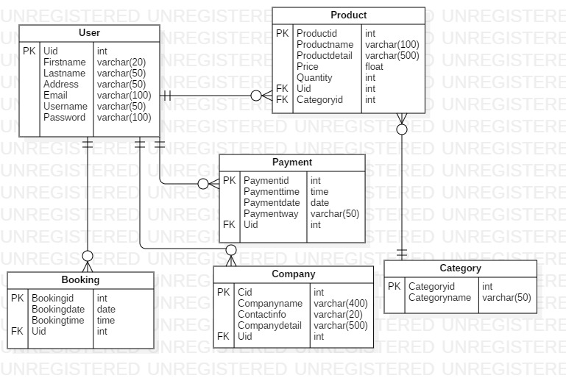

Figure : ER diagram

## Chapter 3.5- Architectural Model

Architectural model is a scale model that is design to meet the structure and design of the system. My architectural model follows 3-tier architecture where the system is divided into:

1. Client layer

It is also called as *Presentation layer* which contains UI part of our application. This layer is used for the design purpose where data is presented to the user or input is taken from the user. For example, designing registration form which contains text box, label, button etc.

1. Business layer

In this layer all business logic written like validation of data, calculations, data insertion etc. This acts as an interface between Client layer and Data Access Layer. This layer is also called the intermediary layer helps to make communication faster between client and data layer.

1. Data Layer

In this layer actual database is comes in the picture. Data Access Layer contains methods to connect with database and to perform insert, update, delete, get data from database based on our input data.

This approach is taken to describe the structure of the system currently being made.

## Chapter 3.6- UI Modeling

User interface modeling is a development technique used by computer application programmers.

## Chapter 3.6.1- Prototyping

A prototype is an early sample, model, or release of a product built to test a concept or process or to act as a thing to be replicated or learned from. It is a term used in a variety of contexts, including semantics, design, electronics, and software programming.

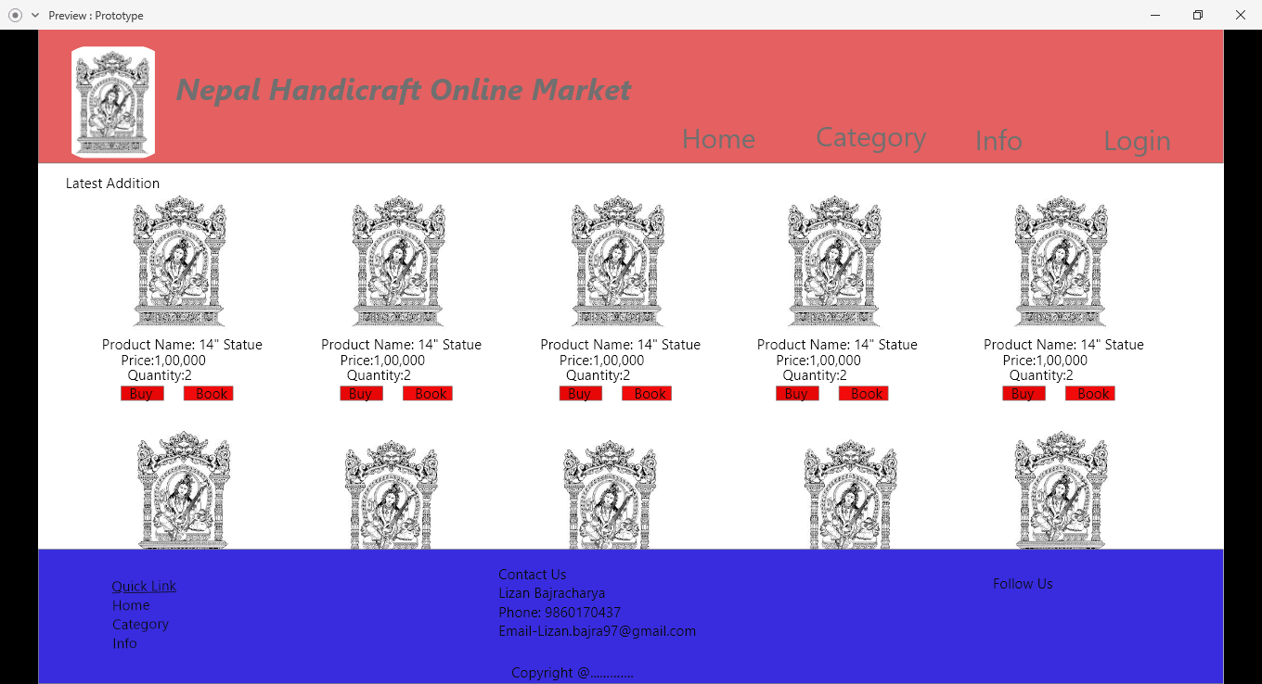

Figure : Main Page

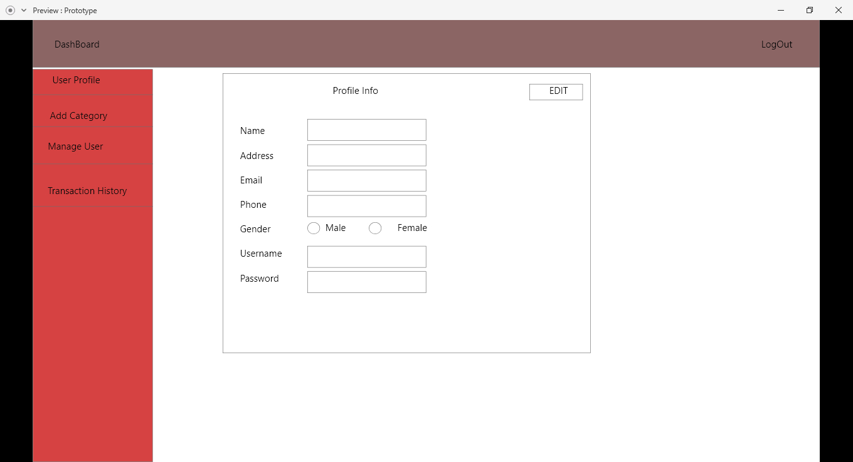

Figure : Admin Profile page

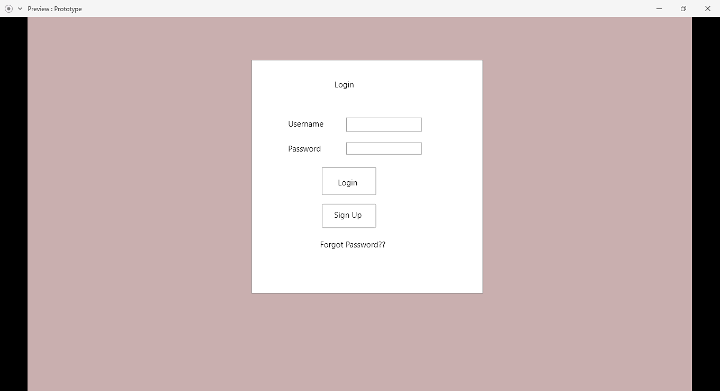

Figure : Login Page

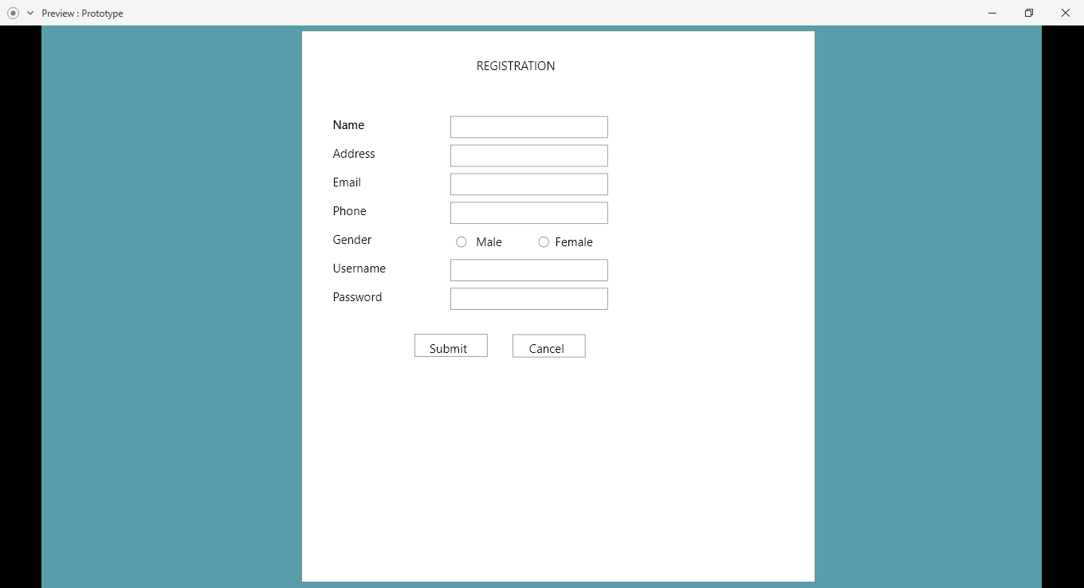

Figure : Registration Page

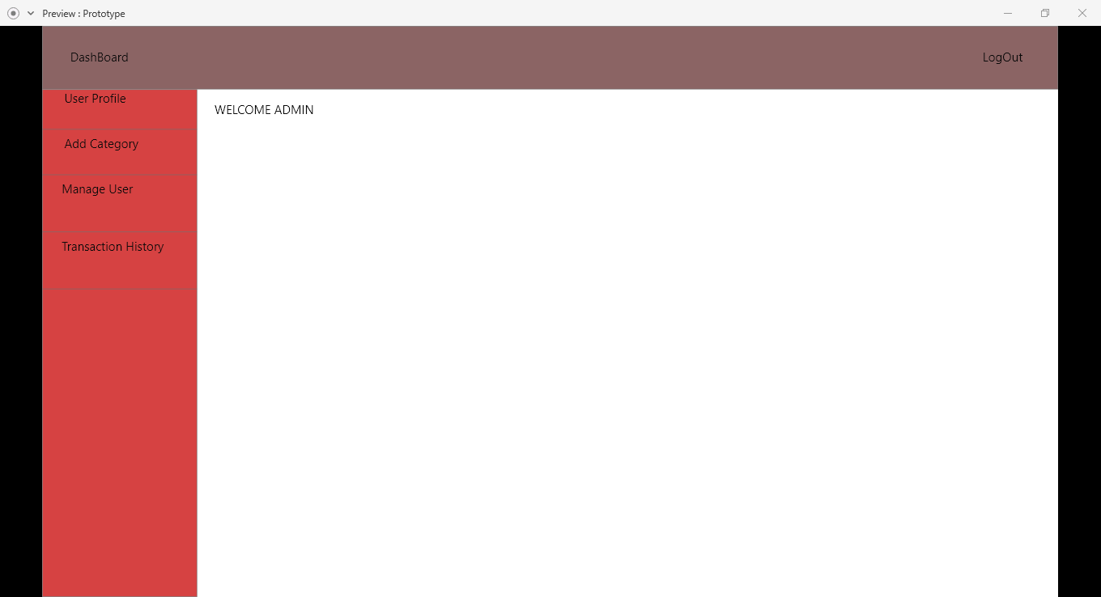

Figure : Dashboard

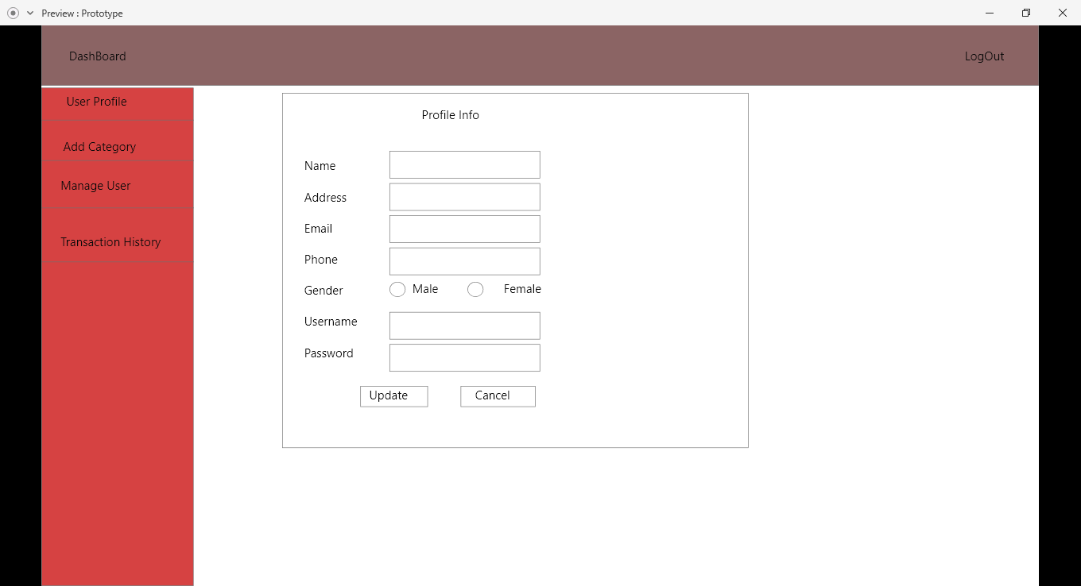

Figure : Profile Update page

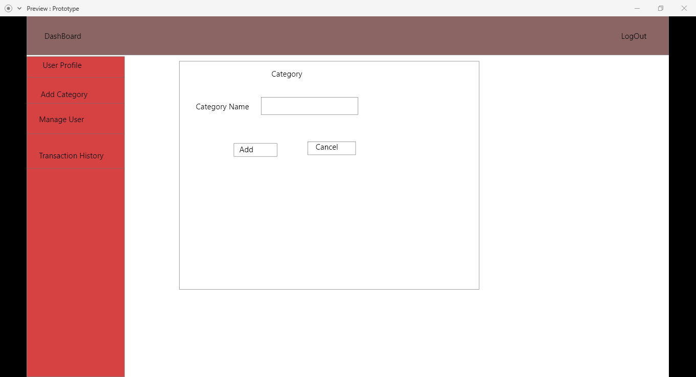

Figure : Category Add page

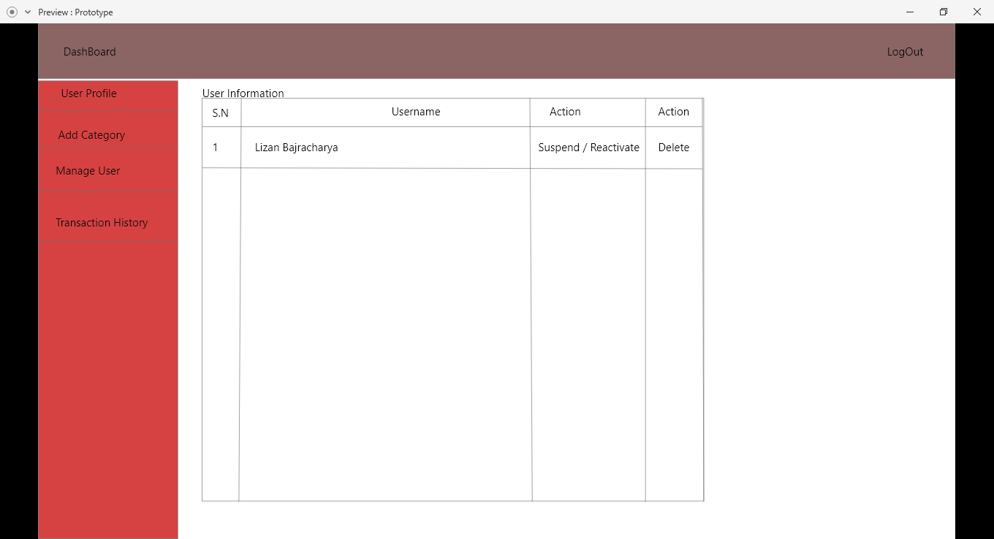

Figure : Manage User form

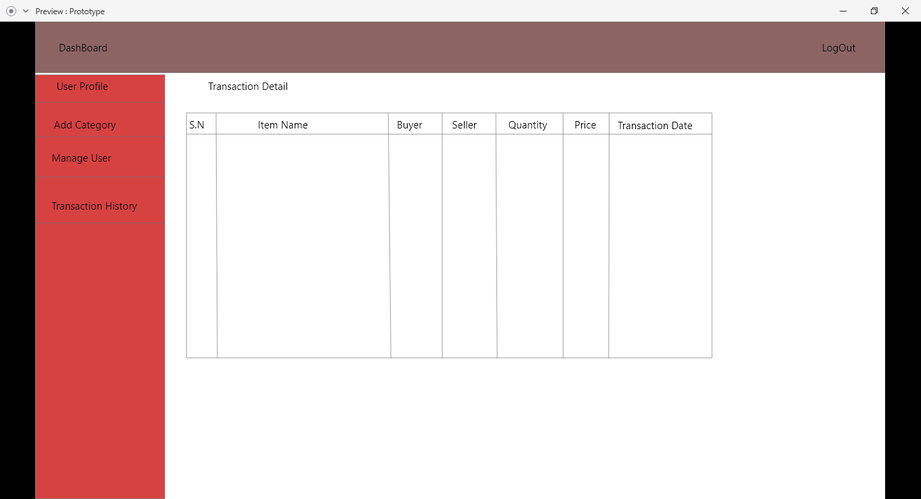

Figure : Admin Transaction form

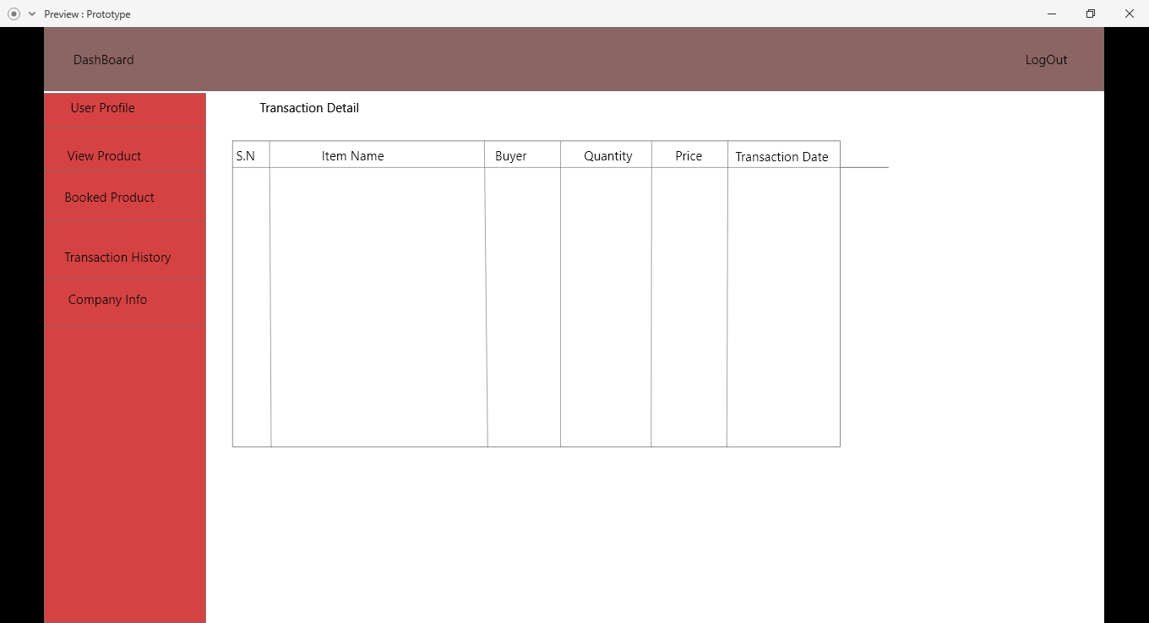

Figure : User transaction form

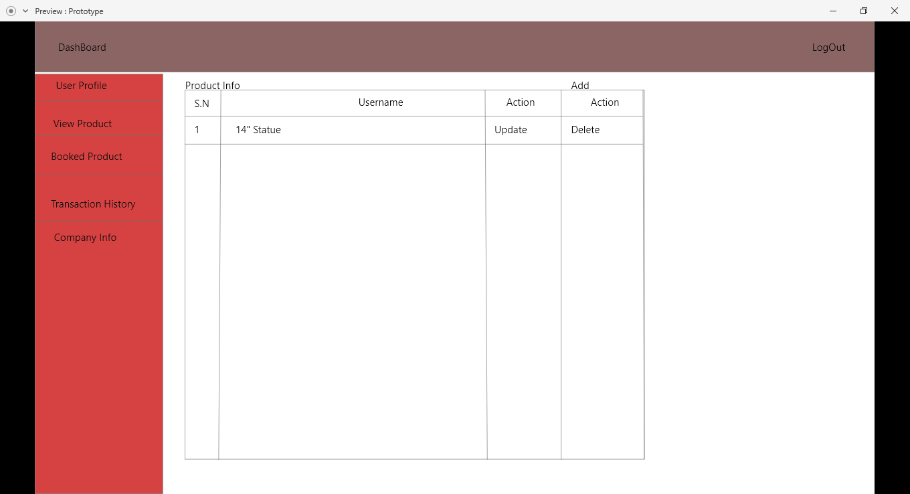

Figure : Product Detail form

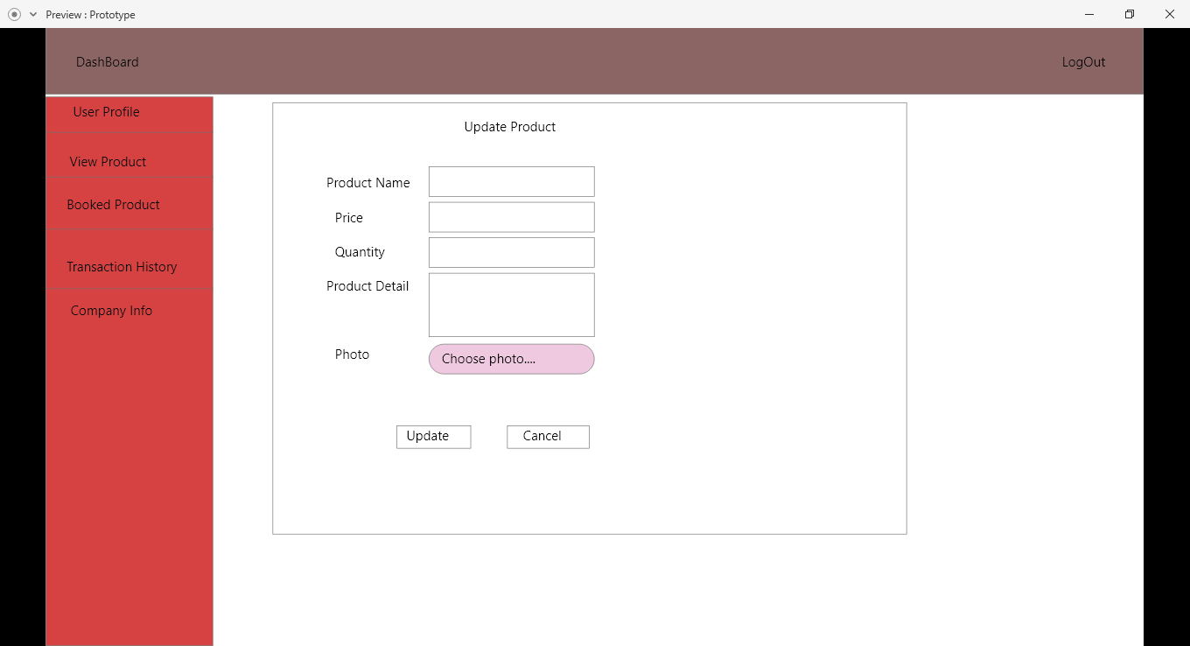

Figure : Product Update form

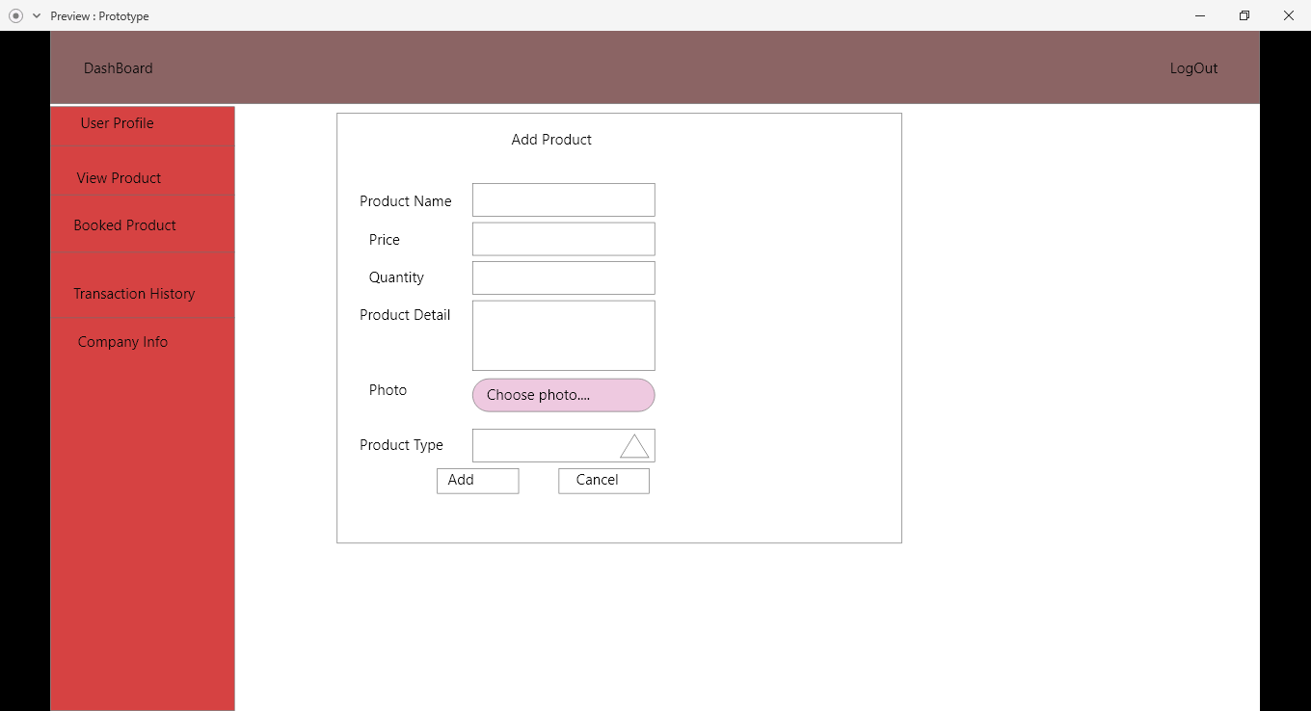

Figure : Product Add Form

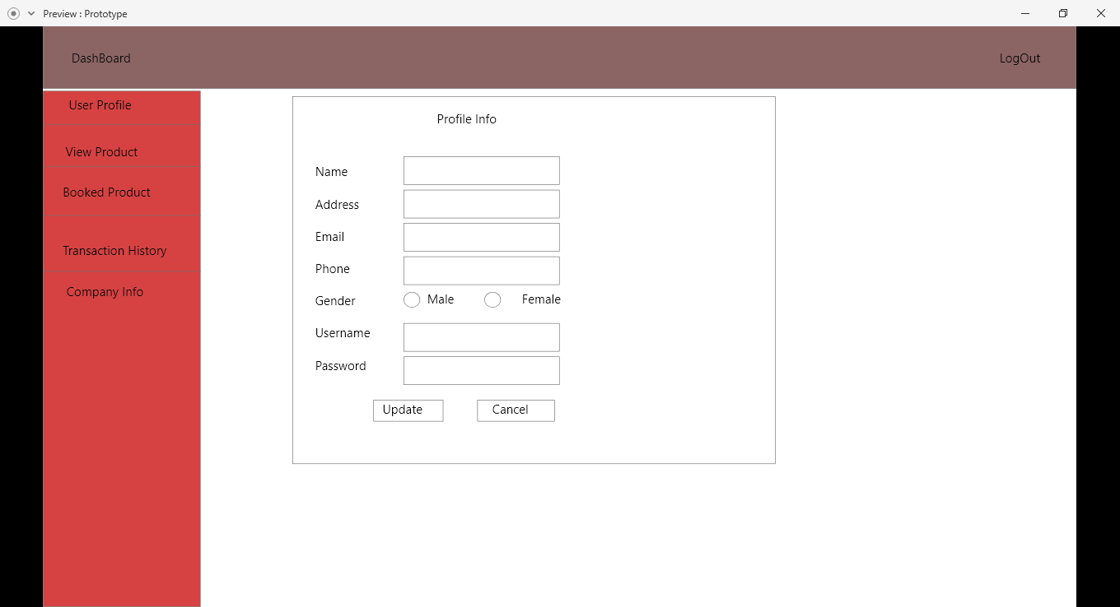

Figure : User Profile update form

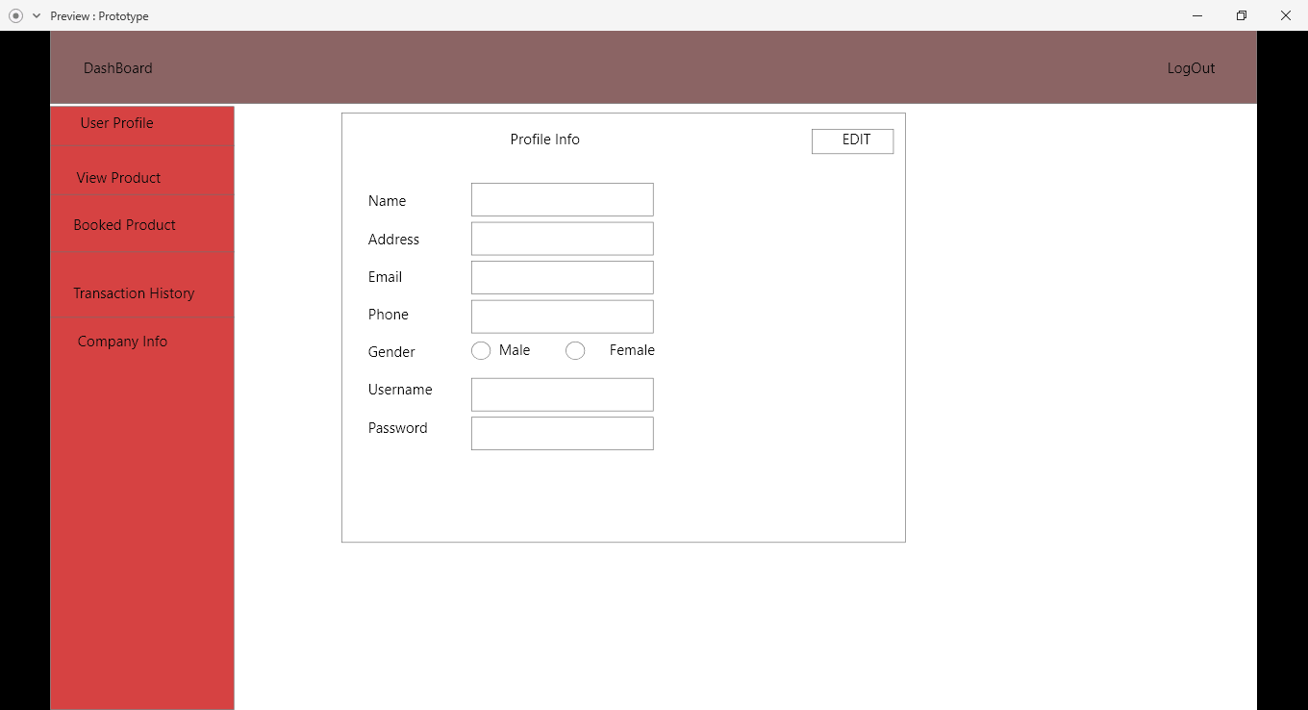

Figure : User profile form

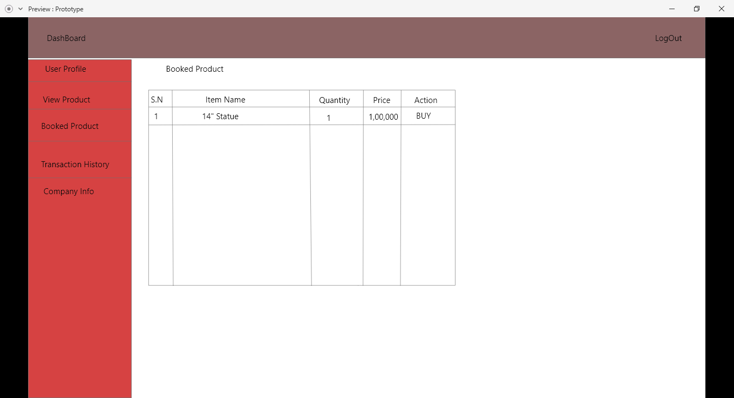

Figure : Booked product form

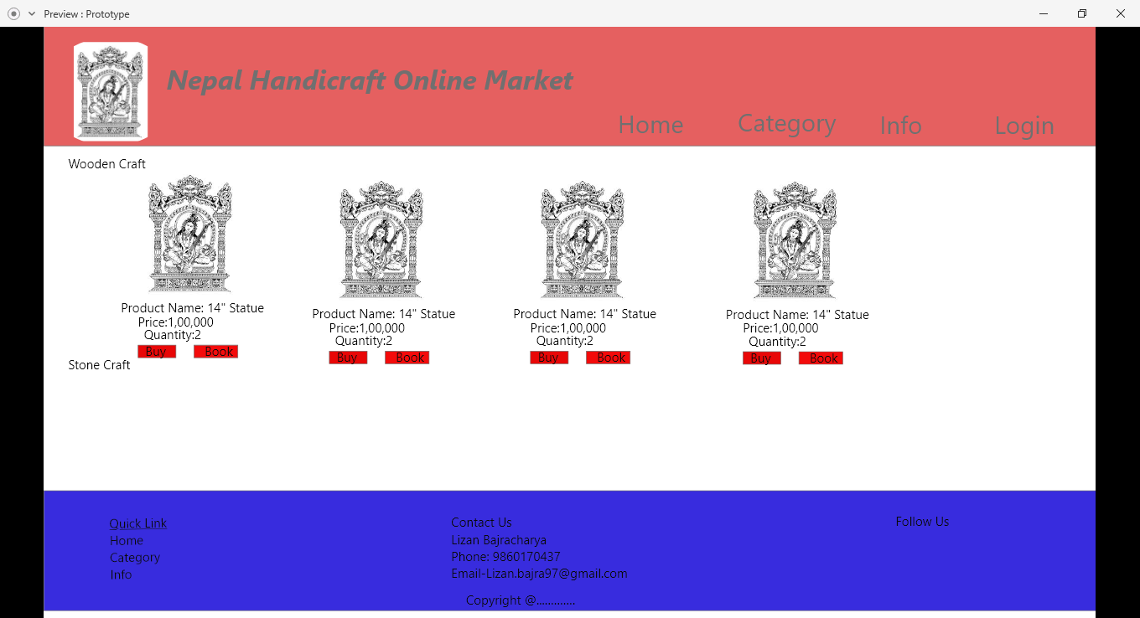

Figure : Category page

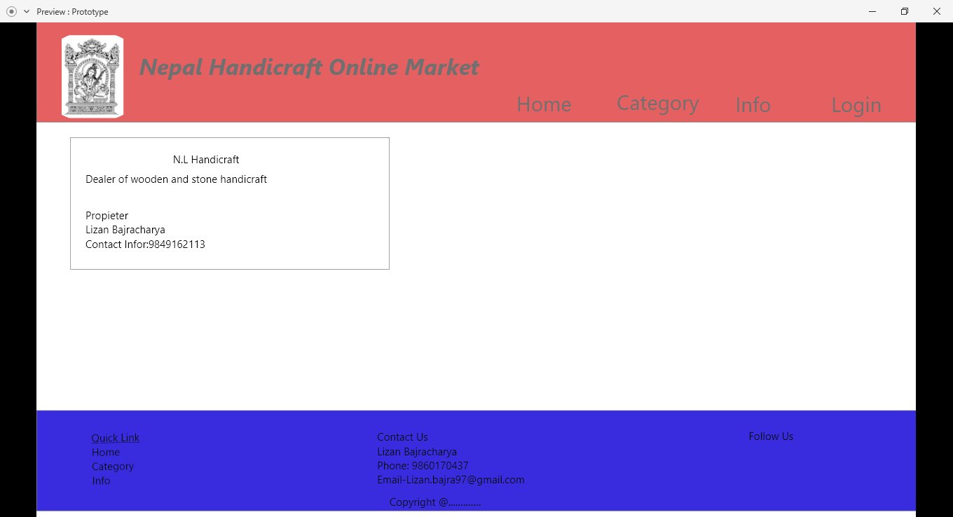

Figure : Info page

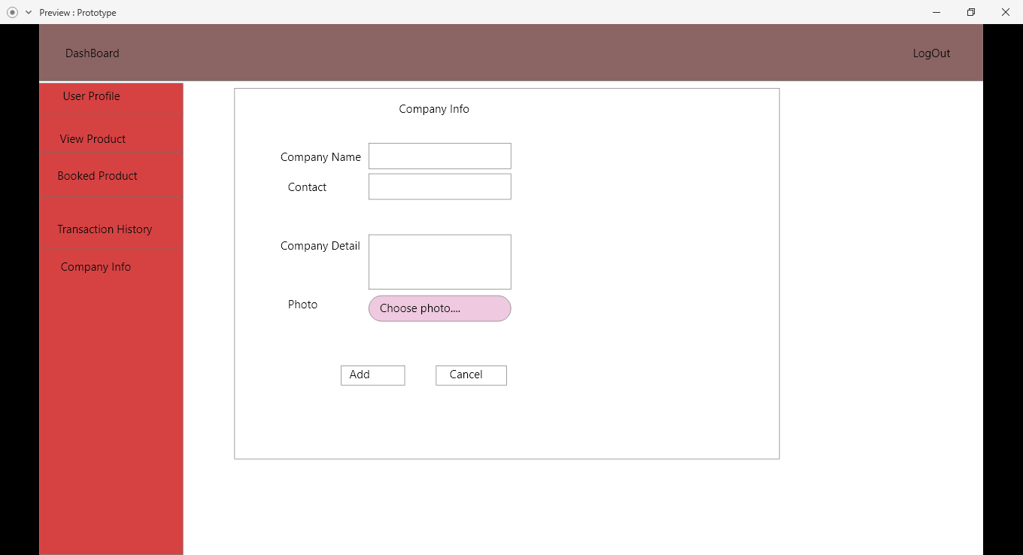

Figure : Company Detail add form

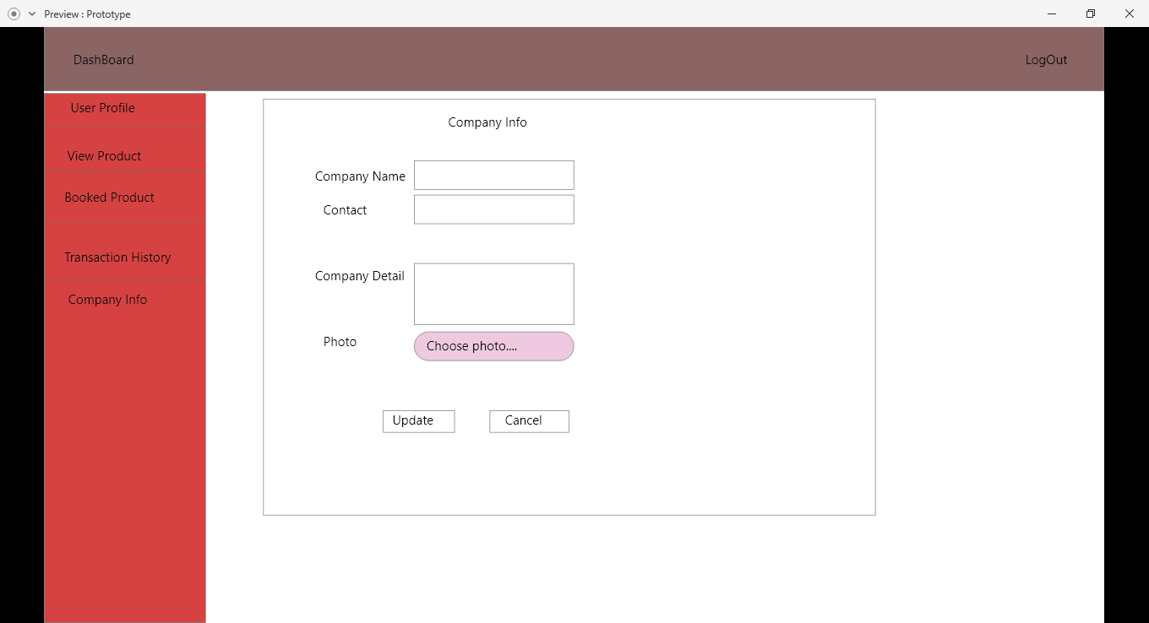

Figure : Company detail update form