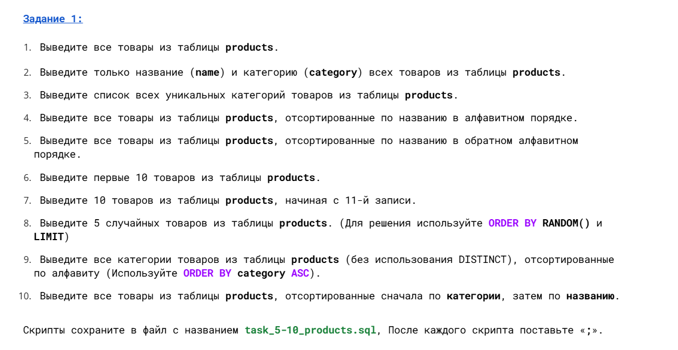

SELECT *

FROM products;

;

SELECT name, category

FROM products;

;

SELECT DISTINCT category

FROM products;

;

SELECT *

FROM products

ORDER BY name ASC
;

;

SELECT *

FROM products

ORDER BY name DESC
;
;
SELECT *

FROM products

order by name asc

LIMIT 10

;

;

SELECT *

FROM products

order by name asc

LIMIT 10

offset 10
;

;

SELECT *

FROM products

order by random ()

LIMIT 5

;

SELECT category

FROM products

order by category ASC
;

;

SELECT *

FROM products

order by category,name asc

;

