DATA SCIENCE TOOLBOX: PYTHON PROGRAMMING

INT375 — PROJECT REPORT
Project Semester: January – April 2026

COMPUTER SCIENCE AND ENGINEERING

A Data-Driven Jupyter Dashboard Analysis Using Python Libraries

Submitted By:
LIZA RAWAT
Registration No.: 12409771
Roll No.: R4M029A 14 | Section: 4M029

Submitted To:
Dr. Savleen Kaur
School of Computer Science and Engineering



LOVELY PROFESSIONAL UNIVERSITY
Phagwara, Punjab — 2026

CERTIFICATE
This is to certify that Liza Rawat bearing Registration no. 12409771, Roll No. 14, has completed the INT375 project titled, “Census Analysis 2011” under my guidance and supervision. To the best of my knowledge, the present work is the result of her original development, effort, and study.

Signature and Name of the Supervisor
Designation of the Supervisor
School of Computer Science and Engineering
Lovely Professional University
Phagwara, Punjab

Date: 17-04-2026

DECLARATION
I, Liza Rawat, student of B.Tech under CSE/IT Discipline at Lovely Professional University, Punjab, hereby declare that all the information furnished in this project report is based on my own intensive work and is genuine.

Date: 17-04-2026
Registration No.: 12409771
Name of the Student: Liza Rawat

ACKNOWLEDGEMENT
I would like to express my sincere gratitude to my faculty coordinator for providing continuous guidance and support throughout this project. I am thankful to the Government of India for making comprehensive census data publicly available through the Data.gov platform, which served as the primary data source for this analysis. I also wish to acknowledge the tools and technologies — Jupyter Notebook and Python libraries — that enabled the data preprocessing, visualization, and analytical work presented in this report. Finally, I thank my peers and family for their encouragement and support during the course of this project.
LIZA RAWAT
Registration No.: 12409771

TABLE OF CONTENTS
- Introduction
- Source of Dataset
2.1 Primary Data Source
2.2 Dataset Coverage
- Dataset Preprocessing
3.1 Data Loading
3.2 Data Cleaning
3.3 Data Integration
3.4 Final Dataset Summary
- Exploratory Data Analysis (EDA)
4.1 Overall Population Analysis
4.2 Gender Distribution Analysis
4.3 Rural–Urban Distribution Analysis
4.4 State and Regional Patterns
4.5 Religion-wise Demographic Analysis
4.6 Workforce and Literacy Insights
- Dashboard Architecture
Tab Structure
- Overview Dashboard Visualizations
6.1 Population Distribution Chart
6.2 Bottom States Literacy Rate Chart
6.3 Literacy vs Worker Percentage Scatter Plot
6.4 Gender Literacy Gap Chart
6.5 Comparative Distribution (Box Plot)
6.6 Villages vs Area Chart
6.7 Correlation Heatmap
6.8 Literate vs Illiterate Dumbbell Chart
- Detailed Dashboard Analysis
7.1 Population Distribution (Top States Bar Chart)
7.2 Population Pyramid (Age–Gender Distribution)
7.3 Literacy Rate by State (Male vs Female vs Overall)
7.4 Workforce Composition by State
7.5 SC vs ST Distribution by State
7.6 Religion Distribution (Tamil Nadu vs All India)
7.7 Religion Distribution — All India
7.8 Literate vs Illiterate (Dumbbell Chart)
7.9 Correlation Heatmap of Demographic Indicators
7.10 Villages vs Area by State
7.11 Comparative Analysis (Literacy, Workforce & Distribution)
- Key Insights and Findings
- Conclusion
- Future Scope
- References
- Inportant Links

1. Introduction
The Census of India 2011 provides one of the most comprehensive and detailed datasets on the demographic, social, and economic characteristics of the Indian population. As the second most populous country in the world, India’s diversity in terms of population distribution, literacy levels, workforce participation, and urbanization makes census analysis crucial for effective governance and policy-making. The 2011 Census recorded a population of over 1.21 billion people, offering valuable insights into the structure and dynamics of Indian society.
Understanding these patterns is essential for planning infrastructure, improving educational initiatives, enhancing employment opportunities, and ensuring balanced regional development. Census data plays a vital role in identifying disparities across states and regions, analyzing gender distribution, assessing literacy rates, and evaluating rural-urban divides. Such insights help policymakers, researchers, and organizations design data-driven strategies for national development.
This project presents a systematic, data-driven analysis of the Census 2011 dataset, focusing on multiple dimensions of demographic information. The study examines gender distribution (male and female population), geographic variation across different states and union territories, literacy rates and educational indicators, and workforce composition including working and non-working population segments. Additionally, the project explores population density and rural-urban classification to better understand settlement patterns across India.
The analysis is implemented as an interactive Python-based dashboard using Jupyter Notebook, incorporating powerful libraries such as Pandas for data manipulation, Plotly for visualization, and ipywidgets for interactive controls. The dashboard is structured into multiple analytical sections, including population overview, state-wise analysis, and demographic insights, allowing users to explore the dataset dynamically through filters and visual elements.
The findings from this study aim to provide meaningful insights for policymakers, researchers, and students by highlighting key demographic trends and patterns in India. By transforming raw census data into intuitive visualizations and interactive tools, this project contributes to a better understanding of India’s population landscape and supports informed decision-making.

2. Source of Dataset
2.1 Primary Data Source
All data used in this project is sourced from the Government of India through the official open data platform Open Government Data Platform India (data.gov.in). This platform provides reliable and publicly accessible datasets related to the Census of India 2011, covering various demographic, social, and economic indicators across the country.
The datasets used in this project are derived from Census 2011 tables and related demographic records. These datasets provide detailed information on population distribution, workforce participation, household characteristics, and religious composition across different states and regions of India.
For this project, multiple CSV datasets were used, each representing a distinct dimension of census analysis:
- Dataset File: PCA0000_2011_MDDS.csv
Category: Population Data
Description: Contains primary census abstract data including total population, male and female population, and basic demographic indicators at state and district levels.
- Dataset File: DDW-0000C-13.csv
Category: Workforce Data
Description: Provides detailed information about working and non-working population, including classification into main workers, marginal workers, and non-workers.
- Dataset File: DDWC-000013.csv
Category: Worker Classification
Description: Contains category-wise distribution of workers based on different economic activities and employment types.
- Dataset File: popby_religion_0.csv
Category: Religion-wise Population
Description: Includes population distribution based on major religious groups, helping in understanding demographic diversity.
- Dataset File: RHS_2015_ch-1_table_1.csv
Category: Household and Demographic Indicators
Description: Provides additional demographic insights such as household characteristics and related statistical indicators useful for comparative analysis.
2.2 Dataset Coverage
- Parameter: Time Reference
Value: Census 2011 (with some supplementary datasets for comparative insights)
- Parameter: Geographic Coverage
Value: All States and Union Territories of India
- Parameter: Population Categories
Value: Total, Male, Female
- Parameter: Major Dimensions
Value: Population, Workforce, Religion, Household Characteristics
- Parameter: Subcategories
Value: Multiple indicators including worker types, religious groups, and demographic attributes
- Parameter: Total Records (Unified)
Value: Large-scale dataset with thousands of rows after cleaning and integration
- Parameter: Data Scope
Value: Comprehensive coverage of demographic and socioeconomic characteristics across India

3. Dataset Preprocessing
The raw Census 2011 datasets required multiple preprocessing steps before they could be effectively used for analysis and visualization. The preprocessing pipeline consisted of three major stages: Data Loading, Data Cleaning, and Data Integration.
3.1 Data Loading
All CSV files were loaded into individual Pandas DataFrames using Python in Jupyter Notebook. Each dataset was organized within the project directory for structured access. Initial inspection was performed using methods such as .info(), .head(), and .describe() to understand the schema, data types, presence of null values, and basic statistical distribution.
Although the datasets varied in structure, most of them contained common attributes such as State/District identifiers, population counts, gender classification, and category-specific indicators like workforce type or religion.
3.2 Data Cleaning
Data cleaning was performed separately on each dataset to ensure consistency and reliability. The following steps were applied:
Step 1: Dropping Unnecessary Columns
Columns that did not contribute to analysis, such as redundant codes or serial identifiers, were removed to simplify the datasets and improve processing efficiency.
Step 2: Standardizing Column Names
Column names across datasets were standardized to maintain uniformity. For example, population-related columns were renamed consistently (Total, Male, Female), and categorical columns were aligned to common naming conventions such as category and subcategory wherever applicable.
The resulting generalized schema used across datasets is as follows:

Column | Data Type | Description
region_name | String | Name of the State, District, or Region
gender | String | Population category (Male / Female / Total)
value | Integer | Numerical value representing population or related metric
category | String | Broad classification such as Population, Workforce, or Religion
subcategory | String | Specific subgroup within a category, such as worker type or religious group

Step 3: Handling Missing Values
Rows containing null or missing values were identified and handled appropriately. In most cases, such rows were removed to maintain data accuracy, especially where numerical values were essential for aggregation and visualization.
3.3 Data Integration
After cleaning, multiple datasets were combined into a unified master DataFrame using appropriate methods such as concatenation and structured merging where required.
Since different datasets represented different aspects of the census (population, workforce, religion, etc.), they were integrated in a way that preserved their categorical distinctions. A unified structure was created to enable consistent analysis across all dimensions.
The final master dataset served as the central source for all exploratory data analysis and visualization tasks in the project.
3.4 Final Dataset Summary
Parameter | Value
Total Rows (Unified) | Large-scale dataset with thousands of records after preprocessing
Year Reference | Census 2011
Geographic Coverage | All States and Union Territories of India
Broad Categories | Population, Workforce, Religion, Household Indicators
Subcategories | Multiple classifications including worker types, religious groups, and demographic segments
Gender Categories | Male, Female, Total
Data Scope | Comprehensive demographic and socioeconomic coverage across India

4. Exploratory Data Analysis (EDA)
Following data preprocessing, Exploratory Data Analysis was conducted to uncover key patterns, distributions, and relationships within the Census 2011 dataset. The EDA helped in identifying demographic trends, regional disparities, and structural characteristics of the population, which further guided the visualization design and selection of meaningful metrics.
4.1 Overall Population Analysis
The aggregated dataset shows that India had a total population of approximately 1.21 billion in 2011. Out of this, males accounted for around 623 million, while females accounted for approximately 587 million, indicating a noticeable gender gap.
Rural population constituted the majority, with about 833 million people living in rural areas compared to 377 million in urban areas. This clearly highlights India’s predominantly rural demographic structure during the census period.
The child population (age group 0–6 years) formed a significant portion of the total population, reflecting ongoing population growth and future demographic pressure on resources such as education, healthcare, and employment.
4.2 Gender Distribution Analysis
Gender-wise analysis reveals that males consistently outnumber females in the total population. This imbalance is reflected across both rural and urban regions, although the gap is slightly narrower in urban areas.
In rural regions, the male population is significantly higher than the female population, indicating possible socio-cultural factors influencing gender distribution. In urban areas, while the difference persists, the ratio appears relatively more balanced compared to rural regions.
This gender disparity is an important indicator for policymakers, as it reflects underlying social issues and impacts long-term demographic stability.
4.3 Rural–Urban Distribution Analysis
The dataset clearly indicates that a large majority of India’s population resides in rural areas. Rural population accounts for nearly 69% of the total population, while urban population makes up about 31%.
This uneven distribution highlights the dependence on agriculture and rural-based livelihoods, as well as the need for improved infrastructure, healthcare, and education in rural regions.
Urban areas, although smaller in population share, show higher density and are associated with better access to facilities, employment opportunities, and services. The contrast between rural and urban population distribution is crucial for planning balanced regional development.
4.4 State and Regional Patterns
State-wise and regional data reveal significant variation in population distribution across India. Some states contribute a disproportionately large share of the total population, while others have relatively smaller populations.
The dataset also shows differences in rural dominance across states, with some regions being highly rural, while others exhibit higher urbanization levels. These variations highlight the diverse demographic and developmental characteristics across the country.
Such geographic disparities are important for targeted policy interventions, resource allocation, and infrastructure planning at both state and district levels.
4.5 Religion-wise Demographic Analysis
Religion-based analysis shows that Hindus form the majority population, followed by Muslims and Christians as the next largest groups. Other religious communities such as Sikhs, Buddhists, and Jains constitute smaller proportions of the population.
State-level data, such as that of Tamil Nadu, indicates regional variations in religious composition. While Hindus dominate the population share, minority communities contribute significantly to the cultural and social diversity of the region.
Comparing state-level percentages with national-level percentages helps in understanding regional deviations and demographic concentration of different religious groups.
4.6 Workforce and Literacy Insights
The dataset provides insights into workforce participation and literacy levels. A substantial portion of the population is categorized as non-working, indicating dependency on the working population.
Among workers, classifications such as main workers and marginal workers highlight differences in employment stability and duration. Agricultural laborers and cultivators form a significant part of the workforce, especially in rural areas.
Literacy analysis shows that a large number of individuals are literate; however, a considerable portion of the population still remains illiterate. This reflects the need for continued focus on education and skill development initiatives.
Overall, the EDA highlights key demographic characteristics such as population concentration, gender imbalance, rural dominance, regional diversity, and socioeconomic structure. These insights form the foundation for further visualization and dashboard-based analysis in the project.
- Dashboard

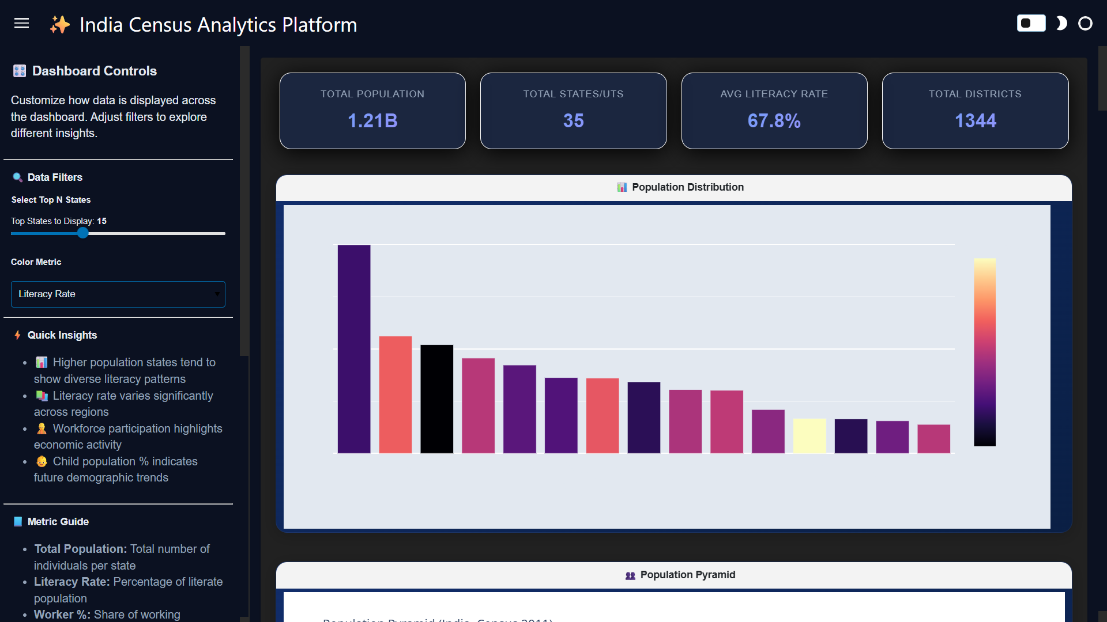

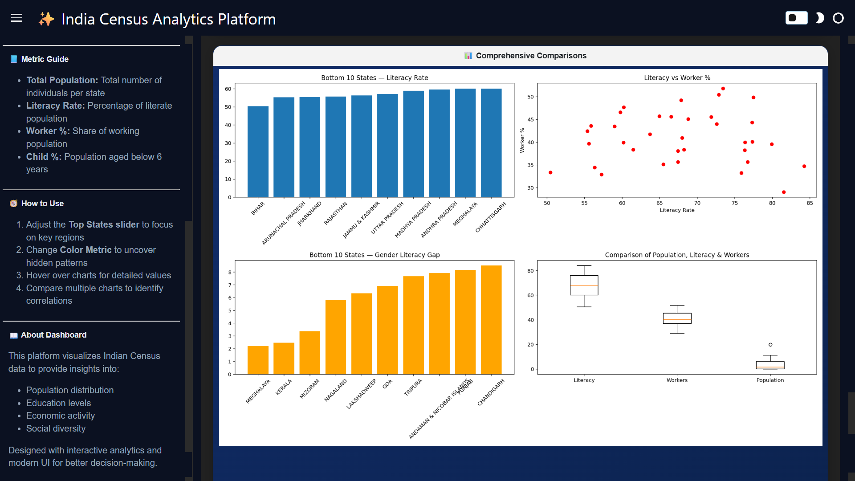

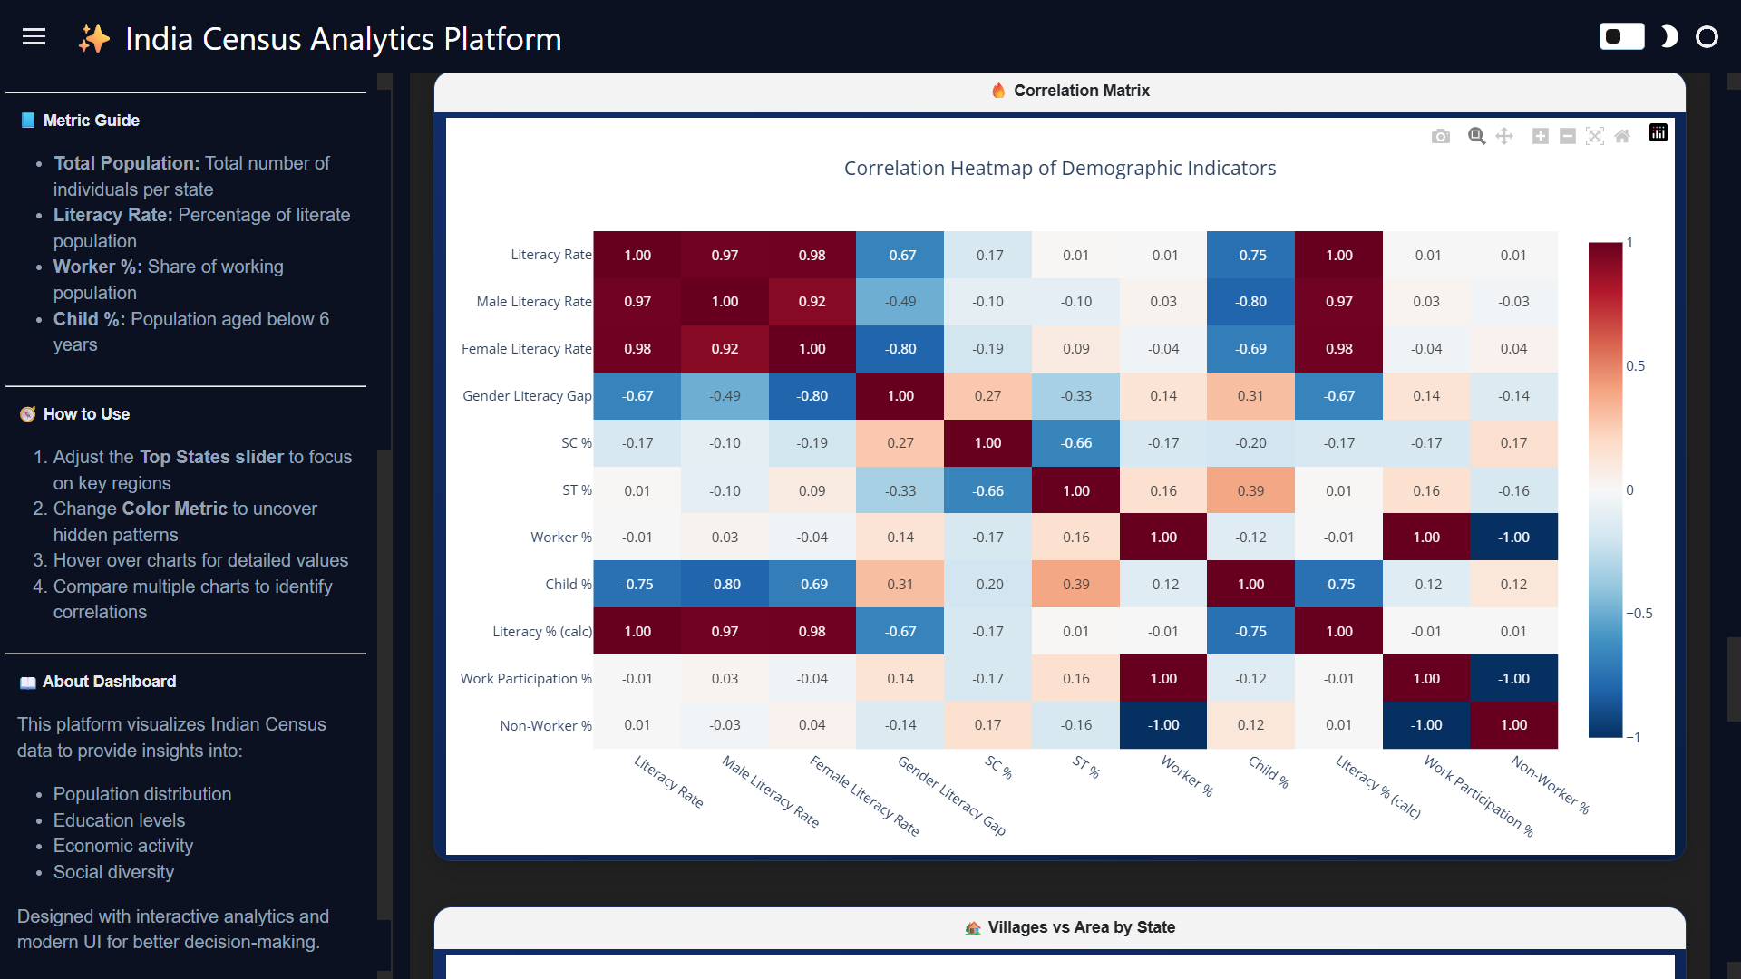

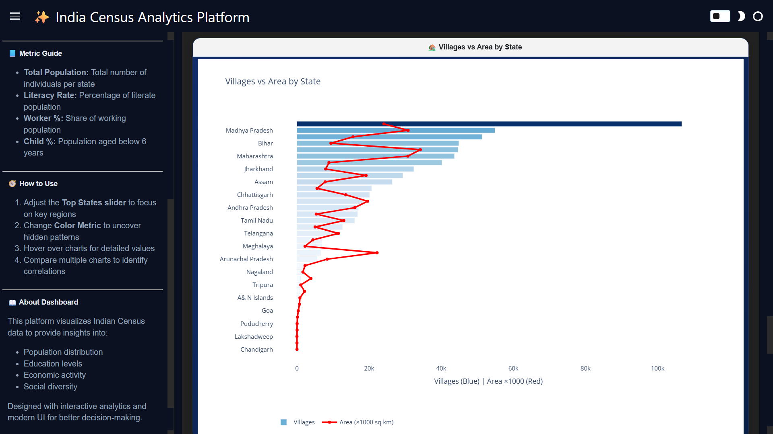

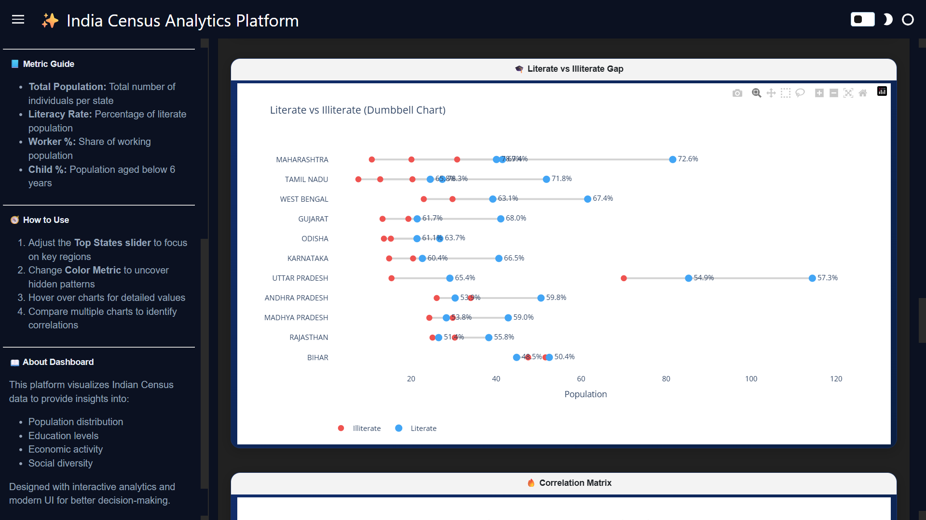

6. Overview Dashboard Visualizations
The Overview section presents multiple visualizations that collectively provide a comprehensive understanding of India’s demographic structure using Census 2011 data. Each chart highlights a different dimension such as population distribution, literacy patterns, workforce relationships, and regional disparities.
6.1 Population Distribution Chart
The Population Distribution bar chart displays the top states based on the selected metric, such as total population or literacy rate. Each bar represents a state, and the height of the bar indicates its relative value.
The chart clearly shows that population and related metrics are unevenly distributed across states, with a few states dominating while others contribute smaller shares. The use of color gradients enhances interpretation by visually distinguishing higher and lower values. This chart helps in quickly identifying high-impact states that significantly influence national statistics.
6.2 Bottom States Literacy Rate Chart
This bar chart focuses on the states with the lowest literacy rates. It highlights regional disparities in education, showing that certain states consistently lag behind others in terms of literacy.
The gradual variation across bars indicates that while differences are not extreme, there is a clear gap between lower-performing and relatively better-performing states. This visualization emphasizes the need for targeted educational policies in under-performing regions.
6.3 Literacy vs Worker Percentage Scatter Plot
The scatter plot visualizes the relationship between literacy rate and worker participation percentage across states. Each point represents a state, plotted based on its literacy rate (X-axis) and worker percentage (Y-axis).
The distribution of points suggests a moderate relationship between literacy and workforce participation. While some states with higher literacy also show higher workforce participation, the pattern is not strictly linear, indicating that other socioeconomic factors also influence employment levels.
6.4 Gender Literacy Gap Chart
This bar chart represents the difference between male and female literacy rates across selected states. The height of each bar indicates the magnitude of the gap.
The visualization reveals that gender disparity in literacy still exists in several regions, with some states showing significantly higher gaps than others. This highlights the importance of gender-focused educational initiatives to ensure balanced development.
6.5 Comparative Distribution (Box Plot)
The box plot compares the distribution of literacy rate, worker percentage, and population metrics. It provides insights into median values, spread, and outliers for each variable.
The chart shows that literacy rates are relatively more consistent across states, while workforce participation and population exhibit greater variability. This helps in understanding the overall distribution and identifying extreme values within the dataset.
6.6 Villages vs Area Chart
This combined bar and line chart compares the number of villages (bars) with the geographical area (line) for each state. It highlights how population settlements relate to geographic size.
Some states with large areas have a high number of villages, indicating dispersed rural settlements, while others show fewer villages despite significant area. This contrast reflects differences in population density and settlement patterns across regions.
6.7 Correlation Heatmap
The correlation heatmap presents relationships between multiple demographic indicators such as literacy rate, gender literacy gap, worker percentage, child population percentage, and social categories.
Strong positive correlations are observed between overall literacy and male/female literacy rates, while negative correlations are visible between literacy and child population percentage. The heatmap helps in identifying interdependencies between variables and supports deeper analytical insights.
6.8 Literate vs Illiterate Dumbbell Chart
This chart compares literate and illiterate population percentages across states using paired points connected by a line. It clearly visualizes the gap between educated and non-educated populations.
States with higher literacy show a wider separation between the two points, while states with lower literacy have closer values. This visualization effectively highlights educational disparities and helps compare progress across regions.

- Dashboard Charts

  - Population Distribution (Top States Bar Chart)
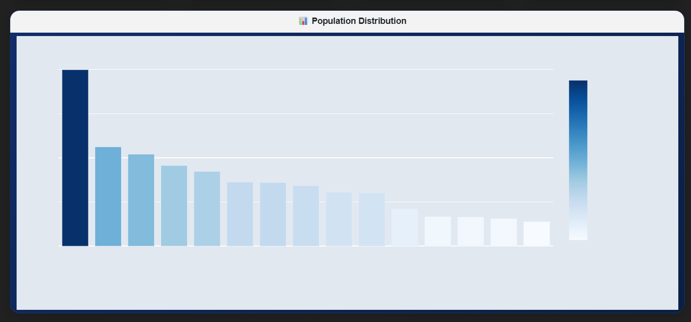
The Population Distribution chart presents a comparative analysis of the top states based on total population. The X-axis represents the selected top states, while the Y-axis represents the total population count. The states are arranged in descending order, allowing clear identification of the most populous regions.
The chart shows that one state significantly dominates in terms of population, followed by a gradual decline across the remaining states. The difference between the top state and others is substantial, indicating a high concentration of population in specific regions. As the bars progress, the variation becomes less steep, suggesting relatively closer population values among mid-ranked states.
The use of a color gradient enhances the visual interpretation, where darker shades indicate higher population values and lighter shades represent lower values. This visualization highlights the uneven distribution of population across India and emphasizes the dominance of a few states in contributing to the overall population.

  - Population Pyramid (Age–Gender Distribution Chart)
  - 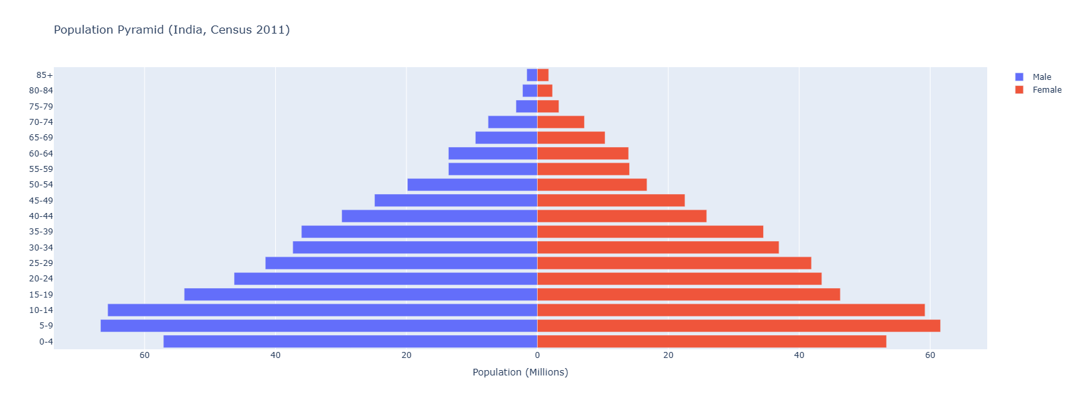
The Population Pyramid visualizes the age-wise distribution of the population, separated by gender. The Y-axis represents different age groups ranging from younger to older populations, while the X-axis represents population in millions. Male population is shown on the left side and female population on the right side.
The chart exhibits a broad base and a gradually narrowing top, forming a classic pyramid shape. This indicates a large proportion of the population in younger age groups, reflecting a growing population with high birth rates. As age increases, the population steadily decreases, showing lower representation in older age groups.
A comparison between the two sides shows that the male population is slightly higher than the female population across most age groups, though the difference is relatively small. In higher age groups, the gap narrows further, suggesting relatively balanced gender distribution among older populations.
Overall, the pyramid highlights India’s youthful demographic structure, indicating future potential for workforce growth as younger age groups move into working-age categories.

7.3 Literacy Rate by State (Male vs Female vs Overall)
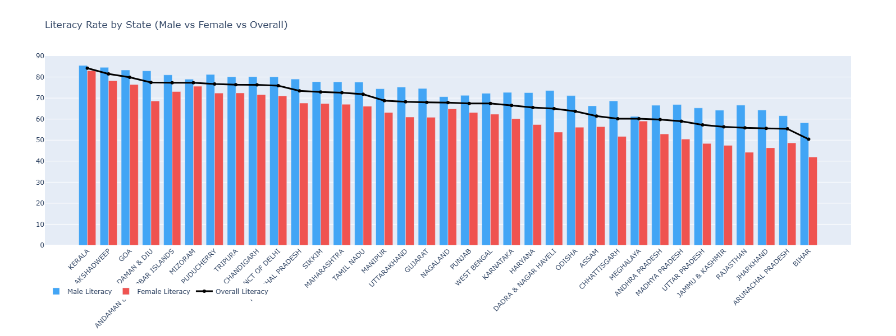
The Literacy Rate chart compares male literacy, female literacy, and overall literacy across different states. The X-axis represents the states, while the Y-axis shows the literacy percentage. Male literacy is shown using blue bars, female literacy using red bars, and overall literacy is represented by a line graph.
The chart shows that male literacy rates are consistently higher than female literacy rates across all states, indicating a persistent gender gap in education. The overall literacy line follows a declining trend from left to right, suggesting that states are arranged in decreasing order of literacy performance.
States at the higher end of the chart exhibit strong literacy levels with relatively smaller gender gaps, while states toward the lower end show reduced literacy rates along with more noticeable disparities between male and female literacy.
This visualization highlights both regional and gender-based inequalities in education, emphasizing the need for targeted efforts to improve female literacy and uplift lower-performing states.

  - Workforce Composition by State
The Workforce Composition chart presents a stacked horizontal bar representation of different worker categories across states. The Y-axis lists the states, while the X-axis represents the population engaged in various types of work. The bars are divided into segments such as cultivators, agricultural laborers, household industry workers, and other workers.
The chart shows that the “Other Workers” category forms the largest share of the workforce in most states, indicating a shift towards non-agricultural occupations such as services and industrial work. Agricultural laborers and cultivators still contribute significantly, especially in states with strong rural and agrarian economies.
There is noticeable variation across states, with some states showing a higher dependence on agriculture, while others have a more diversified workforce structure. Smaller states and union territories display comparatively lower workforce values, reflecting their smaller population size.
Overall, the chart highlights the diversity in employment patterns across India and indicates an ongoing transition from agriculture-based work to more varied economic activities.
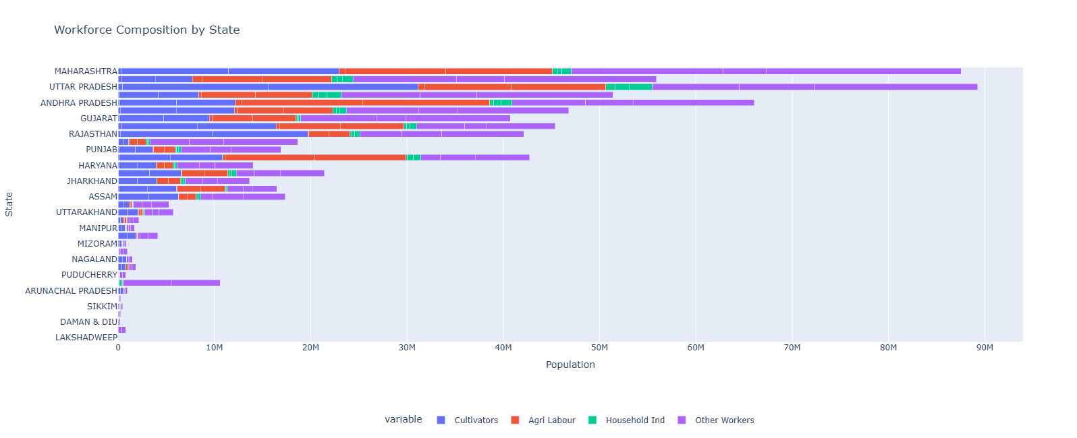

7.5 SC vs ST Distribution by State
The SC vs ST Distribution chart compares the percentage share of Scheduled Castes (SC) and Scheduled Tribes (ST) across different states. The X-axis represents the states, while the Y-axis shows the percentage distribution. The two categories are visually distinguished using separate colored areas.
The chart reveals that SC population percentages are relatively stable across most states, showing moderate variation. In contrast, ST population percentages exhibit significant fluctuations, with some states showing very high concentrations while others have minimal presence.
Certain states display sharp peaks in ST population, indicating strong tribal representation, while others are dominated by SC population with comparatively low ST presence. This highlights the uneven distribution of social groups across regions.
Overall, the visualization emphasizes regional diversity in social composition and reflects how demographic structures vary significantly between states, which is important for targeted social and policy planning.

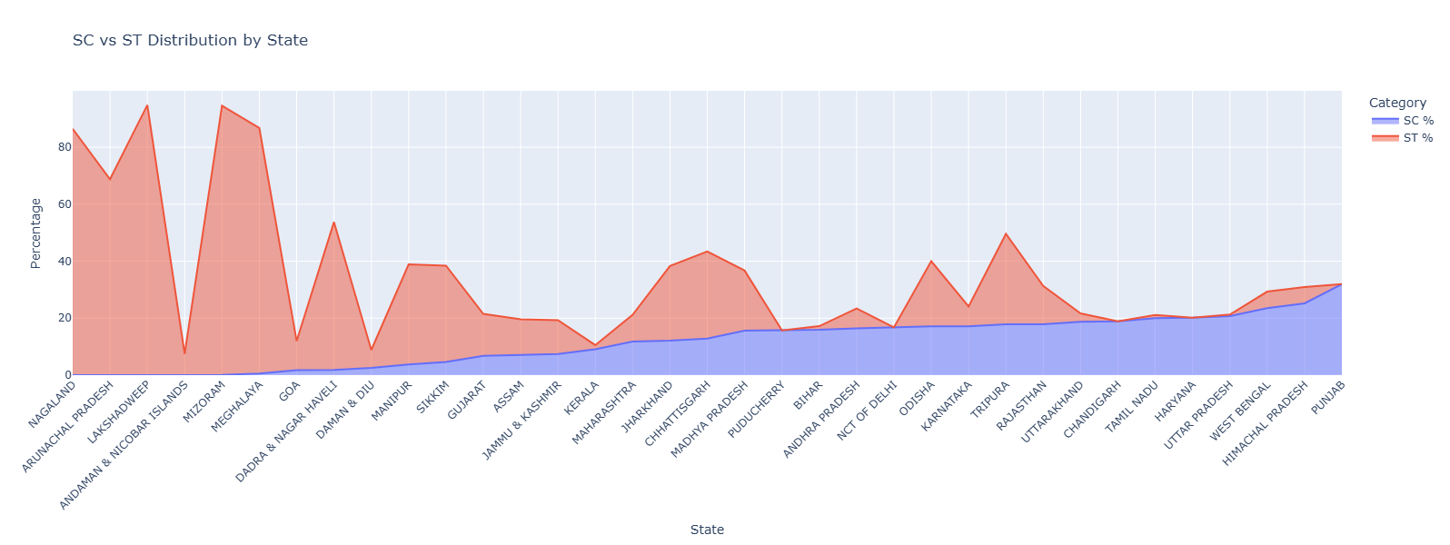

  - Religion Distribution (Tamil Nadu vs All India)

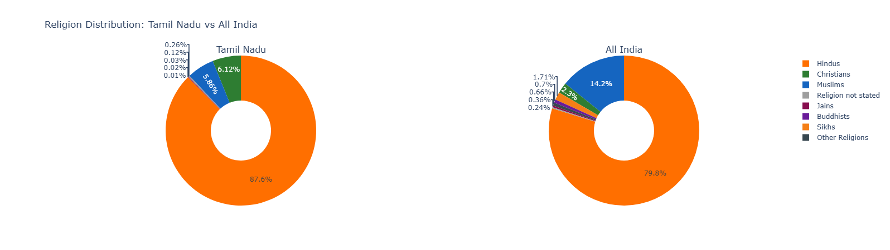

The Religion Distribution chart presents a comparative view of religious composition between Tamil Nadu and the overall population of India using two donut charts. Each segment represents a religious group, and the size of the segment indicates its percentage share in the population.
The chart shows that Hindus form the majority in both Tamil Nadu and India; however, their proportion is higher in Tamil Nadu compared to the national average. Christianity has a noticeably larger share in Tamil Nadu, while Islam has a smaller proportion compared to its national presence.
Other religions such as Sikhs, Buddhists, Jains, and minor categories occupy very small portions in both charts, indicating limited population share. The differences between the two charts highlight regional variations in religious composition.
Overall, the visualization clearly demonstrates how Tamil Nadu’s religious distribution differs from the national pattern, emphasizing the diversity of demographic structures across states.

  - Religion Distribution — All India (Bar Chart)

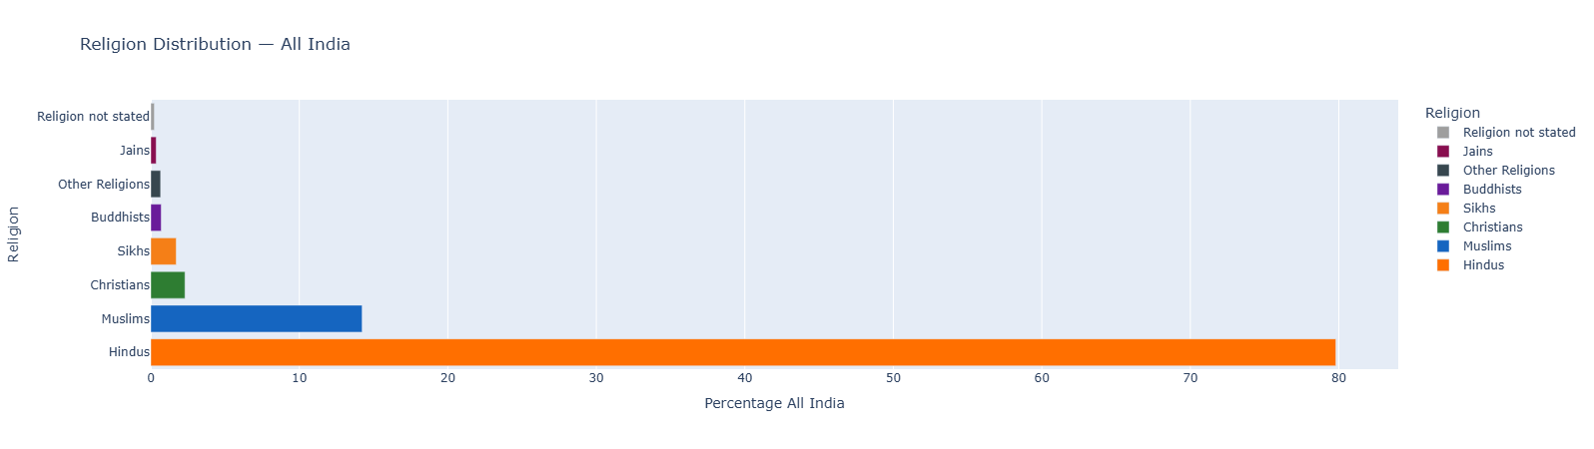

The Religion Distribution bar chart presents the percentage share of major religions across India. The Y-axis lists different religious groups, while the X-axis represents their percentage contribution to the total population.
The chart clearly shows that Hindus form the overwhelming majority, occupying the largest share by a significant margin. Muslims represent the second-largest group, followed by Christians with a smaller but notable proportion. Other religions such as Sikhs, Buddhists, and Jains contribute relatively minor shares to the overall population.
Categories like “Other Religions” and “Religion not stated” appear with very minimal percentages, indicating their limited presence in the national demographic structure.
Overall, the chart highlights the dominant position of Hinduism in India while also reflecting the presence of religious diversity, with minority communities contributing to the country’s multicultural composition.

  - Literate vs Illiterate (Dumbbell Chart)

The Literate vs Illiterate chart uses a dumbbell format to compare the percentage of literate and illiterate populations across different states. The Y-axis lists the states, while the X-axis represents the population percentage. Each state has two points — one for literate (blue) and one for illiterate (red) — connected by a line to show the gap between them.
The chart clearly shows that in all states, the literate population is higher than the illiterate population, indicating overall progress in education. However, the distance between the two points varies significantly across states, highlighting differences in literacy levels.
States with higher literacy rates display a wider gap between literate and illiterate populations, reflecting better educational development. In contrast, states with lower literacy rates show a smaller gap, indicating a relatively higher proportion of illiterate individuals.
Overall, the chart effectively visualizes educational disparities across states and emphasizes the need for focused efforts in regions where literacy levels remain comparatively low.

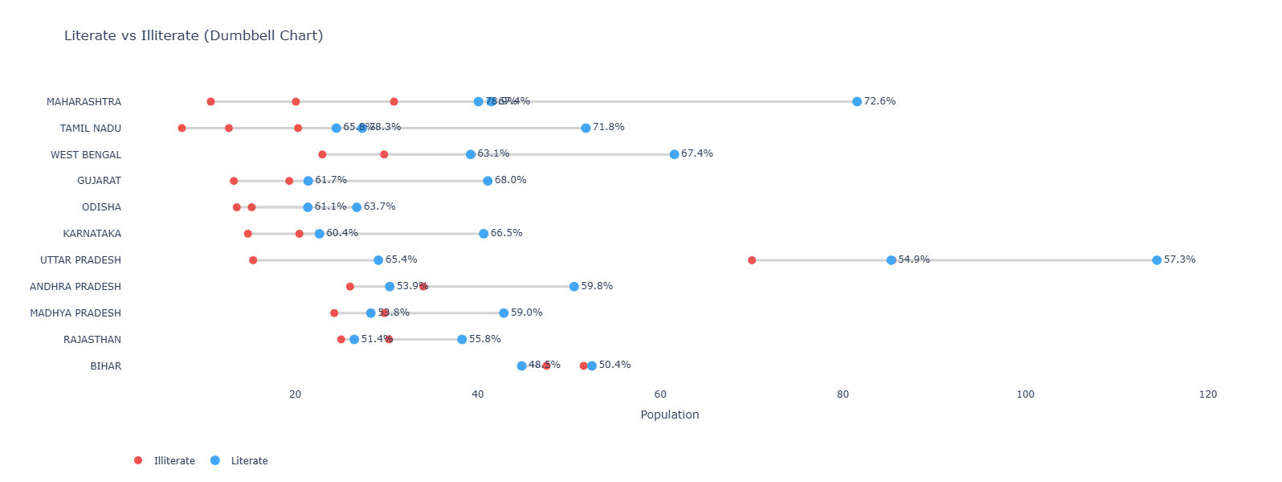

7.9 Correlation Heatmap of Demographic Indicators
The Correlation Heatmap visualizes the relationships between multiple demographic indicators such as literacy rate, male and female literacy, gender literacy gap, SC/ST population percentages, worker participation, and child population percentage. Each cell represents the correlation coefficient between two variables, with values ranging from -1 to +1.
Strong positive correlations are observed between overall literacy rate and both male and female literacy rates, indicating that states with higher literacy levels tend to perform well across both genders. Similarly, work participation percentage shows a strong positive relationship with worker percentage, confirming consistency within employment-related indicators.
Negative correlations are evident between literacy rate and child population percentage, suggesting that states with higher literacy tend to have lower proportions of young population. Additionally, gender literacy gap shows a negative relationship with female literacy, indicating that higher female literacy reduces the gap.
The heatmap also highlights inverse relationships such as between worker participation and non-worker percentage, which are naturally expected. Overall, this visualization provides a comprehensive understanding of how different demographic factors are interrelated and helps identify key patterns influencing population characteristics.

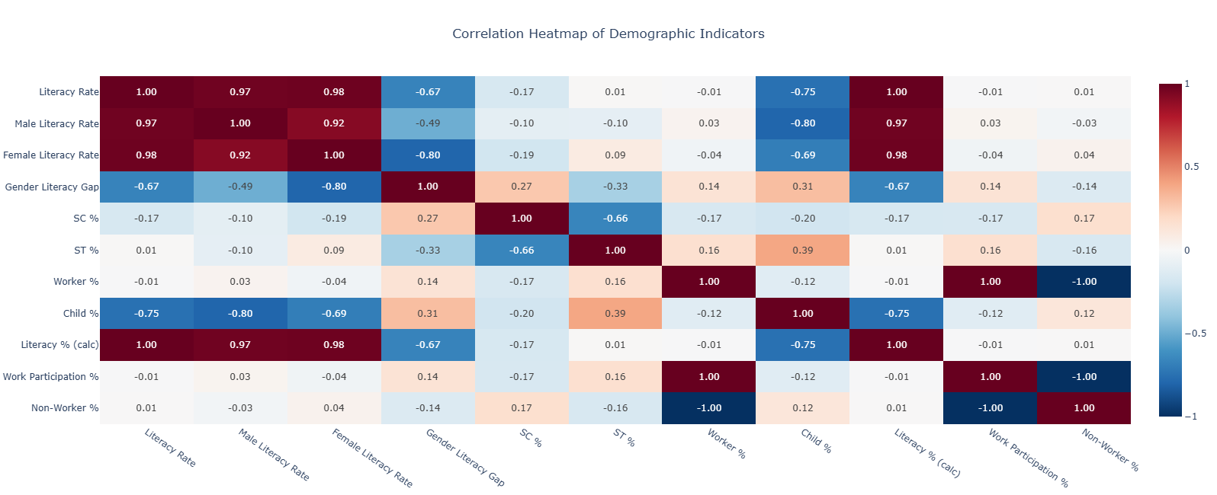
7.10 Villages vs Area by State
The Villages vs Area chart compares the number of villages and the geographical area across different states using a combination of horizontal bars and a line plot. The Y-axis represents the states, while the X-axis shows the number of villages (blue bars) and area in thousand square kilometers (red line).
The chart reveals that states like Madhya Pradesh have the highest number of villages, indicating a highly rural settlement structure. Other large states such as Bihar and Maharashtra also show a significant number of villages, reflecting dense rural habitation.
The red line representing area shows variation that does not always align directly with the number of villages. Some states with large geographical areas do not necessarily have the highest number of villages, indicating differences in population density and settlement patterns.
Smaller states and union territories appear at the lower end with both minimal area and fewer villages. Overall, the chart highlights the relationship between geographic size and rural settlement distribution, emphasizing that village density varies significantly across states.
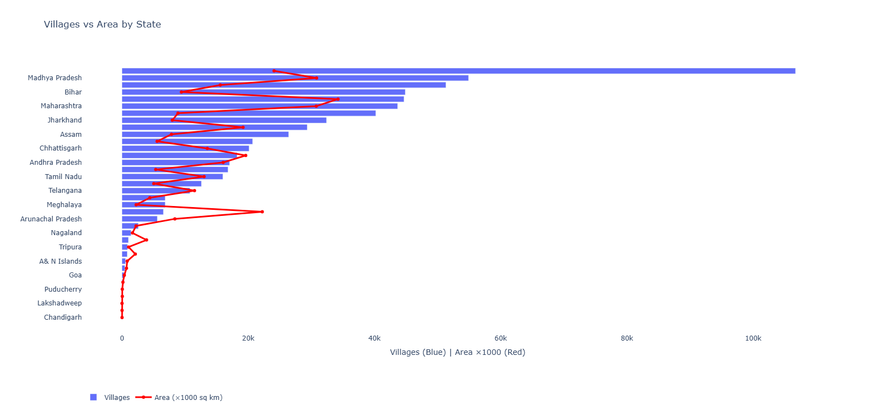
7.11 Comparative Analysis (Literacy, Workforce, and Distribution Patterns)
The Bottom 10 States Literacy Rate chart highlights the states with the lowest literacy levels. The bars show a gradual increase from the lowest to relatively better-performing states, indicating that while differences exist, the gap among these states is moderate. This chart emphasizes regions that require focused educational development and policy intervention.
The Literacy vs Worker % scatter plot examines the relationship between literacy rate and workforce participation. Each point represents a state, and the scattered distribution indicates that the relationship is not strictly linear. While some states with higher literacy also show higher workforce participation, others deviate from this trend, suggesting that employment levels are influenced by additional socioeconomic factors beyond literacy alone.
The Gender Literacy Gap chart for the bottom states shows the difference between male and female literacy rates. The increasing height of the bars indicates that certain states experience a larger gender gap, highlighting disparities in access to education. States with higher gaps require targeted initiatives to improve female literacy and ensure equitable education.
The box plot comparing Literacy, Workers, and Population provides a summary of distribution across these variables. Literacy rates show relatively consistent values with moderate spread, while worker participation exhibits greater variability. Population values show the widest variation, indicating large differences in population size across states. This comparison helps in understanding how these key indicators differ in scale and distribution across regions.

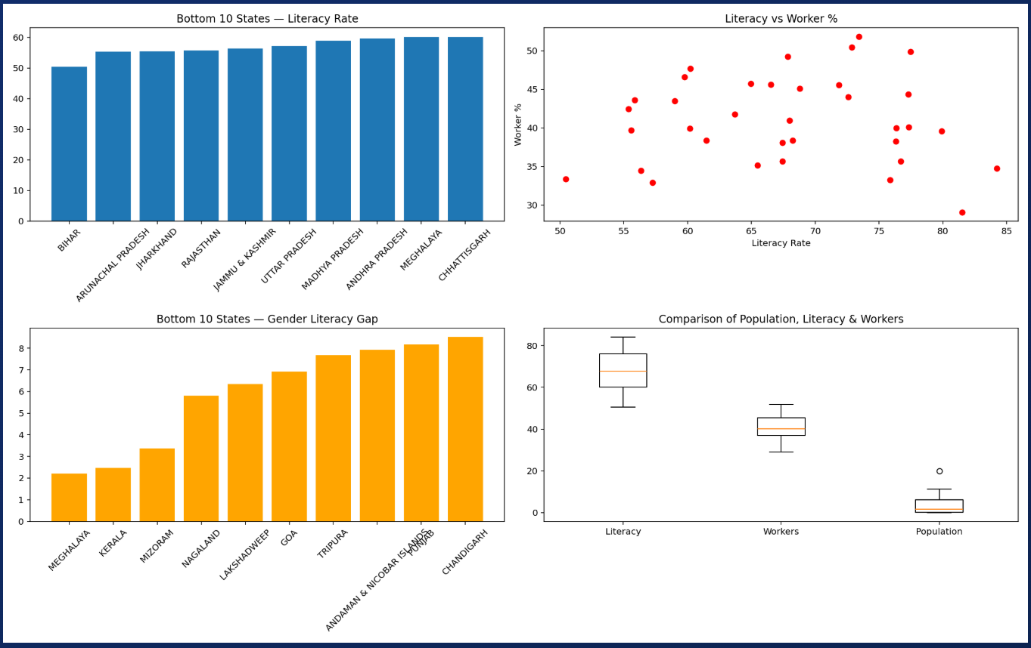

8. Conclusion
This project presents a comprehensive, data-driven analysis of the Census of India 2011 using multiple datasets integrated and visualized through an interactive Python-based dashboard. The study explores key demographic dimensions including population distribution, literacy levels, workforce composition, social structure, and regional disparities. The analysis provides meaningful insights into India’s demographic patterns and highlights areas that require focused attention for balanced development.
India’s population structure is characterized by a large and diverse population exceeding 1.21 billion, with a significant rural majority and noticeable regional imbalances. The analysis reveals that population is heavily concentrated in a few states, while others contribute relatively smaller shares. This uneven distribution has important implications for resource allocation, infrastructure planning, and governance.
Literacy analysis shows that although the overall literacy rate has improved, there remains a consistent gap between male and female literacy across states. Certain regions continue to lag behind in educational attainment, emphasizing the need for targeted policies to improve access to education, particularly for women and underdeveloped areas.
Workforce analysis highlights a transition in employment patterns, where a significant portion of the population is still engaged in agriculture, while a growing share is moving toward non-agricultural sectors. Variations across states indicate differences in economic development and opportunities, suggesting the need for region-specific employment strategies.
Social composition analysis, including SC/ST and religion-based distribution, reflects India’s diversity and regional variation. These patterns are crucial for designing inclusive policies and ensuring equitable development across different communities.
The correlation analysis further demonstrates how demographic indicators are interconnected, with literacy playing a key role in influencing workforce participation and population characteristics. States with higher literacy tend to exhibit more balanced demographic and economic indicators.
The interactive dashboard developed in this project effectively transforms complex census data into intuitive visual insights. Its ability to dynamically explore different states, categories, and indicators enables both high-level understanding and detailed analysis. This makes the project valuable for policymakers, researchers, and students aiming to understand India’s demographic landscape and support data-driven decision-making.

9. Future Scope
This study establishes a strong foundation for understanding demographic patterns using Census 2011 data. Several enhancements and extensions can further improve the depth, accuracy, and usability of the analysis.
1. Per-Capita and Density-Based Analysis
Integrating additional datasets such as state-wise area and updated population estimates would enable calculation of population density and per-capita indicators. This would allow fair comparison across states of different sizes and help identify regions with unusually high or low demographic concentrations.
2. Predictive Modeling and Forecasting
Machine learning models and time-series techniques such as ARIMA, Prophet, or LSTM can be applied to historical census and related datasets to forecast future population growth, literacy trends, and workforce changes. These predictions can support long-term planning in areas like urban development, education, and employment.
3. Socioeconomic Correlation Analysis
Incorporating external datasets such as GDP per capita, unemployment rates, education expenditure, and healthcare access can enable deeper correlation analysis. This would help identify which socioeconomic factors most strongly influence literacy, workforce participation, and population distribution, moving beyond descriptive analysis to more explanatory insights.
4. District-Level and Localized Analysis
The current analysis is primarily at the state level. Extending the study to district or sub-district level data would provide more granular insights, helping identify specific regions that require targeted interventions in education, employment, or infrastructure.
5. Temporal and Comparative Analysis
Combining Census 2011 data with earlier (2001) and later datasets or projections would allow longitudinal analysis of demographic changes over time. This would help in understanding growth trends, migration patterns, and shifts in literacy and workforce structure across decades.
6. Dashboard Enhancement and Deployment
The existing Jupyter Notebook dashboard can be transformed into a full-fledged web application using frameworks such as Dash or Streamlit. Deploying the dashboard on cloud platforms would make it accessible to a wider audience, including policymakers, researchers, and students, enabling real-time interaction and broader impact.

10. References
[1] Government of India, Census of India 2011, Office of the Registrar General & Census Commissioner, India. Available: https://censusindia.gov.in
[2] Open Government Data Platform India, Census and Demographic Datasets. Available: https://data.gov.in
[3] Ministry of Statistics and Programme Implementation (MoSPI), Government of India, Statistical Data and Reports. Available: https://mospi.gov.in
[4] Python Software Foundation, Python Language Reference, version 3.x. Available: https://www.python.org
[5] Plotly Technologies Inc., Plotly Python Open Source Graphing Library. Available: https://plotly.com/python/
[6] Project Jupyter, Jupyter Notebook Documentation. Available: https://jupyter.org/documentation
[7] ipywidgets Development Team, ipywidgets: Interactive HTML Widgets for Jupyter. Available: https://ipywidgets.readthedocs.io
[8] Pandas Development Team, Pandas: Python Data Analysis Library. Available: https://pandas.pydata.org
[9] Government of India, Primary Census Abstract (PCA) 2011 Tables and Metadata. Available: https://censusindia.gov.in
[10] Government of India, Religion-wise Population Data, Census 2011. Available: https://censusindia.gov.in
[11] Government of India, District Census Handbook and Workforce Data Tables, Census 2011. Available: https://censusindia.gov.in

Project Links
GitHub Repository:
https://github.com/lizarawat/Census-Analysis-2011

LinkedIn Project Post
https://www.linkedin.com/posts/liza-rawat-912975352_datascience-python-datavisualization-activity-7453127085243465728-qHw-?utm_source=share&utm_medium=member_desktop&rcm=ACoAAFgQad4BnTBSquJP2h3zX-XUDmABldjx9NA

Google Drive (Project Files):
https://drive.google.com/drive/folders/1bQIAiW2uKDiIM814Kl8-V3sSdy_924M9?usp=sharing



