AN ILLUSTRATED HISTORY
The Astrocade Arcade Story
Inside the Bally Midway hardware, games, and hidden software architecture
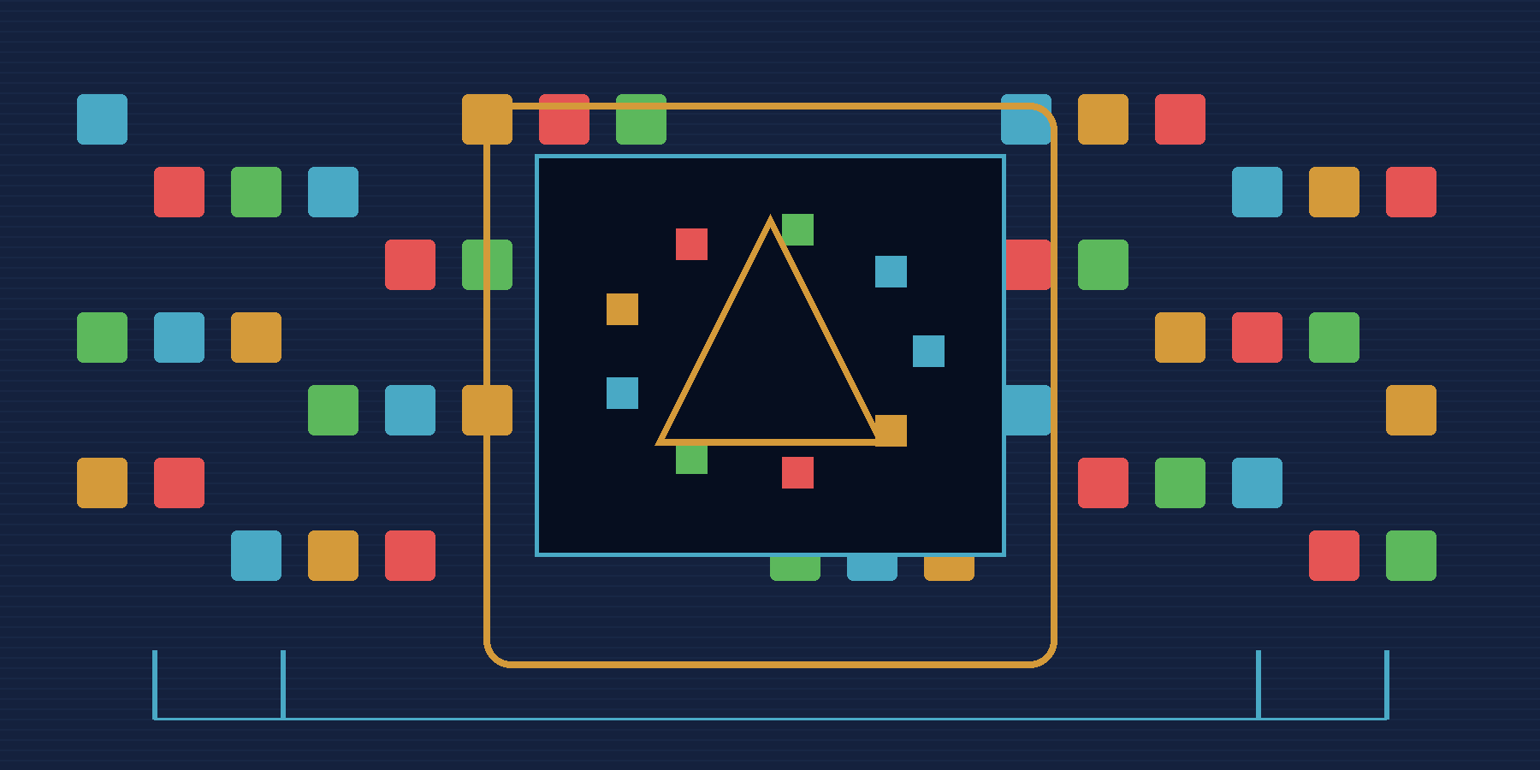
Working draft 0.1 • September 2026

About this working draft
This first pass establishes the book's shape and voice. It contains a complete expandable outline, finished opening chapters, a technical orientation to the arcade hardware, concise first treatments of the principal games, and a bridge into the deeper TERSE material. It deliberately leaves room for cabinets, photographs, advertisements, schematics, source listings, correspondence, and firsthand accounts that will be evaluated in later passes.
The subject is the commercial arcade family. The Bally home machine matters because the consumer and arcade products grew from related custom-chip work and share recognizable display and sound ideas. It is introduced as the seed, then moved to the background. Bally Alley already documents the console and its software culture in depth; this story concentrates on what the technology became inside coin-operated games.
The working term arcade Astrocade is useful but historically slippery. The best-known Astrocade name belongs to the consumer machine, while the arcade boards changed across games and years. This draft uses the term for the related Bally/Midway arcade family, then names individual boards and configurations whenever precision matters.

Editorial principles
- Lead with cabinets, play, people, and visible results; introduce engineering when it explains something the player can see or hear.
- Treat the console as origin and context, not as a second subject competing with the arcade story.
- Distinguish released games, field revisions, prototypes, development artifacts, and later reconstructions.
- Use code sparingly in the main narrative. Place dense disassembly, dictionaries, address maps, and ROM inventories in sidebars or appendices.
- Make each illustration carry information: a physical comparison, a chronology, a data path, a game mechanic, or a proven source relationship.
- Keep uncertainty visible and specific. Do not turn recollection into fact when ROMs, source, or dated records can settle the question.

Working contents and expandable architecture
The structure is intentionally generous. Chapters can grow, split, or move as the external material is reviewed. The game sequence is chronological enough to preserve development, but thematic chapters interrupt the chronology when hardware, graphics, sound, speech, or TERSE needs a clear explanation.
Chapter | Working title | Purpose and likely contents
Prologue | A voice in the arcade | Open inside a crowded arcade with Gorf speaking, Wizard of Wor breathing through a maze, and Sea Wolf II's twin periscopes. Ask what connects cabinets that appear unrelated.
1 | The arcade family nobody quite names correctly | Define the scope, explain the term arcade Astrocade, introduce the evidence, and preview the games.
2 | The seed machine | Give the consumer system only the space needed to explain the custom video/sound design, Z80 environment, and the path toward arcade specialization.
3 | Bally, Midway, and Dave Nutting Associates | Tell the institutional and human story: who designed, programmed, manufactured, marketed, and supported the machines.
4 | The machine beneath the games | Explain memory, display RAM, Function Generator/Magic RAM, sound, inputs, interrupts, protected memory, and board variation.
5 | Sea Wolf II | Use the two-player cabinet and compact 8 KB program as the early foundation; introduce Alan McNeil and the first known commercial TERSE implementation.
6 | Space Zap, Extra Bases, and the flexible middle | Show how shared technical ingredients served radically different controls and genres; include Ten Pin Deluxe where the evidence supports it.
7 | Wizard of Wor | Follow maze construction, two-player play, monsters, palette effects, synthesized sound, speech, diagnostics, and cabinet personality.
8 | Gorf | Treat the five-mission structure, rank system, graphics, sound, speech, revisions, and mature software architecture.
9 | The hidden language | Explain TERSE in approachable layers, then show VGS, VGER, native Z80, cross-compilation, and selective target vocabularies.
10 | Robby Roto | Use the surviving source to enter the development workshop: tasks, maze systems, graphics, sprite headers and hotspots, build variants, and source-to-ROM proof.
11 | Ms. Gorf | Follow the unreleased project through disks, logic objects, pattern products, animation data, loaders, patching, and ICE execution.
12 | Demons & Dragons | Present the unreleased 16-color, bank-switched bridge and its direct technical relationship to Professor Pac-Man.
13 | Professor Pac-Man | Explain the quiz-game concept, program banks, question ROMs, protected memory, presentation machinery, diagnostics, and the commercial end of the line.
14 | Graphics made from constraints | Compare packed pixels, color limits, expanded patterns, sprites, collision/intercept data, animation, and the visual signatures of the games.
15 | The sound of the family | Trace the custom sound hardware, event players, music, Votrax speech, phrase construction, foreign sets, and the ways audio defined cabinet identity.
16 | Building a game at DNA | Reconstruct the host tools, Forth blocks, editor, assembler, debugger, TERSE compiler, VGS/VGER libraries, asset generation, object merging, ICE, and EPROM production boundary.
17 | Cabinets, operators, and service | Move from software back to the floor: controls, coin handling, service tests, audits, DIP switches, manuals, field changes, and maintainability.
18 | Preservation and reconstruction | Show how cabinets, ROMs, source, disks, schematics, manuals, MAME, and modern disassembly preserve different layers of truth.
Epilogue | The architecture that stayed hidden | Return to the player experience and explain why this small hardware family deserves a larger place in arcade history.
Appendices | Technical reference | Game/board chronology; ROM maps; people and credits; TERSE primer; vocabulary comparison; source inventory; terminology; image and artifact credits.

Illustration program
The final work should mix historical images with newly drawn explanatory figures. Historical images establish physical presence and period context; diagrams reveal relationships that photographs cannot; ROM-derived graphics show what the machines actually stored and displayed.
Illustration family | Examples | Acquisition or production plan
Cabinet and period | Cabinets, marquees, control panels, flyers, advertisements, trade photographs | Review supplied material first; record owner, date, source, and permission status.
Hardware | Board photographs, chip callouts, memory maps, signal and graphics paths | Use schematics and verified board images; redraw diagrams for legibility.
Screen and asset | MAME captures, palette comparisons, sprites, fonts, pattern tables, animations | Capture from verified ROM revisions and label each set.
Software | TERSE threads, source blocks, debugger screens, build disks, source-to-ROM comparisons | Derive from preserved source and byte-exact disassemblies.
Human history | Portraits, résumés, correspondence, oral-history excerpts | Confirm identity, context, date, and quotation provenance.

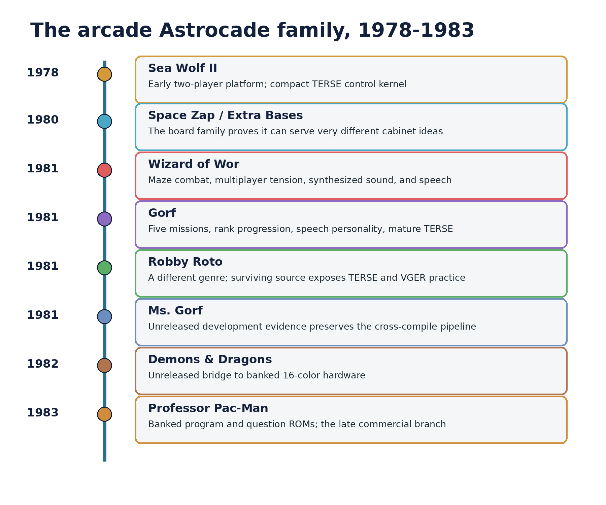
Figure 1. Working chronology of the principal released and unreleased projects. Dates and project spans will be tightened against the external source collection.

Prologue — A voice in the arcade
The first clue is not hidden in a circuit diagram. It is standing on the arcade floor.
A two-player submarine cabinet asks both players to peer into separate viewing stations. A maze game surrounds its players with monsters, warning tones, and a synthesized voice. Another cabinet promotes the player through military ranks while jumping from one style of space battle to another. Nearby, a digging game fills a screen with dirt, passages, creatures, and small animated decisions. A few years later, the same engineering lineage attempts something stranger still: an arcade quiz game carrying banks of questions and enough program structure to manage them.
Sea Wolf II, Wizard of Wor, Gorf, The Adventures of Robby Roto!, and Professor Pac-Man do not look like a conventional hardware series. Their cabinets, controls, genres, and ambitions pull in different directions. The resemblance appears in motion: the crisp packed-pixel display, the way color is organized, the characteristic electronic sound, the service logic, and the repeated solutions found deep inside their ROMs.
Beneath those differences lies a family of Z80 arcade systems built around Bally custom video and sound technology and developed through the partnership among Bally, Midway, and Dave Nutting Associates. The family was not frozen into one board sold under one stable platform name. It changed. Memory grew. Controls changed. Speech appeared. Protection and bank switching were added. A later 16-color branch carried much more program and data than the early machines. Yet important hardware ideas and software habits survived those changes.
One of those habits remained nearly invisible for decades. Alan McNeil's TERSE system let programmers combine compact threaded control code with native Z80 routines. In Sea Wolf II it appears as a small kernel organizing an 8 KB game. In Gorf and Robby Roto it becomes part of a mature development method with graphics and task vocabularies. Development disks from Ms. Gorf expose the cross-compiler and asset pipeline. Demons & Dragons carries the method onto banked 16-color hardware. Professor Pac-Man preserves it inside a large, specialized commercial program.
TERSE is not the whole story. A language does not explain why Wizard of Wor feels tense, why Gorf talks like an adversary, why Sea Wolf II needs two viewing stations, or why Professor Pac-Man became such a peculiar endpoint. But TERSE connects the human act of making the games to the machine code that survives. It gives us a way to see not merely what the cabinets did, but how their creators organized the work.
This book follows that connection from the outside inward. It begins with cabinets and games, descends through boards and custom chips, enters the source and development tools, and returns to the arcade floor with a fuller understanding of what the machines represent.

1 — The arcade family nobody quite names correctly
The convenient name is the Astrocade arcade platform. It is also a name that needs immediate qualification.
Astrocade is most familiar as the name attached to Bally's consumer video-game system. Arcade collectors and emulator developers also use it more broadly for related Bally and Midway machines built around the same lineage of custom video and sound technology. That broader usage is practical because the games share recognizable mechanisms. It can become misleading when it suggests that every cabinet contains the console board, that the arcade family remained electrically identical, or that the commercial games were ports from a home library. None of those shortcuts is adequate.
The arcade machines are relatives, not duplicates. They share an engineering inheritance while adapting it to coin operation, specialized controls, additional memory, speech, protected storage, diagnostic requirements, and later banked hardware. A useful history must therefore hold two ideas at once: the shared family matters, and the differences between individual machines matter just as much.

A family defined by recurring solutions
Hardware platforms are often described by a board number, a CPU, or a release list. This family is better recognized by a cluster of recurring solutions:
- A Z80 program running close to the video, sound, and input hardware.
- A packed bitmap display rather than a tile-only screen architecture.
- A Function Generator, commonly discussed through Magic RAM behavior, that assists shifts, rotation, expansion, logical combination, and collision or intercept work.
- Sound generated through Bally custom circuitry and driven directly by software-visible registers.
- Interrupt-driven housekeeping that shares the machine with foreground game logic.
- Game-specific cabinet controls and memory maps assembled around a recognizable technical core.
- Across several DNA projects, a TERSE execution contract that lets threaded definitions and native Z80 routines call through one vocabulary.
No single bullet is sufficient. Together they create the engineering accent heard across the games.

The boundaries of this story
The main line begins with Sea Wolf II in 1978 and follows the commercial and development lineage through Professor Pac-Man in 1983. It includes released cabinets, prototypes, and development artifacts when each contributes evidence about the platform or the way games were built.
Group | Projects | Why they belong
Early and transitional | Sea Wolf II; Space Zap; Extra Bases; Ten Pin Deluxe | They establish the adaptable arcade environment before the best-known speech games.
Mature 1981 line | Wizard of Wor; Gorf; The Adventures of Robby Roto! | They display the family's range in play, presentation, and software organization.
Unreleased evidence | Ms. Gorf; Demons & Dragons | They preserve development and hardware transitions not visible in released games alone.
Late banked branch | Professor Pac-Man | It expands the architecture into banked program and question storage on specialized hardware.

Clones, revisions, foreign-language sets, field changes, and closely related board variants will appear where they reveal development or operation. They will not be allowed to turn the narrative into a catalog.

What the evidence can and cannot say
Arcade history is often forced to work backward. Cabinets are separated from their paperwork. Boards lose labels. ROM sets survive without source. Personal memories retain the shape of an event while dates and exact names blur. A good story does not erase those gaps; it organizes the surviving evidence so that one source can test another.
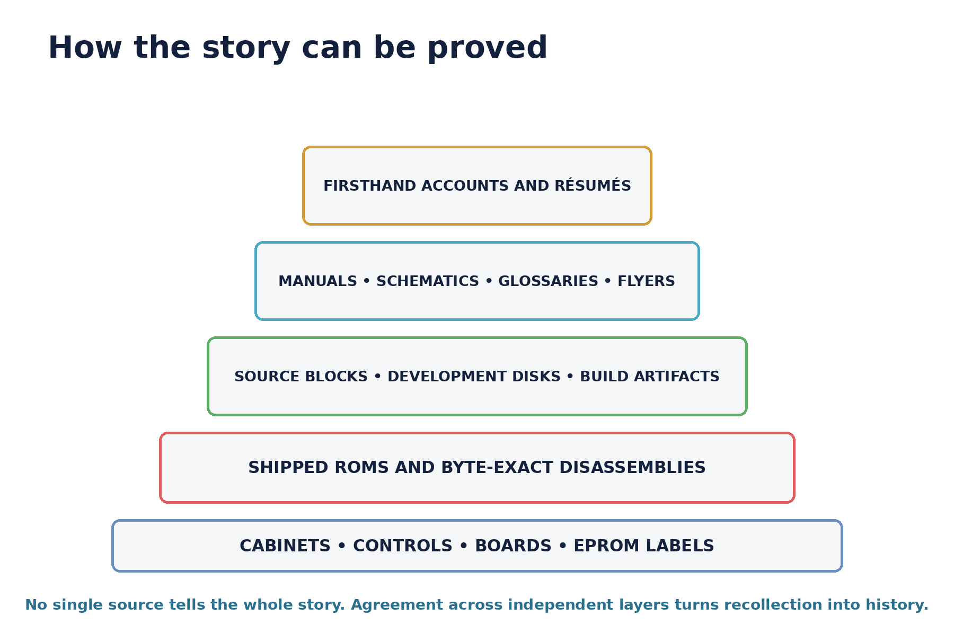
Figure 2. The evidence is complementary rather than hierarchical in every case. ROMs prove executed behavior; source and development artifacts reveal names and working methods; physical machines show the final product.
This book uses a simple standard. A shipped ROM establishes what a released machine executed. Original source can preserve developer names, organization, and intent. Schematics establish connections and device roles. Manuals describe operation and service expectations. Firsthand accounts establish authorship and working history when they are identified and placed in context. Modern disassembly and emulation connect these layers, but they do not replace them.
That standard matters most when a story becomes attractive. The temptation is to make every shared byte prove a sweeping corporate plan or every recollection settle a disputed detail. The stronger result is narrower and more durable: identify exactly what survives, show how independent evidence agrees, and state where the record remains open.

2 — The seed machine
The arcade story begins with a consumer machine, but it does not remain there for long.
Bally's home system supplied a compact environment in which a Z80 worked beside custom display and sound logic. Its bitmap screen, packed pixels, programmable color, sound registers, and assisted graphics operations gave software unusually direct control over what appeared and sounded on a television. Those ingredients became a seed for arcade designs that demanded more memory, harder timing, cabinet-specific controls, service features, and the durability of coin-operated operation.
The consumer system deserves attention here because it makes the custom technology legible. It shows the basic bargain: replace large amounts of dedicated display logic with a programmable processor and specialized helpers. The CPU chooses patterns, positions, colors, and sounds; the custom hardware turns compact writes into useful screen and audio behavior.
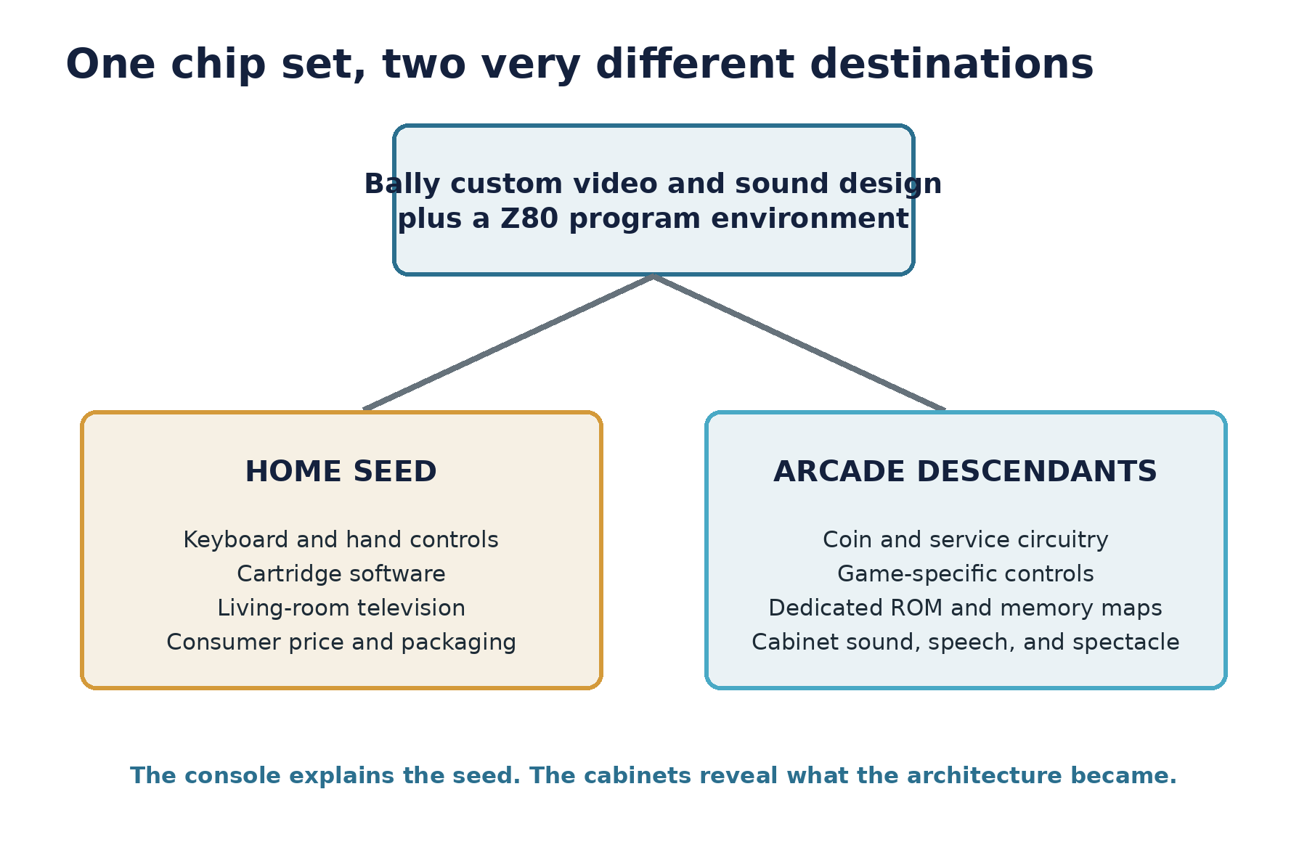
Figure 3. Shared custom-chip ideas fed two product worlds. The arcade machines added specialized control, memory, protection, service, and presentation requirements rather than simply enclosing a console in a cabinet.

What carries forward
Several ideas from the consumer environment explain the arcade descendants particularly well.
- The display is a writable bitmap. Game code is responsible for composing the image rather than choosing only from a fixed tile map.
- Pixels are packed. A byte represents several visible pixels, so movement, masking, and color expansion reward specialized hardware support.
- The graphics helper is not a separate sprite engine in the later tile-and-sprite sense. It transforms writes into display memory and can combine new data with what is already present.
- Sound is programmable and register-oriented. Musical patterns and effects emerge from timed software control of tone, noise, volume, and related state.
- The Z80 remains close to the machine. High-level software systems can organize play, but performance-critical work still benefits from native routines written for the exact hardware.

What the arcade demands
An arcade cabinet is not a home computer with a coin switch. It must wake into attract mode, accept and audit credits, survive rough controls, run for long periods, expose service tests, support operator adjustments, drive a particular monitor and speaker arrangement, and create enough theater to win attention in a noisy room. Every cabinet can also demand a new physical vocabulary: dual periscopes, baseball controls, opposing joysticks, start lamps, speech hardware, or question-selection buttons.
Those demands push the shared technology in several directions. Program ROM replaces consumer cartridges. Memory maps become game specific. Protected RAM may preserve bookkeeping or prevent accidental writes. Interrupt code must advance sound, timers, and object systems at a stable rhythm. Later machines add bank selection because one visible address space can no longer hold the program and data required by the design.
The result is best understood as adaptation. The seed contributes a vocabulary of pixels, sound, and processor-visible hardware. Arcade engineering turns that vocabulary into a succession of purpose-built products.

Why this book moves on
The consumer machine has its own deep history: built-in programs, cartridges, programming languages, expansions, newsletters, community software, and modern preservation. Bally Alley has assembled that world with an authority and breadth this arcade history should acknowledge rather than duplicate.
From this point forward, the home system returns only when it clarifies a chip behavior, a development connection, or a contrast with the commercial boards. The story belongs to the cabinets.

3 — Bally, Midway, and Dave Nutting Associates
The hardware family did not emerge from one isolated engineering department. It grew at the intersection of Bally's corporate resources, Midway's coin-operated business, and the small, inventive engineering culture of Dave Nutting Associates.
That arrangement is essential to the story because the names printed on a cabinet do not always identify the people who designed its internal systems or wrote its software. Product development moved through corporate, manufacturing, marketing, and contract-engineering boundaries. Credits were rarely presented to the player. Reconstructing authorship therefore depends on résumés, source comments, surviving documents, correspondence, and technical fingerprints in the programs themselves.

A partnership built for experimentation
Dave Nutting Associates occupied a productive middle ground. It was small enough to build unusual systems around particular ideas and connected enough to place those systems inside Bally and Midway products. That combination helps explain both the unity and the eccentricity of the arcade line. The teams could reuse custom-chip knowledge, development tools, graphics services, and software architecture while still delivering cabinets as different as a submarine duel, a maze shooter, a multi-mission space game, a digging game, and a quiz machine.
The reusable layer did not make the games uniform. It made experimentation affordable. A programmer could inherit a graphics word, a task scheduler, a diagnostic framework, a sound player, or a familiar execution convention, then devote more of the limited ROM and schedule to the new game.

The people visible in the surviving record
Alan McNeil stands at the beginning of the TERSE line. His résumé identifies TERSE as a Z80 direct-threaded version of Forth and names Sea Wolf II among his DNA projects. Former DNA engineers Tony Miller and Rickey Spiece also credited McNeil with the engine. Their recollections differ on the exact expansion of the acronym, so TERSE is safest treated as the historical name without forcing one disputed phrase.
Jamie Fenton becomes central to the later history: Gorf, the software and development culture around TERSE, the Ms. Gorf materials, and the recollections that helped later investigators recognize what survived. Robby Roto contributes an even rarer witness: extensive source blocks that expose how a DNA game was actually organized. Other programmers, hardware designers, artists, technicians, and production staff must be added as the external record is reviewed; this chapter will ultimately carry a documented people-and-project matrix rather than a short list of famous names.
The rule for this chapter is attribution by evidence. A cabinet trademark is not a programming credit. A familiar style is not proof of authorship. Where the record supports a person, role, and project, the book will say so directly. Where the evidence supports only a team or organization, it will stop there.

Work products, not just job titles
The most revealing way to introduce the team may be through the things it built. TERSE supplied a language and target execution architecture. VGS exposed graphics and hardware services as callable words. VGER organized timed game behavior and objects. The editor, debugger, assembler, block-file system, cross-compiler, asset generators, loaders, and ICE target formed a development workshop around those runtime layers.
This shift—from biographies alone to people connected with concrete work products—lets the reader see collaboration. One engineer's runtime becomes another programmer's vocabulary. A graphics pipeline feeds an artist's patterns into generated objects. Native Z80 routines become words used by high-level game logic. A service test created for development becomes an operator's tool in the field.

4 — The machine beneath the games
A player experiences one machine. The cabinet, controls, monitor, speaker, program, graphics hardware, and sound system merge into a single object. For the engineer, that unity is built from layers that must cooperate on every frame.
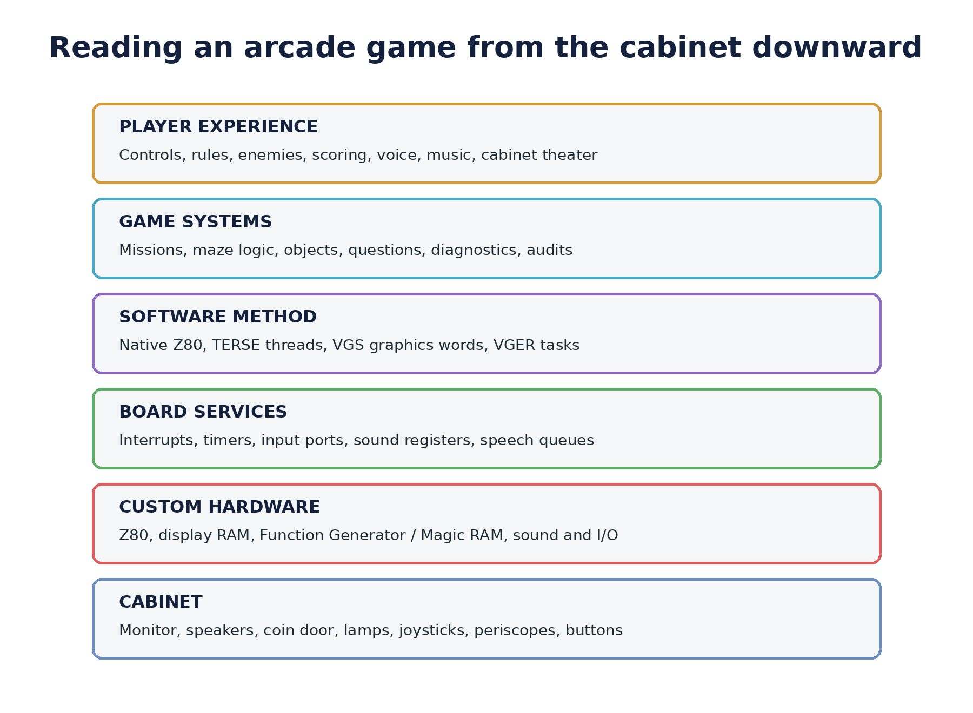
Figure 4. The player encounters the stack from the top. Reverse engineering often begins at the ROM and moves both downward into hardware and upward into game behavior.

The Z80 at the center
The Z80 gives the family a flexible general-purpose processor with a 16-bit address space, separate I/O ports, alternate register sets, and index registers that later become useful to TERSE. It executes the game, services interrupts, reads controls, writes display memory, programs sound, and coordinates any speech or bank hardware added by a particular cabinet.
The processor's apparent simplicity is deceptive. An arcade frame is a negotiation among foreground game decisions and time-critical background work. A player moves. Enemies advance. Timers expire. Sound registers change. Speech hardware becomes ready for another phoneme. A collision latch must be read before it is overwritten. The program stays responsive by dividing these responsibilities between foreground code, scheduled tasks, and interrupt services.

A bitmap that belongs to the program
The display architecture gives software direct responsibility for the visible frame. Screen memory stores packed pixels. Color interpretation depends on programmable state and the mode used by the game. This offers freedom: the same basic machinery can draw submarines, maze walls, star fields, baseball figures, text, animated creatures, or question screens.
Freedom costs time and memory. Erasing and redrawing an object touches display RAM. Moving an irregular shape requires shifts and masks. Enlarging compact source art requires expansion. Drawing into an occupied region must preserve or combine existing pixels. Collision detection needs information about overlap. The custom graphics hardware exists to make those operations practical.

Function Generator and Magic RAM
The names Function Generator and Magic RAM describe the programmable path through which a write can be shifted, rotated, expanded, flipped, logically combined, and checked for intercept. The exact controls vary across documentation and board use, but the central idea is stable: a byte written by the Z80 can become more than a literal byte copied to the screen.
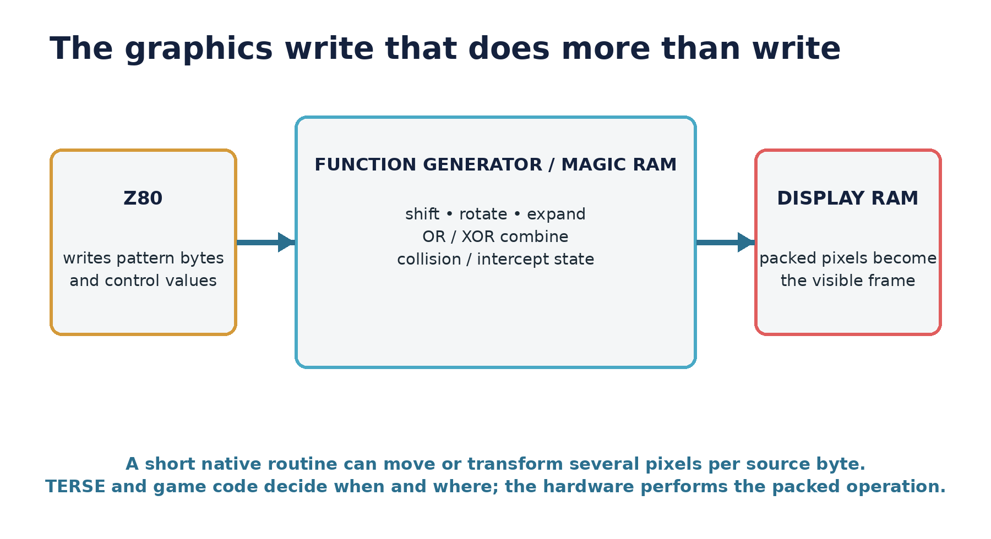
Figure 5. Conceptual graphics data path. Later passes will add a board-specific register table and one worked sprite write taken from a verified game routine.
This is why the graphics system belongs in the narrative rather than a technical appendix. It shapes the art. Packed source patterns, horizontal alignment, expansion modes, logical drawing, and intercept behavior influence how objects are designed and animated. The visual character of the games is partly a record of the operations the hardware makes cheap.

Sound written as changing state
The custom sound system is likewise close to the program. Tone, noise, volume, and related behavior are controlled through registers. A game can submit a sound event or musical stream while an interrupt-driven player advances the necessary changes over time. The player hears a continuous effect; the ROM contains a sequence of values, tables, counters, and service routines.
Wizard of Wor and Gorf add speech as a separate but coordinated layer. The Votrax SC-01 accepts phoneme codes and reports readiness. A phrase is therefore not a sampled recording stored in ROM. It is a timed stream of phonemes, pauses, and transitions delivered while the rest of the game continues. Gorf's personality depends on both authored phoneme data and the queueing machinery that turns game events into speech.

Inputs are cabinet architecture
Controls are not a generic afterthought. Sea Wolf II's paired stations, Extra Bases' sports controls, Wizard of Wor's two-player maze combat, and Professor Pac-Man's response buttons make different electrical and software demands. Input ports are decoded into game state, debounced or edge-detected when needed, and integrated with credits, starts, service switches, and operator settings.
This point will become highly visual in later passes. Control-panel photographs can sit beside simplified port diagrams and the corresponding input routine. The reader should be able to follow a physical action—from button or joystick, through a port bit, into the game decision it triggers.

Memory maps tell the history of ambition
Memory is where the family's evolution becomes measurable. The early 8 KB Sea Wolf II program can keep most of its work in native code around a very small threaded kernel. Wizard of Wor and Gorf use a larger but still compact fixed environment. Robby Roto fills that environment with a different kind of world and exposes a large software organization in surviving source. Demons & Dragons and Professor Pac-Man require banked windows because program, graphics, tables, presentation data, and questions no longer fit into a simple fixed image.
A later chapter will compare the maps side by side. The comparison will not be a wall of hexadecimal addresses. It will show what each region is for, which parts remain stable, which devices force special handling, and how the available space constrains the game.

5 — The games take the stage
The following profiles are deliberately concise first treatments. Each will grow into a full chapter as cabinet images, manuals, flyers, source, and firsthand accounts are reviewed. Their purpose here is to establish the narrative arc and the distinct question each game asks of the shared technology.

Sea Wolf II — the compact foundation
Sea Wolf II begins with the cabinet. Two players occupy adjacent viewing stations and fight through controls designed around the submarine fantasy. The machine is social and competitive, yet it gives each player a constrained private viewpoint. That physical arrangement is as important as anything in the ROM.
Inside, the complete program fits in 8 KB. Reverse engineering reveals a compact TERSE kernel linked beside native application routines. Six complete threaded programs organize initialization, control, and localized GAME OVER presentation. Rendering, collision, scoring, target motion, sound submission, and device handling remain native. The division is instructive: the thread says when; the native word knows how.
Sea Wolf II therefore introduces two themes that will persist. The hardware family can be shaped around a strong cabinet concept, and the software can separate compact control structure from specialized machine work without pretending the machine is generic.

Space Zap and Extra Bases — proof of range
Space Zap and Extra Bases prevent the story from becoming a straight line from submarine to maze to space opera. They show an arcade environment being applied to different pacing, controls, and screen organizations. Space Zap compresses attention into attacks from multiple directions. Extra Bases turns the same broad engineering inheritance toward a sports cabinet.
These games deserve careful board-by-board treatment because their value lies in difference. The chapter will compare input arrangements, screen composition, memory maps, sound behavior, and service design. Ten Pin Deluxe belongs nearby as a related project to be placed precisely once its surviving hardware and software evidence is assembled.

Wizard of Wor — tension, cooperation, and voice
Wizard of Wor gives the family one of its clearest identities. The maze is readable immediately, but play depends on limited knowledge: enemies move through passages, vanish, reappear, and pressure two players who may cooperate or shoot one another. Color and sound communicate state as much as decoration.
The game also demonstrates how a technically modest display can create theater through timing. Maze drawing, object motion, flashes, sounds, and speech are coordinated events. The synthesized voice does not merely announce information; it frames the cabinet as a hostile presence. A full chapter can move from maze construction and monster scheduling through palette behavior, sound events, speech phrases, diagnostics, and multiplayer rules.

Gorf — the spectacle machine
Gorf expands presentation through variety. Its five missions deliberately change the play grammar while rank progression and voice hold the experience together. The cabinet does not ask the player to master one repeating formation. It asks the player to survive a sequence of recognizable but differently organized challenges.
The ROM shows a mature software environment: a broad TERSE dictionary, compiled utility and service words, native graphics and sound machinery, queued Votrax speech, diagnostics, audits, and mission-specific systems. The achievement is not that every subsystem is written in one language. It is that different techniques share a stable execution and service vocabulary.

Robby Roto — the workshop door opens
Robby Roto changes genre and changes the historical evidence. The released game provides ROMs; the surviving development corpus provides source blocks, task definitions, native code, tables, conditional builds, and comments. It is possible to follow exact source forms into exact bytes in the commercial image.
Its graphics deserve a visual chapter of their own. Four-byte sprite headers preserve dimensions and hotspot or origin information that tells the renderer how a pattern relates to position. Maze, dirt, creatures, objects, and animation can be extracted and presented as both artwork and data. A gallery that discards the metadata would miss part of the design; the hotspot belongs beside the image.

Ms. Gorf — a game preserved as a process
Ms. Gorf is important even where a complete finished cabinet story remains elusive. Its development disks preserve the production method: cross-compiled logic, separate pattern and animation objects, allocation tables, loaders, patching, and transfer to an ICE target. The material turns an abstract description of a toolchain into named files and repeatable operations.
This chapter should read like entering a development room after the programmers have left. Screens, object names, target addresses, and damaged or incomplete artifacts remain on the benches. Their arrangement shows how code and art moved toward a running machine.

Demons & Dragons — the 16-color bridge
Demons & Dragons is the crucial bridge between the mature 1981 environment and Professor Pac-Man. Its ROMs preserve the established TERSE execution contract and vocabulary lineage while moving the program onto bank-switched 16-color hardware. Fixed and banked regions cooperate through exported entries and shared services.
Prototype residue makes the project unusually revealing. A linked fragment of the host Forth dictionary survives in one ROM; another ROM retains the structure of an 8 KB block file with one target block and unused source screens. These are not decorative curiosities. They connect the development environment directly to the programmed image.

Professor Pac-Man — the ambitious last act
Professor Pac-Man takes the banked platform into a genre far from Gorf. Nine program ROMs are joined by a large question-ROM system. Bank selection exposes program and data through changing address windows. Protected-memory services, diagnostics, presentation code, recent-question avoidance, and question directories turn the cabinet into a specialized information machine.
The game retains the TERSE-family execution ABI and dictionary organization but does not carry a mechanical copy of Gorf. It removes unused words, promotes selected operations to native code, and adds services required by the new hardware and application. That combination—stable contract, selective vocabulary, new specialization—is the clearest evidence that the software system evolved rather than fossilized.
Professor Pac-Man is also where commercial history and technical ambition collide. Its chapter must explain the cabinet as a product, not merely celebrate its architecture. The question database, operator expectations, player experience, production history, and market result belong beside the ROM map.

6 — The hidden language
The games can be enjoyed and understood without TERSE. Their deeper development history cannot.
TERSE was a Z80 direct-threaded system created at Dave Nutting Associates. At runtime, a compiled definition is largely a sequence of 16-bit addresses. Each address identifies a native primitive, a game-specific application word, or another compiled definition. The dispatcher fetches the next address and jumps directly to it. Native words perform arithmetic, graphics, I/O, collision, sound, or any other work that benefits from direct Z80 code.
The word threaded sometimes suggests a slow interpreter reading abstract bytecodes. That is not the right picture. In TERSE, an execution token is already a native address. The system pays for fetching and indirectly jumping to each word, but it does not translate a symbolic opcode through a separate table. Expensive hardware work stays native.

The small mechanism
The mature inner dispatcher used by Gorf, Robby Roto, Demons & Dragons, and Professor Pac-Man is only seven instructions:
DSPATCH:
ld a,(bc)
inc bc
ld l,a
ld a,(bc)
inc bc
ld h,a
jp (hl)
BC points into the thread. The dispatcher reads a little-endian address, advances BC, and jumps through HL. A normal native word returns with JP (IY), where IY holds the continuation back into the dispatcher. Compiled colon definitions save and restore the caller's threaded position on a separate IX control stack.

Why it fits this hardware
TERSE fits the arcade environment because it does not demand purity. Control logic can be compact and factored into named words. Rendering, collision, sound, interrupts, and unusual cabinet I/O can remain hand-written Z80. Both sides follow one calling convention, so a native routine becomes another word in the game's vocabulary.
Compiled control decides | Native service performs
When a game state changes | The exact memory, port, or object update
Which graphic or phrase to request | Packed-pixel drawing or phoneme delivery
How tasks sequence and wait | Interrupt timing, counters, and hardware servicing
Which bank or object is needed | Bank latch writes, address decoding, and data transfer

From kernel to development system
Sea Wolf II proves the idea at minimum scale: a narrow linked kernel and a small set of threaded programs organize mostly native game services. By 1981, TERSE had grown into a larger working environment with a source-block editor, compiler forms, debugger, postfix Z80 assembler, dictionary tools, disk services, and game vocabularies.
VGS exposed drawing, coordinates, text, color, and related hardware services as words. VGER added scheduled behavior, tasks, timers, animation, and object services. The boundaries were practical rather than protected: a game task could call a core primitive, a graphics word, a scheduler service, or a project-specific native routine through the same execution contract.
The shipped cabinet did not contain the entire development environment. The host system cross-compiled selected target words, native bodies, and data objects into game images. Each product carried the vocabulary it needed. This is why the lineage appears as stable mechanisms and recognizable word families rather than identical ROM regions copied forever.

The story TERSE tells
The importance of TERSE is not that it makes these games secretly Forth programs. The importance is organizational. It reveals a maintained software method spanning different cabinets, genres, and hardware generations. Sea Wolf II, Gorf, Robby Roto, Ms. Gorf, Demons & Dragons, and Professor Pac-Man become stages in one engineering history.
The existing technical paper remains the companion for readers who want stack effects, inline operand formats, word-by-word comparisons, compiler-output examples, and quantitative vocabulary analysis. This book will borrow only the examples that illuminate the people, production process, or visible behavior of a game.

7 — Preservation is part of the story
These machines survive in pieces. A cabinet may preserve its controls and art but carry a replacement board. A board may retain its ROMs but lose the paperwork that identifies a revision. A source listing may describe a development state that differs from the released image. A floppy may preserve the compiler or patterns but not the last production step. An emulator may reproduce behavior accurately while hiding the physical experience of the cabinet.
Preservation becomes strongest when the pieces are allowed to answer different questions.
- Cabinets establish scale, controls, sound projection, artwork, and the player's physical relationship to the game.
- Boards and schematics establish devices, buses, decoding, protection, and electrical differences between revisions.
- ROMs establish the exact bytes executed by a particular set.
- Source and development disks preserve names, comments, tools, build organization, and experiments that may not survive in production.
- Manuals and flyers establish service expectations, operator-facing configuration, and the product story sold at the time.
- MAME provides a reproducible model that can be traced, instrumented, and compared with original hardware.
- Byte-exact disassembly connects machine behavior to named routines, data structures, sounds, speech, graphics, and game events.
The reverse-engineering work behind this draft follows one discipline: preserve the original bytes, make the build reproduce them, and let new labels and comments explain the program without altering it. That discipline makes a disassembly more than a transcription. It becomes an auditable map between historical artifact and human explanation.

What remains to be gathered
The next passes will review the external collection against the chapter architecture. Each item should earn its place by answering a question, correcting a claim, identifying a person, illustrating a machine, or revealing how a game was produced or operated.
- Inventory the material by game, person, hardware generation, document type, date, and provenance.
- Extract claims, quotations, diagrams, photographs, and technical data without assuming that every source is correct.
- Compare historical statements with ROMs, schematics, source blocks, and independent accounts.
- Assign accepted material to chapters and record unresolved conflicts in the research notes.
- Replace the current visual positions with credited historical images and verified ROM-derived figures.
- Expand game chapters only after their evidence packets are coherent enough to support a narrative.

Appendix A — Current source base
This first draft is built from the latest DNA TERSE evolution and architecture paper and its underlying technical work. The source base already includes:
- Sea Wolf II byte-exact Z80/TERSE disassembly and technical documentation.
- Gorf revision 2 byte-exact disassembly, TERSE analysis, sound and speech mapping, and runtime traces.
- Robby Roto disassembly, surviving TERSE source blocks, source index, and exact source-to-ROM comparisons.
- Ms. Gorf development-disk images, pattern and animation sources, allocation tables, cross-compile loaders, and object-integration material.
- Demons & Dragons ROM analysis, bank maps, TERSE vocabulary comparison, and embedded host/block-file evidence.
- Professor Pac-Man program-ROM sources, threaded-code map, question and program banking analysis, protected-memory behavior, and hardware documentation.
- The 1981 TERSE Standard Glossary, Terse Verbs screens, Video Game System Glossary, VGER material, Interactive Debugger, Edit Verbs, and Z-80 Assembler documentation.
- Alan McNeil résumé material, Rickey Spiece discussion material, Jamie Fenton development artifacts, and related preserved correspondence.
- MAME's astrocde.cpp driver and associated ROM definitions as a reproducible hardware and set reference.
The external collection will be logged here as it is reviewed. The final book will separate primary artifacts, firsthand recollections, contemporary promotional material, later technical reconstruction, and secondary historical writing.

Appendix B — Draft visual acquisition ledger
Location | Desired visual | State | Editorial purpose
Cover | Representative cabinet lineup or board-and-screen composition | Needed | Must represent the family without implying one uniform board.
Prologue | Arcade-floor view; Sea Wolf II stations; Wizard of Wor and Gorf cabinets | Needed | Favor physical experience and control differences.
Seed machine | Consumer console and motherboard; custom-chip diagram | Needed | Keep concise; refer readers to Bally Alley for the deeper console history.
People | Dave Nutting Associates team photographs, portraits, résumé excerpts | Needed | Verify identities, dates, and permissions.
Hardware | Representative boards and chip callouts; memory-map comparison | Partial | Original explanatory diagrams begun in this draft.
Sea Wolf II | Cabinet, periscopes, board, gameplay, object and font sheets | Needed | Pair cabinet theater with compact program architecture.
Wizard of Wor | Cabinet, maze states, palette effects, sound/speech data | Needed | Use verified ROM set and captured state.
Gorf | Cabinet, mission sequence, rank panel, Votrax, speech fragments | Needed | Show one coherent journey rather than disconnected screenshots.
Robby Roto | Cabinet, sprites with hotspots, source blocks, task flow | Partial | Preserve metadata in the sprite presentation.
Ms. Gorf | Disk directory, source screens, pattern pipeline, ICE material | Partial | Development artifacts may carry the chapter visually.
Demons & Dragons | Prototype screens, ROM/bank map, retained block structure | Partial | Differentiate artifact evidence from reconstructed interpretation.
Professor Pac-Man | Cabinet, controls, question screens, boards, bank diagram | Needed | Connect physical quiz interface to the internal question system.

Appendix C — Questions for the next research pass
- Which cabinet and trade photographs have reliable dates, owners, and reproduction permission?
- Which people can be assigned to specific projects and roles from primary or firsthand evidence?
- What board nomenclature was used contemporaneously, and where did later collectors or emulators introduce broader family labels?
- How should Space Zap, Extra Bases, and Ten Pin Deluxe be ordered technically rather than only by release date?
- Which Wizard of Wor and Gorf revisions materially change code, speech, language support, diagnostics, or field behavior?
- What surviving VGS and VGER material can be illustrated without forcing the main reader through a glossary?
- Which Ms. Gorf artifacts represent intended game content, and which are tools, experiments, or damaged working files?
- What is the clearest documented production relationship among Demons & Dragons, the 16-color hardware, and Professor Pac-Man?
- Which question ROMs and program configurations shipped with Professor Pac-Man, and how did operators encounter that complexity?
- Which modern photographs and MAME captures should be commissioned specifically because no suitable historical image survives?
END OF WORKING DRAFT 0.1

