**AMAZON WEB SERVICES RDS (RELATIONAL DATABASE SERVICE)**

RDS eliminates the need of installing servers on your local system. Best suited for developers who can actually build datamarts and applications on Amazon without bothering about Administration, scalability and performance tuning which are all handled by Amazon.

Login to <http://aws.amazon.com>

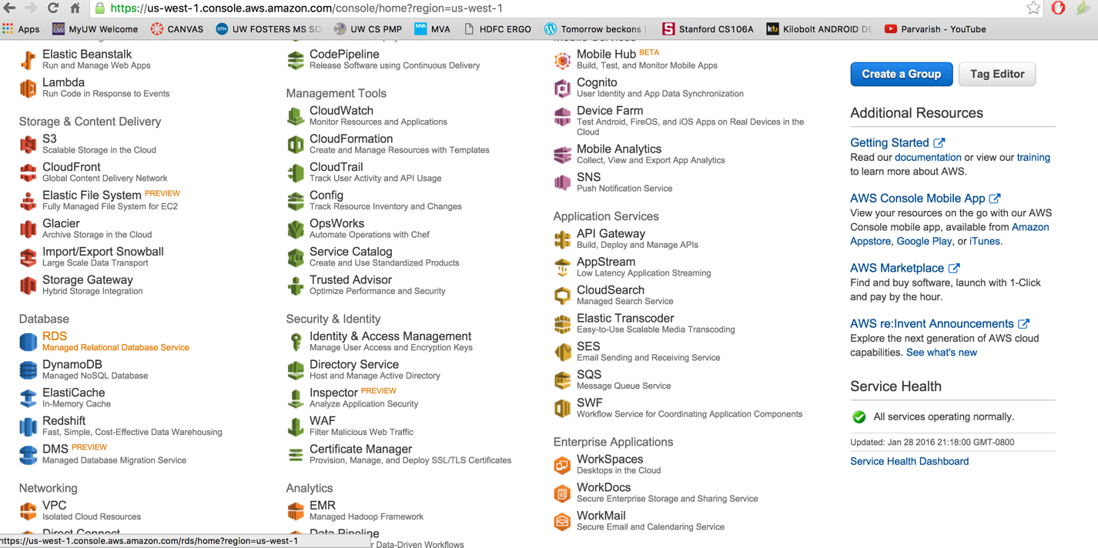

In the databases click on RDS