Meeting protocol
17.04.2007

Participants
- Thomas Tischler
- Stefan Zeltner
- Philipp Gruber
- Reinhard Jeschull
- Thomas Kuhndörfer

Steps done
- Performance testing during meeting
- Started with the rotational solid plugin
- Spike deformation modificator completed
- Concept for the online update
- Selection rectangle is now usable to select just part of scene objects
- Visual feedback while moving scene objects
- Task list updated, see attached task.pdf

Tasks until the next meeting

- Finishing explosion modifier: pgruber
- Modifier to make holes into polygons: rjeschull
- Command objects for undo/redo: szeltner/tkuhndo
- Automatition of installer packages: szeltner
- Support for single vertex insertion and editing: tkuhndo
- Using zlib to compress blacksun scene files: tkuhndo/ttischler
- Finishing hiding and unhiding of scene objects: tkuhndo
- Creating the basic implementation of a help browser using QTextBrowser for the user documentation: ttischler

Next milestone
- Release candidate: 03.05.2007

Notices
- Because of the short time period between this and the last meeting, most tasks are overtaken for the next meeting

Attachment
- Attachment 1: Improved screenshot taking dialog

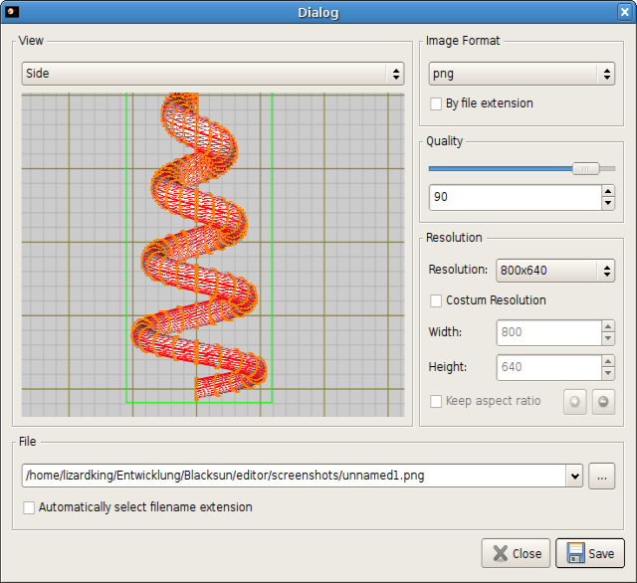

- Attachment 2: New spike modificator applied to a helix

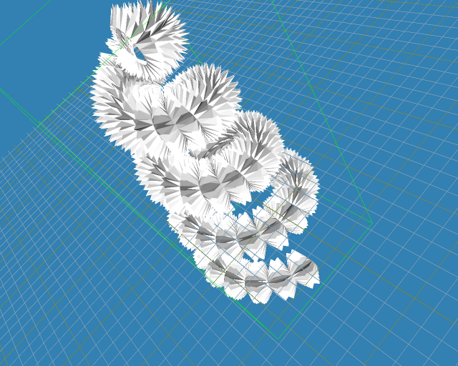

- Attachment 3: Selection of some vertices of a sphere and then moved this selection downwards

