Meeting protocol
24.04.2007

Participants
- Thomas Tischler
- Stefan Zeltner
- Philipp Gruber
- Reinhard Jeschull
- Thomas Kuhndörfer

Steps done
- Spoke about the standard usage keys of the editor
- Most plugins can now parametrized by their own forms
- Many shortcuts for often needed actions were added
- Finished convex hull modifier
- Finished explosion modifier
- Finished make holes modifier
- Testversion of the plugin searcher added
- Single vertices can be added to the scene
- Scene objects can set to status hidden or freezed
- Blacksun files are now compressed via zlib
- Decided to not implement the selection using the perspective view, because it's not really necessary

Tasks until the next meeting
- Adding configuration forms for his plugins: pgruber
- Object and material browser for quick selection and material applying: ttischler
- Finishing the automatic plugin system: szeltner
- Customizable usage keys for the editor with standard template: ttischler
- Starting with the extrusion modificator: tkuhndo
- Automatic zooming depending on the size of all selected objects: rjeschull/tkuhndo
- Creating the basic implementation of a help browser using QTextBrowser for the user documentation: ttischler
- Splitting the current action menu into 2 seperate menus, one for actions and one for loaded plugins: ttischler

Next milestone
- Release candidate: 03.05.2007

Notices

Attachment
- Attachment 1: Explosion modificator applied to a sphere

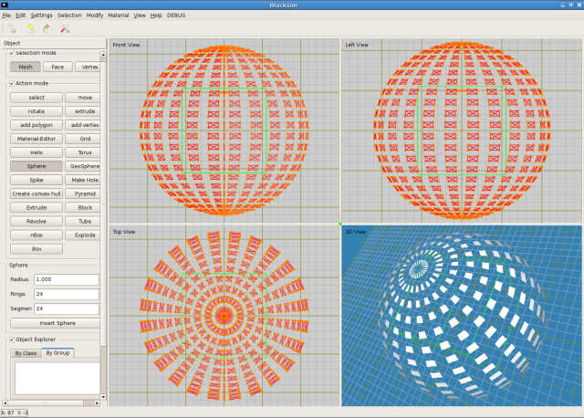

- Attachment 2: Sphere who was „freezed“
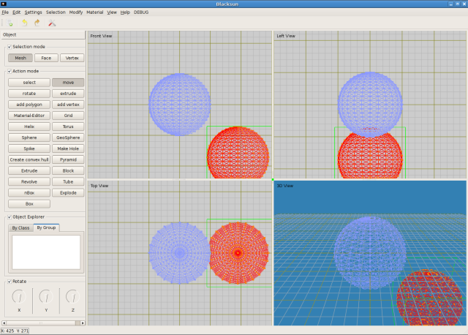

- Attachment 3: Hole modificator applied to a sphere
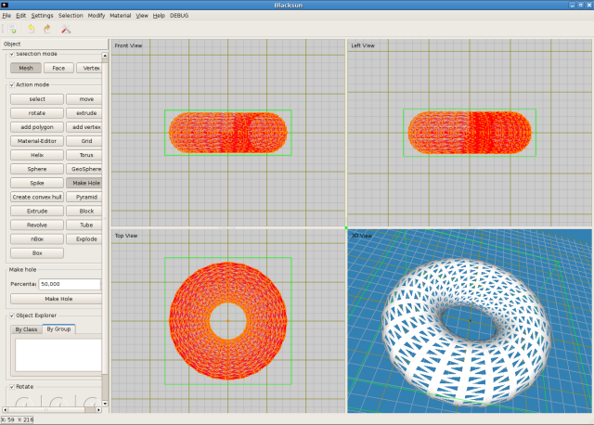

- Attachment 4: Example for a customizable plugin
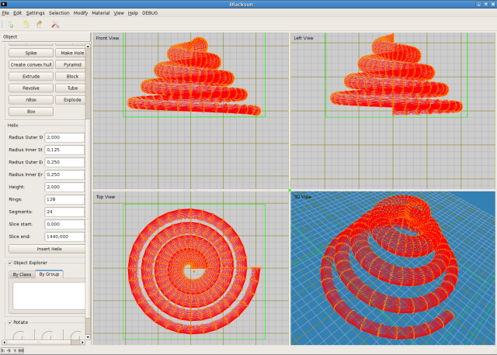
- Attachment 5: Modificator convex hull applied to a deformed mesh
