Meeting protocol
03.04.2007

Participants
- Thomas Tischler
- Stefan Zeltner
- Philipp Gruber
- Reinhard Jeschull
- Thomas Kuhndörfer

Steps done
- Viewport enhancement called „Quad splitter“ to change the sizes of the viewports easily
- Added menu structure that can be binded by the scenegraph with slots
- Screenshot functionality for each viewport in common formats (jpg,png,bmp,xbm,ppm), see attachment 1
- Working on the undo/redo-system has begun
- Import of md2-models, see attachment 2
- Plugin for loading textures from common image formats
- Finished plugin „Block“ but it will be added later cause of hardware error
- Scene can be saved / loaded with all created materials

Tasks until the next meeting

- Importation of 3ds-files: rjeschull
- Explosion modifier realized as a plugin : pgruber
- Test implementation of the undo/redo-system: szeltner
- Extend the SelectionBuffer for accesing single vertices needed by several plugins: tkuhndo
- Further integration of the menu to scenegraph: tkuhndo
- Creating the basic implementation of a help browser using QTextBrowser for the user documentation: ttischler
- Selection functionality in the viewports: ttischler

Next milestone
- Release candidate: 03.05.2007

Attachment
- Attachment 1: Screenshot taken by the screenshot function in compressed jpg quality

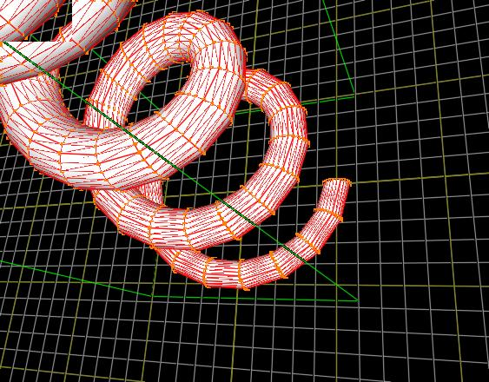

- Attachment 2: Screenshot of an imported md2-model called rhino.md2

