The system created to automate the processes of the mobile operator.

It consists of two applications: the main part (it includes all the processes for managing clients, tariffs, contracts, options: the second application is an advertising booth of the current tariffs.

Spring-framework 4

Maven 3

Junit 4

Log4j 1

Tomcat 9

JSP/JSTL

MySQL

Bootstrap

jQuery

ActiveMQ

Selenium

Hibernate

Spring Security

Mockito

SecondApplication

EJB

angular

MySQL

Hibernate

ActiveMQ

wildFly

maven

Client functionality

Page where client can choose contract

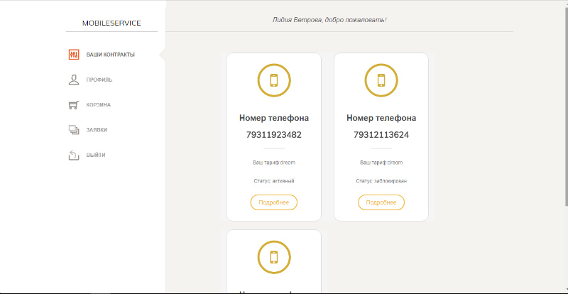

Client profile

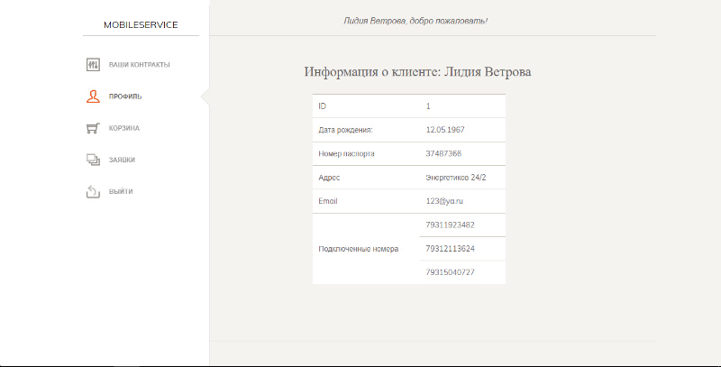

List of all tariffs with the ability to change the current

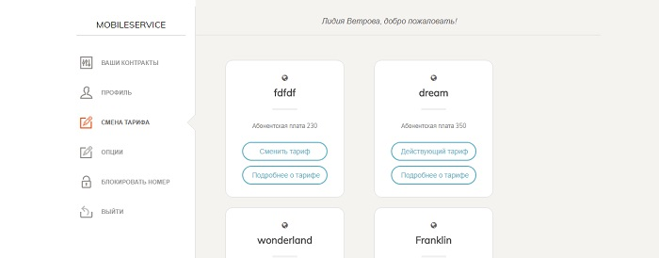

List of options, which compatible with current tariff

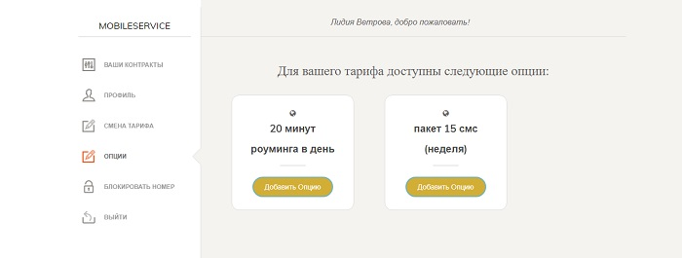

Bucket with selected item

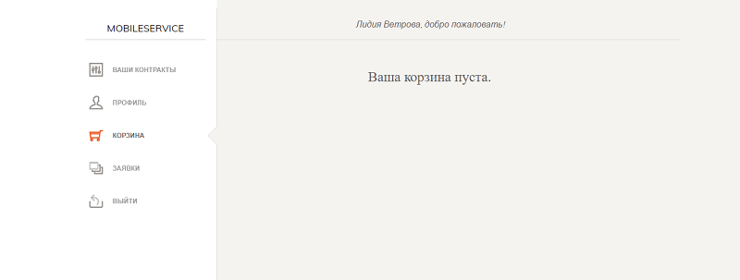

List of all items

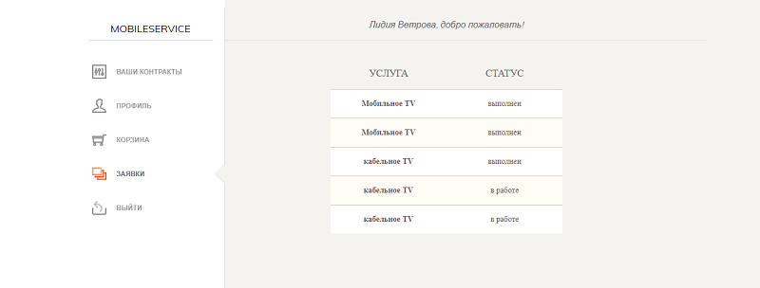

User can block and unblock contract (If contract was blocked by admin, client cannot unblock it )

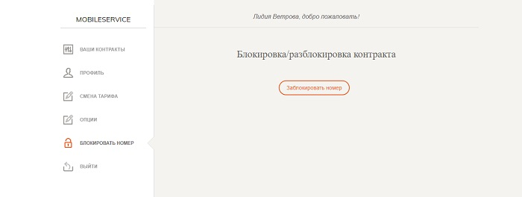

Admin account

Admin can use list of all clients. On this page :

delete user

update user information

edit contract

find client by passport number

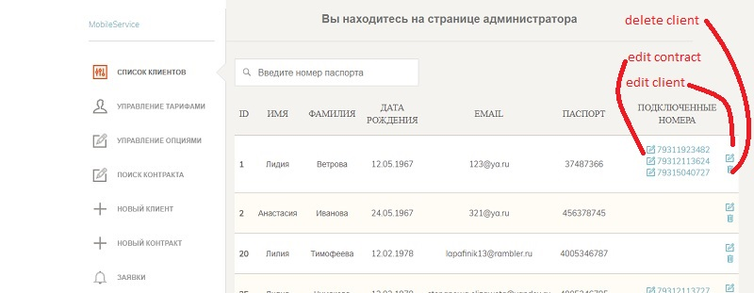

Edit selected contract:

first page - contract information

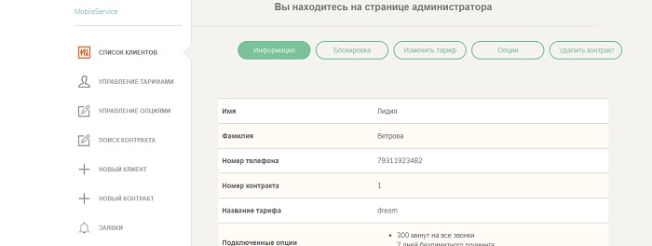

Block and unblock contract

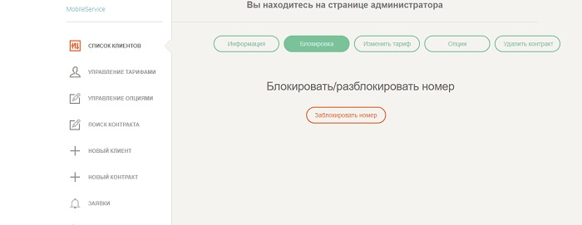

Change current tariff

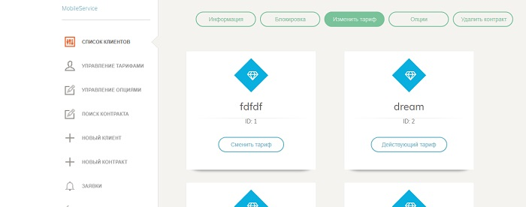

Edit available options for current contract

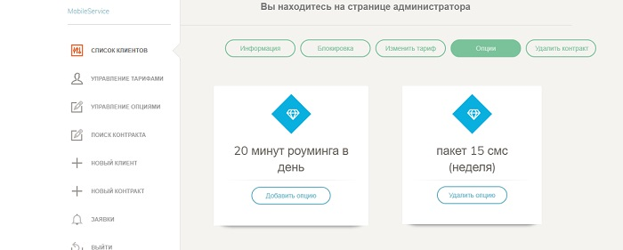

2. Tariffs

on this page there are all tariffs

The folowing actions are available”

delete tariff

edit tariff

create tariff

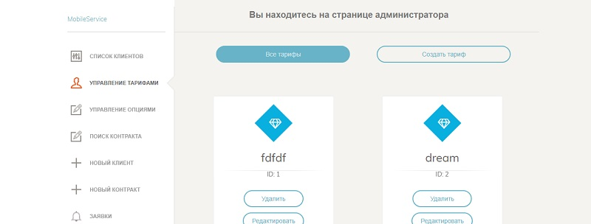

Set compatible and incompatible types for options

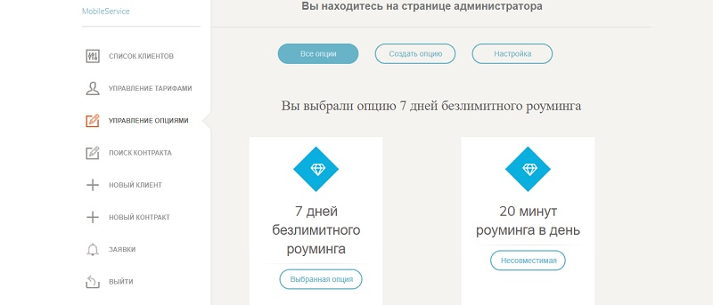

Create client

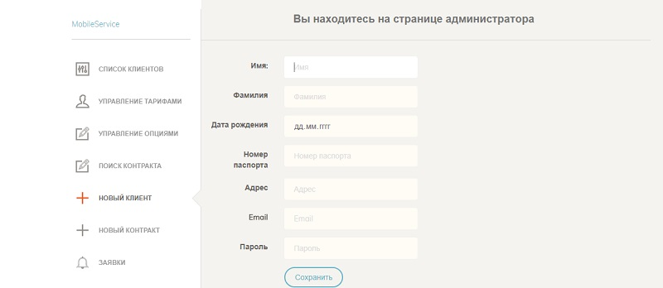

List of all orders with actual status

