Aaron Mai

Elizabeth Ortiz

Jayden Thurston

Robert Tang

Ryan Pham

**Analysis Doc**

**Introduction**

Fiji is a client that organizes various digital products by their category while providing these products for purchase on the market. This client will be portable in the fact that it will be available for all operating systems and will consist of other various features, such as account profile editing, a friends system to emphasize the social media aspect of the software, content gifting, and a chat system.

Overall Requirement Description

* Content Checker
  + The content checker ensures that the content being uploaded and downloaded does not contain explicit or illegal material and that the copyrights and licenses are being respected.
* User Accounts
  + Every user that registers for Fiji will have a rank that determines what privileges are given and overall gives access to Fiji’s main features.
* Log-In
  + After registration has been completed, users can log into that account to access Fiji’s features.
* User Authentication
  + This feature will provide a leeway for users to log into their accounts and prevents unwanted users from accessing other accounts. There is password-based authentication, pin based authentication, and location based authentication.
* Administration
  + This feature allows users with admin privileges to manage user accounts and products available on the market.
* Overlay
  + Users can select what programs they would like to have an overlay for and once a hotkey has been pressed, the overlay will appear over the selected program consisting of menu items for store, messaging, etc.
* Messaging
  + Each user will be given an inbox to send and receive messages, as well as a feature to open a chat box to instant message their friends.
* Rating System
  + Users will be given the ability to rate the products available on the market by providing a 1 to 5-star rating and a written description on their thoughts.
* Wish List
  + The wish list will allow users to add desired products from the market into this list for others to view and the user themselves to reflect back on in case they would like to purchase in the future.
* Uploading/Downloading
  + This file transfer feature is necessary because all of the products will be digital, so users must be able to download the products and content creators should be able to upload their products to be sold on the market.
* Licenses
  + Content creators will be given the ability to upload their license to be associated to their products to ensure fair use and copyright.
* Store
  + The store will contain all of the products uploaded onto the database for users to purchase.
* Advertisement
  + Advertisements will appear on every user’s interface to display products of popular consensus or the user’s personal preference.
* Analytics/Reporting
  + Content creators will be able to view the statistics, such as downloads, sales, income, and trending.
* Settings
  + Users will be able to modify account and client preferences if the default settings are not desirable.
* Gifting
  + Users will be given the option to gift the product that they have purchased from the market to another user.

Project Constraints & Assumptions

The most crucial constraint for this project is the hardware aspect for Fiji’s server. Assuming that there will be a vast number of digital products being uploaded to the servers with various file sizes with the possibility that several users are downloading/uploading simultaneously, servers will need to keep up with this load by having plenty of hard drive space and an efficient RAM to process user requests. A design constraint would include having all coding being done in C#, so everybody in the team will be required to have knowledge on how to use this programming language.

**Functional Requirements**

Entity Relationship Diagram (ERD)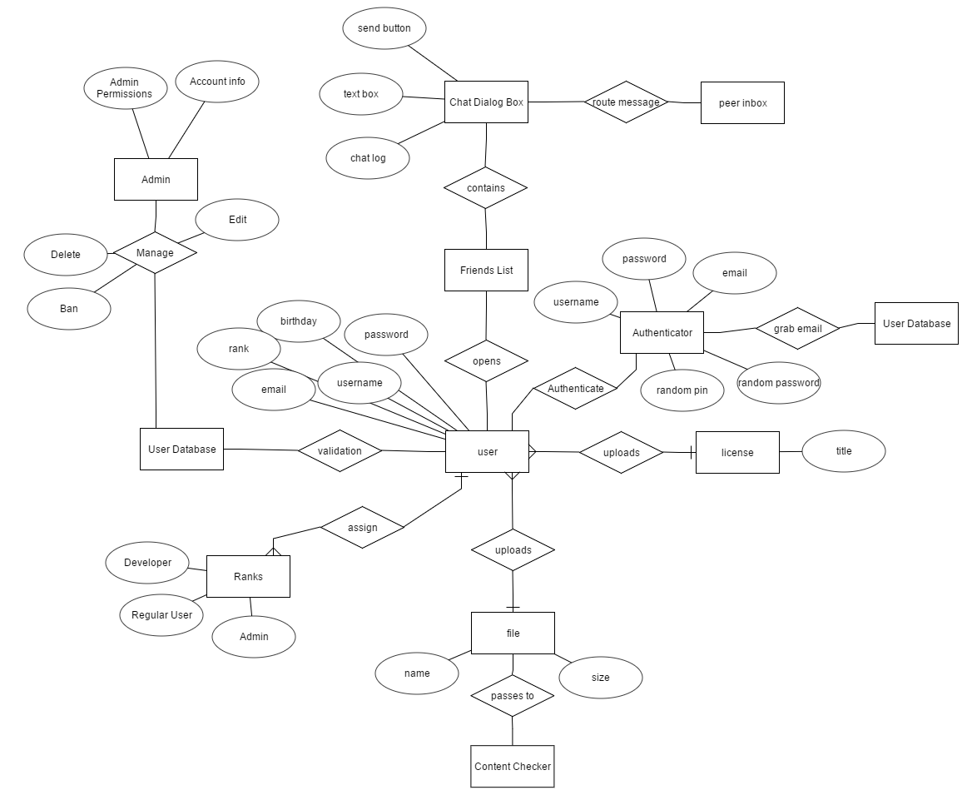

**Figure 1 (Admin, Chat, Authentication, Login, and File Upload with Content Checker)**

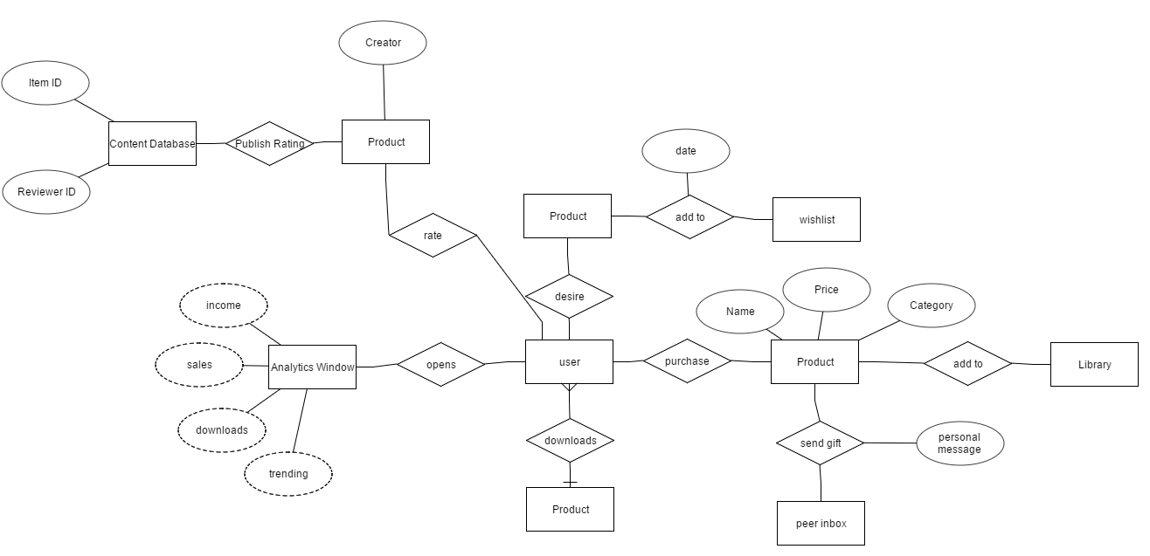

**Figure 2 (Store, Review, Analytics, Downloading, Gifting, and Wishlist)**

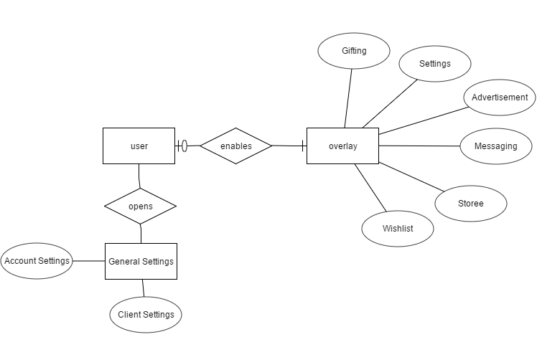

**Figure 3 (Overlay and Settings)**

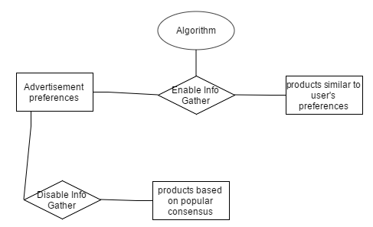

**Figure 3 (Advertisement)**

Data Flow Diagram (DFD)

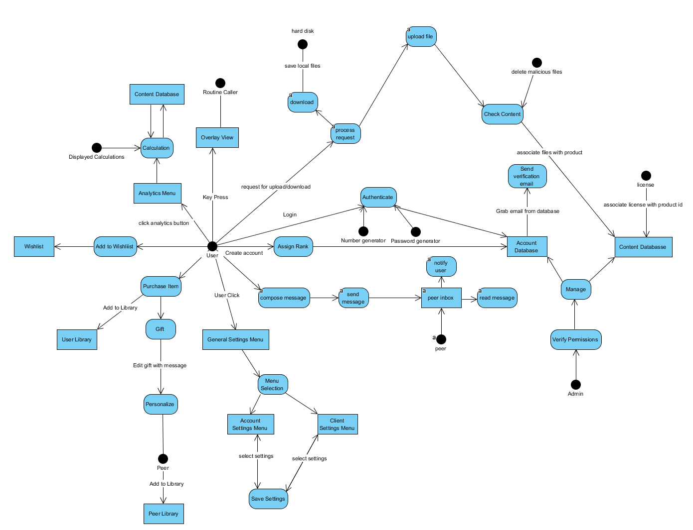

**Figure 4 (Wishlist, Analytics, Overlay, Authentication, Login, Registration, Upload/Download with Content Checker, Admin, Settings, Store, and Gifting)**

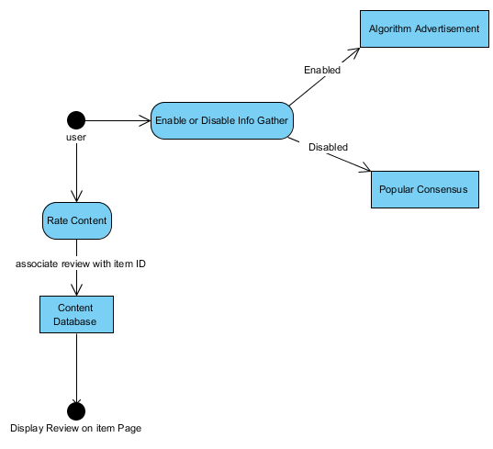

**Figure 5 (Rating and Advertisement)**

Process Descriptions

**User**

User settings will go into an object that creates an account, which will have a default rank assigned until it goes into the database for it to be changed by an admin later.

**Login**

Given a user account, the user will login to get an authentication by having a number generator object send a random number/password to the email which will be grabbed from the database and sent to the email.

**Verify** **Permissions**

Inputting a Username and Rank value, the isAdmin function verifies that said User has the appropriate permissions in the Account database and returns true if verified.

**Manage**

Given Verify Permissions process succeeds. Manage process gives Admin user unilateral access to alter a User’s content and account information. Having the ability to change a User’s username, rank, password, email, and content.

**Wishlist**

Given an Item ID, the Wishlist function saves the Item ID and records the date and price into an Object. And then adds the object to a Wishlist database. Likewise, this process also can remove items from the Wish List database.

**Update**

Update process is an operation that periodically returns news on desired items in a user’s Wish List database. The input from the database would be compared to current information of the product and notify the user is any pertinent changes have occurred. These changes could be spontaneous sales, discounts, and/or increase in prices(unlikely).

**Gift**

Gift process takes an already purchased item with its ID and formats it into Gift object. It appends the Sender’s name and Recipient’s name to the item ID.

**Personalize**

This process then proceeds to append a personalize message to the Gift object. And it then has the functionality to send the item to the recipient.

**Store**

The store process allows the user to purchase content items . Content items can either be purchased for personal use or as a gift. Once a content item is purchased, the item’s ID is used to create a new entry in the appropriate user’s library.

**Rating system**

The rating process allows users to rate owned content items. Once a user rates an item the newly created rating record is added to the item’s page in the store for viewing by other users.

**Advertisement**

The advertisement process utilizes an algorithm to determine which products are most similar to the user’s content preferences if information gathering is enabled. Otherwise, advertisement preferences utilize popular consensus.

**Save Settings**

The save settings process writes the selected settings into disk memory and then applies the new settings.

**Routine Caller**

The routine caller process runs the function selected from the overlay

**Calculation**

The calculation process gathers the data needed from the database server and computes the selected report and displays the result.

Design Specification

Fiji will be implemented in C# using MySQL database for its server. Our software will initially operate on Windows OS. Subsequently we will have releases on Mac OSX and Linux OS.

Performance & Reliability Requirements

The maximum number of content and users is only limited by the size of the database. The maximum percentage of CPU used should be under 25% The maximum amount of memory usage should be less than or equal to 1gb.

Component/Deployment Diagrams

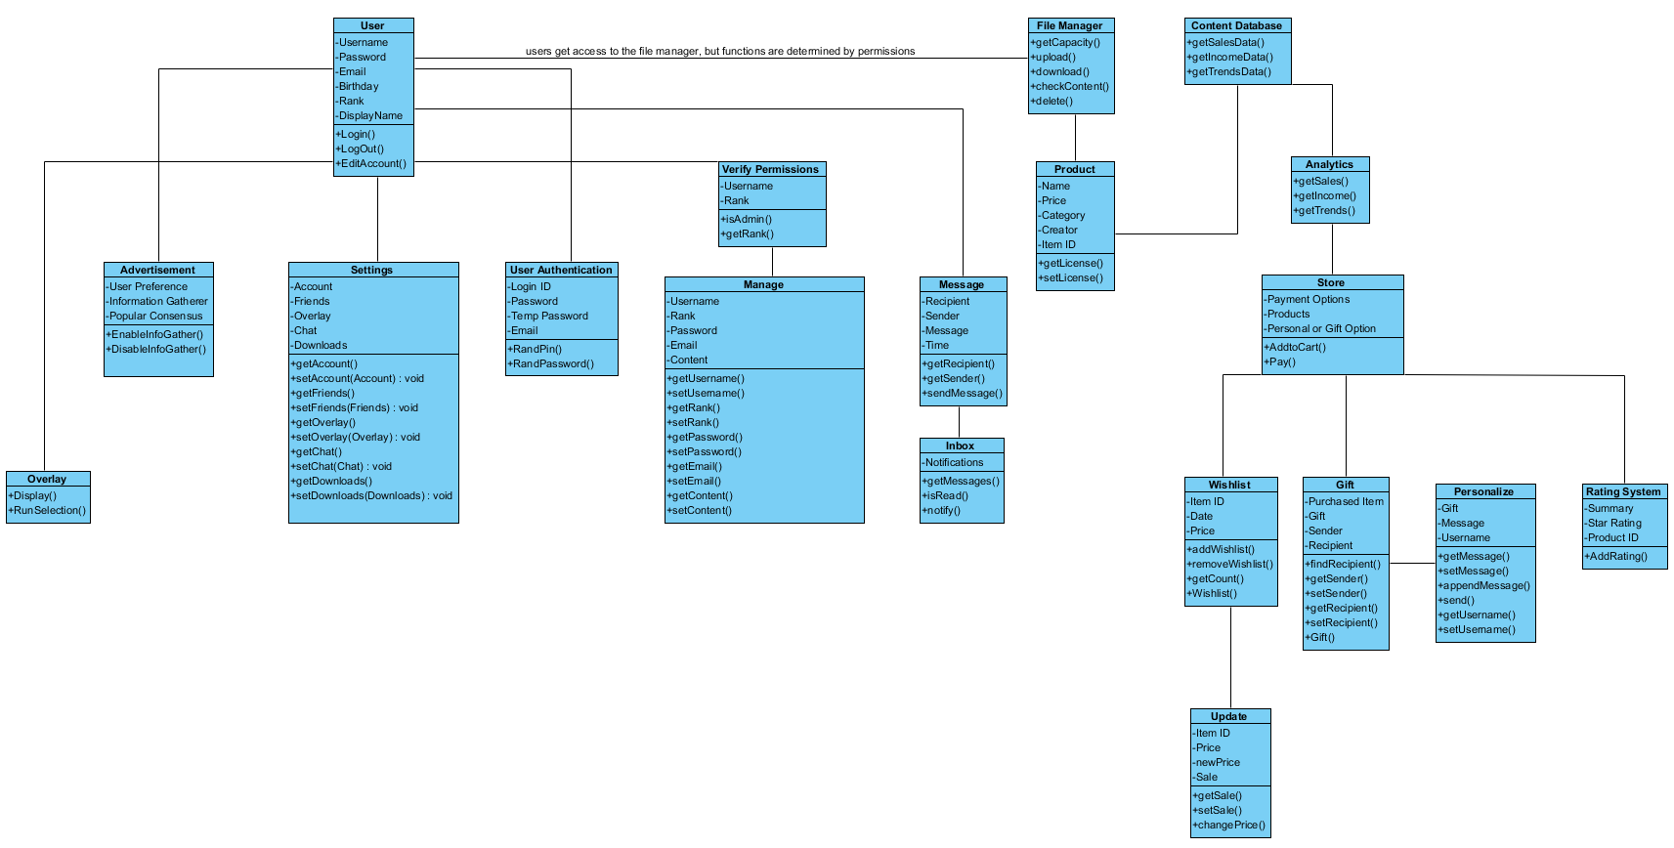

Test Plan

|  |  |  |  |
| --- | --- | --- | --- |
| **ID** | **Input** | **Expected Result** | **Actual Result** |
| **1** | **Enter user credentials** | **Display Fiji’s dashboard** |  |
| **2** | **Enter invalid user credentials** | **Throw exception and allow user to retry** |  |
| **3** | **Select Friends List** | **Display window with all friends user has added** |  |
| **4** | **Select friend from Friends List** | **Display chat box** |  |
| **5** | **Select Add Item to Cart in store** | **Item will be saved and added to “cart” to be paid for later** |  |
| **6** | **Adding non-existent item to Cart** | **Throw 404 error and give user option to return to store page** |  |
| **7** | **Select Add to Wishlist** | **Item will be saved and added to “wishlist”** |  |
| **8** | **Adding non-existent item to Wishlist** | **Throw 404 error and give user option to return to store page** |  |
| **9** | **Selecting a gift recipient** | **Item will be selected as “Purchase as a gift” with a pop up display window of friends list** |  |
| **10** | **Selecting Uploading Content** | **Window display will show which file you want to upload** |  |
| **11** | **Selecting Downloading Content** | **A download display will pop up with the time it will take to finish** |  |
| **12** | **Selecting Store Option** | **Displays featured, new, and available content** |  |
| **13** | **Selecting Library Content** | **Displays a list of content that is owned** |  |
| **14** | **Selecting Account Recovery** | **Email will be sent with a random password/Pin generator** |  |
| **15** | **Selecting Account Setting** | **Shows User Information** |  |