fechas
(0?[1-9]|[12][0-9]|3[01])\/(0?[1-9]|1[012])\/((19|20)\d\d)
teléfonos
\d{3}[.-\s]\d{3}[.-\s]\d{2}[.-\s]\d{2}
Urls
^(https?:\/\/)?(www\.)[a-zA-Z0-9.-_]+\.(com|net|com\.mx)
http?:/\/\www.
http[s]?:\/\/(www\.)?[a-zA-Z.-_]+\.[a-z.]+
$
Correos
[a-zA-Z0-9._-]+@[a-zA-Z0-9.-]+\.[a-z][a-z]+
IP válida
(((25[0-5])|(2[0-4][0-9])|([01]?[0-9][0-9]?))\.){3}(((25[0-5])|(2[0-4][0-9])|([01]?[0-9][0-9]?)))
CORRECTA
(((25[0-5])|(2[1-4][0-9])|(1[0-9][0-9])|([1-9]?[0-9]))\.){3}((25[0-5])|(2[1-4][0-9])|(1[0-9][0-9])|([1-9]?[0-9]))$

CORRECTA Ago2024
((25[0-5])|(2[0-4]\d)|(1\d\d)|([1-9]\d)|[1-9])\.((25[0-5])|(2[0-4]\d)|(1\d\d)|([1-9]\d)|[1-9])\.((25[0-5])|(2[0-4]\d)|(1\d\d)|([1-9]\d)|[1-9])\.((25[0-5])|(2[0-4]\d)|(1\d\d)|([1-9]\d)|[1-9])
CORRECTA MEJORADA AGO2024
^((25[0-5])|(2[0-4]\d)|(1\d\d)|([1-9]\d)|[1-9])\.(((25[0-5])|(2[0-4]\d)|(1\d\d)|([1-9]\d)|\d)\.){2}((25[0-5])|(2[0-4]\d)|(1\d\d)|([1-9]\d)|\d)$

10.130.240.5
1 – 255
250 – 255
200 – 249
100 – 199
10 – 99
0-9

URLS
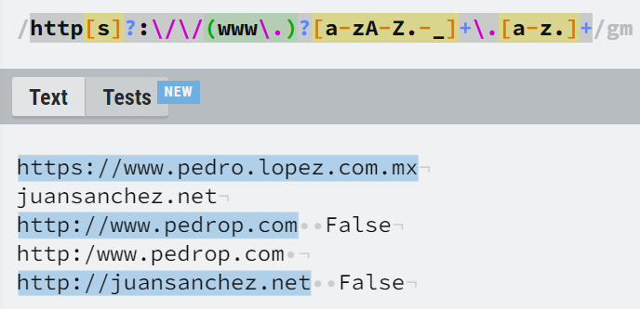

REGRESE LOS URLS REVISAR

