https://docs.python.org/es/3/library/re.html
https://relopezbriega.github.io/blog/2015/07/19/expresiones-regulares-con-python/
https://relopezbriega.github.io/blog/2015/07/19/expresiones-regulares-con-python/

https://pythondiario.com/2018/06/expresiones-regulares-con-python.html
https://docs.python.org/es/3/howto/regex.html
https://docs.hektorprofe.net/python/funcionalidades-avanzadas/expresiones-regulares/
https://unipython.com/uso-de-expresiones-regulares-en-python/

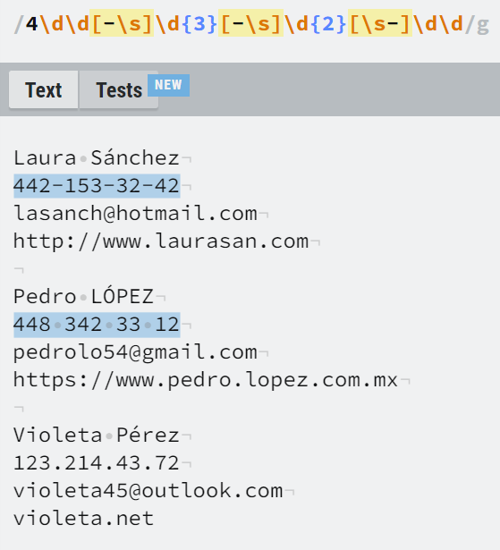

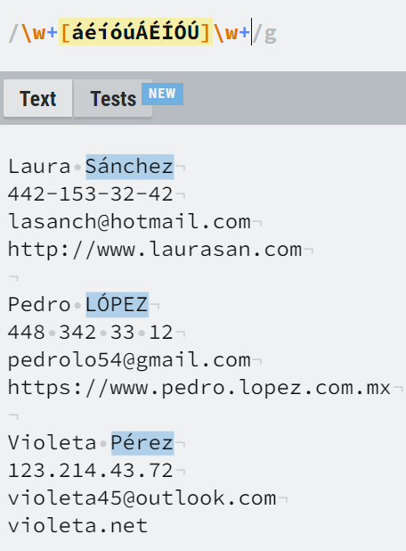
[A-Z][A-Za-záéíóúÁÉÍÓÚ]+

Freedom Moses
