Lab 9.1.4.9 Subnetting Network Topologies

1. Objectives

* Determine the number of subnets.Design an appropriate addressing scheme.
* Assign addresses and subnet mask pairs to device interfaces.
* Examine the use of the available network address space and future growth potential.

1. Network Topology A

In Part 1, you have been given the 192.168.10.0/24 network address to subnet, with the following topology. Determine the number of networks needed and then design an appropriate addressing scheme.

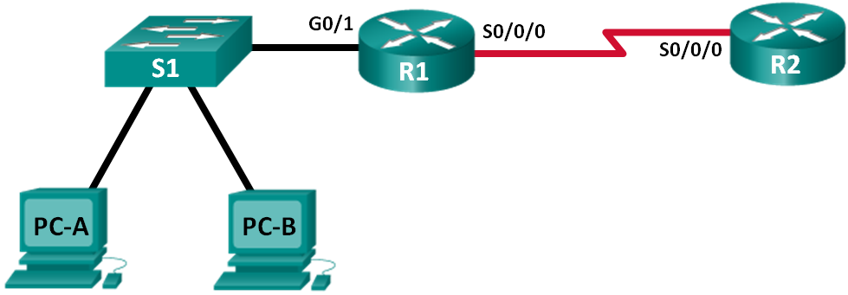

* 1. Determine the number of subnets in Network Topology A.
     1. How many subnets are there? ___________ 2
     2. How many bits should you borrow to create the required number of subnets? _1________
     3. How many usable host addresses per subnet are in this addressing scheme? _2 a la 7 – 2 = 126__
     4. What is the new subnet mask in dotted decimal format? __255.255.255.128_______________________
     5. How many subnets are available for future use? ___0____________
  2. Record the subnet information.

Fill in the following table with the subnet information:

|  |  |  |  |  |
| --- | --- | --- | --- | --- |
| Subnet Number | Subnet Address | First Usable Host Address | Last Usable Host Address | Broadcast Address |
| 0 | 192.168.10.0 | 192.168.10.1 | 192.168.10.126 | 192.168.10.127 |
| 1 | 192.168.10.128 | 192.168.10.129 | 192.168.10.254 | 192.168.10.255 |
| 2 |  |  |  |  |
| 3 |  |  |  |  |
| 4 |  |  |  |  |
| 5 |  |  |  |  |

1. Network Topology B

The network topology from Part 1 has expanded to accommodate the addition of router R3 and its accompanying network, as illustrated in the following topology. Use the 192.168.10.0/24 network address to provide addresses to the network devices, and then design a new addressing scheme to support the additional network requirement.

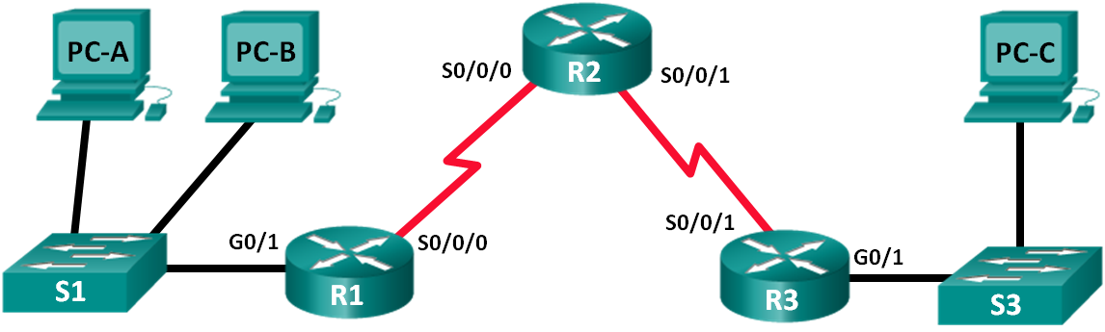

* 1. Determine the number of subnets in Network Topology B.
     1. How many subnets are there? _________4__
     2. How many bits should you borrow to create the required number of subnets? ____2_____
     3. How many usable host addresses per subnet are in this addressing scheme? ___2 a la 6 – 2 = 62___
     4. What is the new subnet mask in dotted decimal format? ___255.255.255.192______________________
     5. How many subnets are available for future use? _______________0
  2. Record the subnet information.

Fill in the following table with the subnet information:

|  |  |  |  |  |
| --- | --- | --- | --- | --- |
| Subnet Number | Subnet Address | First Usable Host Address | Last Usable Host Address | Broadcast Address |
| 0 | 192.168.10.0 | 192.168.10.1 | 192.168.10.62 | 192.168.10.63 |
| 1 | 192.168.10.64 | 192.168.10.65 | 192.168.10.126 | 192.168.10.127 |
| 2 | 192.168.10.128 | 192.168.10.129 | 192.168.10.190 | 192.168.10.191 |
| 3 | 192.168.10.192 | 192.168.10.193 | 192.168.10.254 | 192.168.10.255 |
| 4 |  |  |  |  |
| 5 |  |  |  |  |
| 6 |  |  |  |  |
| 7 |  |  |  |  |