Lab 9.1.4.9 Subnetting Network Topologies
Objectives
- Determine the number of subnets.Design an appropriate addressing scheme.
- Assign addresses and subnet mask pairs to device interfaces.
- Examine the use of the available network address space and future growth potential.
- Network Topology A
In Part 1, you have been given the 12.0.0.0 /8 network address to subnet, with the following topology. Determine the number of networks needed and then design an appropriate addressing scheme.
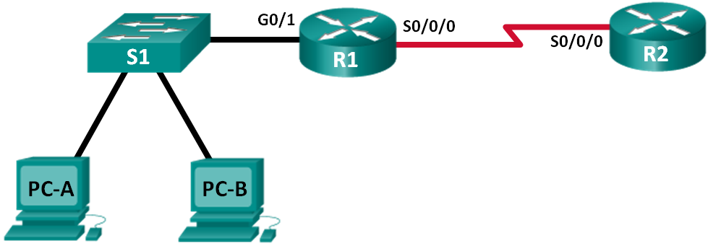
  - Determine the number of subnets in Network Topology A.
    - How many subnets are there? ___________ 2
    - How many bits should you borrow to create the required number of subnets? _1________
    - How many usable host addresses per subnet are in this addressing scheme? _2 a la 7 – 2 = 126__
    - What is the new subnet mask in dotted decimal format? __255.128.0.0_______________________
    - How many subnets are available for future use? ___0____________
  - Record the subnet information.
Fill in the following table with the subnet information:
Subnet Number | Subnet Address | First Usable Host Address | Last Usable Host Address | Broadcast Address
0 | 12.0.0.0 | 12.0.0.1 | 12.127.255.254 | 12.0+127.255.255  12.127.255.255
1 | 12.128.0.0 | 12.128.0.1 | 12.255.255.254 | 12.128+127.255.255  12.255.255.255
2
3

- Network Topology B
The network topology from Part 1 has expanded to accommodate the addition of router R3 and its accompanying network, as illustrated in the following topology. Use the 192.168.10.0/24 network address to provide addresses to the network devices, and then design a new addressing scheme to support the additional network requirement.
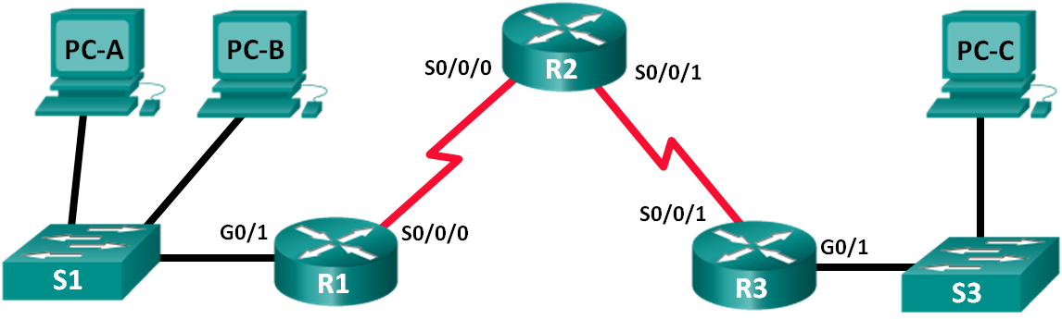
  - Determine the number of subnets in Network Topology B.
    - How many subnets are there? _________4__
    - How many bits should you borrow to create the required number of subnets? ____2_____
    - How many usable host addresses per subnet are in this addressing scheme? ___2 a la 6 – 2 = 62___
    - What is the new subnet mask in dotted decimal format? ___255.255.255.192______________________
    - How many subnets are available for future use? _______________0
  - Record the subnet information.
Fill in the following table with the subnet information:
Subnet Number | Subnet Address | First Usable Host Address | Last Usable Host Address | Broadcast Address
0 | 192.168.10.0 | 192.168.10.1 | 192.168.10.62 | 192.168.10.63
1 | 192.168.10.64 | 192.168.10.65 | 192.168.10.126 | 192.168.10.127
2 | 192.168.10.128 | 192.168.10.129 | 192.168.10.190 | 192.168.10.191
3 | 192.168.10.192 | 192.168.10.193 | 192.168.10.254 | 192.168.10.255
4
5
6
7

