Tabla de direccionamiento

Dispositivo | Interfaz | IP Address | Prefijo de red | Default Gateway
Router  R-OficinasCentrales | G0/0 | Penúltima dirección IP del bloque asignado | /24 | NA
 | G0/1.789 | 172.30.190.254 | /29 | NA
 | G0/1.1000 | 172.30.180.190 | /26 | NA
 | G0/1.1001 | 172.30.177.254 | /23 | NA
 | S0/0/0 | 172.30.187.85 | /30 | NA
Switch  S-Distribución1 | VLAN 789 | 172.30.190.249 | /29 | 172.30.190.254
Switch  S-ETrabajoCentrales | VLAN 789 | 172.30.190.250 | /29 | 172.30.190.254
CamCent | NIC | 172.30.180.129 | /26 | 172.30.180.190
PC6 | NIC | DHCP | DHCP | DHCP
PC7 | NIC | DHCP | DHCP | DHCP
Laptop2 | NIC | DHCP | DHCP | DHCP
Switch  S-DisenoCentrales | VLAN 789 | 172.30.190.251 | /29 | 172.30.190.254
Server IT2.com | NIC | 172.30.176.5 | /23 | 172.30.177.254
PtrIT2 | NIC | 172.30.176.1 | /23 | 172.30.177.254
Laptop1 | NIC | DHCP | DHCP | DHCP
Router  R-OficinasNorte | G0/1.789 | 172.30.190.246 | /29 | NA
 | G0/1.100 | 172.30.191.254 | /24 | NA
 | G0/1.101 | 172.30.183.190 | /27 | NA
 | S0/0/0 (DCE) | 172.30.187.86 | /30 | NA
Switch  S-Distribución2 | VLAN 789 | 172.30.190.241 | /29 | 172.30.190.246
Switch  S-DisenoNorte | VLAN 789 | 172.30.190.242 | /29 | 172.30.190.246
PC9 | NIC | DHCP | DHCP | DHCP
PC10 | NIC | DHCP | DHCP | DHCP
Switch  S-ETrabajoNorte | VLAN 789 | 172.30.190.243 | /29 | 172.30.190.246
Laptop3 | NIC | DHCP | DHCP | DHCP
PC8 | NIC | DHCP | DHCP | DHCP
CamNorte | NIC | 172.30.183.161 | /27 | 172.30.183.190

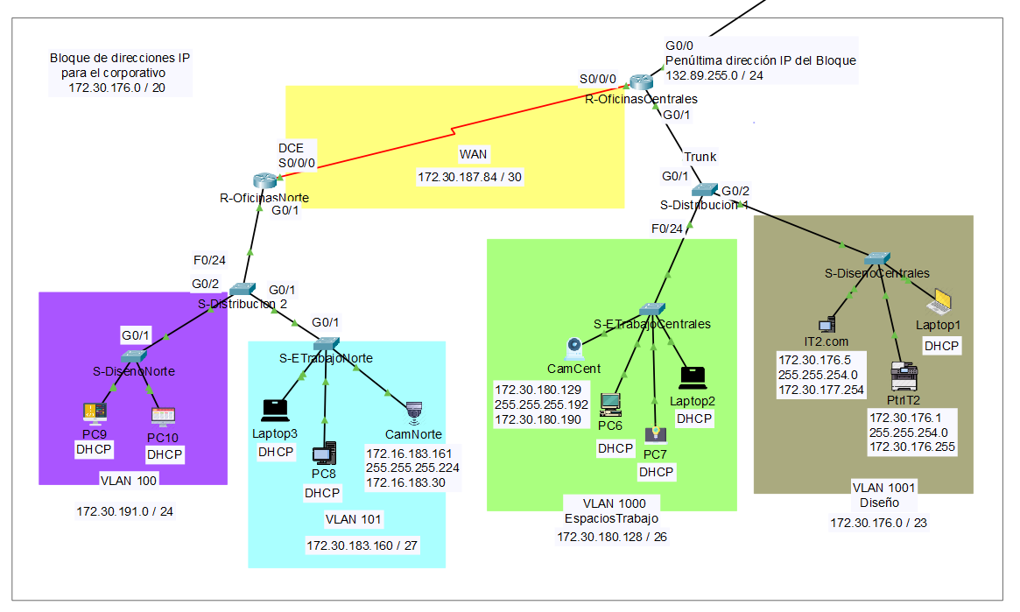

Tabla de direccionamiento

Dispositivo | Interfaz | IP Address | Prefijo de red | Default Gateway
Router  R-OficinasNorte | G0/1.789 | 172.30.190.246 | 255.255.255.248 /29 | NA
 | G0/1.100 | 172.30.191.254 | 255.255.255.0 /24 | NA
 | G0/1.101 | 172.30.183.190 | 255.255.255.224 /27 | NA
 | S0/0/0 | 172.30.187.85 | 255.255.255.252  /30 | NA
Switch  S-Distribución2 | VLAN 789 | 172.30.190.241 | 255.255.255.248 /29 | 172.30.190.246
Switch  S-DisenoNorte | VLAN 789 | 172.30.190.242 | 255.255.255.248 /29 | 172.30.190.246
PC9 | NIC | DHCP | DHCP | DHCP
PC10 | NIC | DHCP | DHCP | DHCP
Switch  S-ETrabajoNorte | VLAN 789 | 172.30.190.243 | 255.255.255.248 /29 | 172.30.190.246
Laptop3 | NIC | DHCP | DHCP | DHCP
PC8 | NIC | DHCP | DHCP | DHCP
CamNorte | NIC | 172.16.183.161 | 255.255.255.224 /27 | 172.16.183.30
Router  R-OficinasCentrales | G0/0 | 132.89.255.253 | 255.255.255.0  /24 | NA
 | G0/1.1000 | 172.30.180.190 | 255.255.255.192 /26 | NA
 | G0/1.1001 | 172.30.177.254 | 255.255.254.0  /23 | NA
 | S0/0/0 (DCE) | 172.30.187.86 | 255.255.255.252 /30 | NA
Switch  S-Distribución1 | VLAN 789 | 172.30.190.249 | 255.255.255.248 /29 | 172.30.190.254
Switch  S-ETrabajoCentrales | VLAN 789 | 172.30.190.250 | 255.255.255.248 /29 | 172.30.190.254
CamCent | NIC | 172.30.180.129 | 255.255.255.192 /26 | 172.30.180.190
PC6 | NIC | DHCP | DHCP | DHCP
PC7 | NIC | DHCP | DHCP | DHCP
Laptop2 | NIC | DHCP | DHCP | DHCP
Switch  S-DisenoCentrales | VLAN 789 | 172.30.190.251 | 255.255.255.248 /29 | 172.30.190.254
Server IT2.com | NIC | 172.30.176.5 | 255.255.254.0 /23 | 172.30.177.254
PtrIT2 | NIC | 172.30.176.1 | 255.255.254.0 /23 | 172.30.176.255
Laptop1 | NIC | DHCP | DHCP | DHCP

