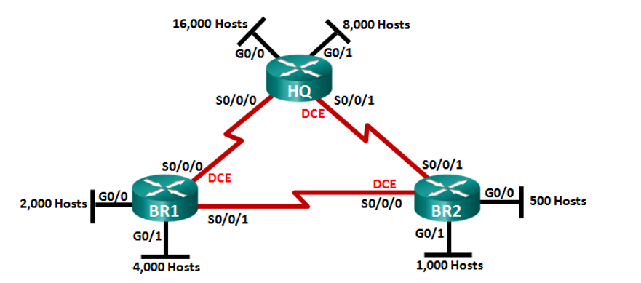

**172.16.192.0 / 19**

**172.16.254.8 /30**

**172.16.254.0 /30**

**172.16.224.0 / 20**

**172.16.254.4 / 30**

**172.16.240.0 /21**

**172.16.248.0 / 22**

**172.16.252.0 / 23**

**172.16.128.0/18**

|  |  |  |  |  |  |  |  |  |  |
| --- | --- | --- | --- | --- | --- | --- | --- | --- | --- |
| Subnet | #Hosts | Mask | #bits in subnet | Maximum host usable | Two Network Address | Subnet | First Host Address | Last Host Address | Broadcast Address |
| **HQ-G0/0** | **16000** | **255.255.11000000. 00000000**  **255.255.192.0/18**  **256 – 192 = 64** | **1** | **2 a la 14 -2 = 16, 382** | **172.16.128.0**  **172.16.192.0** | **172.16.128.0** | **172.16.128.1** | **172.16.191.254** | **172.16.191.255** |
| HQ-G0/1 | **8000** | **255.255.11100000. 00000000**  **255.255.224.0 /19**  **256 – 224 = 32** | **2** | **2 a la 13 – 2 = 8190** | **172.16.192.0**  **172.16.224.0** | **172.16.192.0** | **172.16.192.1** | **172.16.223.254** | **172.16.223.255** |
| BR1 – G0/1 | **4000** | **255.255.11110000. 00000000**  **255.255.240.0**  **256 – 240 = 16** | **3** | **2 a la 12 – 2 = 4094** | **172.16.224.0**  **172.16.240.0** | **172.16.224.0** | **172.16.224.1** | **172.16.239.254** | **172.16.239.255** |
| BR1 – G0/0 | 2000 | **255.255.11111000. 00000000**  255.255.248.0  256 – 248 = 8 | 4 | 2 a la 11 – 2 = 2046 | **172.16.240.0**  **172.16.248.0** | **172.16.240.0** | **172.16.240.1** | **172.16.247.254** | **172.16.247.255** |
| BR2 – G0/1 | 1000 | **255.255.11111100. 00000000**  255.255.252.0  256 – 252 = 4 | 5 | 2 a la 10 – 2 = 1022 | **172.16.248.0**  **172.16.252.0** | **172.16.248.0** | **172.16.248.1** | **172.16.251.254** | **172.16.251.255** |
| BR2 – G0/0 | 500 | **255.255.11111110. 00000000**  255.255.254.0  256 – 254 = 2 | 6 | 2 a la 9 – 2 = 510 | **172.16.252.0**  **172.16.254.0** | **172.16.252.0** | **172.16.252.1** | **172.16.253.254** | **172.16.253.255** |

**172.16.128.0 / 17**

**255.255.1000 0000. 0000 0000**

**255.255.1111 1111. 1111 1100**

**172.16.1111 1100. 0000 0000 172.16.252.0**

**1. 1111 1111 172.16.253.255**