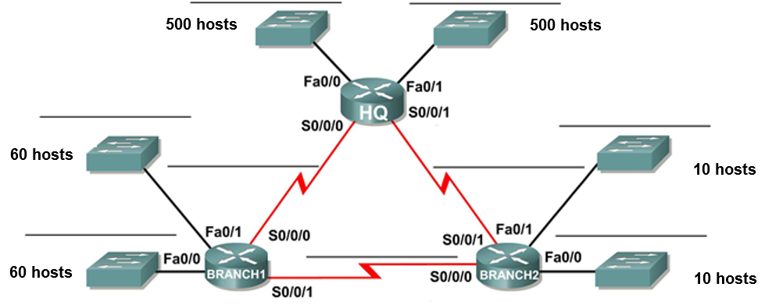

**130.168.248.0/21**

**.**

**.**



**.**

**.**

**.**

**.**

**.**

**.**

**.**

**130.168.248.0/21**

**255.255.11111000. 00000000**

|  |  |  |  |  |  |  |  |
| --- | --- | --- | --- | --- | --- | --- | --- |
| Subnet | #bits subnet | Mask decimal | Maximum host usable | Subnet | First Host Address | Last Host Address | Broadcast Address |
| HQ-F0/0 | **2** | **255.255.254.0**  **255.255.11111110.0**  **256 – 254 = 2** | **2 a la 9 – 2 = 510** | 130.168.248.0  130.168.11111000.00000000  1.11111111  130.168.11111010.00000000 | 130.168.248.1 | 130.168.249.254 | 130.168.249.255 |
| HQ-F0/1 | **2** | **255.255.254.0**  **255.255.11111110.0**  **256 – 254 = 2** | **2 a la 9 – 2 = 510** | 130.168.250.0  130.168.11111010.00000000 1.11111111  130.168.252.0 | 130.168.250.1 | 130.168.251.254 | 130.168.251.255 |
| BR1 -F0/0 | **5** | **255.255.255.192 /26**  **255.255.11111111.11000000**  **256 – 192 = 64** | **2 a la 6 – 2 = 62** | 130.168.252.0  130.168.11111100.00000000  111111  130.168.11111100.01000000  130.168.252.64 | 130.168.252.1 | 130.168.252.62 | 130.168.252.63 |
| BR1 -F0/1 | **5** | **255.255.255.192 /26**  **255.255.11111111.11000000**  **256 – 192 = 64** | **2 a la 6 – 2 = 62** | 130.168.252.64  130.168.11111100.01000000  111111  130.168.252.128 | 130.168.252.65 | 130.168.252.126 | 130.168.252.127 |
| BR2 – F0/0 | 7 | **255.255.255.240 /28**  **255.255.11111111.11110000**  **256 – 240 = 16** | 2 a la 4 – 2 = 14 | 130.168.252.128  130.168.11111100.10000000  1111  130.168.11111100.10010000  130.168.252.144 | 130.168.252.129 | 130.168.252.142 | 130.168.252.143 |
| BR2 – F0/1 | 7 | **255.255.255.240 /28**  **255.255.11111111.11110000**  **256 – 240 = 16** | 2 a la 4 – 2 = 14 | 130.168.252.144  130.168.11111100.10010000  1111  130.168.252.160 | 130.168.252.145 | 130.168.252.158 | 130.168.252.159 |
| HQ -BR1 | 9 | **255.255.255.252 /30**  **255.255.11111111.11111100**  **256 – 252 = 4** | 2 a la 2 – 2 = 2 | 130.168.252.160  130.168.11111100.10100000  130.168.11111100.10100011  130.168.11111100.10100100  130.168.11111100.10101000 | 130.168.252.161 | 130.168.252.162 | 130.168.252.163 |
| HQ- BR2 | 9 | **255.255.255.252 /30**  **255.255.11111111.11111100**  **256 – 252 = 4** | 2 a la 2 – 2 = 2 | 130.168.252.164 | 130.168.252.165 | 130.168.252.166 | 130.168.252.167 |
| BR1 – BR2 | 9 | **255.255.255.252 /30**  **255.255.11111111.11111100**  **256 – 252 = 4** | 2 a la 2 – 2 = 2 | 130.168.252.168 | 130.168.252.169 | 130.168.252.170 | 130.168.252.171 |

