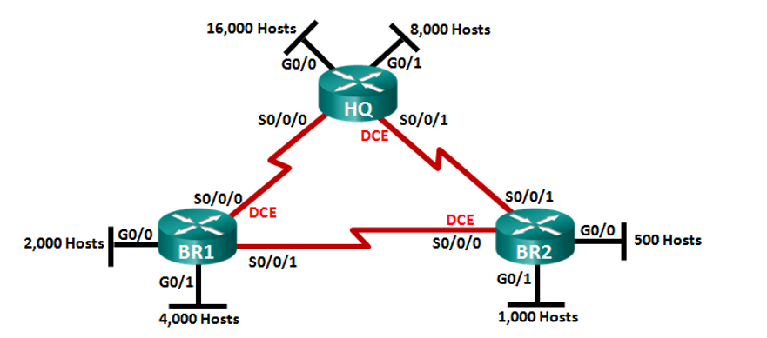

**.**

**.**

**.**

**.**

**.**

**.**

**.**

**.**

**.**

|  |  |  |  |  |  |  |  |  |  |
| --- | --- | --- | --- | --- | --- | --- | --- | --- | --- |
| Subnet | #Hosts | Mask | #bits in subnet | Maximum host usable | Two Network Address | Subnet | First Host Address | Last Host Address | Broadcast Address |
|  |  |  |  |  |  |  |  |  |  |
|  |  |  |  |  |  |  |  |  |  |
|  |  |  |  |  |  |  |  |  |  |
|  |  |  |  |  |  |  |  |  |  |
|  |  |  |  |  |  |  |  |  |  |
|  |  |  |  |  |  |  |  |  |  |