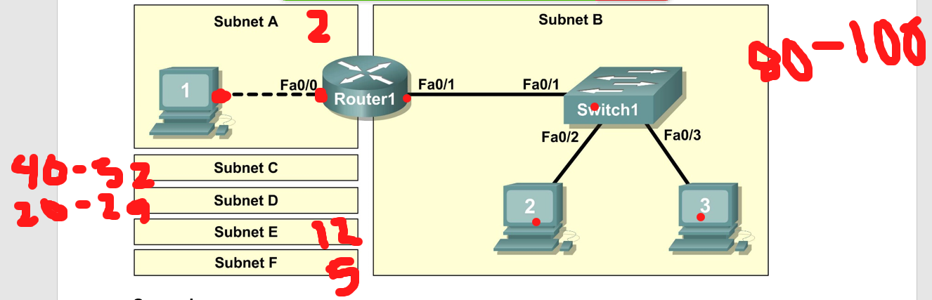

|  |  |  |  |  |
| --- | --- | --- | --- | --- |
| **Network Address** | **Mask** | **First Host Address** | **Last Host Address** | **Broadcast** |
| B. 172.20.0.0 /24  255.255.255.0  255.255.255.10000000  17.20.0. 0 0000000  1111111  172.20.0.128 | 255.255.255.128 /25  256 – 128 = 128 | 172.20.0.1 | 172.20.0.126 | 172.20.0.127 |
| C.172.20.0.128  255.255.255.1100 0000  172.20.0.10 000000 SUB  111111 BRO  172.20.0.192 | 255.255.255.11000000 /26  255.255.255.192  256 – 192 = 64 | 172.20.0. 129 | 172.20.0. 190 | 172.20.0. 191 |
| D. 172.20.0.192  255.255.255.111 00000  172.20.0.110 00000 SUB  11111 BRO  172.20.0.224 | 255.255.255.224 / 27  256 – 224 = 32 | 172.20.0.193 | 172.20.0.222 | 172.20.0.223 |
| E. 172.20.0.224  255.255.255.1111 0000  172.20.0.1110 0000 SUB  1111 BRO  172.20.0.240 | 255.255.255.240 /28  256 – 240 = 16 | 172.20.0.225 | 172.20.0.238 | 172.20.0.239 |
| F. 172.20.0.240  255.255.255.11111000  172.20.0.11110 000 SUB  111 BRO  172.20.0.248 | 255.255.255.248 / 29  256 – 248 = 8 | 172.20.0.241 | 172.20.0.246 | 172.20.0.247 |
| A. 172.20.0. 248  255.255.255.11111100  172.20.0.111110 00 SUB  11 BRO  172.20.0.252 | 255.255.255.252 / 30  256 – 252 = 4 | 172.20.0.249 | 172.20.0.250 | 172.20.0.251 |