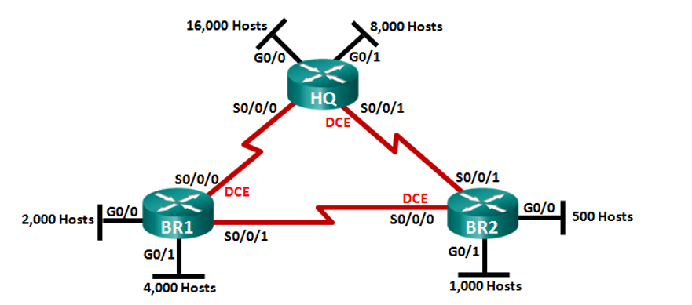

**. 172.16.192.0 /19**

**. .172.16.254.8 /30**

**. 172.16.254.0 /30**

**. 172.16.224.0 /20**

**. 172.16.254.4 /30**

**. 172.16.240.0 /21**

**. 172.16.248.0 / 22**

**. 172.16.252.0 /23**

**. 172.16.128.0 /18**

255.255.1000 0000.0000 0000

|  |  |  |  |  |  |  |  |  |  |
| --- | --- | --- | --- | --- | --- | --- | --- | --- | --- |
| Subnet | #Hosts | Mask | #bits in subnet | Maximum host usable | Two Network Address | Subnet | First Host Address | Last Host Address | Broadcast Address |
| HQ-G0/0 | **16000** | **255.255.1100 0000.0**  **255.255.192.0 /18** | **1** | **2 a la 14 – 2 =**  **16382** | **172.16.128.0**  **172.16.192.0**  **172.16.1000 0000.0**  **11 1111.255**  **172.16.1100 0000.0** | 172.16.128.0 | 172.16.128.1 | 172.16.191.254 | **172.16.191.255** |
| HQ-G0/1 | **8000** | **255.255.1110 0000.0**  **255.255.224.0 /19** | **2** | **2 a la 13 – 2 = 8190** | **172.16.192.0**  **172.16.224.0**  **172.16.1100 0000.0**  **1 1111.255**  **172.16.1110 0000.0** | **172.16.192.0** | **172.16.192.1** | **172.16.223.254** | **172.16.223.255** |
| BR1 -G0/1 | **4000** | **255.255.1111 0000.0**  **255.255.240.0 /20** | **3** | **2 a la 12 – 2 = 4094** | **172.16.224.0**  **172.16.240.0**  **172.16.1110 0000.0**  **1111.255**  **172.16.1111 0000.0** | **172.16.224.0** | **172.16.224.1** | **172.16.239.254** | **172.16.239.255** |
| BR1 -G0/0 | 2000 | **255.255.1111 1000.0**  **255.255.248.0 /21** | 4 | 2 a la 11 -2 = 2046 | **172.16.240.0**  **172.16.248.0**  **172.16.1111 0000.0**  **111.255**  **172.16.1111 1000.0** | **172.16.240.0** | **172.16.240.1** | **172.16.247.254** | **172.16.247.255** |
| BR2 – g0/1 | 1000 | **255.255.1111 1100.0**  **255.255.252.0 /22** | 5 | 2 a la 10 -2 = 1022 | **172.16.248.0**  **172.16.252.0**  **172.16.1111 1000.0**  **11.255**  **172.16.1111 1100.0** | **172.16.248.0** | **172.16.248.1** | **172.16.251.254** | **172.16.251.255** |
| BR2 – g0/0 | 500 | **255.255.1111 1110.0**  **255.255.254.0 /23** | 6 | 2 a la 9 – 2 = 510 | **172.16.252.0**  **172.16.254.0**  **172.16.1111 1100.0**  **1.255**  **172.16.1111 1110.0** | **172.16.252.0** | **172.16.252.1** | **172.16.253.254** | **172.16.253.255** |
| BR1 - HQ | 2 | **255.255.1111 1111.11111100**  **255.255.255.252 /30** | 13 | 2 a la 2 – 2 = 2 | **172.16.254.0**  **172.16.254.4**  **172.16.254.8**  **172.16.11111110.0000 0000**  **11**  **172.16.1111 1110.00000100**  **172.16.1111 1110.00001000** | **172.16.254.0** | **172.16.254.1** | **172.16.254.2** | **172.16.254.3** |
| BR2 - HQ | 2 | **255.255.1111 1111.11111100**  **255.255.255.252 /30** | 13 | 2 a la 2 – 2 = 2 | **172.16.254.4** | **172.16.254.4** | **172.16.254.5** | **172.16.254.6** | **172.16.254.7** |
| BR1 – BR2 | 2 | **255.255.1111 1111.11111100**  **255.255.255.252 /30** | 13 | 2 a la 2 – 2 = 2 | **172.16.254.8** | **72.16.254.8** | **72.16.254.9** | **72.16.254.10** | **72.16.254.11** |