**Tarea. Designing and Implementing a VLSM Addressing Scheme**

**Nombre:____________________________________________ Matrícula:_________________**

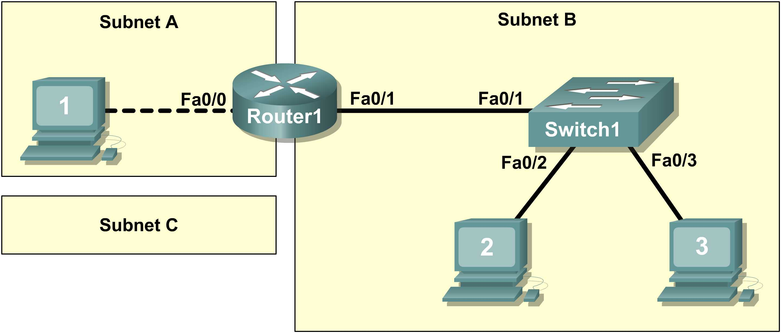

**Learning Objectives**

* Design the logical lab topology.

**Scenario**

In this lab students will create a small network that requires connecting network devices and configuring Host computers for basic network connectivity. Subnet A and Subnet B are subnets that are currently needed. Subnet C is an anticipated subnet, not yet connected to the network.

**Task 1: Configure the logical lab topology.**

Given an IP address of **209.165.200.224 / 27** (address / mask), design an IP addressing scheme that satisfies the following requirements:

|  |  |
| --- | --- |
| **Subnet** | **Number of Hosts** |
| Subnet A | 2 |
| Subnet B | Between 2 - 6 |
| Subnet C | Between 10 – 12 |

Step 1: Design Subnet C address block.

Begin the logical network design by satisfying the requirement for Subnet C, the largest IP address block. Using binary numbers to create your subnet chart, pick the next available address block that will support Subnet C.

Fill in the following table with IP address information for **Subnet C**:

|  |  |  |  |
| --- | --- | --- | --- |
| Number of bits in the subnet | | **1** | |
| IP mask (binary) | **111111111.1111111.11111111. 1111 0000** | | |
| IP mask (decimal) | | | **255.255.255.240** |
| Maximum Number of usable hosts per subnet | | | **2 a la 4 – 2 = 14** |
| IP Subnet | | | **209.165.200.224** |
| First IP Host address | | | **209.165.200.225** |
| Last IP Host address | | | **209.165.200.238** |
| IP Broadcast | | | **209.165.200.239** |

Step 2: Design Subnet B address block.

Satisfy the requirement of Subnet B, the next largest block of IP addresses. Using binary numbers to create your subnet chart, pick the first address block that will support Subnet B.

Fill in the following table with IP address information for **Subnet B**:

|  |  |  |
| --- | --- | --- |
| Number of bits in the subnet | | **2** |
| IP mask (binary) | **111111111.1111111.11111111. 1111 1000** | |
| IP mask (decimal) | | **255.255.255.248** |
| Maximum Number of usable hosts per subnet | | **2 a la 3 – 2 = 6** |
| IP Subnet | | **209.165.200.240** |
| First IP Host address | | **209.165.200.241** |
| Last IP Host address | | **209.165.200.246** |
| IP Broadcast | | **209.165.200.247** |

Step 3: Design Subnet A address block.

Satisfy the requirement of Subnet A, the smallest IP address block. Using binary numbers to create your subnet chart, pick the next available address block that will support Subnet A.

Fill in the following table with IP address information for **Subnet A**:

|  |  |  |
| --- | --- | --- |
| Number of bits in the subnet | | **3** |
| IP mask (binary) | **111111111.1111111.11111111. 1111 1100** | |
| IP mask (decimal) | | **255.255.255.252** |
| Maximum Number of usable hosts per subnet | | **2 a la 2 -2 = 2** |
| IP Subnet | | **209.165.200.248** |
| First IP Host address | | **209.165.200.249** |
| Last IP Host address | | **209.165.200.250** |
| IP Broadcast | | **209.165.200.251** |

**Task 2: Configure the Logical Topology.**

Document logical network settings.

Host computers will use the first two IP addresses in the subnetwork. The network router will use the LAST network host address. Write down the IP address information for each device:

|  |  |  |  |  |
| --- | --- | --- | --- | --- |
| **Device** | **Subnet** | **IP address** | **Mask** | **Gateway** |
| R1-Fa0/0 | **209.165.200.248 ó A** | **209.165.200.250** | **255.255.255.252 ó /30** | **NA** |
| Host1 | **209.165.200.248 ó A** | **209.165.200.249** | **255.255.255.252 ó /30** | **209.165.200.250** |
| R1-Fa0/1 | **209.165.200.240 ó B** | **209.165.200.246** | **255.255.255.248 ó /29** | **NA** |
| Host2 | **209.165.200.240 ó B** | **209.165.200.241** | **255.255.255.248 ó /29** | **209.165.200.246** |
| Host3 | **209.165.200.240 ó B** | **209.165.200.242** | **255.255.255.248 ó /29** | **209.165.200.246** |
| Switch1 | N/A | N/A | N/A | N/A |