Tarea. Designing and Implementing a VLSM Addressing Scheme

Nombre:____________________________________________ Matrícula:_________________

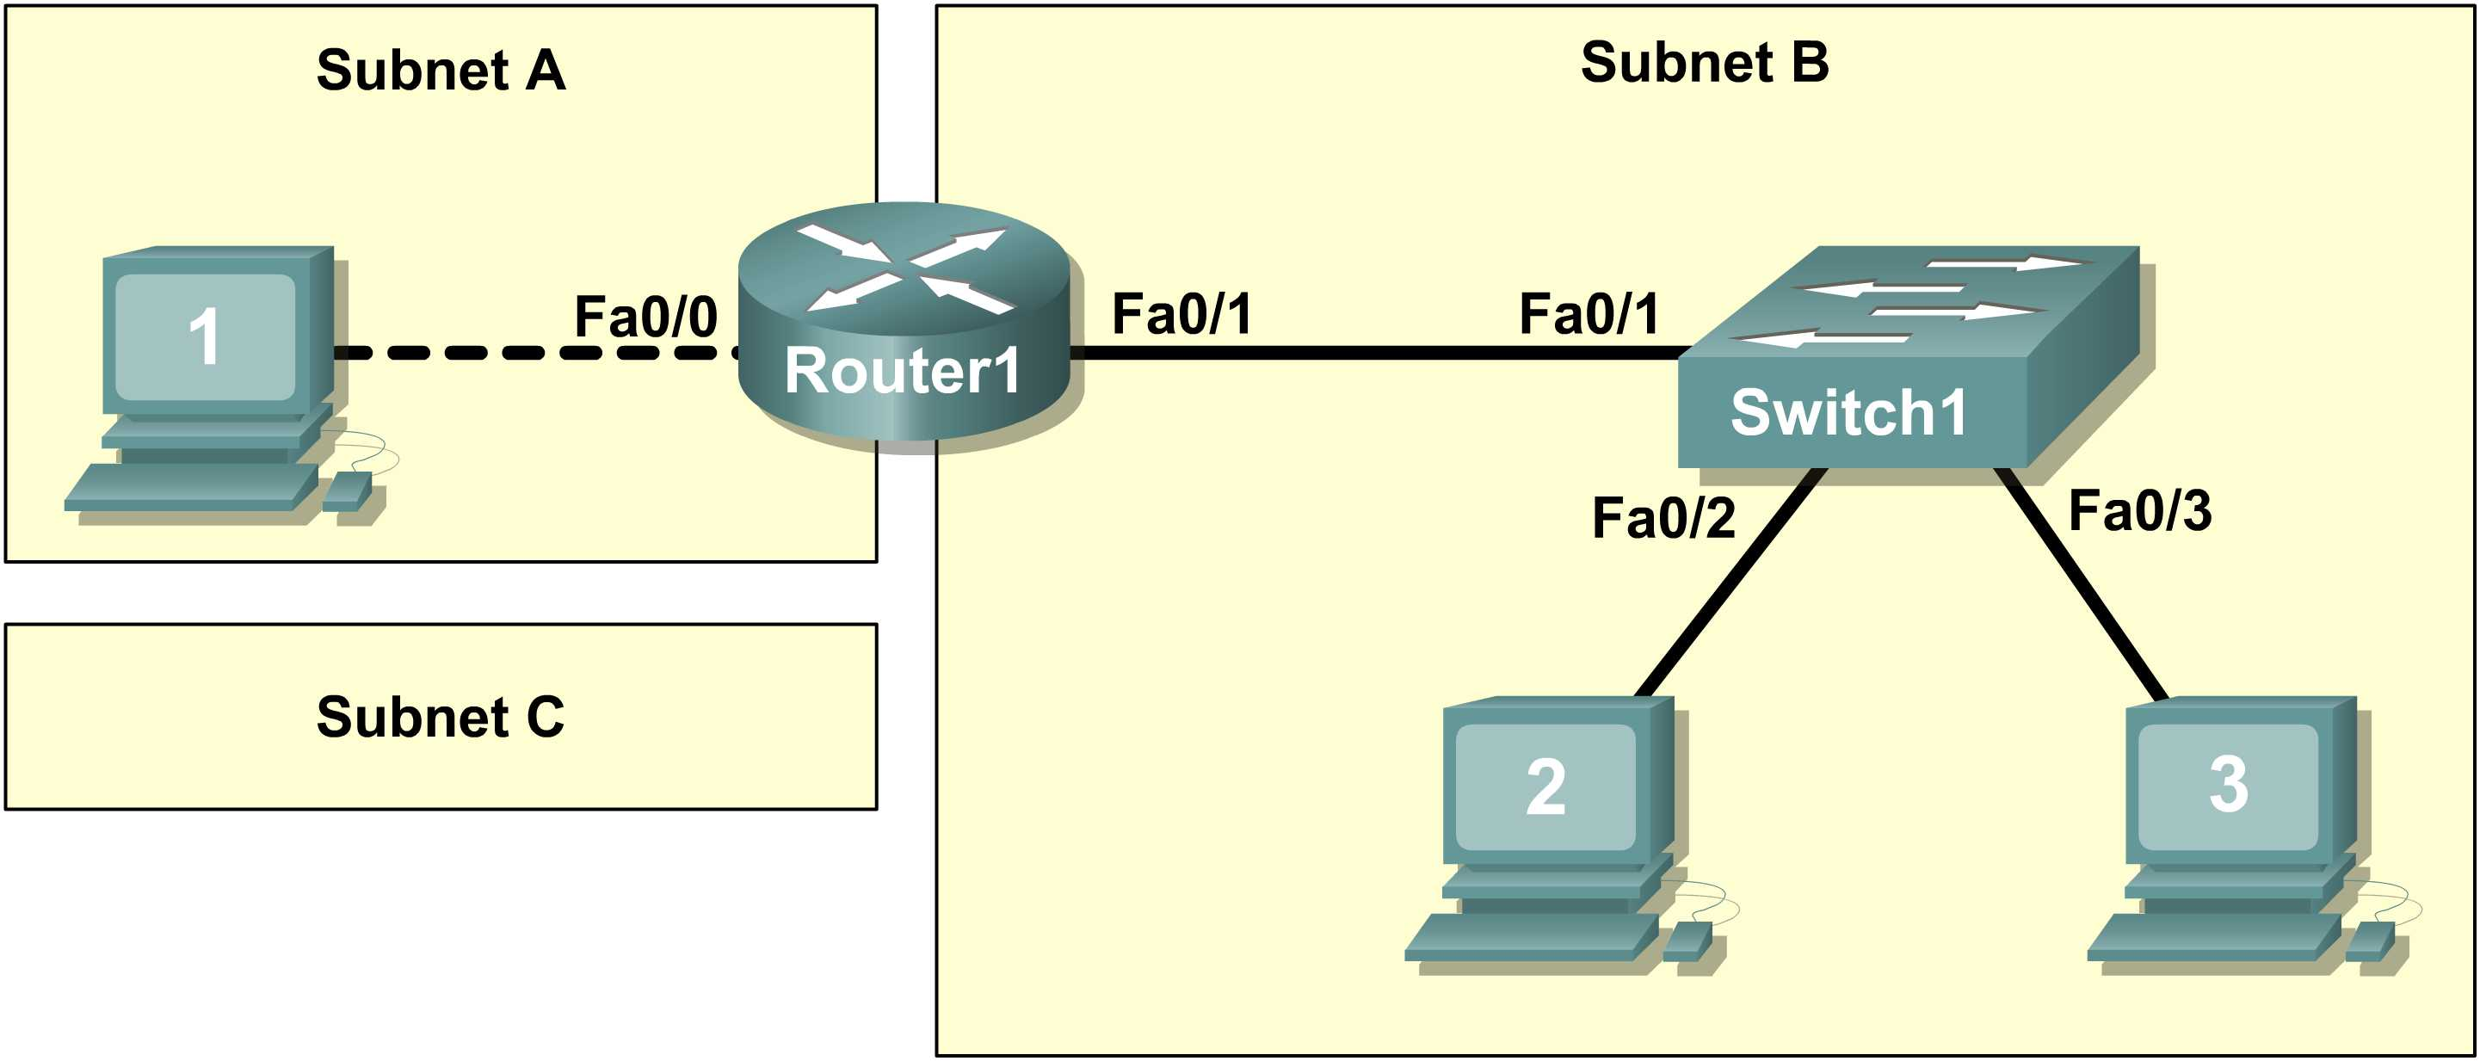

Learning Objectives

- Design the logical lab topology.

Scenario

In this lab students will create a small network that requires connecting network devices and configuring Host computers for basic network connectivity. Subnet A and Subnet B are subnets that are currently needed. Subnet C is an anticipated subnet, not yet connected to the network.

Task 1: Configure the logical lab topology.

Given an IP address of 209.165.200.224 / 27 (address / mask), design an IP addressing scheme that satisfies the following requirements:

Subnet | Number of Hosts
Subnet A | 2
Subnet B | Between 2 - 6
Subnet C | Between 10 – 12
Step 1: Design Subnet C address block.
Begin the logical network design by satisfying the requirement for Subnet C, the largest IP address block. Using binary numbers to create your subnet chart, pick the next available address block that will support Subnet C.
Fill in the following table with IP address information for Subnet C:

Number of bits in the subnet |  | 1
IP mask (binary) | 111111111.1111111.11111111. 1111 0000
IP mask (decimal) |  |  | 255.255.255.1111 0000  255.255.255.240
Maximum Number of usable hosts per subnet |  |  | 2 a la 4 – 2 = 14
IP Subnet |  |  | 209.165.200.224  209.165.200.240  209.165.200.1110 0000 subred  1111 broadcast  209.165.200.1111 0000 subred
First IP Host address |  |  | 209.165.200.225
Last IP Host address |  |  | 209.165.200.238
IP Broadcast |  |  | 209.165.200.239
Step 2: Design Subnet B address block.
Satisfy the requirement of Subnet B, the next largest block of IP addresses. Using binary numbers to create your subnet chart, pick the first address block that will support Subnet B.

Fill in the following table with IP address information for Subnet B:

Number of bits in the subnet |  | 2
IP mask (binary) | 111111111.1111111.11111111. 1111 1000
IP mask (decimal) |  | 255.255.255.248  255.255.255.1111 1000
Maximum Number of usable hosts per subnet |  | 2 a la 3 – 2 = 6
IP Subnet |  | 209.165.200.240  209.165.200.248  209.165.200.1111 0 000  111  209.165.200.1111 1 000
First IP Host address |  | 209.165.200.241
Last IP Host address |  | 209.165.200.246
IP Broadcast |  | 209.165.200.247
Step 3: Design Subnet A address block.
Satisfy the requirement of Subnet A, the smallest IP address block. Using binary numbers to create your subnet chart, pick the next available address block that will support Subnet A.

Fill in the following table with IP address information for Subnet A:

Number of bits in the subnet |  | 3
IP mask (binary) | 111111111.1111111.11111111. 1111 1100
IP mask (decimal) |  | 255.255.255.252  255.255.255.1111 1100 /30
Maximum Number of usable hosts per subnet |  | 2 a la 2 -2 = 2
IP Subnet |  | 209.165.200.248  209.165.200.252
First IP Host address |  | 209.165.200.249
Last IP Host address |  | 209.165.200.250
IP Broadcast |  | 209.165.200.251

Task 2: Configure the Logical Topology.

Document logical network settings.
Host computers will use the first two IP addresses in the subnetwork. The network router will use the LAST network host address. Write down the IP address information for each device:

Device | Subnet | IP address | Mask | Gateway
R1-Fa0/0 | 209.165.200.248 | 209.165.200.250 | 255.255.255.252 ó /30 | NA
Host1 | 209.165.200.248 | 209.165.200.249 | 255.255.255.252 ó /30 | 209.165.200.250
R1-Fa0/1 | 209.165.200.240 | 209.165.200.246 | 255.255.255.248 ó /29 | NA
Host2 | 209.165.200.240 | 209.165.200.241 | 255.255.255.248 ó /29 | 209.165.200.246
Host3 | 209.165.200.240 | 209.165.200.242 | 255.255.255.248 ó /29 | 209.165.200.246
Switch1 | N/A | N/A | N/A | N/A

