Tarea. Designing and Implementing a VLSM Addressing Scheme

Nombre:____________________________________________ Matrícula:_________________

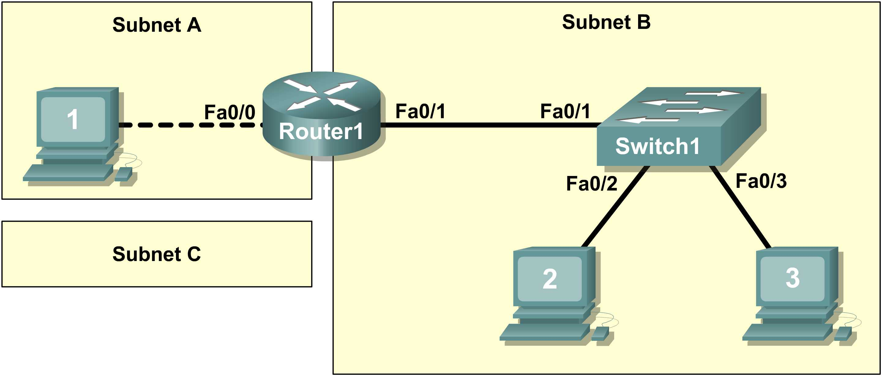

Learning Objectives

- Design the logical lab topology.

Scenario

In this lab students will create a small network that requires connecting network devices and configuring Host computers for basic network connectivity. Subnet A and Subnet B are subnets that are currently needed. Subnet C is an anticipated subnet, not yet connected to the network.

Task 1: Configure the logical lab topology.

Given an IP address of 209.165.200.224 / 27 (address / mask), design an IP addressing scheme that satisfies the following requirements:

Subnet | Number of Hosts
Subnet A | 2
Subnet B | Between 2 - 6
Subnet C | Between 10 – 12
Step 1: Design Subnet C address block.
Begin the logical network design by satisfying the requirement for Subnet C, the largest IP address block. Using binary numbers to create your subnet chart, pick the next available address block that will support Subnet C.
Fill in the following table with IP address information for Subnet C:

Number of bits in the subnet |  | 1
IP mask (binary) | 11111111. 11111111. 11111111.11110000
IP mask (decimal) |  |  | 255.255.255.240 /28
Maximum Number of usable hosts per subnet |  |  | 2 a la 4 – 2 =14
IP Subnet |  |  | 209.165.200.224
First IP Host address |  |  | 209.165.200.225
Last IP Host address |  |  | 209.165.200.238
IP Broadcast |  |  | 209.165.200.239
Step 2: Design Subnet B address block.
Satisfy the requirement of Subnet B, the next largest block of IP addresses. Using binary numbers to create your subnet chart, pick the first address block that will support Subnet B.

Fill in the following table with IP address information for Subnet B:

Number of bits in the subnet |  | 2
IP mask (binary) | 11111111. 11111111. 11111111.11111000
IP mask (decimal) |  | 255.255.255.248 /29
Maximum Number of usable hosts per subnet |  | 2 a la 3 -2 = 6
IP Subnet |  | 209.165.200.240
First IP Host address |  | 209.165.200.241
Last IP Host address |  | 209.165.200.246
IP Broadcast |  | 209.165.200.247
Step 3: Design Subnet A address block.
Satisfy the requirement of Subnet A, the smallest IP address block. Using binary numbers to create your subnet chart, pick the next available address block that will support Subnet A.

Fill in the following table with IP address information for Subnet A:

Number of bits in the subnet |  | 3
IP mask (binary) | 11111111. 11111111. 11111111.11111100
IP mask (decimal) |  | 255.255.255.252 /30
Maximum Number of usable hosts per subnet |  | 2 a la 2 – 2 = 2
IP Subnet |  | 209.165.200.248
First IP Host address |  | 209.165.200.249
Last IP Host address |  | 209.165.200.250
IP Broadcast |  | 209.165.200.251

Task 2: Configure the Logical Topology.

Document logical network settings.
Host computers will use the first two IP addresses in the subnetwork. The network router will use the LAST network host address. Write down the IP address information for each device:

Device | Subnet | IP address | Mask | Gateway
R1-Fa0/0 | 209.165.200.248 | 209.165.200.250 | 255.255.255.252 /30 | NA
Host1 | 209.165.200.248 | 209.165.200.249 | 255.255.255.252 /30 | 209.165.200.250
R1-Fa0/1 | 209.165.200.240 | 209.165.200.246 | 255.255.255.248 /29 | NA
Host2 | 209.165.200.240 | 209.165.200.241 | 255.255.255.248 /29 | 209.165.200.246
Host3 | 209.165.200.240 | 209.165.200.242 | 255.255.255.248 /29 | 209.165.200.246
Switch1 | N/A | N/A | N/A | N/A

