

**Actividad: “Evaluación de código”**

Nombre: ____________________________________ Matrícula: ____________________

Resolver los siguientes ejercicios y escribir la corrida de escritorio en cada tabla:

**Ejercicio 1**

|  |  |
| --- | --- |
| **i** | **n** |
|  |  |
|  |  |
|  |  |
|  |  |
|  |  |
|  |  |

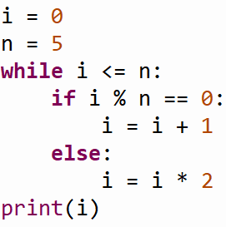

¿Cuál es el valor final de **i**? **____**

**Ejercicio 2**

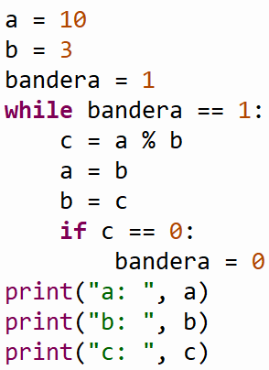

|  |  |  |  |
| --- | --- | --- | --- |
| **a** | **b** | **c** | **bandera** |
|  |  |  |  |
|  |  |  |  |
|  |  |  |  |
|  |  |  |  |
|  |  |  |  |

¿Cuál es el valor final de **a**, **b** y **c**? **____**

**Ejercicio 3**

|  |  |  |
| --- | --- | --- |
| **sum** | **i** | **j** |
|  |  |  |
|  |  |  |
|  |  |  |
|  |  |  |
|  |  |  |
|  |  |  |
|  |  |  |
|  |  |  |
|  |  |  |
|  |  |  |
|  |  |  |
|  |  |  |
|  |  |  |
|  |  |  |
|  |  |  |
|  |  |  |
|  |  |  |
|  |  |  |

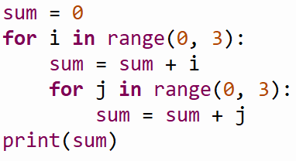

¿Cuál es el valor final de **sum**? **____**

|  |  |  |
| --- | --- | --- |
| **sum** | **i** | **j** |
|  |  |  |
|  |  |  |
|  |  |  |
|  |  |  |
|  |  |  |
|  |  |  |
|  |  |  |
|  |  |  |
|  |  |  |
|  |  |  |
|  |  |  |
|  |  |  |
|  |  |  |
|  |  |  |
|  |  |  |
|  |  |  |
|  |  |  |
|  |  |  |
|  |  |  |

**Ejercicio 4**

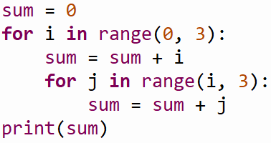

¿Cuál es el valor final de **sum**? **____**

|  |  |  |
| --- | --- | --- |
| **sum** | **i** | **j** |
|  |  |  |
|  |  |  |
|  |  |  |
|  |  |  |
|  |  |  |
|  |  |  |
|  |  |  |
|  |  |  |
|  |  |  |
|  |  |  |
|  |  |  |
|  |  |  |
|  |  |  |
|  |  |  |
|  |  |  |
|  |  |  |
|  |  |  |
|  |  |  |
|  |  |  |
|  |  |  |
|  |  |  |

**Ejercicio 5**

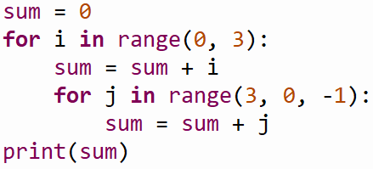

¿Cuál es el valor final de **sum**? **____**