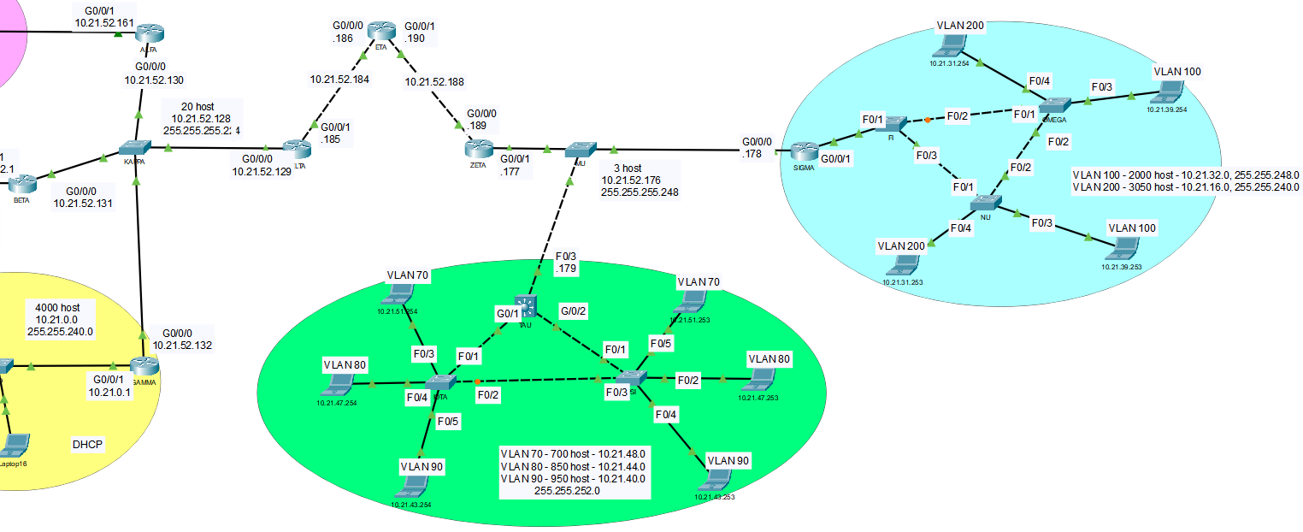
20 host
10.21.52.128
255.255.255.224

